
BSc Data Sciences & Analytics | Semester V – Advanced Data Analytics & Visualization
LAB 5
D3.JS FORCE-DIRECTED GRAPHS & GITHUB PAGES DEPLOYMENT
PROBLEM STATEMENT
Static dashboards and charts show fixed snapshots of data, but they do not let users explore and interact. Interactive visualizations allow users to hover, drag, zoom and discover patterns themselves. D3.js is the industry standard library for building such visualizations.
However, work built in a Jupyter or Colab notebook stays private. This lab builds three interactive D3.js visualizations of a data pipeline in Google Colab and then deploys one of them to GitHub Pages, giving a permanent, shareable public URL that can be used as a portfolio piece.
OBJECTIVES
- To write D3.js code in a Colab %%html cell to create an interactive network visualization.
- To understand how D3 binds data to visual elements and responds to user interactions.
- To build a force-directed graph with draggable nodes.
- To build a Sankey diagram showing data flow between pipeline stages, with a hover transition.
- To build a hierarchical treemap using d3.hierarchy() and d3.treemap().
- To export the visualizations as standalone HTML files.
- To learn the Git workflow (initialize, commit, push) and deploy a visualization on GitHub Pages.
PROCEDURE
TASK 1: BUILD A FORCE-DIRECTED GRAPH
A force-directed graph of a data-science pipeline with seven stages (Data Cleaning, EDA, Feature Engineering, Model Training, Evaluation, Visualization, Deployment) was created in a Colab %%html cell. Nodes are drawn as circles and relationships as lines, and the nodes can be dragged.
Steps
- Create a Colab cell beginning with %%html, add <div id="graph"> and load D3 v7 from the jsDelivr CDN.
- Define the seven nodes and eight links (each stage to the next, plus an extra EDA → Visualization link).
- Append an SVG (700 × 450) to the div.
- Create d3.forceSimulation(nodes) with forceLink (distance 110), forceManyBody (strength −320) and forceCenter.
- Draw lines, circles and text labels using .data().join().
- Add d3.drag(): fix the node at the pointer while dragging (fx, fy) and release it on drag end.
- In the tick handler, update the line, circle and label positions on every frame.
Code Used
%%html
<div id="graph"></div>
<script src="https://cdn.jsdelivr.net/npm/d3@7/dist/d3.min.js"></script>
<script>
const width = 700, height = 450;

const nodes = [
{id: "Data Cleaning"},{id: "EDA"},{id: "Feature Engineering"},{id: "Model Training"},{id: "Evaluation"}, {id: "Visualization"}, {id:"Deployment"}
];
const links = [
{source: "Data Cleaning", target: "EDA"},
{source: "EDA", target: "Feature Engineering"},
{source: "Feature Engineering", target: "Model Training"},
{source: "Model Training", target: "Evaluation"},
{source: "Evaluation", target: "Visualization"},
{source: "Visualization", target: "Deployment"},
{source: "EDA", target: "Visualization"},
];
const svg = d3.select("#graph")
.append("svg")
.attr("width", width)
.attr("height", height).style("border", "1px solid #ccc");

const simulation = d3.forceSimulation(nodes)
.force("link", d3.forceLink(links).id(d => d.id).distance(110))
.force("charge", d3.forceManyBody().strength(-320))
.force("center", d3.forceCenter(width / 2, height / 2));

const link = svg.append("g")
.selectAll("line").data(links).join("line").attr("stroke", "#999").attr("stroke-width", 1.5);

const node = svg.append("g")
.selectAll("circle").data(nodes).join("circle")
.attr("r", 10).attr("fill", "#69b3a2").call(d3.drag()
.on("start", (event, d) => {if (!event.active) simulation.alphaTarget(0.3).restart();d.fx = d.x; d.fy = d.y;})
.on("drag", (event, d) => {d.fx = event.x; d.fy = event.y;})
.on("end", (event, d) => {if (!event.active) simulation.alphaTarget(0);d.fx = null; d.fy = null;}));

const label = svg.append("g")
.selectAll("text").data(nodes).join("text").text(d => d.id).attr("font-size", 11).attr("dx", 14).attr("dy", 4);

simulation.on("tick", () => {
link.attr("x1", d => d.source.x).attr("y1", d => d.source.y)
.attr("x2", d => d.target.x).attr("y2", d => d.target.y);
node.attr("cx", d => d.x).attr("cy", d => d.y);
label.attr("x", d => d.x).attr("y", d => d.y);
});
</script>
Interpretation
- forceLink pulls connected stages together at a fixed distance, forceManyBody pushes all nodes apart, and forceCenter keeps the graph in the middle of the SVG.
- The tick event runs repeatedly while the simulation settles, so the picture re-draws until the layout is stable.
- Dragging a node pins it to the cursor and reheats the simulation (alphaTarget 0.3); connected nodes follow, and the node is released on drag end.
- EDA has three connections (Data Cleaning, Feature Engineering and Visualization), so it acts as the hub of the pipeline.
Output
The graph rendered correctly with seven labelled circular nodes joined by lines, and the nodes can be dragged.
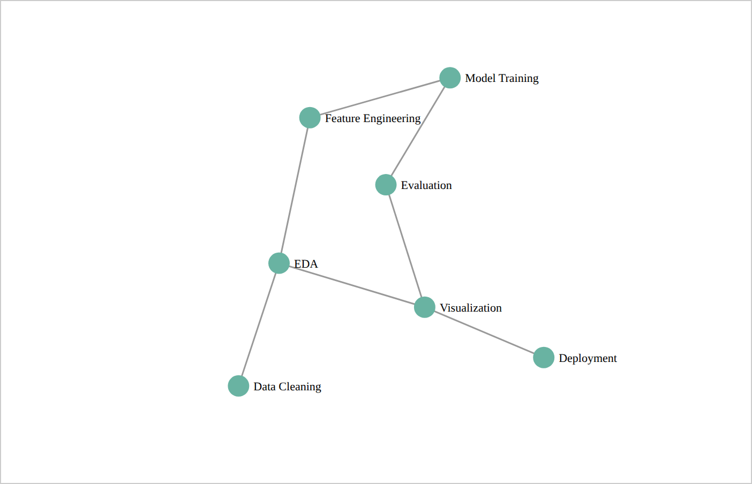
Figure 1: Force-directed graph of the data pipeline
TASK 2: BUILD A SANKEY DIAGRAM
A Sankey diagram was built to show how data flows from three input sources (Web Logs, Mobile App, CRM Export) through the processing stages to Deployment. A Rejected node represents records removed during cleaning. The d3-sankey library was loaded from the required CDN link, and the code was saved as the standalone file index.html.
Data Used
Source | Target | Flow Value
Web Logs | Data Cleaning | 5000
Mobile App | Data Cleaning | 3000
CRM Export | Data Cleaning | 2000
Data Cleaning | EDA | 8500
Data Cleaning | Rejected | 1500
EDA | Feature Engineering | 6000
EDA | Visualization | 2500
Feature Engineering | Model Training | 4800
Feature Engineering | Evaluation | 1200
Model Training | Evaluation | 4800
Evaluation | Deployment | 5000
Evaluation | Visualization | 1000

Steps
- Write a complete HTML page with %%writefile index.html and load D3 v7 followed by d3-sankey 0.12.
- Define 11 nodes and 12 weighted links.
- Configure d3.sankey() with nodeId, nodeWidth(16), nodePadding(20) and an extent, then pass copies of the nodes and links to it.
- Draw each flow as a path with d3.sankeyLinkHorizontal(), coloured by its source node, with stroke width equal to the flow size.
- Draw each node as a rectangle and add text labels.
- Add mouseover and mouseout handlers that use transition().duration(200) to fade the node colour.
- Use a wait() function so draw() only runs after d3 and d3.sankey have loaded.
Code Used
%%writefile index.html
<!DOCTYPE html>
<html lang="en">
<head>
<meta charset="utf-8">
<title>D3 Sankey – Data Pipeline</title>
</head>
<body>
<div id="graph"></div>
<script src="https://cdn.jsdelivr.net/npm/d3@7/dist/d3.min.js"></script>
<script src="https://cdn.jsdelivr.net/npm/d3-sankey@0.12/dist/d3-sankey.min.js"></script>
<script>
function draw() {
const width = 900, height = 450;
const nodes = [
{name: "Web Logs"}, {name: "Mobile App"}, {name: "CRM Export"},
{name: "Data Cleaning"}, {name: "Rejected"}, {name: "EDA"},
{name: "Feature Engineering"}, {name: "Model Training"},
{name: "Evaluation"}, {name: "Visualization"}, {name: "Deployment"}
];
const links = [
{source: "Web Logs", target: "Data Cleaning", value: 5000},
{source: "Mobile App", target: "Data Cleaning", value: 3000},
{source: "CRM Export", target: "Data Cleaning", value: 2000},
{source: "Data Cleaning", target: "EDA", value: 8500},
{source: "Data Cleaning", target: "Rejected", value: 1500},
{source: "EDA", target: "Feature Engineering", value: 6000},
{source: "EDA", target: "Visualization", value: 2500},
{source: "Feature Engineering", target: "Model Training", value: 4800},
{source: "Feature Engineering", target: "Evaluation", value: 1200},
{source: "Model Training", target: "Evaluation", value: 4800},
{source: "Evaluation", target: "Deployment", value: 5000},
{source: "Evaluation", target: "Visualization", value: 1000}
];
const svg = d3.select("#graph").append("svg")
.attr("width", width).attr("height", height)
.style("border", "1px solid #ccc");
const graph = d3.sankey()
.nodeId(d => d.name).nodeWidth(16).nodePadding(20)
.extent([[10, 10], [width - 10, height - 10]])
({nodes: nodes.map(d => ({...d})), links: links.map(d => ({...d}))});
const color = d3.scaleOrdinal(d3.schemeTableau10);
svg.append("g")
.selectAll("path").data(graph.links).join("path")
.attr("d", d3.sankeyLinkHorizontal())
.attr("fill", "none")
.attr("stroke", d => color(d.source.name))
.attr("stroke-opacity", 0.4)
.attr("stroke-width", d => Math.max(1, d.width));
const node = svg.append("g")
.selectAll("rect").data(graph.nodes).join("rect")
.attr("x", d => d.x0).attr("y", d => d.y0)
.attr("width", d => d.x1 - d.x0).attr("height", d => d.y1 - d.y0)
.attr("fill", d => color(d.name))
.on("mouseover", function (event, d) {
d3.select(this).transition().duration(200)
.attr("fill", d3.color(color(d.name)).brighter(0.7));
})
.on("mouseout", function (event, d) {
d3.select(this).transition().duration(200)
.attr("fill", color(d.name));
});
svg.append("g")
.selectAll("text").data(graph.nodes).join("text")
.text(d => d.name).attr("font-size", 11)
.attr("x", d => d.x0 < width / 2 ? d.x1 + 6 : d.x0 - 6)
.attr("y", d => (d.y0 + d.y1) / 2).attr("dy", "0.35em")
.attr("text-anchor", d => d.x0 < width / 2 ? "start" : "end");
}
(function wait() {if (window.d3 && window.d3.sankey) draw(); else setTimeout(wait, 50);})();
</script>
</body>
</html>
Interpretation
- d3.sankey() calculates the position and size of every node and link; the width of each flow is proportional to its value.
- Data Cleaning receives 10,000 records (5000 + 3000 + 2000) and sends 8,500 to EDA and 1,500 to Rejected, a loss of 15%.
- EDA splits into Feature Engineering (6000) and Visualization (2500); Feature Engineering splits into Model Training (4800) and Evaluation (1200).
- Evaluation receives 6,000 records and sends 5,000 to Deployment and 1,000 to Visualization, so half of the original 10,000 records reach Deployment.
- Hovering over a node brightens its colour smoothly over 200 ms, and moving away restores it.
Output
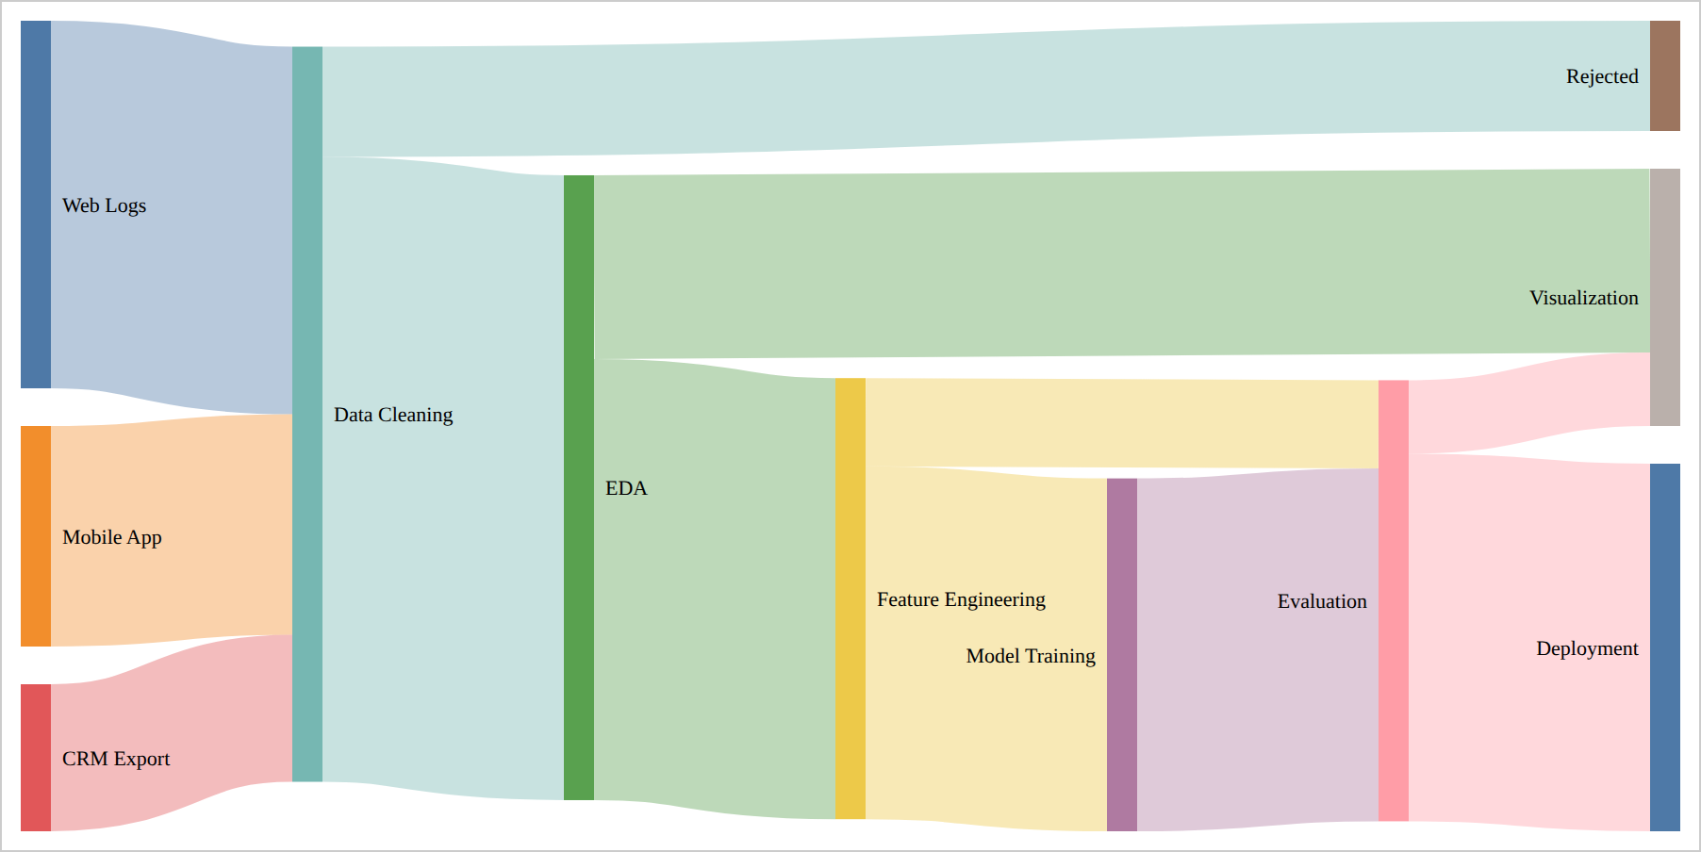
Figure 2: Sankey diagram of the data pipeline (index.html)
TASK 3: BUILD A TREEMAP
An interactive treemap was created to show hierarchical data volume. The root is Data Science, with four categories, each containing individual items. The size of each rectangle is proportional to its value. The code was saved as treemap.html.
Hierarchical Data
Category | Item | Value
Data Sources | Web Logs | 5000
Data Sources | Mobile App | 3000
Data Sources | CRM Export | 2000
Data Processing | Data Cleaning | 4000
Data Processing | Data Transformation | 2500
Data Processing | Feature Engineering | 3000
Machine Learning | Model Training | 4500
Machine Learning | Evaluation | 2500
Machine Learning | Deployment | 2000
Visualization | EDA | 3000
Visualization | Dashboards | 2000

Steps
- Create treemap.html and load D3 v7.
- Write the nested data object (root → categories → items with values).
- Build the hierarchy with d3.hierarchy(data).sum(d => d.value).sort(...).
- Compute rectangle positions with d3.treemap() using size, paddingOuter, paddingInner and paddingTop.
- Draw a translucent rectangle and a bold label for each category, then a rectangle for each leaf coloured by its parent category.
- Add item names and values as labels, and mouseover/mouseout transitions that highlight a leaf.
Code Used
%%writefile treemap.html

<!DOCTYPE html>
<html>
<head>
<meta charset="UTF-8">
<title>Treemap</title>
</head>
<body>

<div id="treemap"></div>

<script src="https://cdn.jsdelivr.net/npm/d3@7/dist/d3.min.js"></script>

<script>

const width = 900;
const height = 500;

// Hierarchical data
const data = {
name: "Data Science",
children: [
{
name: "Data Sources",
children: [
{name: "Web Logs", value: 5000},
{name: "Mobile App", value: 3000},
{name: "CRM Export", value: 2000}
]
},
{
name: "Data Processing",
children: [
{name: "Data Cleaning", value: 4000},
{name: "Data Transformation", value: 2500},
{name: "Feature Engineering", value: 3000}
]
},
{
name: "Machine Learning",
children: [
{name: "Model Training", value: 4500},
{name: "Evaluation", value: 2500},
{name: "Deployment", value: 2000}
]
},
{
name: "Visualization",
children: [
{name: "EDA", value: 3000},
{name: "Dashboards", value: 2000}
]
}
]
};

// Create SVG
const svg = d3.select("#treemap")
.append("svg")
.attr("width", width)
.attr("height", height)
.style("border", "1px solid #ccc");

// Create hierarchy
const root = d3.hierarchy(data)
.sum(d => d.value)
.sort((a, b) => b.value - a.value);

// Create treemap layout
d3.treemap()
.size([width, height])
.paddingOuter(5)
.paddingInner(3)
.paddingTop(25)
(root);

// Color scale
const color = d3.scaleOrdinal(d3.schemeTableau10);

// Draw category groups
const groups = svg.selectAll(".group")
.data(root.children)
.join("g")
.attr("class", "group");

// Category background rectangles
groups.append("rect")
.attr("x", d => d.x0)
.attr("y", d => d.y0)
.attr("width", d => d.x1 - d.x0)
.attr("height", d => d.y1 - d.y0)
.attr("fill", d => color(d.data.name))
.attr("fill-opacity", 0.25)
.attr("stroke", d => color(d.data.name))
.attr("stroke-width", 2);

// Category labels
groups.append("text")
.attr("x", d => d.x0 + 6)
.attr("y", d => d.y0 + 18)
.text(d => d.data.name)
.attr("font-size", 14)
.attr("font-weight", "bold");

// Leaf nodes
const leaves = svg.selectAll(".leaf")
.data(root.leaves())
.join("g")
.attr("class", "leaf");

// Leaf rectangles
leaves.append("rect")
.attr("x", d => d.x0)
.attr("y", d => d.y0)
.attr("width", d => d.x1 - d.x0)
.attr("height", d => d.y1 - d.y0)
.attr("fill", d => color(d.parent.data.name))
.attr("fill-opacity", 0.8)
.attr("stroke", "white")
.attr("stroke-width", 1)

// Hover effect
.on("mouseover", function(event, d) {
d3.select(this)
.transition()
.duration(200)
.attr("fill-opacity", 1)
.attr("stroke", "black")
.attr("stroke-width", 2);
})

.on("mouseout", function(event, d) {
d3.select(this)
.transition()
.duration(200)
.attr("fill-opacity", 0.8)
.attr("stroke", "white")
.attr("stroke-width", 1);
});

// Leaf labels
leaves.append("text")
.attr("x", d => d.x0 + 5)
.attr("y", d => d.y0 + 18)
.text(d => d.data.name)
.attr("font-size", 11)
.attr("fill", "black");

// Values
leaves.append("text")
.attr("x", d => d.x0 + 5)
.attr("y", d => d.y0 + 33)
.text(d => d.value)
.attr("font-size", 10)
.attr("fill", "black");

</script>

</body>
</html>
Interpretation
- d3.hierarchy() organises the nested data, and .sum() adds up the child values so every parent has a total.
- Category totals: Data Sources 10,000; Data Processing 9,500; Machine Learning 9,000; Visualization 5,000.
- Web Logs (5000) and Model Training (4500) are the largest items, so they occupy the largest rectangles.
- On hover a leaf becomes fully opaque and gets a black border, which shows exactly which item is selected.
Output
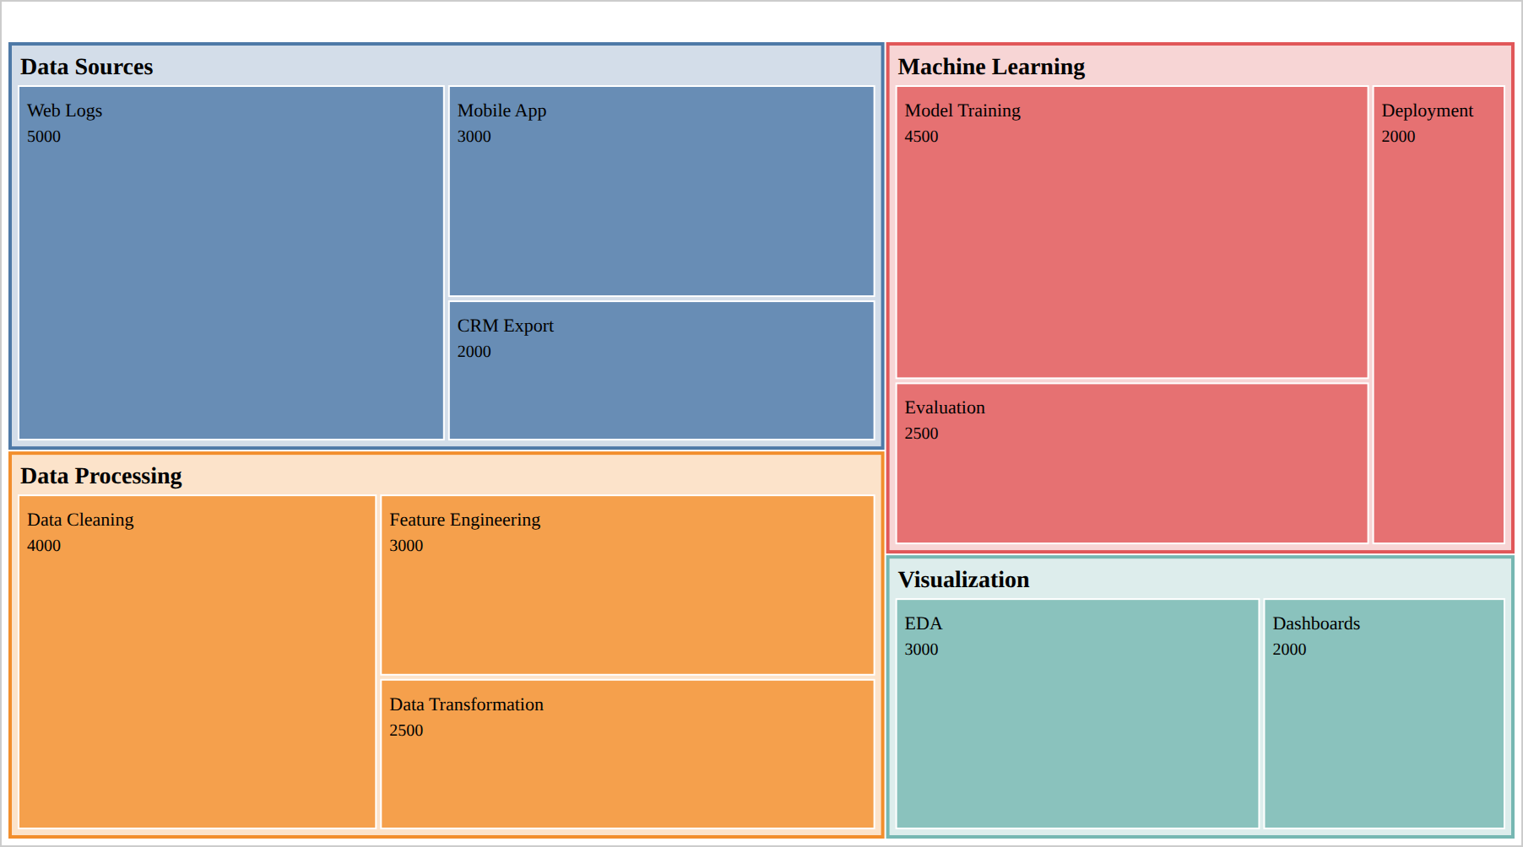
Figure 3: Treemap of pipeline data volume (treemap.html)
TASK 4: DEPLOY TO GITHUB PAGES
The Sankey diagram (index.html) was deployed through GitHub Pages. The three files (index.html, treemap.html and the Colab notebook) were committed to a new GitHub repository, and Pages was enabled from the main branch and the root folder.
Deployment Procedure
- Download index.html, treemap.html and the notebook from Colab into one folder.
- Create a new public GitHub repository, d3-lab-user.
- Run git init, then git add and git commit for each file (one commit per file).
- Rename the branch with git branch -M main and connect it with git remote add origin <repository URL>.
- Push with git push -u origin main.
- Open Settings → Pages, choose Deploy from a branch, select the main branch and the /(root) folder, and click Save.
- Wait 1–2 minutes and open the generated URL to check that the visualization loads.
Verification in the Notebook
import os

print(os.path.exists("index.html"))
print(os.path.getsize("index.html"))
The notebook printed True for os.path.exists("index.html") and reported a file size of 2963 bytes, confirming that the Sankey diagram was saved as a standalone HTML file.
GitHub Repository Link: https://github.com/K1A1Z1I1M1/d3-lab-user
Live GitHub Pages URL: https://k1a1z1i1m1.github.io/d3-lab-user/
GitHub Pages Settings
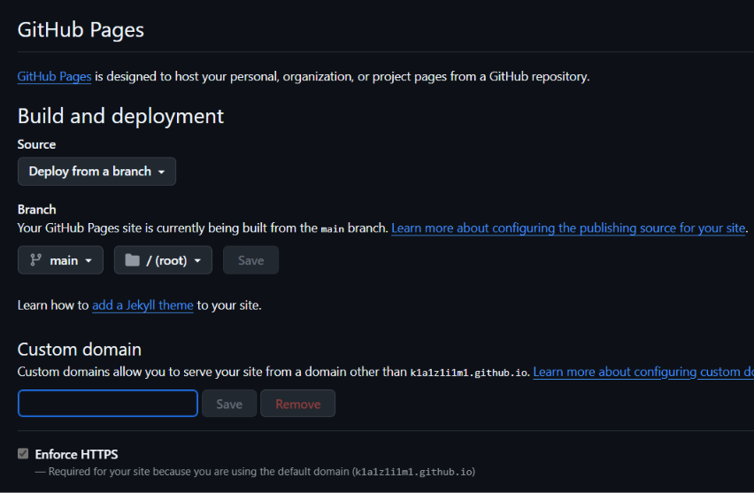
Figure 4: GitHub Pages configured to deploy from main / (root)
Repository Files
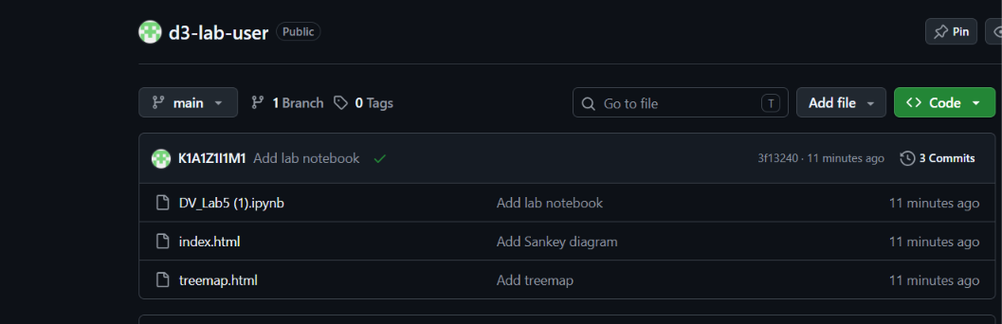
Figure 5: Repository with three commits and the uploaded files
Git Commit History
Figure 6: git log showing the three commits on the main branch
DATA INSIGHTS & FINDINGS
- The force-directed graph shows the relationships between the seven pipeline stages, and EDA is its most connected node.
- The Sankey diagram shows that 10,000 records enter Data Cleaning, 1,500 (15%) are rejected, and 5,000 (50% of the original records) reach Deployment.
- The EDA stage sends 6,000 records to Feature Engineering and 2,500 straight to Visualization.
- The treemap shows Data Sources as the largest category (10,000), followed by Data Processing (9,500), Machine Learning (9,000) and Visualization (5,000).
- Hover transitions on the Sankey diagram and treemap make the visualizations easier to explore.
- The files index.html and treemap.html were exported as standalone pages, and index.html was published on GitHub Pages.
Overall Insight
Each chart answers a different question: the force-directed graph shows relationships, the Sankey diagram shows flow and loss, and the treemap shows proportion within a hierarchy. Visualizations built in Colab can be exported as standalone HTML and shared publicly through GitHub Pages.
BUSINESS APPLICATIONS
- Force-directed graphs can map relationships between systems, teams, customers or process stages.
- Sankey diagrams can follow customers, budgets, energy or data through stages and expose where volume is lost.
- Treemaps compare categories and sub-categories efficiently when data is hierarchical.
- Interactive visualizations let stakeholders explore data themselves through hovering, dragging and transitions.
- GitHub Pages and Git provide free hosting and version history for sharing visual projects.
CONCLUSION
Three interactive D3.js visualizations (a draggable force-directed graph, a Sankey diagram with hover transitions and a hierarchical treemap) were built and tested for a seven-stage data pipeline. The Sankey diagram was committed to a GitHub repository with Git and published through GitHub Pages at a public URL.
The lab showed how D3 binds data to SVG elements, how force, Sankey and treemap layouts compute positions and sizes, how interactions are added, and how a notebook visualization can become a shareable web page.

