SMART PLANT MONITORING SYSTEM
SCHOOL OF ENGINEERING

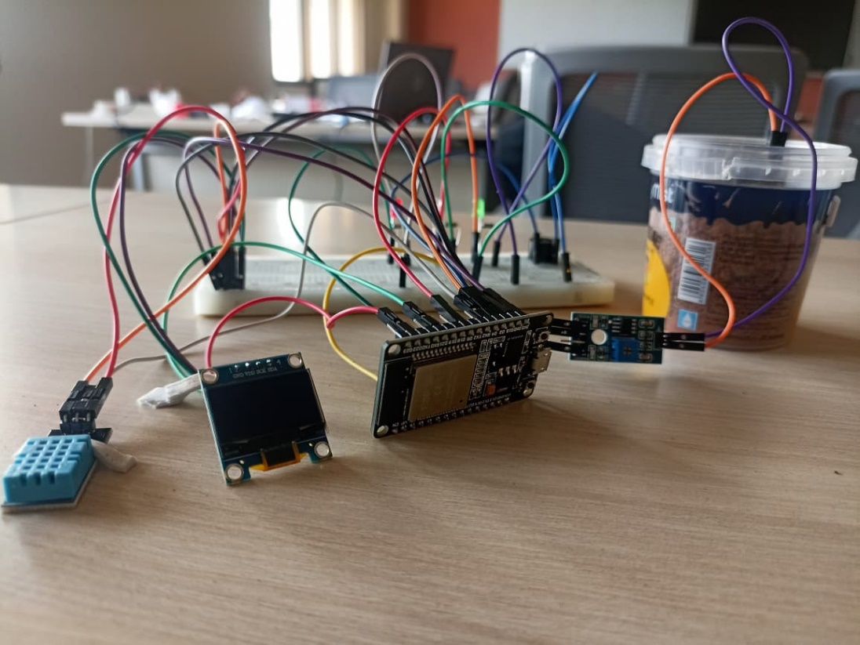

Subject Code: CSY407
Subject Name: IoT Lab

Report Submitted By,
SHAMITHA
REG NO: CU22BCA002A

BCA Hons.

Chanakya University

ABSTRACT

The Internet of Things (IoT) enables intelligent monitoring and automation by interconnecting sensors, devices and microcontrollers through smart technologies. In this project, an IoT-based Smart Plant Monitoring System is developed using the ESP32 microcontroller to continuously track the essential environmental parameters required for healthy plant growth. The system integrates a soil moisture sensor and a DHT11 sensor to measure real-time soil moisture, temperature and humidity. An OLED display is used to present live readings directly on the device, while a tri-colour RGB LED and a buzzer provide visual and audible alerts whenever any parameter goes beyond the safe threshold.
The ESP32 acts as the main processing unit due to its high performance, low power consumption and built-in Wi-Fi capability makes it suitable for handling multiple sensors efficiently. In addition to the local display and alerts, the project is enhanced with a Blynk-based web dashboard, allowing users to monitor plant conditions remotely. Through Blynk’s cloud platform, sensor values can be viewed in real time from anywhere and users can receive instant notifications on their phones when critical conditions occur. Although the basic prototype can operate offline, the integration of the Blynk dashboard transforms it into a fully scalable IoT system capable of remote monitoring, data logging and future automation features such as automatic watering.
The proposed system addresses the common challenges faced in plant care, such as inconsistent watering, unmonitored temperature variations and environmental stress. Traditional plant maintenance requires frequent manual checking, which is often difficult for busy individuals or those with limited gardening knowledge. This automated monitoring solution ensures that users receive continuous feedback on plant health, helping to prevent overwatering, dryness and extreme climate conditions. The device can be deployed in homes, greenhouses, farms, nurseries and educational environments. Overall, the project demonstrates an efficient, affordable and scalable approach to integrating technology with plant care, highlighting the potential of IoT-based systems in promoting smarter and more sustainable gardening practices.

INTRODUCTION

About Internet of Things (IoT):

Internet of Things depicts a general concept for the power of network devices to sense and collect data from the planet around us, then share that data across the Internet where it can be processed and applicable for various interesting purposes. Internet of Things is extremely quickly becoming a reality. We can see the results of it around us. Our devices are becoming smarter every day from smart phones to smart TV to smart car to Smart kitchen. Everything is now getting connected to Internet. Internet of Things (IoT) describes a network of physical objects that hook up with one another through the web. Objects or ‘things’ can transfer data wirelessly without requiring human interaction. A ‘thing’ are often any object which will be assigned an IP address and given the power to transfer data over a network.

Internet of Things (IoT) is an architecture that comprises of especial hardware boards, Software systems, web APIs, and protocols which together creates a seamless environment that allows smart embedded devices which is to be connected to the web such that sensory data can be accessed and control system can be activated over internet. Also, such devices could be connected to internet using various means like WiFi, Ethernet and so on. Furthermore, devices might not need to be connected to internet independently.

EMBEDDED SYSTEMS:
In these present scenarios, the world is becoming more and more digital and using advanced technologies as like connected and automated. Embedded system is one of the advanced technologies. This system is the one which has computer hardware with software embedded in it. The embedded system is designed to perform a specific task/function. But the task assigned has to be completed in a given time interval and it is an arrangement in which all its units, assembled work together according to set of info provided. When the system performs the given tasks at high speed, then it is used for real-time applications. A set of information or code embedded into the micro controller.
The characteristics of the Embedded Systems are: -
- Specific-Functioned
- Tightly constrained
- Reactive and Real time
- Microprocessors based
- Memory
- Hardware-Software systems
- Accuracy, reliability and adaptability.

Advantages
  - Easily Customizable
  - Less power consumption
  - Cheap
  - Enhanced performance

Disadvantages
  - High development effort
  - Larger time to market

SCOPE OF THE PROJECT:

Home Gardening
The system helps homeowners monitor the health of indoor and outdoor plants by providing real-time soil moisture, temperature, and humidity information.

Smart Agriculture
Farmers can use this system to monitor crop conditions effectively and prevent issues caused by overwatering, dryness, or extreme temperature variations.

Greenhouses
Greenhouse environments require strict control of humidity and temperature; this system provides continuous monitoring to maintain ideal growth conditions.

Plant Nurseries
Nursery workers can monitor several plants at once and receive alerts when any plant needs immediate attention, improving plant survival rates.

Urban Gardening / Terrace Farming
This system supports modern gardening practices by helping users grow plants in limited spaces with proper environmental monitoring.

HARDWARE COMPONENTS USED AND SPECIFICATION
In this project some hardware components have been used to control the plant monitoring systems such as:
    - ESP32 Microcontroller
    - Breadboard
    - Soil moisture sensor
    - DHT11 sensor
    - OLED Display (SSD1306 I2C)
    - Buzzer
    - LEDs (red, Green, Blue)
    - Jumper Wire

DoIt ESP32 DevKit V1 Microcontroller
The ESP32 is a powerful, low-cost and low-power system-on-chip (SoC) microcontroller developed by Espressif Systems widely used in modern IoT and embedded applications.

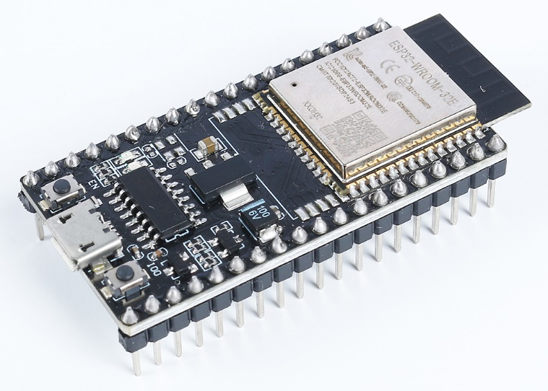

Figure 1: DoIt ESP32 DevKit V1

It supports 2.4 GHz Wi-Fi and dual-mode Bluetooth enabling wireless connectivity and ultra-low power consumption modes makes it ideal for battery-powered devices. Its compact size, flexible GPIO configuration and support for over-the-air (OTA) updates make it highly developer-friendly.
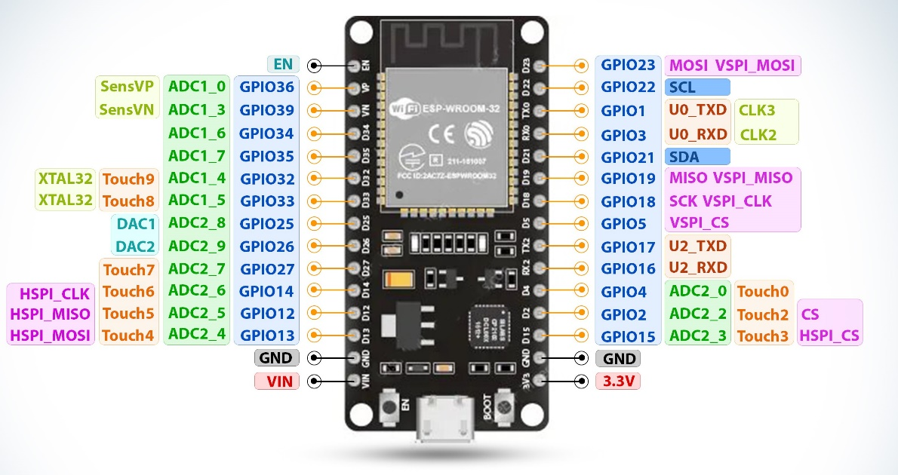
Figure 2: DoIt ESP32 DevKit V1 Pinout

DoIt ESP32 DevKit V1 SPECIFICATIONS & FEATURES

- Microcontroller: Dual-core 32-bit Xtensa LX6 CPU
- Operating Voltage: 3.3V
- Input Voltage: 6-12V
- Digital I/O Pins (DIO): 30 GPIOs
- Analog Input Pins (ADC): 15 ADC channels
- UARTs: 3
- I2Cs: 2
- Flash Memory: 4 MB
- SRAM: 520 KB
- Clock Speed: Up to 240 MHz
- USB-TTL supported CP2102 is included onboard, Enabling Plug n Play
- Programming support: Arduino IDE, ESP-IDF, Micro Python
DoIt ESP32 DevKit V1 Board Pinout Configuration:

Pin Category | Name | Description
Power | Micro-USB, 3.3V, GND,  Vin | Micro-USB: ESP32 can be powered through the USB port  3.3V: Regulated power supply of 3.3V can be supplied to this pin to power the board  GND: Ground pins  Vin: External Power Supply
Control Pins | EN, RST | The pin and the button resets the microcontroller
Analog Pin | A0 | Used to measure analog voltage in the range of 0-3.3V
GPIO Pins | 30 GPIO Pins | Almost every pin can be digital input/output (GPIO0 to GPIO39 except a few)
UART Pins | TXD0, RXD0,  GPIO9, GPIO10  GPIO16, GPIO17 | ESP32 has three UART interfaces.
I2C Pins | GPIO21 and GPIO22 | ESP32 has I2C functionality support

DHT11 Sensor:
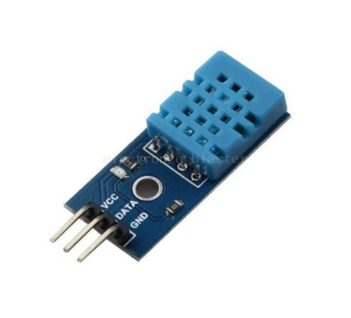

Figure 3: DHT11 Sensor
The DHT11 is a low-cost, digital temperature and humidity sensor which provides calibrated digital output for both relative humidity and temperature. It is commonly used in weather stations, home automation systems, greenhouses and ESP32 beginner projects. DHT11 can measure temperature from 0°C to 50°C with a ±2.0°C accuracy and humidity from 20 to 80% with a 5% accuracy. It has a sampling rate of 1Hz, which means it can provide new data once every second.

Working Principle:
The DHT11 operates on the principle of humidity sensing component and thermistor-based temperature measurement.
Humidity measurement
Humidity is measured using humidity sensing component inside the sensor. The humidity sensing component has two electrodes with a moisture-holding substrate (usually a salt or conductive plastic polymer) in between. As the humidity rises, the substrate absorbs water vapor, resulting in the release of ions and a decrease in the resistance between the two electrodes. This change in resistance is proportional to the humidity, which can be measured to estimate relative humidity
Temperature measurement
A simple NTC (negative temperature coefficient) thermistor is used to measure temperature. A thermistor
is a type of resistor whose resistance varies with temperature.
The sensor also includes an 8-bit SOIC-14 packaged IC. This IC measures and processes the analog signal using stored calibration coefficients, converts the analog signal to digital and outputs a digital signal containing the temperature and humidity.

Pin Configuration
- Pin 1 – VCC (3.3–5.5 V)
- Pin 2 – DATA
- Pin 3 – GND

Soil Moisture sensor
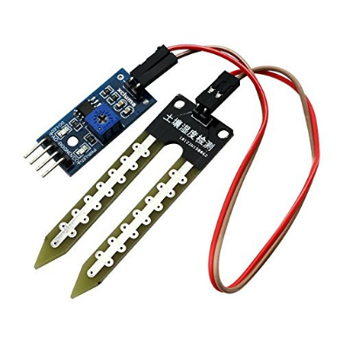

Figure 4: Soil Moisture Sensor

The resistive soil moisture sensor (also called analog soil humidity sensor) is the cheapest and most commonly used sensor in Arduino/ESP32 gardening, automatic plant watering and smart agriculture projects. It simply measures how easily electricity passes between two metal probes inserted in soil, the wetter the soil the better it conducts electricity and the lower the resistance.

Working Principle
- Two conductive probes act as a variable resistor.
- When soil is dry, resistance is high
- When soil is wet, resistance is low
- Output:
- AO (Analog Out): 0 - 3.3 V (or 0 - 5 V) proportional to moisture
- DO (Digital Out): HIGH or LOW based on adjustable threshold (set by potentiometer)

Pin Configuration
- VCC - 3.3V
- GND - GND
- AO - ADC pin
- DO - GPIO pin

OLED SSD1306 I2C
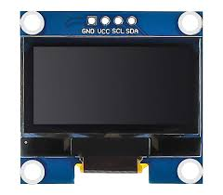

Figure 5: OLED SSD1306 I2C Display

The SSD1306 is a single-chip CMOS OLED driver with a built-in 128×64 pixel monochrome display. The SSD1306 controller operates at 1.65V to 3.3V. It is the most popular and affordable small screen used in Arduino, ESP8266 and ESP32 projects. They are used in ESP32 projects such as weather stations, smart watches, sensor monitors, Wi-Fi managers and IoT dashboards.
Working Principle
The SSD1306 contains 128 × 64 = 8192 individual OLED pixels organized in a GDDRAM (Graphic Display Data RAM). Each pixel can be turned ON or OFF. The controller receives commands and data over I2C from the microcontroller, stores the bitmap in its internal RAM and constantly refreshes the OLED matrix using built-in charge pump voltage generator.

Pin Configuration
- VCC – 3.3V
- GND - GND
- SCL - GPIO22
- SDA – GPIO21

SOFTWARE REQUIREMENTS

Arduino IDE
The Arduino IDE (integrated development environment) is a cross-platform application which is written in the functions from C, C++ and JAVA. The Arduino IDE is also a derivative of Processing IDE. The Arduino IDE is used for easy to write and upload programs in Arduino boards by using a cable that is connected between board and IDE. The operating system for Arduino software can be Windows, Mac Os and Linux depending upon the user. The IDE has a software library from the wiring projects and to provide a common input and output procedures.
- setup(): a function that runs once at the start of a program and that can declare and initialize settings.
- loop(): a function that is called repeatedly until the board powers off.
DoIt ESP32 DevKit board can be easily programmed with Arduino IDE using a USB cable.
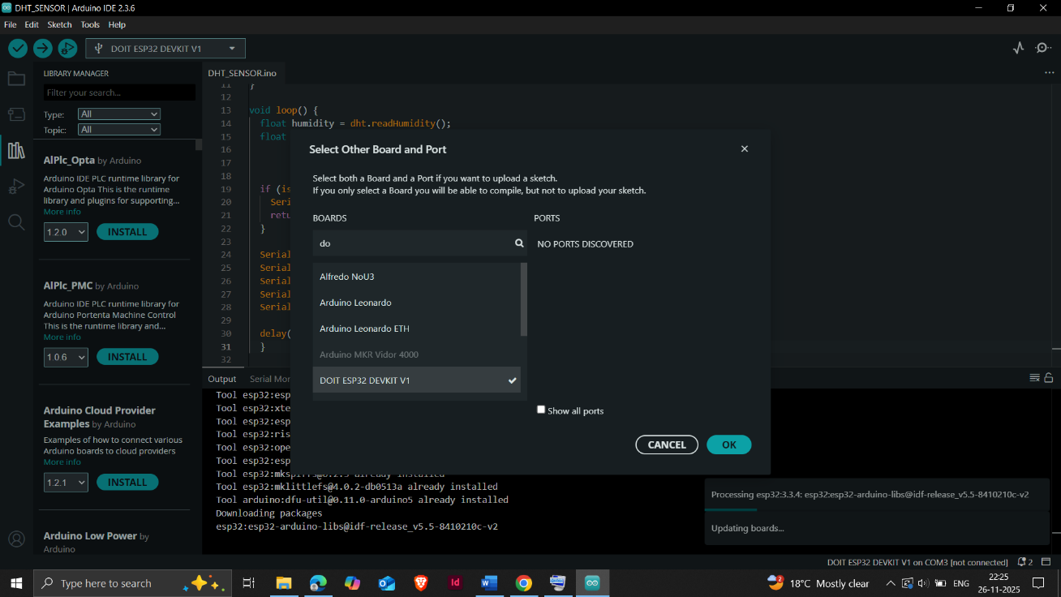

Figure 6: Arduino IDE Setup

Working process:
The Smart Plant Monitoring System is designed to continuously observe the environmental conditions of a plant and ensure healthy growth by providing real-time monitoring and alert notifications. The entire system is controlled by the ESP32 microcontroller, which acts as the central processing unit. The working process begins when the ESP32 powers on and initializes all the connected sensors and output devices. Each component plays a specific role in collecting data, interpreting plant conditions and providing feedback to the user.
The soil moisture sensor measures the water content in the soil by detecting changes in electrical resistance. When the soil is dry, the resistance is high resulting in a lower moisture percentage and when the soil is wet, the resistance decreases producing a higher moisture percentage. This analog value is read by the ESP32 which maps and converts it into a percentage form. This value helps the system determine whether the plant requires watering or not.
Meanwhile, the DHT11 sensor continuously monitors the temperature and humidity around the plant. These two factors are extremely important for plant development, as temperature affects metabolic activities while humidity influences transpiration and water absorption. The ESP32 reads these digital values every few seconds to ensure the system has the most up-to-date information.
Once the ESP32 receives all sensor readings, it processes the values based on predefined threshold levels. If the soil moisture drops or the temperature becomes too high or too low, the system identifies it as a critical and the ESP32 activates the red LED and turns on the buzzer to alert the user immediately. This ensures timely action, such as watering the plant or moving it to a more suitable environment. If the moisture level is moderately low but not critical, the system lights up the blue LED to alert user about plants condition. When all conditions are within healthy ranges the green LED glows showing that the plant is in a good environment.
All sensor readings such as moisture level, temperature and humidity are displayed on the OLED display, allowing local monitoring. In addition to this, the system is integrated with Blynk IoT, enabling remote monitoring through a web dashboard. The ESP32 sends real-time sensor data to the Blynk cloud using its built-in Wi-Fi capabilities. Users can view live plant conditions, historical graphs and receive instant push notifications if any parameter reaches a critical level. This greatly enhances the usability of the system and provides complete remote access. The system is refreshed at regular intervals to ensure accuracy, and this automated process ensures the plant receives proper care with minimum human effort. Overall, the working principle of this project combines sensing, data processing, visual feedback, IoT connectivity, and alert mechanisms to create an efficient and modern plant health monitoring solution.

CONNECTION
To make the connections easy to follow, here is a pin map of the connection between the ESP32 and the sensors:

ESP32 – Soil Moisture sensor
- VCC - 3V3/ 3.3V
- GND - GND
- AO - GPIO34
- DO - No Connection

ESP32 – DHT11 sensor
- VCC - 3V3/ 3.3V
- GND - GND
- OUT - GPIO4

ESP32 – OLED Display
- VCC - 3V3/ 3.3V
- GND - GND
- SCL - GPIO22
- SDA - GPIO2

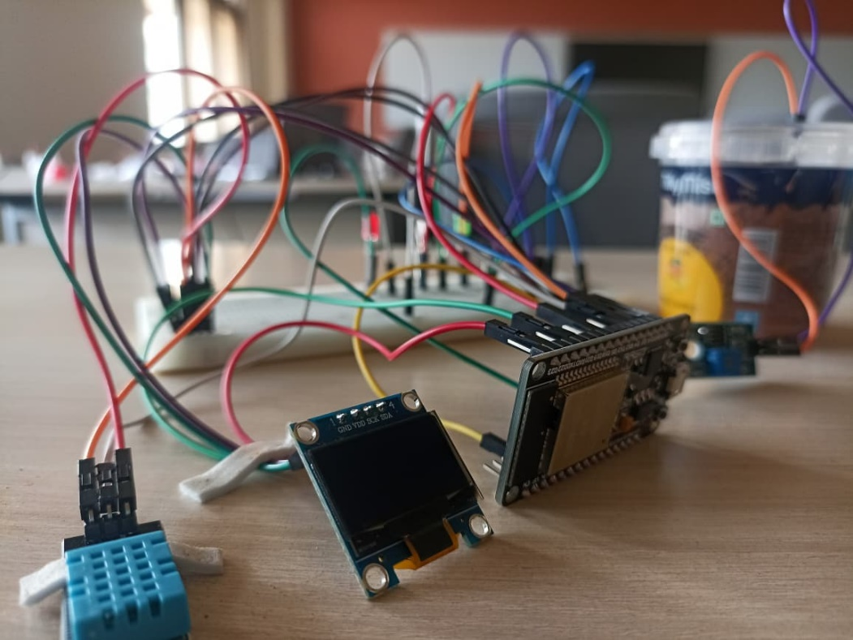
Figure 7: Connected hardware components

CODE:
One of the easiest ways to program the DOIT ESP32 DevKit is by using the Arduino IDE. Before uploading code, the Arduino IDE must be configured by installing the ESP32 board support package from the official Espressif repository. This allows the IDE to recognize ESP32 boards and enables all necessary libraries required for WiFi, GPIO and peripheral control. This library provides all essential functions required for connecting the ESP32 to a WiFi access point, creating a web server, handling client requests and enabling wireless IoT communication.
The program begins by including all essential libraries required for sensor reading, OLED display control, Wi-Fi connectivity, and Blynk IoT communication. Libraries such as Wire.h, Adafruit_GFX.h, Adafruit_SSD1306.h, and DHT.h simplify interaction with the OLED display and DHT11 sensor, while WiFi.h and BlynkSimpleEsp32.h enable cloud connectivity. After defining the pin configurations for the soil moisture sensor, DHT11 sensor, RGB LEDs, and buzzer, the OLED display is initialized using I2C communication. The ESP32 then connects to the configured Wi-Fi network and logs into the Blynk cloud using the assigned authentication token. the ESP32 continuously reads analog soil moisture values and calculates the percentage by mapping raw ADC readings between calibrated dry and wet values. Similarly, the DHT11 sensor provides real-time temperature and humidity readings. These values undergo error checking to ensure valid and reliable data.
The processed sensor readings are displayed on the OLED screen and simultaneously uploaded to the Blynk dashboard through virtual pins. This allows users to monitor moisture, temperature, and humidity remotely via the Blynk app or web dashboard. A timer function sends updated data to Blynk every two seconds, ensuring continuous synchronization. The program also incorporates an intelligent alert system. Based on predefined threshold values, the ESP32 activates the RGB LED in different colors green for healthy conditions, blue for moderately dry soil and red for critical conditions. In severe cases such as extremely low moisture, overwatering or abnormal temperature, the buzzer is triggered and Blynk event notifications are sent automatically to the user. The loop continuously refreshes the sensor readings every two seconds, ensuring accurate and up to date monitoring of the plant's environment.

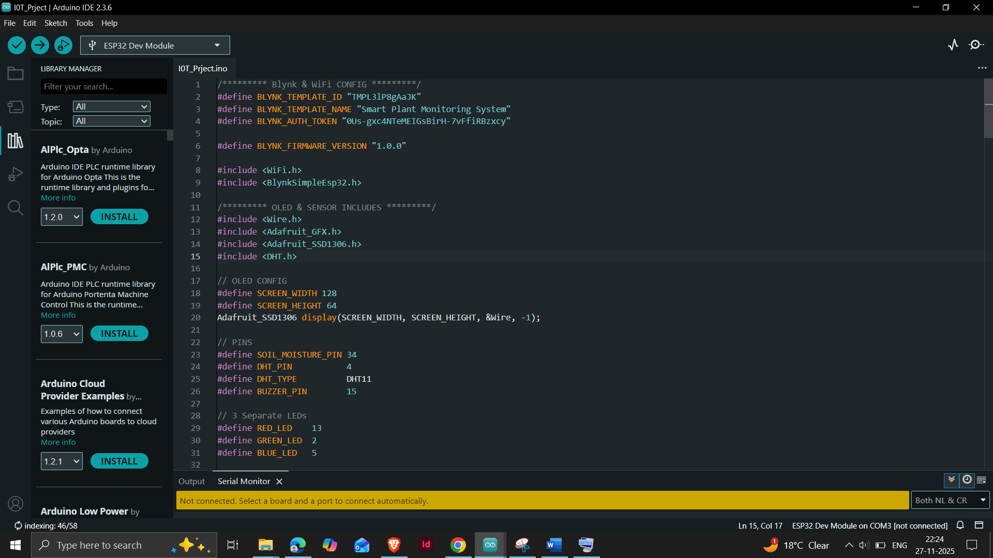

Figure 8: Code 1
Next, is the void setup() function, here the ESP32 performs all the initial configurations required before the system begins continuous monitoring. We start by initializing the serial monitor. This is followed by activating the DHT11 sensor using the dht.begin() command so that temperature and humidity readings can be fetched. The soil moisture sensor pin is configured as an input because it provides an analog signal representing the moisture content in the soil. The buzzer and the RGB LED pins are configured as outputs, as they are used to generate alerts and visualize plant conditions. Next, the OLED display is initialized using the display.begin() function. If the OLED is not detected, the system prints an error message and halts to prevent further malfunction. Once the OLED is successfully initialized, the display is cleared to prepare it for showing real-time data.

The Blynk integration in this project enables the ESP32 to send real-time plant health data to a cloud-based mobile dashboard, allowing remote monitoring from anywhere. After including the Wi-Fi and Blynk libraries the ESP32 connects to the internet using the Blynk.begin() function, which authenticates the device using the unique Blynk Auth Token. A Blynk timer is used to call the sendToBlynk() function every two seconds, ensuring continuous updates of soil moisture, temperature, and humidity. Inside this function, the ESP32 sends sensor values to virtual pins (V0, V1, V2), which are then displayed on the Blynk mobile app gauges, charts or widgets. The project also uses Blynk’s event notification system, when critical conditions occur such as soil moisture dropping below 30%, overwatering above 80% or temperature crossing the safe range the ESP32 triggers cloud based Blynk events using Blynk.logEvent(). These events instantly notify the user through the Blynk app, even if the Arduino IDE or local display is not being monitored. This setup process ensures that the ESP32, sensors, display and alert mechanisms are correctly configured as shown in the below Figure.

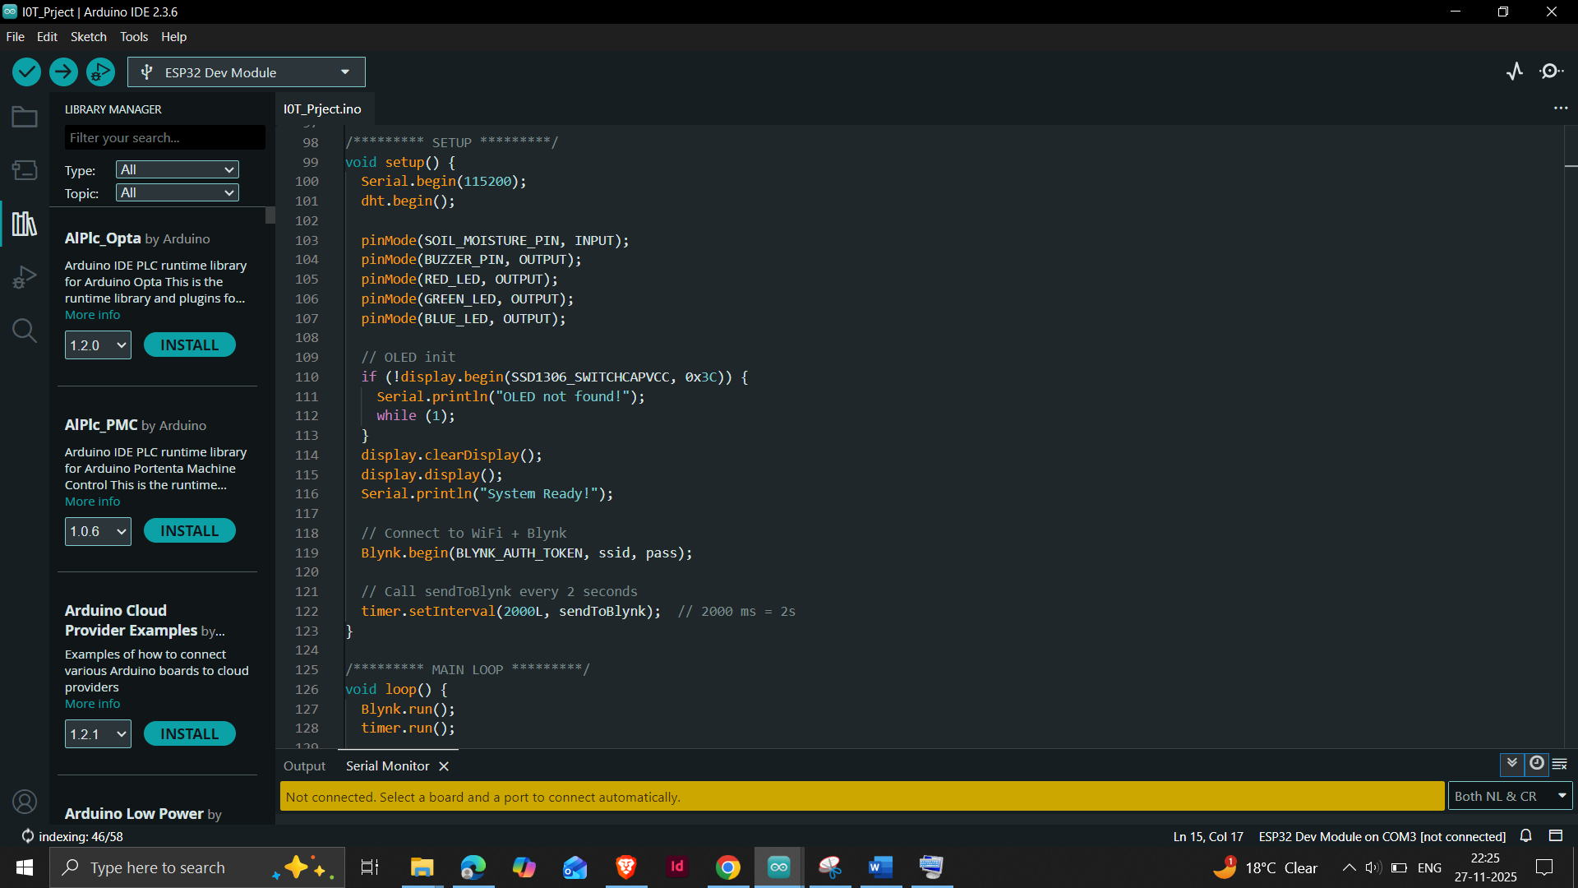

Figure 9: Code 2

If the connection is successful, the system prints message on the serial monitor, indicating that all sensors and output components are ready for use. Upload the code to the ESP32 and ensure everything is connected. After uploading the code, serial monitor displays as shown below.
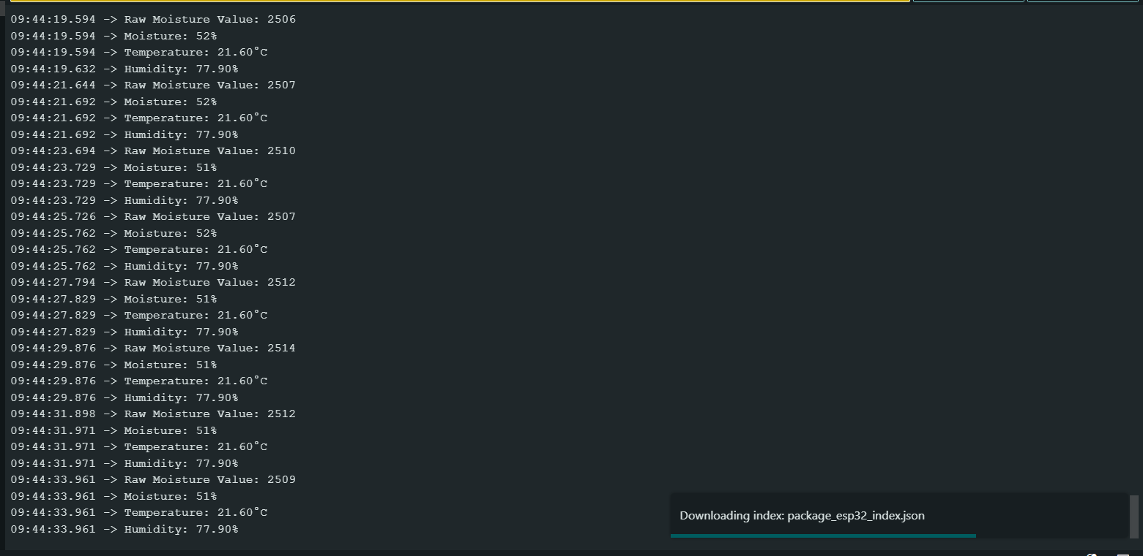

Figure 10: Serial Monitor

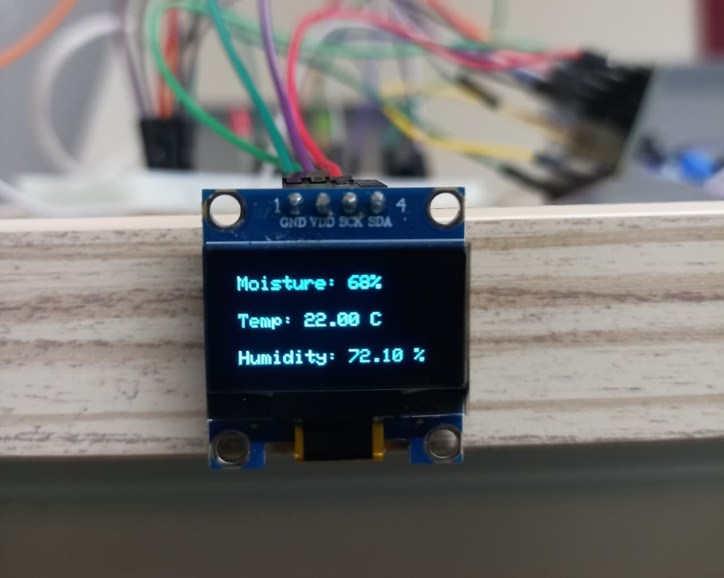
Figure 11: OLED displaying real time data

PRECAUTIONS
To ensure the safe and reliable operation of the Smart Plant Monitoring System, all sensors and components must be connected with the correct polarity and voltage levels to avoid damage. The soil moisture sensor should not be kept continuously submerged in water, as prolonged exposure can corrode its probes and affect accuracy. It is also important to keep the DHT11 sensor away from direct water contact or extreme heat, which can lead to incorrect temperature and humidity readings.

RESULTS AND DISCUSSION
The Smart Plant Monitoring System successfully measured soil moisture, temperature, and humidity using the ESP32 microcontroller and displayed the real-time values on the OLED screen with clear and readable text. During testing, the soil moisture sensor responded accurately to various soil conditions—wet soil produced high moisture percentages, while dry soil resulted in low readings demonstrating the sensor’s reliability. The RGB LED provided immediate visual feedback, where green indicated healthy conditions, blue represented moderately dry soil and red signaled critical dryness or extreme temperature levels. This color-based indication proved highly effective for quick plant-status identification without needing to check the display.
The buzzer also performed as expected, activating only when moisture dropped below the threshold or when temperature went beyond the ideal range of 20°C to 30°C. This alert mechanism helps users take timely action to avoid plant stress. The DHT11 sensor consistently delivered stable temperature and humidity readings, showing only minor variations as expected from low-cost sensors. The OLED display refreshed smoothly every two seconds, ensuring real-time monitoring without noticeable lag or flicker. The integration of the Blynk mobile application greatly enhanced the usability of the system. Sensor readings were successfully uploaded to the cloud and displayed through a virtual dashboard, allowing remote monitoring from anywhere. This demonstrates that the system not only works as a standalone device but also functions as a complete IoT solution for smart plant care, offering both local and remote monitoring with reliable performance.

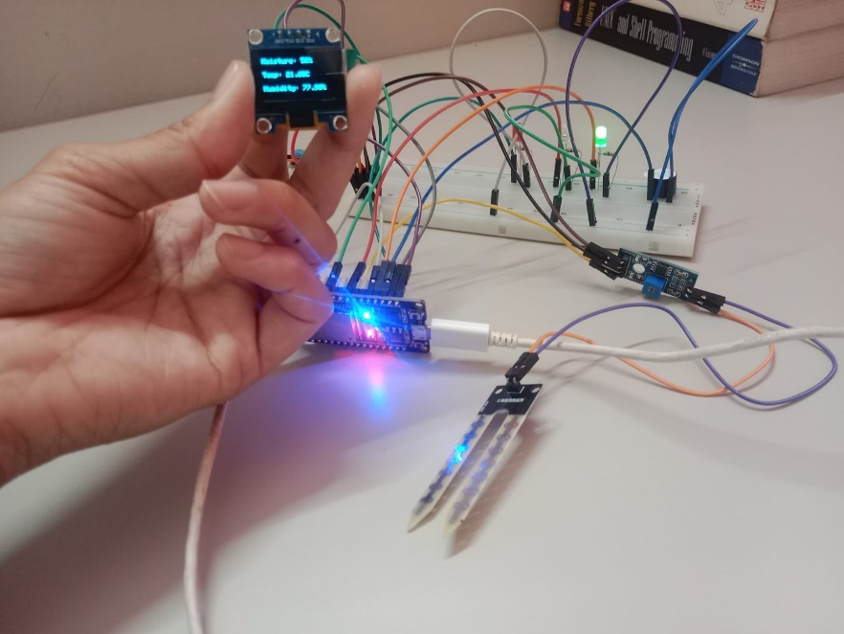
Figure 12: Smart plant monitoring System working

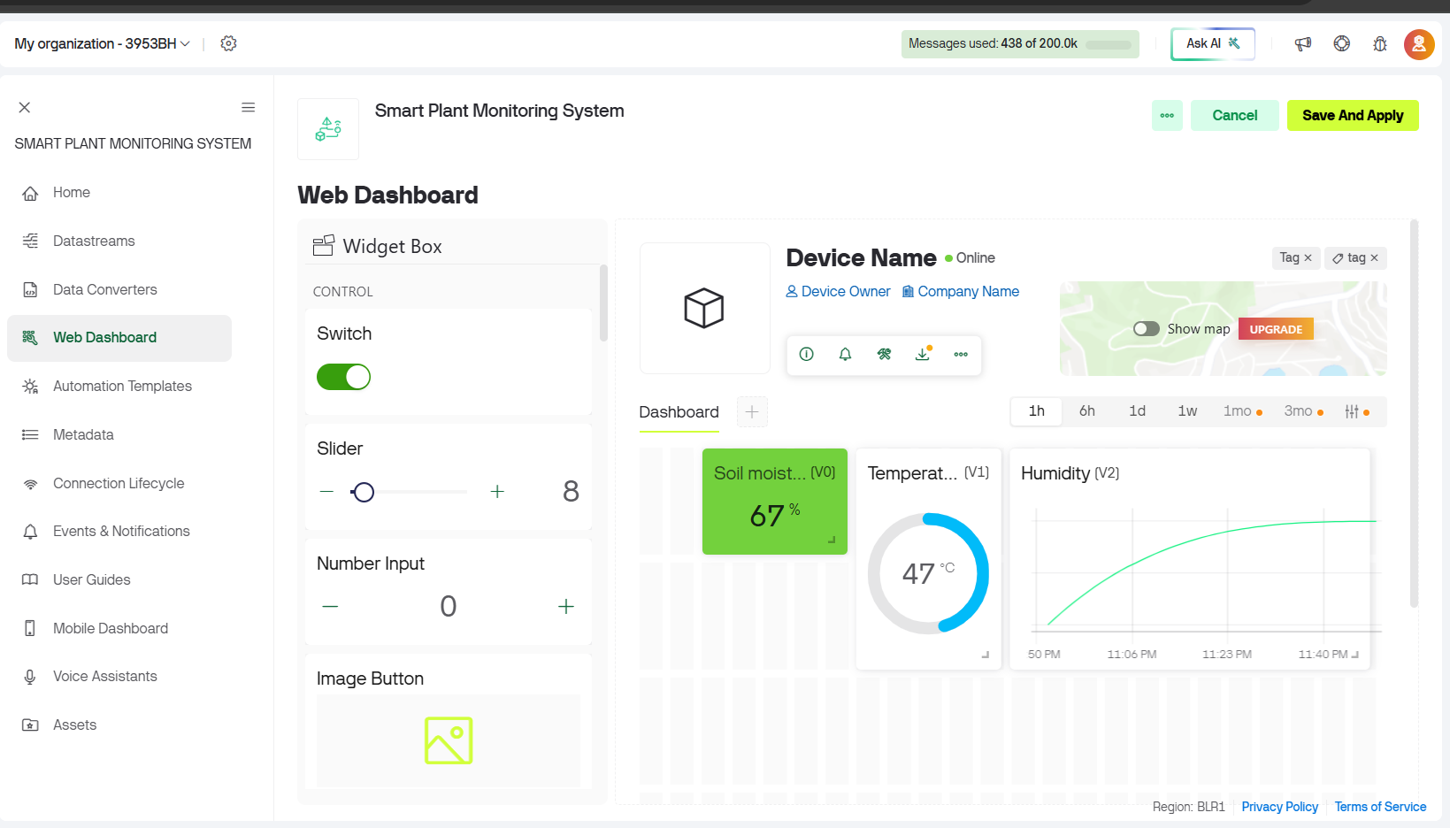
Figure 13: Blynk web dashboard

CONCLUSION
The Smart Plant Monitoring System using ESP32 effectively demonstrates how sensors and microcontroller technology can be combined to create an efficient and reliable plant health monitoring solution. The system continuously measures key environmental parameters such as soil moisture, temperature and humidity, which play a crucial role in plant growth. By displaying real time values on the OLED screen and web dashboard on Blynk for remote access and providing instant alerts through the RGB LED and buzzer, the system ensures that users are immediately informed whenever conditions become unsuitable for plant health.
This project highlights the importance of automation and smart monitoring in modern gardening, especially for users who may not always be available to manually check plant conditions. The design is simple, user-friendly and energy-efficient, making it suitable for home gardens, indoor plants and small agricultural settings. Overall, the project successfully meets its objectives by offering a reliable, easy to use and responsive solution for maintaining optimal plant health, while also showcasing the practical application of IoT and embedded systems in everyday life.

