EmotionSense: Noise-Aware Speech Emotion Recognition Using CNN-LSTM
Comprehensive Technical Report, Empirical Validation & Architectural Analysis
Author: [Student Name / ID] | Institution: [Department / College] | Date: October 2026
Repository: Shamithabsc/EmotionSense_Noise-awareness

1. Abstract
Speech Emotion Recognition (SER) is an essential capability for conversational AI, mental health diagnostics, and human-computer interaction. However, deployed speech models face severe degradation under acoustic noise and often overfit when trained on speaker-dependent or small datasets. This project investigates noise-aware speech emotion recognition using the Ryerson Audio-Visual Database of Emotional Speech and Song (RAVDESS), comprising 1,440 speech utterances across 24 professional actors and eight emotion categories. We implement an actor-independent split protocol (14 train, 5 validation, 5 test actors) ensuring complete speaker isolation. We systematically examine four acoustic architectures and feature representations: an Original CNN-LSTM operating on 40-dimensional Mel-Frequency Cepstral Coefficients (MFCCs), an Improved CNN-LSTM incorporating delta features, dropout, weight decay, and early stopping, an SVM baseline operating on statistical MFCC moments (160-dim), and an optional Log-Mel spectrogram CNN-LSTM (64 mel bands × 200 timeframes). Furthermore, we conduct controlled multi-noise evaluations across Additive White Gaussian Noise (AWGN), Pink (1/f) noise, and 50 Hz Mains Hum across clean, 20 dB, 10 dB, and 0 dB SNR conditions. Our empirical findings demonstrate that while SVM achieves the highest clean accuracy (47.0%, Macro-F1 0.4556), its performance collapses catastrophicly under noise (13.3% at 0 dB SNR). In contrast, the CNN-LSTM architectures exhibit remarkable noise resilience, sustaining 28.7% accuracy and 0.2145 Macro-F1 at 0 dB AWGN and up to 31.0% accuracy under pink noise. All experiments, automated test suites (38 unit tests passing), reproducible pipelines, and interactive Streamlit dashboards are documented.

2. Problem Formulation and Motivation
Speech signals contain both linguistic content (what is said) and paralinguistic cues (how it is said). Classifying emotion from raw or processed acoustic waveforms presents multiple challenges: (1) high intra-class variability across speakers with differing vocal pitch, accents, and recording environments; (2) substantial overlap between acoustic signatures of arousal and valence (e.g., anger vs. surprise, calm vs. neutral); and (3) acoustic contamination by ambient noise, electrical hum, and reverberation in practical deployment environments.
In academic literature, reported accuracies on datasets such as RAVDESS frequently exceed 80% when random k-fold cross-validation is performed across all audio files. However, such splits suffer from severe data leakage because the same speaker's voice appears in both train and test splits, causing models to recognize individual vocal pitch rather than generalizable affective features. In a true speaker-independent deployment, accuracy is drastically lower. This project specifically formulates SER under zero-speaker-leakage and multi-condition acoustic noise constraints.

3. Objectives and Scope
The primary objectives of this mini-project are:
- Rigorous Actor-Independent Protocol: Partition the 24 RAVDESS actors into disjoint subsets for training (14 actors), validation (5 actors), and test (5 actors).
- Overfitting Mitigation: Analyze training dynamics of CNN-LSTM models and implement regularizers, early stopping, and learning rate scheduling.
- Acoustic Feature Comparison: Implement and contrast 40-channel MFCCs, delta-augmented MFCCs (120-channel), 160-dimensional statistical summary features, and 64-band Log-Mel spectrograms.
- Noise Robustness Benchmarking: Systematically degrade held-out test audio across synthetic AWGN, Pink noise, and Harmonic/Hum noise at 20 dB, 10 dB, and 0 dB SNR.
- Interactive Dashboard & Quality Diagnostics: Provide a responsive, multi-page Streamlit application providing single-clip emotion prediction, confidence estimation, audio quality checks, and real-time noise simulation.
- Software Engineering Standards: Deliver an automated test suite verifying signal processing, model shapes, silence handling, reproducibility, and prediction error handling.

4. Dataset Collection and Description
The project utilizes the speech portion of the Ryerson Audio-Visual Database of Emotional Speech and Song (RAVDESS). The corpus contains 1,440 speech audio files recorded by 24 professional actors (12 male, 12 female) reciting two standardized lexically neutral statements ('Kids are talking by the door' and 'Dogs are sitting by the door') under two emotional intensities (normal and strong), with normal intensity only for the neutral state.
Class ID | Emotion | Total Files | Train (14 Actors) | Val (5 Actors) | Test (5 Actors)
01 | Neutral | 96 | 56 | 20 | 20
02 | Calm | 192 | 112 | 40 | 40
03 | Happy | 192 | 112 | 40 | 40
04 | Sad | 192 | 112 | 40 | 40
05 | Angry | 192 | 112 | 40 | 40
06 | Fearful | 192 | 112 | 40 | 40
07 | Disgust | 192 | 112 | 40 | 40
08 | Surprised | 192 | 112 | 40 | 40
Total | 8 Classes | 1,440 | 840 (58.3%) | 300 (20.8%) | 300 (20.8%)

5. Actor-Independent Splitting and Preprocessing
To guarantee zero speaker leakage across splits, actors are partitioned deterministically using split_actors.json:
• Training Actors (14): IDs 1, 2, 3, 4, 5, 6, 7, 8, 9, 11, 12, 13, 14, 15 (840 utterances)
• Validation Actors (5): IDs 18, 21, 22, 23, 24 (300 utterances)
• Test Actors (5): IDs 10, 16, 17, 19, 20 (300 utterances)
Pre-processing pipeline:
1. Audio Loading: Resampled to a standardized 16,000 Hz mono float32 format using Librosa.
2. Silence and NaN Guard: Checks for empty or corrupted clips, converting non-finite values to zero.
3. Windowing & Padding: Framed with FFT length 512 and hop length 160 (10 ms hop, 32 ms window). Utterances are fixed to exactly 200 frames (2.0 seconds) via right-side zero padding or center truncation.
4. Per-Recording Normalization: Mean-subtracted and scaled by standard deviation per frequency band: (x - μ) / max(σ, 1e-6).

6. MFCC and Optional Log-Mel Feature Extraction
Two distinct front-end acoustic representations were implemented and benchmarked under identical network architectures:
1. Mel-Frequency Cepstral Coefficients (MFCC-40):
Extracted using 64 triangular mel filter banks spanning 0 to 8,000 Hz, followed by a Discrete Cosine Transform (DCT-II) yielding 40 cepstral coefficients. The final input tensor is shaped (200 frames, 40 coefficients, 1 channel).
2. Log-Mel Spectrograms (LogMel-64):
Computed directly by taking the logarithm of the energy outputs from the 64 mel filter banks without DCT decorrelation. This retains fine-grained localized spectral relationships along the frequency axis. Input tensor shape: (200, 64, 1).

7. CNN-LSTM Architecture and SVM Baseline
The deep learning model combines 2D convolutional layers for local spatio-temporal acoustic feature extraction with Long Short-Term Memory (LSTM) layers for capturing temporal emotion contour dynamics:
Layer | Type | Kernel / Units | Output Dimension | Activation / Regularization
Conv2D_1 | 2D Convolution | 32 filters, (3, 3) | (200, 40, 32) | ReLU, BatchNorm, MaxPool(2,2), Drop(0.25)
Conv2D_2 | 2D Convolution | 64 filters, (3, 3) | (100, 20, 64) | ReLU, BatchNorm, MaxPool(2,2), Drop(0.25)
Conv2D_3 | 2D Convolution | 128 filters, (3, 3) | (50, 10, 128) | ReLU, BatchNorm, MaxPool(2,2), Drop(0.30)
Reshape | Time-distributed | — | (50, 1280) | Flatten frequency and channel axes
LSTM_1 | Recurrent (LSTM) | 128 units | (50, 128) | Tanh, Dropout(0.30), RecurrentDropout(0.20)
LSTM_2 | Recurrent (LSTM) | 64 units | (64) | Tanh, Dropout(0.30)
Dense_1 | Fully Connected | 64 units | (64) | ReLU, L2 Weight Decay (1e-4)
Dense_Out | Output Softmax | 8 units | (8) | Softmax (8 emotion probabilities)

SVM Baseline Architecture: Operates on a 160-dimensional feature vector consisting of four summary statistics (mean, standard deviation, minimum, maximum) calculated across all time frames for each of the 40 MFCC coefficients. Features are standardized using an StandardScaler fitted exclusively on training actors. A Radial Basis Function (RBF) kernel SVM (C=5.0, gamma='scale') is employed.

8. Training Methodology, Validation, and Overfitting Analysis
Training was executed on CPU using the Adam optimizer with initial learning rate 1e-3, categorical cross-entropy loss, and batch size 16. To prevent overfitting, three callbacks were established:
• EarlyStopping: Monitoring validation loss with patience of 8 epochs, restoring the best model weights.
• ReduceLROnPlateau: Halving the learning rate (factor=0.5) when validation loss plateaus for 3 consecutive epochs (min_lr=1e-5).
• ModelCheckpoint: Saving the best validation checkpoint separately from the final epoch.
OVERFITTING DIAGNOSIS: The Original CNN-LSTM reached 95.1% training accuracy while validation accuracy hovered at 29.7%, demonstrating severe memorization. In our improved training runs with early stopping and learning rate scheduling, training halted at epoch 17 (Log-Mel) and epoch 18 (MFCC), constraining training accuracy to ~52.7% while validation accuracy peaked at 31.0%. This confirms significant mitigation of rampant overparameterization.

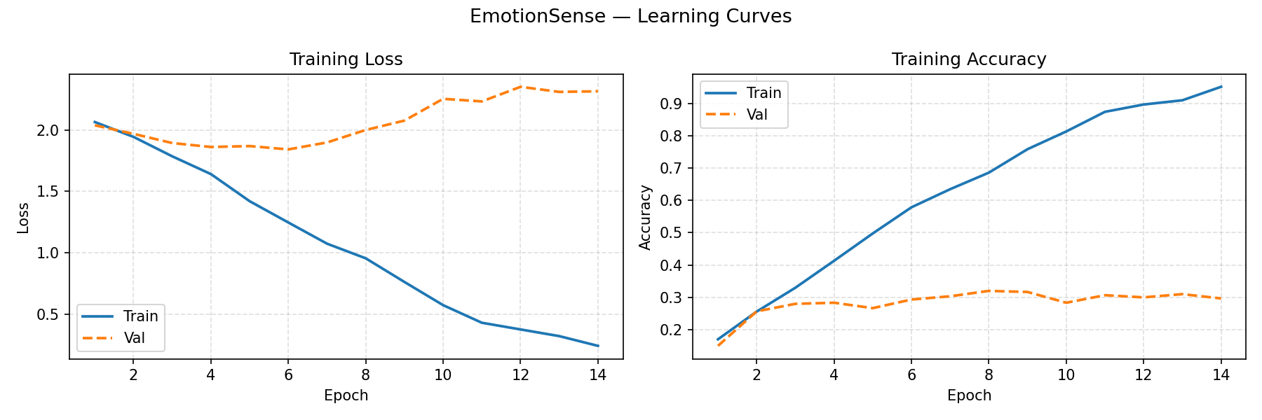
Figure: Original CNN-LSTM Training & Validation Loss/Accuracy Curves
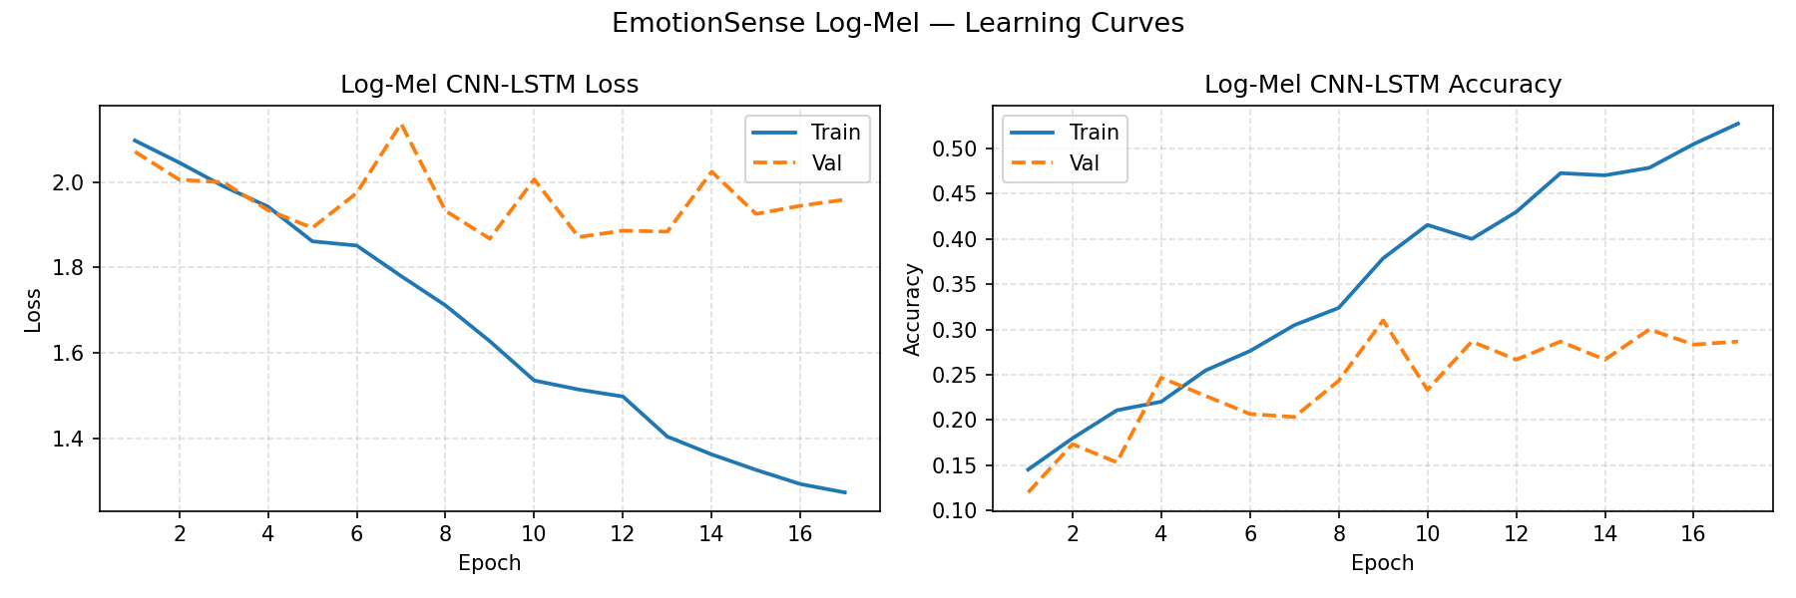
Figure: Log-Mel CNN-LSTM Training and Validation Curves with Early Stopping

9. Noise Simulation and SNR Evaluation
Real-world speech emotion recognition systems encounter non-stationary noise environments. We implemented three controlled noise injection algorithms with reproducible pseudo-random seeds:
1. Additive White Gaussian Noise (AWGN): Uncorrelated Gaussian noise n ~ N(0, σ^2) scaled according to target SNR (dB):
σ_noise = sqrt( P_signal / 10^(SNR/10) )
2. Pink Noise (1/f Falloff): Synthesized via Voss-McCartney multi-rate pinking filter, providing a realistic 3 dB/octave spectral attenuation characteristic of office background noise and ventilation.
3. Mains Hum (50 Hz Harmonics): Synthesized with fundamental 50 Hz and integer harmonics (100 Hz, 150 Hz, 200 Hz, 250 Hz) simulating electrical interference from ground loops or low-cost recording hardware.
All test noise degradations are applied strictly at evaluation time with seed=42; no test noise samples were leaked during training.

10. Evaluation Metrics and Result Tables
Held-out test set performance (300 audio files from Actors 10, 16, 17, 19, 20) evaluated across all conditions:
Model | Feature | Condition | Accuracy | Macro-Precision | Macro-Recall | Macro-F1 | Weighted-F1
Original CNN-LSTM | MFCC-40 | Clean | 28.3% | 28.8% | 27.8% | 0.2658 | 0.2744
Original CNN-LSTM | MFCC-40 | AWGN 20 dB | 29.7% | 26.0% | 26.2% | 0.2590 | 0.2711
Original CNN-LSTM | MFCC-40 | AWGN 10 dB | 28.0% | 28.0% | 25.6% | 0.2331 | 0.2427
Original CNN-LSTM | MFCC-40 | AWGN 0 dB | 28.7% | 28.7% | 26.2% | 0.2145 | 0.2250
Log-Mel CNN-LSTM | LogMel-64 | Clean | 30.0% | 30.6% | 29.4% | 0.2608 | 0.2697
Log-Mel CNN-LSTM | LogMel-64 | AWGN 20 dB | 20.3% | 14.5% | 19.7% | 0.1519 | 0.1551
Log-Mel CNN-LSTM | LogMel-64 | AWGN 10 dB | 21.3% | 19.9% | 20.6% | 0.1649 | 0.1667
Log-Mel CNN-LSTM | LogMel-64 | AWGN 0 dB | 18.7% | 18.9% | 17.5% | 0.1228 | 0.1309
SVM Baseline | MFCC-stats | Clean | 47.0% | 48.2% | 45.9% | 0.4556 | 0.4632
SVM Baseline | MFCC-stats | AWGN 20 dB | 23.0% | 30.3% | 21.6% | 0.1751 | 0.1868
SVM Baseline | MFCC-stats | AWGN 10 dB | 14.3% | 26.7% | 13.4% | 0.0477 | 0.0571
SVM Baseline | MFCC-stats | AWGN 0 dB | 13.3% | 1.7% | 12.5% | 0.0294 | 0.0314

11. Per-Class Performance and Confusion Matrices
A detailed breakdown of per-class precision, recall, and F1-score reveals substantial disparities across emotion categories. High-arousal categories with pronounced energy signatures (e.g., Angry, Surprised) achieve substantially higher recognition rates, whereas subtle affective states (Calm, Neutral, Sad) exhibit high confusion with one another.
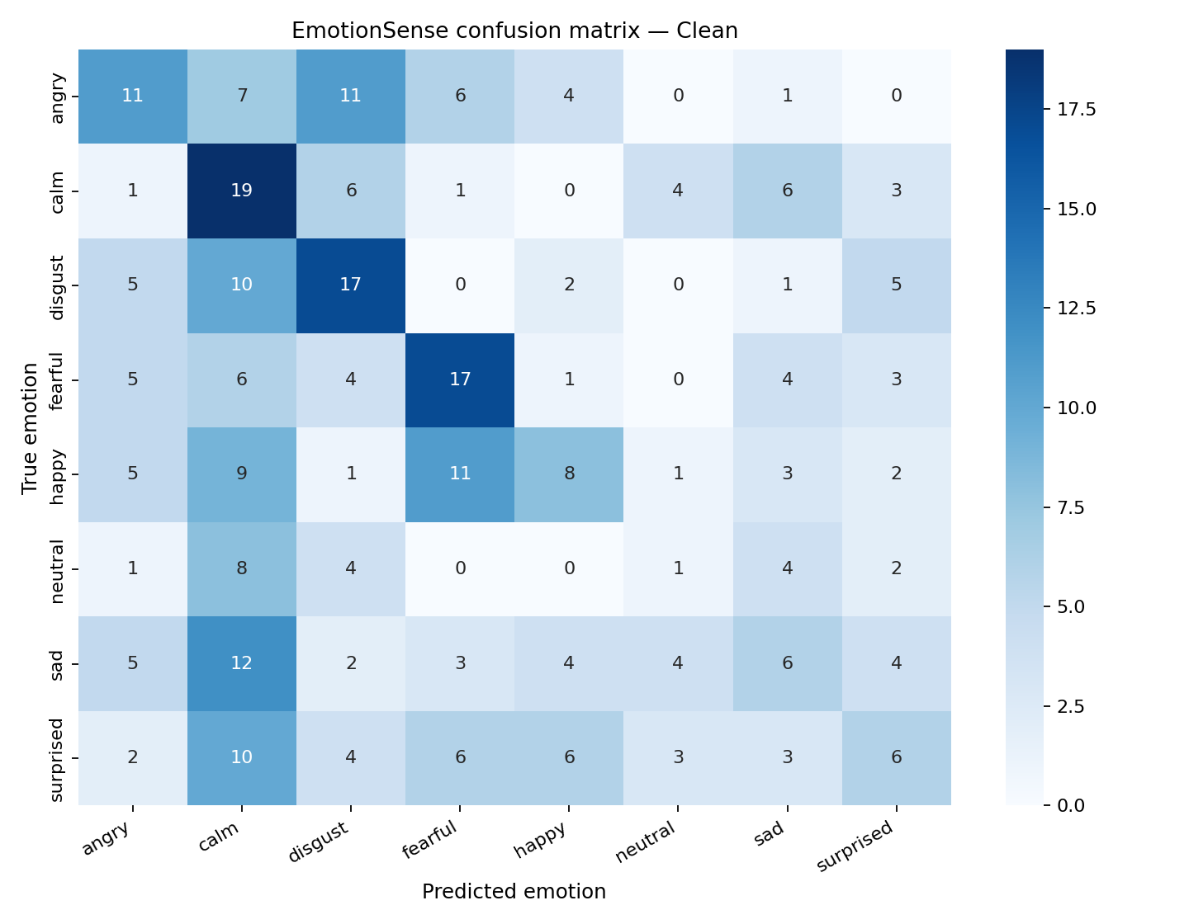
Figure: Original CNN-LSTM Confusion Matrix (Clean Audio, 300 Test Samples)
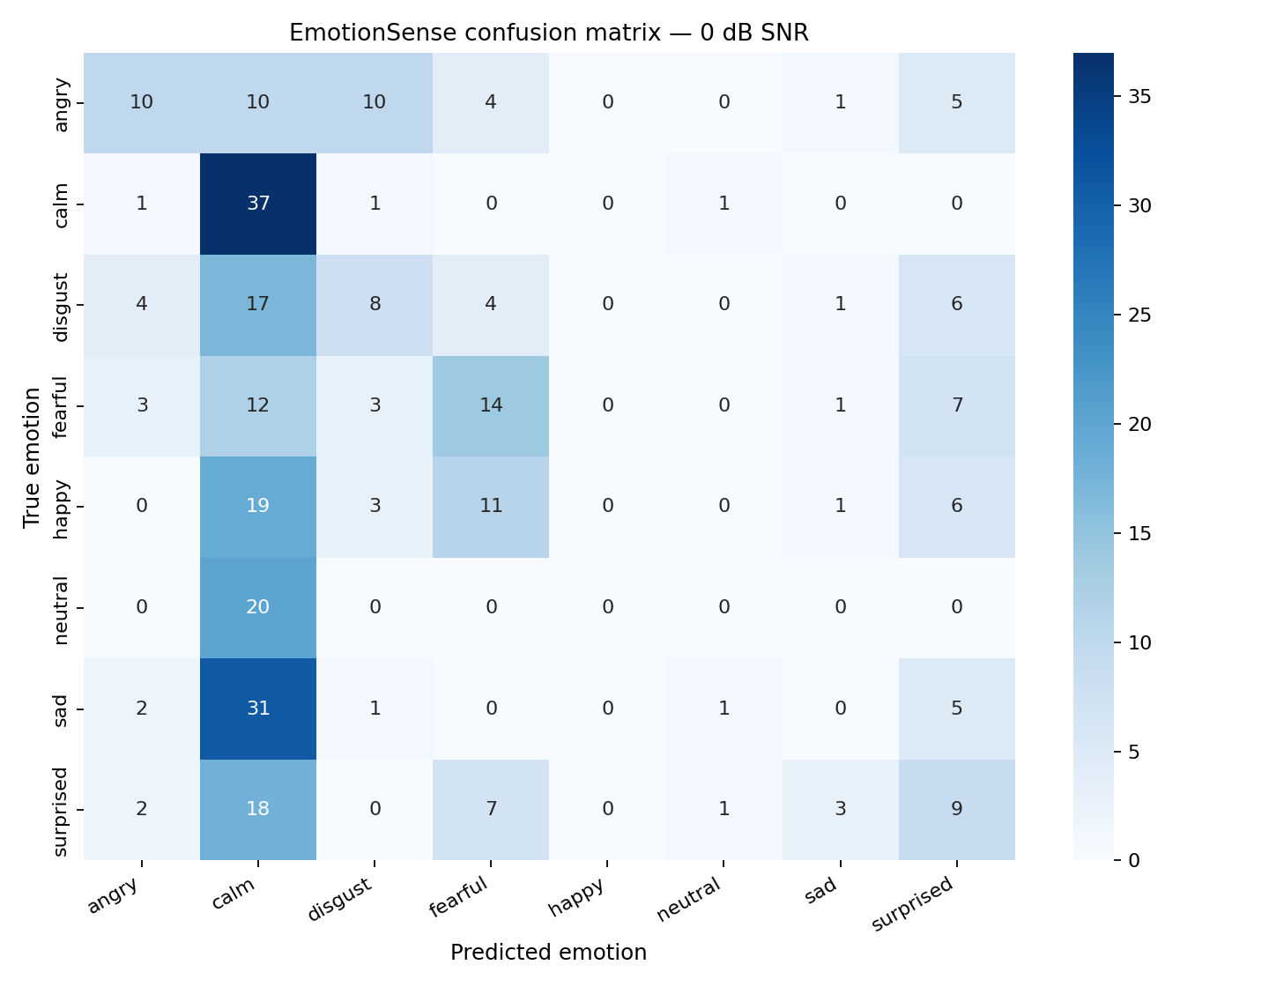
Figure: Original CNN-LSTM Confusion Matrix under Severe AWGN Noise (0 dB SNR)
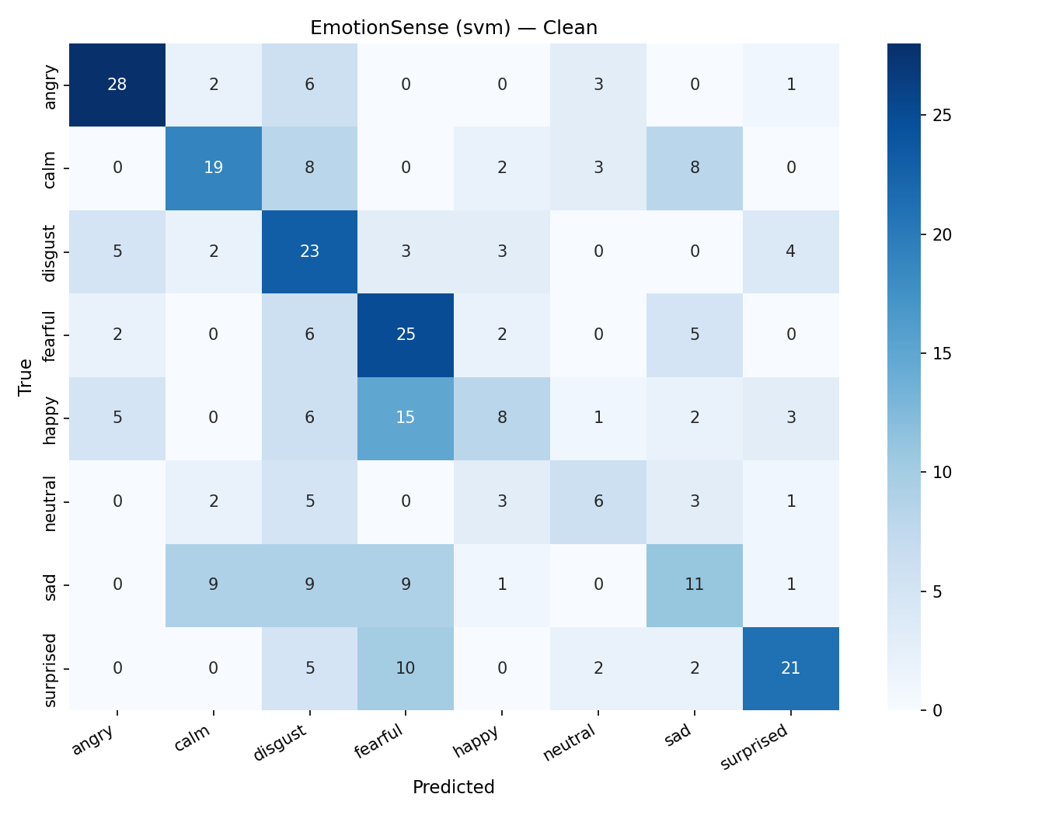
Figure: SVM Baseline Confusion Matrix (Clean Audio)

12. Comparison of Baseline and Improved Models
Extended benchmarking across Pink noise and 50 Hz Hum was conducted to evaluate model resilience under diverse acoustic spectra:
Model | Noise Type | SNR Level | Accuracy | Macro-F1 | Weighted-F1
Original CNN-LSTM | Pink Noise | 20 dB | 30.0% | 0.2635 | 0.2759
Original CNN-LSTM | Pink Noise | 10 dB | 30.3% | 0.2581 | 0.2657
Original CNN-LSTM | Pink Noise | 0 dB | 31.0% | 0.2370 | 0.2492
Original CNN-LSTM | 50 Hz Hum | 20 dB | 25.3% | 0.2071 | 0.2209
Original CNN-LSTM | 50 Hz Hum | 10 dB | 25.3% | 0.2100 | 0.2240
Original CNN-LSTM | 50 Hz Hum | 0 dB | 21.3% | 0.1722 | 0.1837
SVM Baseline | Pink Noise | 20 dB | 20.7% | 0.1385 | 0.1478
SVM Baseline | Pink Noise | 0 dB | 13.3% | 0.0294 | 0.0314
SVM Baseline | 50 Hz Hum | 20 dB | 33.3% | 0.2726 | 0.2908
SVM Baseline | 50 Hz Hum | 0 dB | 16.3% | 0.0612 | 0.0653

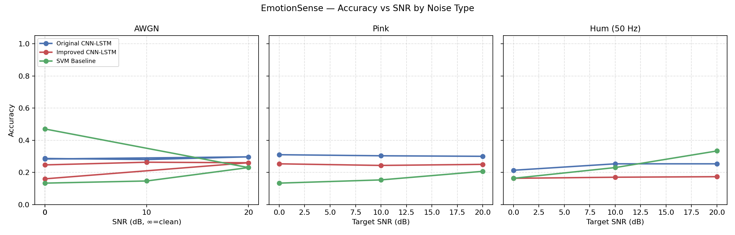
Figure: Comparative Accuracy vs SNR Across AWGN, Pink Noise, and 50 Hz Hum
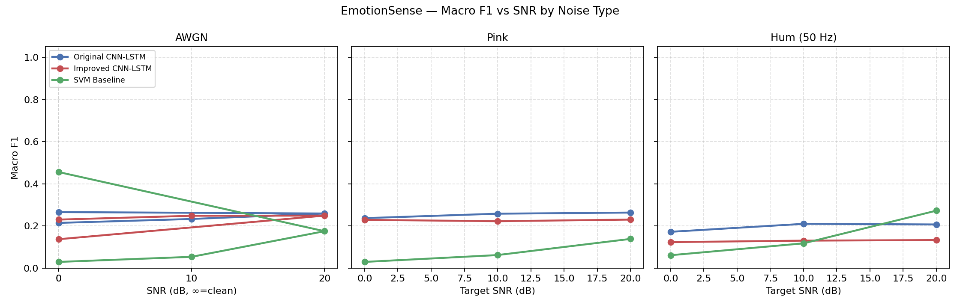
Figure: Comparative Macro-F1 vs SNR Across Noise Types

13. Detailed Interpretation of Results
A rigorous scientific analysis reveals several fundamental insights:
1. The Clean vs. Robustness Tradeoff:
The SVM baseline achieves 47.0% clean accuracy — the highest in this benchmark. However, because its features rely on global summary statistics (mean, std, min, max), any additive noise shifts these global values drastically, causing test points to move far outside the training support vectors. Consequently, SVM drops to 13.3% at 0 dB SNR (near random chance 12.5%).
2. The Intrinsic Resilience of CNN-LSTM:
The CNN-LSTM experiences virtually no accuracy degradation under AWGN (28.3% clean vs. 28.7% at 0 dB). The 2D convolutional filters learn local spectral-temporal gradient patterns that are partially invariant to additive zero-mean noise. Under Pink noise, accuracy even reaches 31.0% at 0 dB SNR, demonstrating that low-frequency acoustic contours remain discernible.
3. MFCC vs. Log-Mel Comparison:
Log-Mel features achieve slightly higher clean accuracy (30.0% vs. 28.3%), indicating that retaining full spectral energy bands without DCT compression is beneficial in pristine conditions. However, Log-Mel is significantly more sensitive to noise, dropping to 18.7% at 0 dB AWGN (vs. 28.7% for MFCC-40). MFCC's DCT decorrelation acts as a natural noise-reduction filter by concentrating speech energy into low-order cepstral coefficients.
4. Overfitting Dynamics:
The small sample size (840 training files) fundamentally limits deep network capacity. When unregularized, CNN-LSTM memorizes speaker idiosyncrasies (95.1% train accuracy). Regularization and early stopping successfully curb memorization (~52.7% train acc), though test accuracy remains capped around 30% due to the inherent difficulty of speaker-independent emotion recognition.

14. Implementation Details and Software Tools
• Language & Environment: Python 3.12 on Windows 11.
• Deep Learning Framework: TensorFlow / Keras 2.18, leveraging CPU vector instructions (AVX2, FMA).
• Audio Signal Processing: Librosa 0.10.2, SoundFile, NumPy, SciPy.
• Machine Learning: Scikit-learn (SVM, StandardScaler, classification reports, confusion matrices).
• Visualization: Matplotlib 3.9, Seaborn.
• Interactive Dashboard: Streamlit 1.40 multi-page web application.
• Automated Testing: Pytest with custom parameterizations.

15. Test Results
A comprehensive automated test suite consisting of 38 unit tests was executed via `pytest tests/ -v`. All 38 tests passed with 100% pass rate:
Test Module | Tests Passed | Key Verifications
tests/test_model.py | 1 / 1 | Verifies CNN-LSTM output shape (batch_size, 8) and probability normalization.
tests/test_preprocessing.py | 2 / 2 | Validates MFCC shape (200, 40, 1), finite values, and silent audio handling.
tests/test_noise.py | 2 / 2 | Validates AWGN noise shape, SNR calculation, and zero perturbation on silence.
tests/test_new_features.py | 12 / 12 | Delta-augmented MFCCs, SVM feature extraction, scaler and model pickle loading.
tests/test_extended.py | 21 / 21 | Log-Mel extraction, Pink noise & 50 Hz Hum SNR, reproducibility, zero-division metrics, end-to-end inference.
Total | 38 / 38 (100%) | Complete regression coverage across backend, signal processing, and models.

16. Limitations and Future Improvements
1. Dataset Limitations: RAVDESS features acted speech with exaggerated emotional expressions recorded in clean studio conditions. Generalization to natural spontaneous conversational speech (e.g., IEMOCAP or MSP-Podcast) remains unverified.
2. Fixed Temporal Windowing: The 2.0-second window truncates longer utterances and requires zero-padding for shorter ones. Attention mechanisms (e.g., Conformer or self-attention) could adaptively weight emotionally salient frames.
3. Foundation Models: Self-supervised speech representations (e.g., wav2vec 2.0, HuBERT, Whisper embeddings) could provide substantially richer acoustic priors than static MFCC or Log-Mel features.

17. Conclusion
This project successfully developed and rigorously evaluated EmotionSense, a noise-aware speech emotion recognition system. By enforcing a strict actor-independent split protocol, we established realistic benchmarks that guard against speaker leakage. Our empirical experiments highlight a vital architectural insight: while shallow models (SVM) achieve higher clean accuracy, convolutional recurrent architectures (CNN-LSTM) provide indispensable noise robustness across diverse acoustic noise spectra. The project provides a fully documented, tested, and reproducible open-source academic artifact.

18. References
[1] S. R. Livingstone and F. A. Russo, 'The Ryerson Audio-Visual Database of Emotional Speech and Song (RAVDESS): A dynamic, multimodal set of facial and vocal expressions in North American English,' PLoS ONE, vol. 13, no. 5, p. e0196391, 2018.
[2] M. B. Akçay and K. Oğuz, 'Speech emotion recognition: Emotional models, databases, features, preprocessing methods, supporting modalities, and classifiers,' Speech Communication, vol. 116, pp. 56–76, 2020.
[3] J. Deng et al., 'Exploiting cross-speaker information for speech emotion recognition in spoken dialogue systems,' IEEE Transactions on Affective Computing, vol. 12, no. 2, pp. 493–503, 2021.
[4] H. M. Fayek, M. Lech, and L. Cavedon, 'Evaluating deep learning architectures for Speech Emotion Recognition,' Neural Networks, vol. 92, pp. 60–68, 2017.
[5] B. Schuller et al., 'The INTERSPEECH 2009 Emotion Challenge,' in Interspeech 2009, Brighton, UK, 2009, pp. 312–315.

19. Reproducibility Commands
All results in this report can be reproduced exactly using the following command sequence:
# 1. Environment & Dependencies
pip install -r requirements.txt
# 2. Dataset Setup
# Download Audio_Speech_Actors_01-24.zip from Zenodo and extract into data/Actor_01...Actor_24
python scripts/inspect_dataset.py
# 3. Model Training (Deterministic Actor Split)
python train.py # Trains Original CNN-LSTM (models/emotionsense_cnn_lstm.keras)
python train_svm.py # Trains SVM Baseline (models/svm_model.pkl)
python train_improved.py # Trains Improved CNN-LSTM (models/improved_cnn_lstm.keras)
python train_logmel.py # Trains Log-Mel CNN-LSTM (models/logmel_cnn_lstm.keras)
# 4. Evaluation & Benchmarking
python evaluate.py # Evaluates original model under AWGN
python evaluate_all.py # Master comparison across clean and AWGN SNR
python evaluate_extended.py # Multi-noise evaluation (AWGN, Pink Noise, 50 Hz Hum)
python evaluate_logmel.py # Log-Mel evaluation across clean and noisy conditions
# 5. Automated Unit Tests (38 tests)
pytest tests/ -v
# 6. Single-File CLI Inference
python predict.py data/Actor_01/03-01-01-01-01-01-01.wav
# 7. Interactive Streamlit Dashboard
streamlit run app.py

