**Name: SHAMJAD MAZOOD NAZER**

**Roll No: 36**

**Batch: B**

**Date: 29/03/2022**

**OBJECT ORIENTED PROGRAMMING LAB**

**Experiment No.: 1**

**Aim**

Define a class ‘product’ with data members pcode, pname and price. Create three objects of the class and find the product having the lowest price .

**Procedure**

class Product{

String pcode, pname;

double price;

void details(){

System.out.println("PRODUCT DETAILS");

System.out.println("PCode : "+pcode);

System.out.println("PName : "+pname);

System.out.println("Price : "+price);

}

}

public class ProductDetails{

public static void main(String args[]){

Product p1 = new Product();

p1.pcode = "M200J9PI";

p1.pname = "POCO M2";

p1.price = 10999;

System.out.println("\nProduct 1:-");

p1.details();

Product p2 = new Product();

p2.pcode = "XMSH05HM";

p2.pname = "Mi Band 3";

p2.price = 1799;

System.out.println("\nProduct 2:-");

p2.details();

Product p3 = new Product();

p3.pcode = "EPSP5248";

p3.pname = "Camlin Scale";

p3.price = 5;

System.out.println("\nProduct 3:-");

p3.details();

if(p1.price<p2.price && p1.price<p3.price){

System.out.println("\n\nProduct with lowest price is :");

p1.details();

}

else if(p2.price < p3.price){

System.out.println("\n\nProduct with lowest price is :");

p2.details();

}

else{

System.out.println("\n\nProduct with lowest price is :");

p3.details();

}

}

}

**Output**

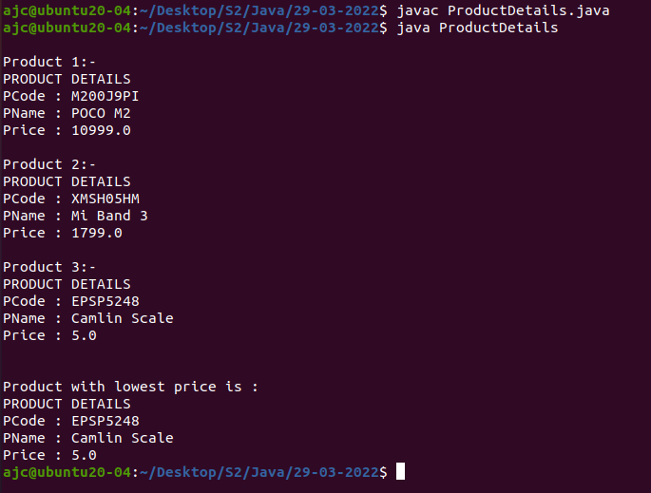

**Name: SHAMJAD MAZOOD NAZER**

**Roll No: 36**

**Batch: B**

**Date: 29/03/2022**

**OBJECT ORIENTED PROGRAMMING LAB**

**Experiment No.: 2**

**Aim**

Define a class student with data members std_id, std_name, and marksof 3 subjects. Create 3 objects of the student class and find the total mark and average mark of each student.

**Procedure**

class StudentsData{

int std_id;

String name;

int m1, m2, m3;

StudentsData(){

std_id = 13313;

name = "SHEFANY SHANAVAS";

m1 = 44;

m2 = 45;

m3 = 43;

}

StudentsData(int id, String std_name, int DBMS, int NSA, int JAVA){

std_id = id;

m1 = DBMS;

m2 = NSA;

m3 = JAVA;

name = std_name;

}

StudentsData(int DBMS, int NSA, int JAVA){

std_id = 13310;

name = "SANIO LUKE SEBASTIAN";

m1 = DBMS;

m2 = NSA;

m3 = JAVA;

}

void display(){

System.out.println("Student ID \t: "+std_id);

System.out.println("Student NAME \t: "+name);

System.out.println("A-DBMS \t\t: "+m1);

System.out.println("NSA \t\t: "+m2);

System.out.println("JAVA \t\t: "+m3);

System.out.println("TOTAL MARK \t: "+(m1+m2+m3));

System.out.println("AVERAGE MARK \t: "+(m1+m2+m3)/3);

}

}

public class StudentsDetails{

public static void main(String args[]){

StudentsData S = new StudentsData();

System.out.println("\nDefault Constructor\n");

S.display();

StudentsData obj2 = new StudentsData(13312, "SHAMJAD MAZOOD NAZER", 47, 48, 50);

System.out.println("\nConstructor Parameter\n");

obj2.display();

StudentsData obj3 = new StudentsData(50, 50, 50);

System.out.println("\nMixed Constructor\n");

obj3.display();

}

}

**Output**

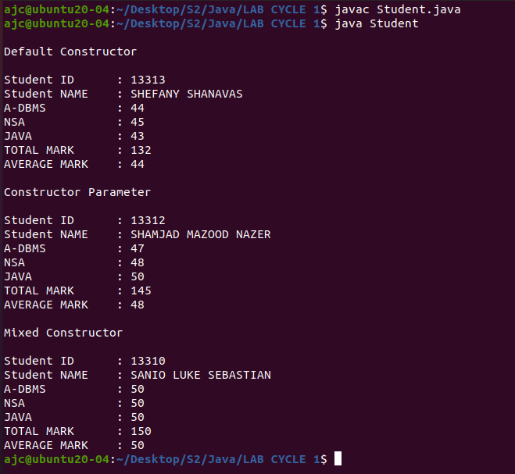

**Name: SHAMJAD MAZOOD NAZER**

**Roll No: 36**

**Batch: B**

**Date: 06/04/2022**

**OBJECT ORIENTED PROGRAMMING LAB**

**Experiment No.: 4**

**Aim**

Java program to perform Vehicle details class.

**Procedure**

class VehicleDetails{

String vname, vmodel;

int vCC, vprice;

VehicleDetails(){

}

VehicleDetails(String vname, String vmodel, int vCC, int vprice){

this.vname = vname;

this.vprice = vprice;

this.vmodel = vmodel;

this.vCC = vCC;

}

void details(){

System.out.println("The Vehicle-Name is\t\t : "+vname);

System.out.println("The Vehicle-Model name is\t : "+vmodel);

System.out.println("The Vehicle-CC is\t\t : "+vCC);

System.out.println("The Vehicle-Price is\t\t : Rs."+vprice);

System.out.print("\n");

}

}

class Vehicle{

public static void main(String args[]){

VehicleDetails[] vehicleDetails= new VehicleDetails[3];

vehicleDetails[0]= new VehicleDetails("YAMAHA R15","V3", 155, 240000);

vehicleDetails[0].details();

vehicleDetails[1]= new VehicleDetails("HYUNDAI i20","sportz", 1500, 1200000);

vehicleDetails[1].details();

vehicleDetails[2]= new VehicleDetails("KTM RC","390",375, 375000);

vehicleDetails[2].details();

}

}

**Output**

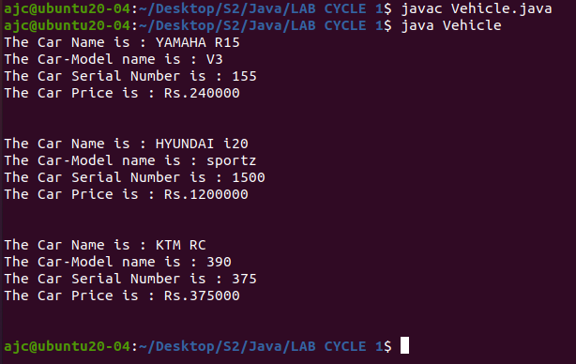

**Name: SHAMJAD MAZOOD NAZER**

**Roll No: 36**

**Batch: B**

**Date: 06/04/2022**

**OBJECT ORIENTED PROGRAMMING LAB**

**Experiment No.: 4**

**Aim**

Read 2 matrices from the console and perform matrix addition.

**Procedure**

import java.util.*;

class MatrixAddition{

public static void main(String args[]){

int row, col;

Scanner sc= new Scanner(System.in);

System.out.print("Enter the number of rows for the Matrices : ");

row= sc.nextInt();

System.out.print("Enter the number of columns for the Matrices : ");

col= sc.nextInt();

int[][] matrixA= new int[row][col];

int[][] matrixB= new int[row][col];

int[][] matrixSum= new int[row][col];

System.out.println("Enter the "+row+" elements for the Matrix A : ");

for(int i=0;i<row;i++){

for(int j=0;j<col;j++){

matrixA[i][j]= sc.nextInt();

}

}

System.out.println("\n");

System.out.println("Enter the "+col+" elements for the Matrix B : ");

for(int i=0;i<row;i++){

for(int j=0;j<col;j++){

matrixB[i][j]= sc.nextInt();

}

}

System.out.println("\n");

System.out.println("Matrix A is : ");

for(int i=0;i<row;i++){

for(int j=0;j<col;j++){

System.out.print(matrixA[i][j]+" ");

}

System.out.println("\n");

}

System.out.println("Matrix B is : ");

for(int i=0;i<row;i++){

for(int j=0;j<col;j++){

System.out.print(matrixB[i][j]+" ");

}

System.out.println("\n");

}

for(int i=0;i<row;i++){

for(int j=0;j<col;j++){

matrixSum[i][j]= matrixA[i][j] + matrixB[i][j];

}

}

System.out.println("MatrixSum is : ");

for(int i=0;i<row;i++){

for(int j=0;j<col;j++){

System.out.print(matrixSum[i][j]+" ");

}

System.out.println("\n");

}

}

}

**Output**

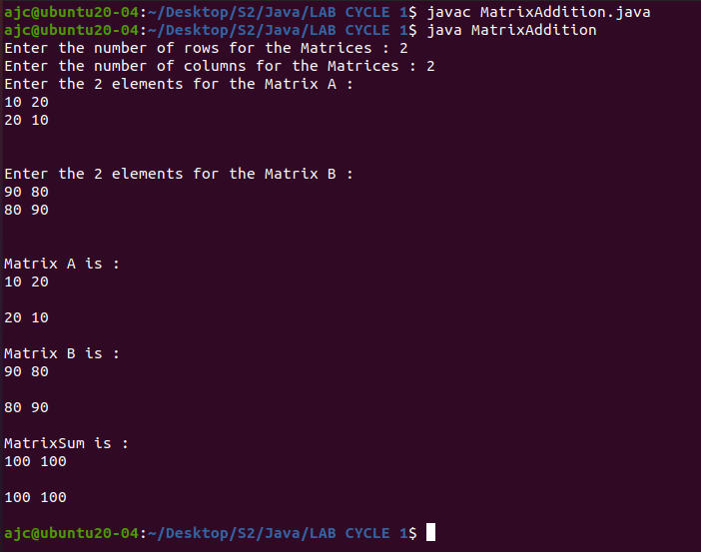

**Name: SHAMJAD MAZOOD NAZER**

**Roll No: 36**

**Batch: B**

**Date: 06/04/2022**

**OBJECT ORIENTED PROGRAMMING LAB**

**Experiment No.: 5**

**Aim**

Java program to perform Addition of complex numbers.

**Procedure**

import java.util.*;

class ComplexNumbers{

int real, imaginary;

ComplexNumbers(){ }

ComplexNumbers(int real, int imaginary){

this.real= real;

this.imaginary= imaginary;

}

void complexAdd(ComplexNumbers compNum){

int real_sum, imaginary_sum;

real_sum= this.real+compNum.real;

imaginary_sum= this.imaginary+compNum.imaginary;

System.out.println("The sum of the complex numbers are : "+real_sum+" + "+imaginary_sum+"i");

}

void display(){

System.out.println("The entered complex number is : "+real+" + "+imaginary+"i");

System.out.println("\n");

}

public static void main(String[] args){

int real_num, imaginary_num;

Scanner sc= new Scanner(System.in);

System.out.print("Enter the real value of the 1st complex number : ");

real_num= sc.nextInt();

System.out.print("Enter the imaginary value of the 1st complex number : ");

imaginary_num= sc.nextInt();

ComplexNumbers com1= new ComplexNumbers(real_num, imaginary_num);

com1.display();

System.out.print("Enter the real value of the 2nd complex number : ");

real_num= sc.nextInt();

System.out.print("Enter the imaginary value of the 2nd complex number : ");

imaginary_num= sc.nextInt();

ComplexNumbers com2= new ComplexNumbers(real_num, imaginary_num);

com2.display();

com1.complexAdd(com2);

}

}

**Output**

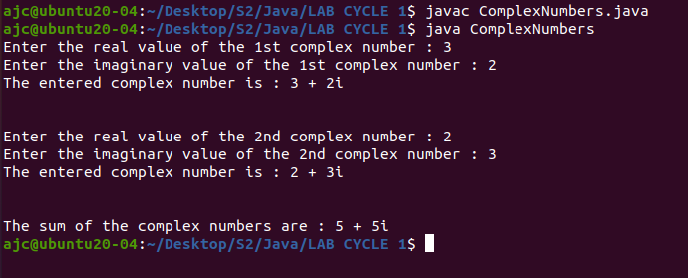

**Name: SHAMJAD MAZOOD NAZER**

**Roll No: 36**

**Batch: B**

**Date: 05/04/2022**

**OBJECT ORIENTED PROGRAMMING LAB**

**Experiment No.: 6**

**Aim**

Read a matrix from the console and check whether it is symmetric or not.

**Procedure**

import java.util.Scanner;

public class SymmetricMatrix{

public static void main(String args[]){

Scanner sc = new Scanner(System.in);

System.out.print("Enter the size of Row \t: ");

int row = sc.nextInt();

System.out.print("Enter the size of Cols \t: ");

int col = sc.nextInt();

int[][] a = new int[row][col];

boolean yes = true;

int i, j;

if(row == col){

for(i=0; i<row; i++){

for(j=0; j<col; j++){

System.out.print("Enter ("+i+","+j+")th Value \t: ");

a[i][j] = sc.nextInt();

}

}

System.out.println("\nMatrix A :");

for(i=0; i<row; i++){

for(j=0; j<col; j++){

System.out.print(a[i][j]+"\t");

}System.out.println("\n");

}

for(i=0; i<row; i++){

for(j=0; j<col; j++){

if(a[i][j] != a[j][i]){

yes = false;

}

}

}

if(yes){

System.out.println("The Matrix is Symmetric\n");

}

else

System.out.println("The Matrix is NOT Symmetric\n");

}

else

System.out.println("The Rows and Columns are NOT equal.");

}

}

**Output**

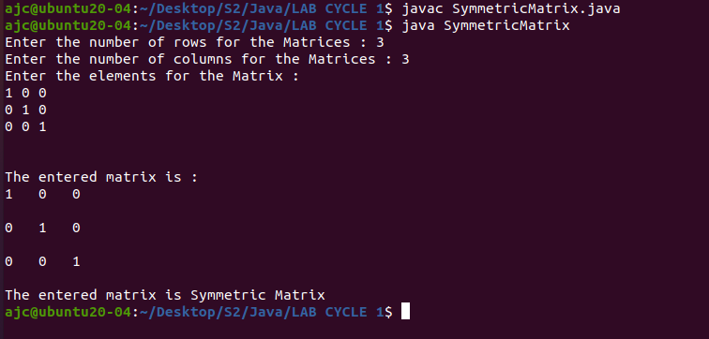

**Name: SHAMJAD MAZOOD NAZER**

**Roll No: 36**

**Batch: B**

**Date: 22/04/2022**

**OBJECT ORIENTED PROGRAMMING LAB**

**Experiment No.: 7**

**Aim**

Program to Sort strings

**Procedure**

import java.util.*;

public class ArrSort{

public static void main(String args[]){

int size;

Scanner sc=new Scanner(System.in);

System.out.print("Enter the size of the Array : ");

size = sc.nextInt();

String[] Names = new String[size];

System.out.println("Enter the Elements of the Array : ");

for(int i=0; i<size; i++){

Names[i] = sc.nextLine();

}

Arrays.sort(Names);

for(int i=0; i<size; i++){

System.out.print(Names[i]);

}

}

}

**Output**

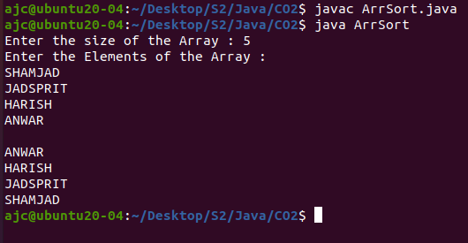

**Name: SHAMJAD MAZOOD NAZER**

**Roll No: 36**

**Batch: B**

**Date: 22/04/2022**

**OBJECT ORIENTED PROGRAMMING LAB**

**Experiment No.: 8**

**Aim**

Search an element in an array.

**Procedure**

import java.util.*;

class ArrSearch{

public static void main(String[] args){

Scanner sc= new Scanner(System.in);

int size, item, flag = 0;

System.out.print("Enter the size for the array : ");

size = sc.nextInt();

int[] arr = new int[size];

System.out.println("\nEnter the elements for the array : ");

for(int i=0; i<size; i++)

arr[i]= sc.nextInt();

System.out.print("Enter the item to search : ");

item = sc.nextInt();

for(int i=0; i<size; i++){

if(arr[i] == item)

flag = 1;

}

if(flag == 1)

System.out.println(item+" found in the Array!");

else

System.out.println(item+" not found in the Array!");

}

}

**Output**

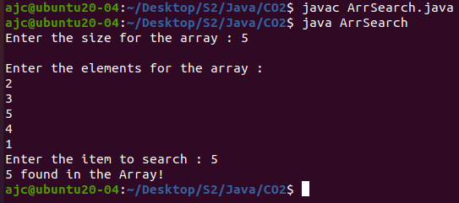

**Name: SHAMJAD MAZOOD NAZER**

**Roll No: 36**

**Batch: B**

**Date: 29/03/2022**

**OBJECT ORIENTED PROGRAMMING LAB**

**Experiment No.: 9**

**Aim**

**Procedure**

**Output**

**Name: SHAMJAD MAZOOD NAZER**

**Roll No: 36**

**Batch: B**

**Date: 29/03/2022**

**OBJECT ORIENTED PROGRAMMING LAB**

**Experiment No.: 10**

**Aim**

**Procedure**

**Output**

**Name: SHAMJAD MAZOOD NAZER**

**Roll No: 36**

**Batch: B**

**Date: 29/03/2022**

**OBJECT ORIENTED PROGRAMMING LAB**

**Experiment No.: 11**

**Aim**

**Procedure**

**Output**

**Name: SHAMJAD MAZOOD NAZER**

**Roll No: 36**

**Batch: B**

**Date: 29/03/2022**

**OBJECT ORIENTED PROGRAMMING LAB**

**Experiment No.: 12**

**Aim**

**Procedure**

**Output**

**Name: SHAMJAD MAZOOD NAZER**

**Roll No: 36**

**Batch: B**

**Date: 29/03/2022**

**OBJECT ORIENTED PROGRAMMING LAB**

**Experiment No.: 13**

**Aim**

**Procedure**

**Output**

**Name: SHAMJAD MAZOOD NAZER**

**Roll No: 36**

**Batch: B**

**Date: 29/03/2022**

**OBJECT ORIENTED PROGRAMMING LAB**

**Experiment No.: 14**

**Aim**

**Procedure**

**Output**