Task 1

Geographic realism
EV charging stations are physically distributed over a two-dimensional geographical area.
A 2-D mesh naturally models this.
A hypercube may have better mathematical communication properties, but its neighbours are determined logically rather than by geographical proximity.
That makes the mesh a more realistic simulation model.

Immediate-neighbour communication
The specification specifically says charging nodes communicate with immediate adjacent nodes.
That is fundamentally what mesh connectivity represents.
This is probably your single strongest argument.

Communication path corresponds to distance
The base station has to identify the closest available charging node and redirect traffic accordingly.
A Cartesian mesh gives you a natural representation of spatial relationships and hop distance.
That makes algorithms for neighbour querying and local availability propagation intuitive.

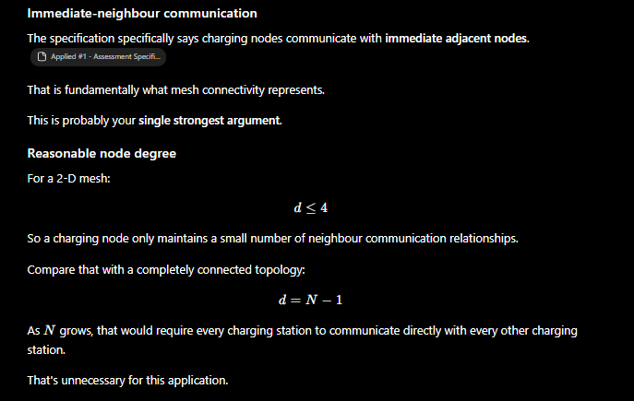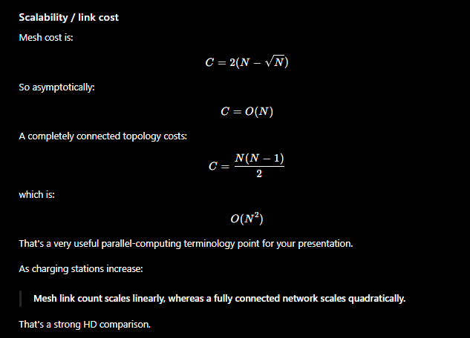

Task 2
A hybrid distributed/shared-memory MIMD simulation using MPI between EV charging-node processes and OpenMP within each process.

Diagram 1

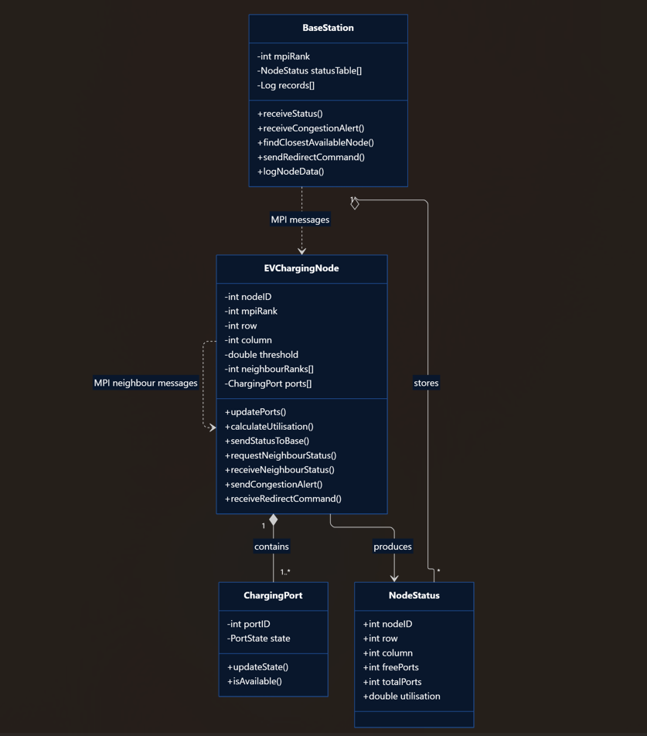

Diagram 2

