FIT3143 PARALLEL COMPUTING
Applied #1 Assessment - Week 6
Distributed Wireless Sensor Network
Electric Vehicle Charging Navigation System Simulation
TEAM MEMBERS
Savin Vindiv De Alwis
Student ID: 35221631 | sdea0018@student.monash.edu
Shamle Thilaksiri
Student ID: 35512075 | wthi0003@student.monash.edu

Contents
Executive Summary | 3
1. Task 1 - Network Topology | 4
1.1 Requirements and assumptions | 4
1.2 Topology comparison criteria | 4
1.3 Comparison of Week 5 topologies | 4
1.4 Selected topology: 2-D mesh | 5
2. Task 2 - Architecture Design | 6
2.1 Hybrid MIMD simulation architecture | 6
2.2 Static software structure | 8
2.3 Simulation workflow and message passing | 9
2.4 Message protocol and synchronization | 10
2.5 Base-station selection algorithm | 10
2.6 Machines, cores and bandwidth | 10
3. Task 3 - Communication Analysis | 12
3.1 Analytical model and message sizes | 12
3.2 Scaling with number of charging nodes | 12
3.3 Scaling with number of base stations | 14
3.4 Additional sensitivity analysis | 15
3.5 Communication-analysis conclusions | 16
Conclusion, Limitations and Future Work | 17
References | 18
AI Declaration | 19

Executive Summary
- Simulates the EVCNS wireless sensor network defined in Applied #1.
- Uses a 2-D mesh for geographically adjacent EV charging stations.
- Uses MPI processes for distributed charging nodes and the base station.
- Uses OpenMP threads inside each charging-node process for shared-memory parallelism.
- Implements the hybrid MIMD model encouraged by the HD rubric and supported by unit theory [1]-[5].
- 2-D mesh: maximum four orthogonal neighbours, O(N) link cost, and direct immediate-neighbour communication.
- MPI rank 0 represents the base station; ranks 1..N represent charging nodes.
- Each node stores charging-port states and aggregates utilisation with an OpenMP parallel-for reduction.
- Over-threshold nodes query neighbours with non-blocking MPI.
- A congestion alert is sent only when all valid neighbours are also above threshold.
- Transmission model: T = (L x H) / B on 1 Gbit/s links [3].
- Fixed-size one-hop message transmission time remains O(1) as N grows.
- Aggregate communication demand grows O(N).
- With S balanced base stations, base-station service demand falls toward O(N/S), while single-message serialization is unchanged.
- Additional analysis covers reporting frequency; queueing, wireless effects, and server synchronization are outside the baseline model.

1. Task 1 - Network Topology
- Charging nodes are distributed across a 2-D geographic area and communicate with immediate adjacent nodes.
- Week 5 comparison metrics: node degree, diameter, bisection width, arc connectivity, and link cost.
- Latency and bandwidth are key MIMD fabric-performance considerations [3].
- The selected topology must balance communication performance with WSN realism.

1.1 Requirements and assumptions
ID | Assumption used by the simulator
A1 | For analytical graphs, N is taken as a perfect square and the EVCS network is a sqrt(N) x sqrt(N) Cartesian grid.
A2 | Charging-node adjacency is orthogonal only (north, south, east and west). Diagonal stations are not direct neighbours.
A3 | Corner nodes have degree 2, edge nodes degree 3 and interior nodes degree 4; therefore d <= 4.
A4 | Every charging-node process can communicate with the base-station process over the cluster interconnect; neighbour messages are one logical mesh hop.
A5 | The utilization threshold is a configurable simulation parameter. No numerical threshold is invented because the assessment specification does not provide one.
Table 1. Simulation assumptions used to resolve details not fixed by the assessment specification.

1.2 Topology comparison criteria
- Node degree: number of I/O links connected to a node; indicates local communication fan-out.
- Network diameter: maximum hop count between any pair of nodes; bounds worst-case path length.
- Bisection width: minimum links cut to split the network approximately in half; relates to aggregate bandwidth.
- Arc connectivity: links whose removal can disconnect the network; supports fault-tolerance analysis.
- Cost: total number of communication links [3].
- Application-specific priorities: geographic realism and immediate-neighbour communication.

1.3 Comparison of Week 5 topologies
Topology | Node degree | Diameter | Bisection width | Arc connectivity | Cost
Linear array | 1 or 2 | N - 1 | 1 | 1 | N - 1
Ring | 2 | N/2 | 2 | 2 | N
Star | 1 or N - 1 | 2 | 1 | 1 | N - 1
Binary tree | 1, 2 or 3 | 2 log2((N+1)/2) | 1 | 1 | N - 1
2-D mesh | 2, 3 or 4 | 2(sqrt(N)-1) | sqrt(N) | 2 | 2(N-sqrt(N))
2-D wraparound / torus | 4 | sqrt(N) | 2sqrt(N) | 4 | 2N
3-D cube | 3, 4, 5 or 6 | 3(cuberoot(N)-1) | N^(2/3) | 3 | 3(N-N^(2/3))
Hypercube | log2(N) | log2(N) | N/2 | log2(N) | N log2(N)/2
Completely connected | N - 1 | 1 | N^2/4 | N - 1 | N(N-1)/2
Table 2. Static interconnection-network parameters taught in Week 5.
- Source: FIT3143 Topic 5, "Summary of Static Network (Fabric) Parameters" [3].
- Week 5 duplicate slides conflict on 2-D mesh arc connectivity and 3-D cube cost; Table 2 uses Topic 5 summary values: mesh arc connectivity = 2 and 3-D cube cost = 3(N-N^(2/3)).
Topology | Geographic realism | Immediate-neighbour fit | Scalability / resilience | Assessment suitability
Linear array | Poor | Limited to two neighbours | O(N) links but O(N) diameter | Low - one-dimensional and long paths
Ring | Poor | Two neighbours | O(N) links; better resilience than a line | Low - wraparound is geographically artificial
Star | Moderate | Traffic is centre-mediated | O(N) links; central bottleneck/failure point | Low-Medium - poor neighbour realism
Binary tree | Poor | Hierarchy, not physical adjacency | O(N) links; O(log N) depth | Low - topology does not match a 2-D road/grid area
2-D mesh | Excellent | Direct orthogonal neighbours | O(N) links; O(sqrt(N)) diameter | Best - direct match to specification
2-D torus | Moderate | Four neighbours | O(N) links; lower diameter than mesh | Medium-High - opposite edges become neighbours
3-D cube | Poor | Includes unnecessary third dimension | O(N) links; good connectivity | Medium - mathematically viable, physically unrealistic
Hypercube | Poor | Logical rather than geographic neighbours | O(N log N) links; O(log N) diameter | Medium - fast but weak WSN realism
Complete | Poor | Every node is a neighbour | O(N^2) links; diameter 1 | Low - excessive links and unrealistic communication
Table 3. Application-specific comparison of all Week 5 topologies.

1.4 Selected topology: 2-D mesh
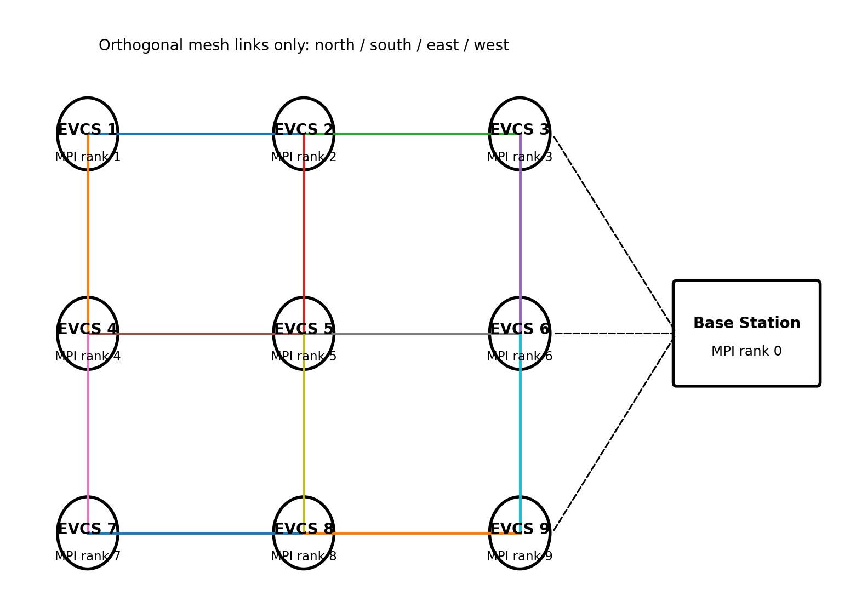
Figure 1. Selected 3 x 3 logical WSN. Solid lines are orthogonal neighbour links; dashed lines illustrate node-to-base-station MPI communication.
- 2-D mesh directly models orthogonal geographic neighbours.
- The specification requires immediate-adjacent node communication [1].
- Neighbour relationships are native to the topology rather than imposed through a hub or arbitrary logical mapping.
- Bounded node degree d <= 4 keeps neighbour fan-out small.
- Mesh link cost is 2(N - sqrt(N)) = O(N), versus O(N^2) for a completely connected network.
- Mesh diameter is 2(sqrt(N)-1) = O(sqrt(N)), which is worse than a hypercube.
- This trade-off is acceptable because the workload is local and geographic realism is the priority.
- Grid coordinates support Manhattan distance d = |r_s-r_j| + |c_s-c_j| for nearest-node redirection.
- Manhattan distance matches the minimum number of orthogonal grid steps.
- Real GPS or road-network distance can replace this metric without changing the MPI architecture.

2. Task 2 - Architecture Design
- Target platform: a cluster of multi-core machines.
- Distributed-memory MIMD uses separate processor/memory pairs connected by an interconnection network.
- Shared-memory MIMD uses multiple processors over a shared address space.
- Hybrid MIMD combines both models [3].
- MPI provides process-level distributed parallelism; OpenMP provides thread-level shared-memory parallelism.

2.1 Hybrid MIMD simulation architecture
- MPI rank 0 models the base station; ranks 1..N each model one EV charging station (EVCS).
- Each EVCS owns its local state and P ChargingPort objects.
- OpenMP threads update ports and aggregate utilisation concurrently.
- Avoiding one MPI process per port reduces unnecessary distributed-memory overhead.
- Parallelism follows the hardware hierarchy: MPI across processes/machines, OpenMP within a process.
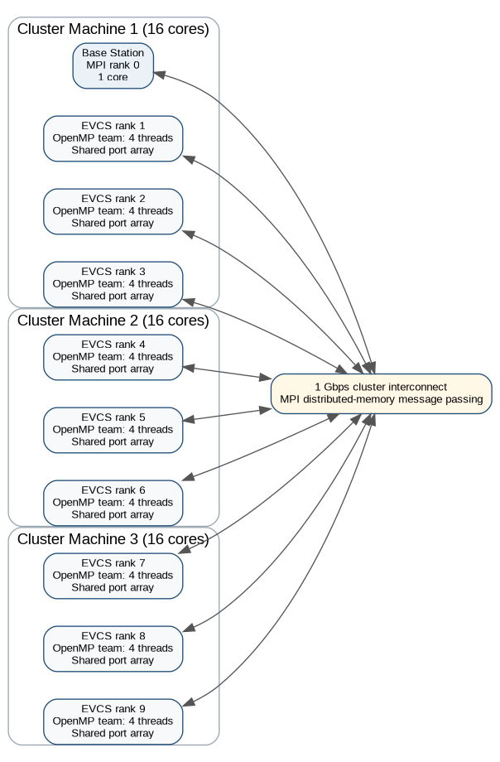
Figure 2. Hybrid deployment example for the 3 x 3 WSN: 10 MPI ranks across three 16-core machines, with four OpenMP threads per EVCS process.
- Figure 2 shows one valid deployment; physical MPI rank placement is not fixed.
- Rank-to-grid coordinates preserve the logical WSN regardless of machine placement.
- Task 3 assumes 1 Gbit/s inter-machine links.
- Even if colocated ranks use faster shared-memory transport, the analysis retains 1 Gbit/s for consistency and conservatism.

2.2 Static software structure
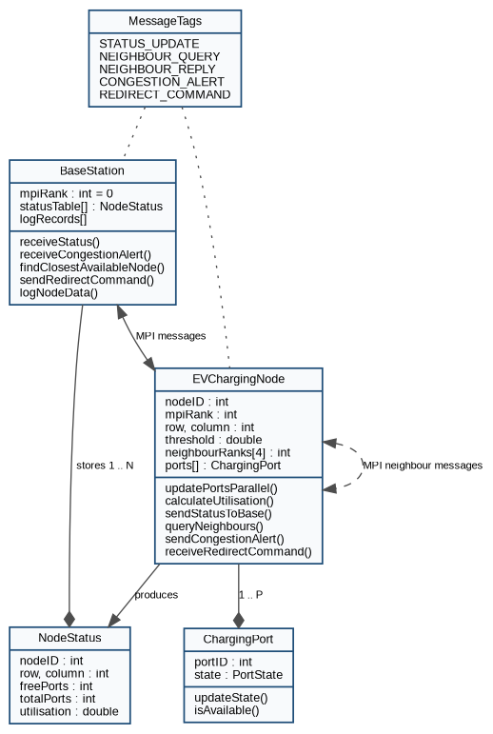
Figure 3. UML-style static structure of the simulation model.
Component | Responsibility
BaseStation | Rank 0; maintains NodeStatus table, logs updates, handles congestion alerts, finds closest available node, sends redirection commands.
EVChargingNode | One object/process per station; owns coordinates, threshold, neighbour ranks and local ports; performs status, neighbour and alert logic.
ChargingPort | Local shared-memory object representing one free/occupied charging port. Port work is partitioned among OpenMP threads.
NodeStatus | Compact status record sent to and stored by the base station. It contains node ID, grid position, free/total ports and utilisation.
MessageTags | Semantic MPI tags that separate status, neighbour-query, neighbour-reply, congestion-alert and redirect traffic.
Table 4. Simulation components and responsibilities.

2.3 Simulation workflow and message passing
- Each EVCS process runs an event loop.
- An OpenMP parallel-for scans or updates the local port array.
- OpenMP reduction safely combines occupied-port counts without a shared-update race or critical-section serialization [5].
- The node calculates utilisation and sends NodeStatus to the base station.
- If utilisation exceeds the threshold, query every valid mesh neighbour.
- Use MPI_Isend/MPI_Irecv to overlap independent neighbour exchanges instead of serial blocking.
- Post receives, issue queries, then synchronize locally with MPI_Waitall [4].
- Send CONGESTION_ALERT to rank 0 only when all neighbour replies are also above threshold.
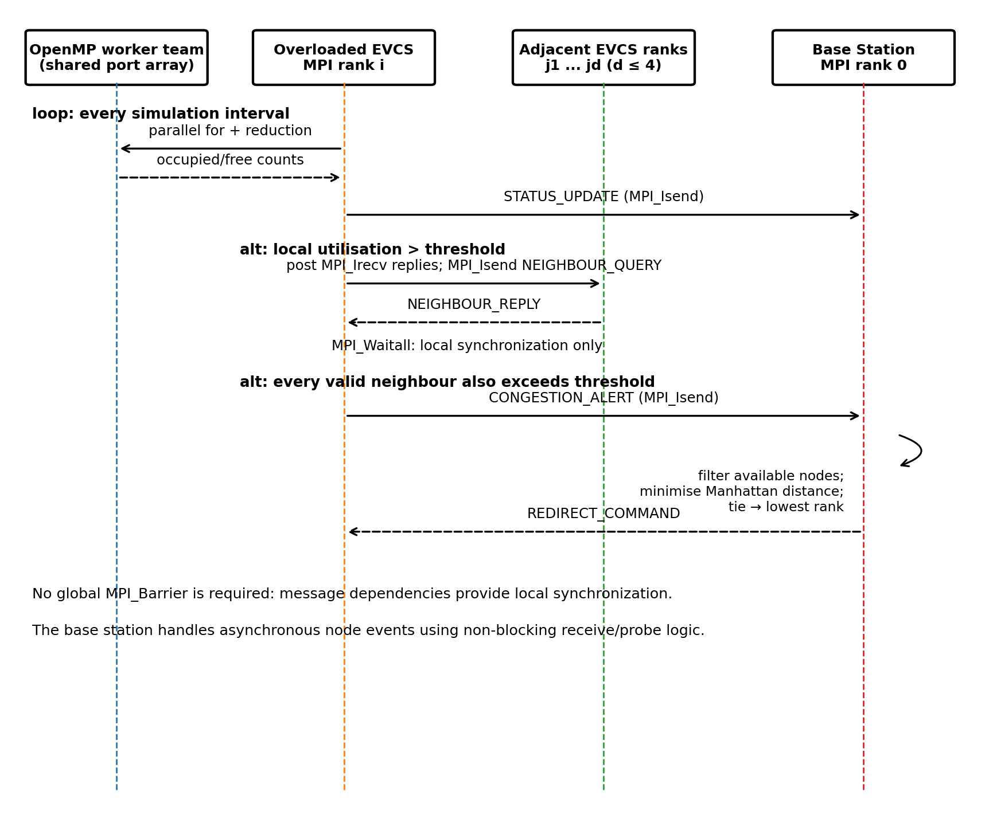
Figure 4. Sequence diagram for one simulation interval and the overload path.
- No global MPI_Barrier is used for each interval.
- A global barrier would force fast ranks to wait for the slowest rank.
- Synchronization is local: a node waits only for neighbour replies required for its decision.
- Message passing therefore provides both data movement and synchronization [3].

2.4 Message protocol and synchronization
Tag | Direction | Payload fields | Bytes* | MPI behaviour
STATUS_UPDATE | EVCS -> base | NodeStatus: nodeID, row, column, freePorts, totalPorts, utilisation | 28 | MPI_Isend; base receives asynchronously
NEIGHBOUR_QUERY | EVCS -> adjacent EVCS | requesterID, simulationRound | 8 | MPI_Isend after posting reply receives
NEIGHBOUR_REPLY | Adjacent EVCS -> requester | nodeID, freePorts, totalPorts, utilisation | 20 | MPI_Isend / requester MPI_Irecv + MPI_Waitall
CONGESTION_ALERT | EVCS -> base | NodeStatus plus simulationRound | 32 | MPI_Isend; event-driven at base station
REDIRECT_COMMAND | Base -> EVCS | targetNodeID, targetRow, targetColumn, simulationRound | 16 | Point-to-point response to alerting node
Table 5. Message-passing protocol used by the architecture.
- Payload sizes assume 4-byte int and 8-byte double fields.
- Sizes exclude MPI/transport headers and implementation-specific padding.
- Use an MPI derived datatype or packed representation to send heterogeneous NodeStatus fields as one logical message.
- Post reply receives before queries; use non-blocking operations and MPI_Waitall.
- This ordering avoids circular blocking send/receive deadlock.
- The base station can use non-blocking receive/probe with MPI_ANY_SOURCE and message tags.
- OpenMP reduction synchronizes only local shared-memory work; no cross-process shared state is used.

2.5 Base-station selection algorithm
- The base station stores the latest status for every EVCS rank.
- On CONGESTION_ALERT from source i, keep only candidates with a free port and utilisation at or below the threshold.
- For Cartesian grid coordinates, compute Manhattan distance from the source to every candidate.
d(i,j) = |r_i - r_j| + |c_i - c_j| | (1)
- Select the candidate with minimum distance d.
- Resolve ties using the lowest MPI rank for deterministic, reproducible results.
- Send REDIRECT_COMMAND with the selected node ID and coordinates.
- Baseline search cost is O(N) per alert.
- For very large N, spatial indexing or regional base stations could reduce search cost.

2.6 Machines, cores and bandwidth
- N = charging nodes; P = ports per node; T = OpenMP threads per EVCS; C = usable physical cores per machine.
- Use T = min(P, T_max), not one thread per port.
- MPI processes required: N + 1.
- Approximate physical-core demand: NT + 1 when rank 0 uses one core.
- Bind cores to prevent OpenMP oversubscription.
MPI processes = N + 1 | (2)
Required cores = N T + 1 | (3)
Machines = ceil((N T + 1) / C) | (4)
- 3 x 3 example: N = 9, T = 4, C = 16.
- Requires 10 MPI ranks, 37 cores, and 3 machines.
- Figure 2 placement: machine 1 hosts rank 0 plus EVCS ranks 1-3 (13 cores); machines 2 and 3 host three EVCS ranks each (12 cores).
- Square-mesh undirected links: E = 2(N - sqrt(N)).
- Directed neighbour relationships: 2E = 4(N - sqrt(N)).
- With f simulation intervals per second, worst-case payload bandwidth sums all five message classes per interval:
BW_payload = f [N L_status + 4(N-sqrt(N))(L_query + L_reply) + N(L_alert + L_redirect)] x 8 | (5)
- At N = 256 and f = 10 Hz: 46,336 bytes/interval, or approximately 3.707 Mbit/s total payload traffic.
- Base-station-bound payload (status + alert + redirect) is approximately 1.556 Mbit/s.
- Both are far below 1 Gbit/s under the payload-only model.
- Headers, queueing, processing, contention, and propagation are excluded here and addressed in Task 3.

3. Task 3 - Communication Analysis
- Task 3 analyses every message type on 1 Gbit/s links as charging-node and base-station counts change.
- Separate per-message transmission time from aggregate serialization/service demand.
- Increasing N does not change one fixed message's bit length, but it increases the number of communicating processes.

3.1 Analytical model and message sizes
- Week 5 store-and-forward model: transmission latency is proportional to message length and hop count.
T_tx = (L x H) / B | (6)
- L = message length (bits), H = hop count, and B = channel bandwidth (bits/s) [3].
- For B = 10^9 bit/s and baseline one-hop traffic, H = 1.
- Neighbour traffic is one mesh hop; node-to-base traffic is treated as one cluster-link transmission.
- Queueing, processing, and propagation delays are excluded to match the Week 5 transmission model.
Message | Payload bytes | Bits | One-hop T_tx (us) | Per-message vs N
STATUS_UPDATE | 28 | 224 | 0.224 | O(1)
NEIGHBOUR_QUERY | 8 | 64 | 0.064 | O(1)
NEIGHBOUR_REPLY | 20 | 160 | 0.160 | O(1)
CONGESTION_ALERT | 32 | 256 | 0.256 | O(1)
REDIRECT_COMMAND | 16 | 128 | 0.128 | O(1)
Table 6. One-hop payload transmission time for every message type on a 1 Gbit/s link.

3.2 Scaling with number of charging nodes
- For fixed-size one-hop messages, L, H, and B do not depend on N.
- Per-message payload transmission time therefore remains O(1).
- Figure 5 intentionally shows flat curves; N increases message count, not individual message length.
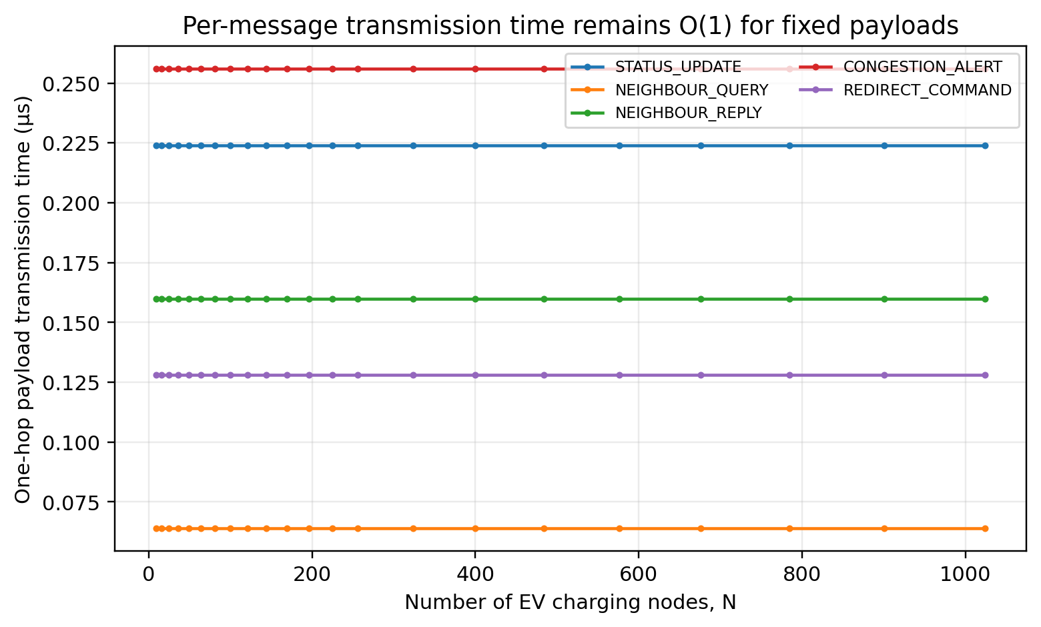
Figure 5. Per-message transmission time versus N. Fixed payload size and H = 1 make each message O(1).
- Square-mesh undirected links: E = 2(N - sqrt(N)).
- Worst-case directed query/reply relationships: 2E = 4(N - sqrt(N)).
- Neighbour query/reply counts therefore grow O(N).
- Periodic status, worst-case alerts, and worst-case redirects also grow O(N).
- Aggregate payload serialization demand:
T_status,total = N L_status / B = O(N) | (7)
T_query,total = 4(N-sqrt(N)) L_query / B = O(N) | (8)
T_reply,total = 4(N-sqrt(N)) L_reply / B = O(N) | (9)
T_alert,total = N L_alert / B = O(N) | (10)
T_redirect,total = N L_redirect / B = O(N) | (11)
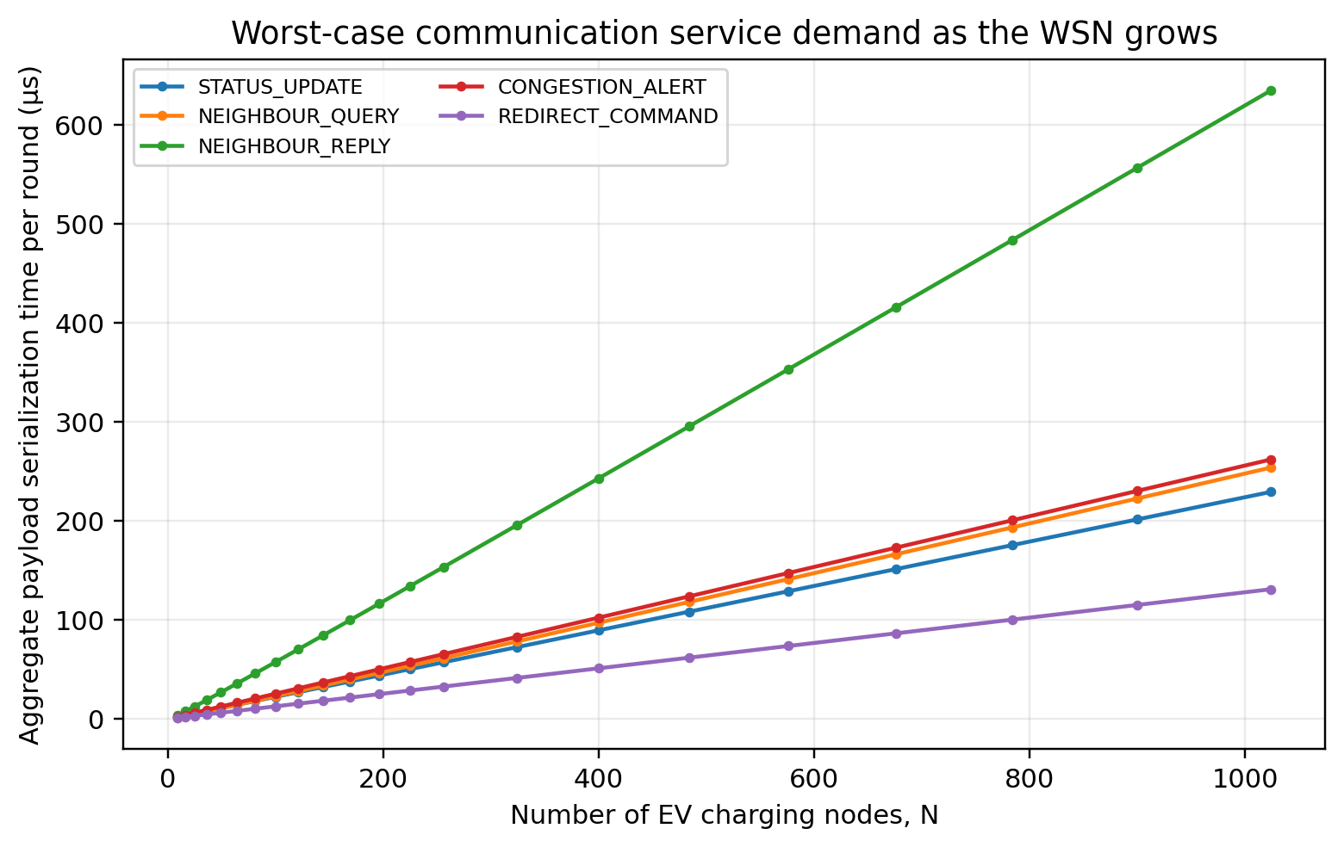
Figure 6. Worst-case aggregate payload serialization time per simulation round as N increases. All message classes grow linearly in the large-N limit.
- More nodes do not make one neighbour message slower in the baseline model.
- More active MPI ranks increase aggregate communication and contention potential.
- A single base station receives O(N) status/alert traffic per interval and is the main fan-in point.
- Mesh neighbour scalability remains strong because d <= 4.
- If base-station traffic were routed through the mesh, worst-case distance would be D = 2(sqrt(N)-1) = O(sqrt(N)).
- Store-and-forward worst-case per-message transmission would then scale O(sqrt(N)).
- The baseline uses direct logical node-to-base communication, as allowed by the assessment.
- Multi-hop routing is therefore a future scalability consideration, not the baseline model.

3.3 Scaling with number of base stations
- Adding base stations does not change L/B for one message on a 1 Gbit/s link.
- It does not affect EVCS-neighbour query/reply traffic.
- Its benefit is load distribution.
- With S balanced base stations, each handles approximately N/S nodes; base-station-bound service demand becomes O(N/S).
T_base,peak approximately (N/S) L / B = O(N/S) | (12)
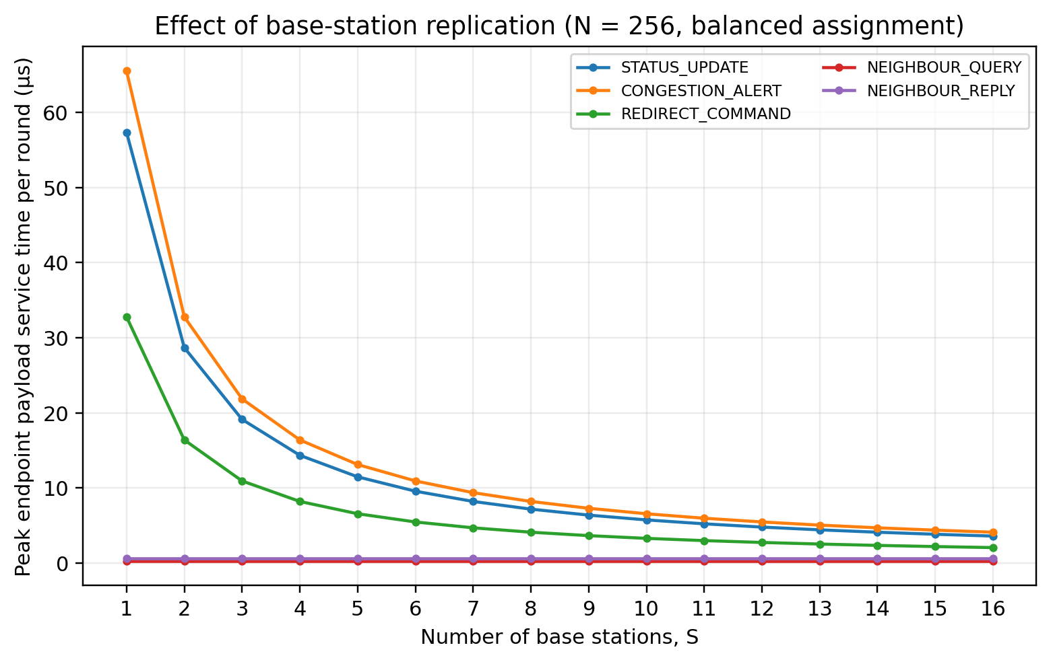
Figure 7. Effect of increasing base stations for N = 256. Base-station-bound endpoint service demand decreases approximately as 1/S; neighbour query/reply demand is unchanged.
- Figure 7 shows peak endpoint serialization demand per interval for balanced assignment.
- STATUS_UPDATE, CONGESTION_ALERT, and REDIRECT_COMMAND decrease as S grows.
- NEIGHBOUR_QUERY and NEIGHBOUR_REPLY remain constant because EVCS degree stays <= 4.
- Real systems may also reduce queueing and processing contention, but those effects are outside the transmission equation.
- Base-station synchronization or partitioning adds coordination overhead and can reduce ideal 1/S scaling.

3.4 Additional sensitivity analysis
- HD analysis includes a third scaling factor beyond N and S [2].
- Reporting/simulation frequency f is a direct communication driver.
- With fixed payload per interval, traffic scales linearly as O(f).
BW_payload(f) = f x Bytes_per_round x 8 = O(f) | (13)
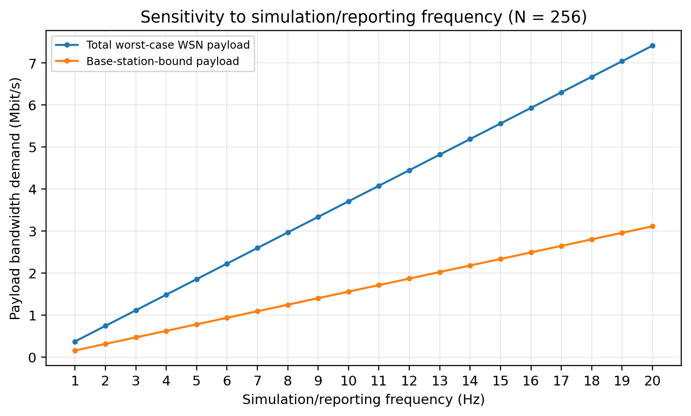
Figure 8. Payload-bandwidth sensitivity to simulation/reporting frequency for N = 256 under the worst-case message mix.
- At N = 256, worst-case payload is 46,336 bytes per interval.
- Traffic is approximately 0.371 Mbit/s at 1 Hz, 3.707 Mbit/s at 10 Hz, and 7.414 Mbit/s at 20 Hz.
- Even 20 Hz remains below 1% of a 1 Gbit/s link in the payload-only model.
- Observed latency may be higher because of headers, MPI protocol behaviour, wireless interference, and simultaneous-flow queueing.

3.5 Communication-analysis conclusions
Quantity | Complexity | Reason
Per-message neighbour traffic | O(1) | One hop, fixed payload; bounded node degree.
Per-message node/base traffic | O(1) | Direct logical MPI channel in baseline architecture.
Aggregate status traffic | O(N) | Every EVCS reports once per interval.
Aggregate worst-case neighbour traffic | O(N) | 4(N-sqrt(N)) directed neighbour relationships.
Aggregate worst-case alerts/redirects | O(N) | At most one alert/redirect pair per active node per interval in the model.
Peak base-station load with S servers | O(N/S) | Assumes even partitioning and independent ingress capacity.
Reporting-frequency sensitivity | O(f) | Payload volume per interval is constant; intervals per second increase.
Table 7. Communication-complexity conclusions for the proposed architecture.

Conclusion, Limitations and Future Work
- 2-D mesh best matches immediate geographic adjacency, bounded degree, and O(N) link cost.
- Hybrid MIMD maps WSN components to MPI ranks and port-level work to OpenMP threads.
- Non-blocking neighbour communication overlaps independent exchanges.
- Local synchronization avoids unnecessary global barriers.
- Fixed-size one-hop messages have O(1) transmission time; aggregate traffic grows O(N).
- A single base station is the main fan-in bottleneck.
- With S balanced base stations, peak server demand approaches O(N/S), while single-message serialization is unchanged.
- At N = 256 and 20 Hz, the modelled worst-case payload remains below 1% of 1 Gbit/s.
- Baseline abstractions exclude radio interference, packet loss, failure routing, propagation, MPI headers, queueing, OS scheduling, and detailed road travel distance.
- The base station is modelled as a direct MPI endpoint rather than a multi-hop wireless destination.
- These assumptions keep Task 3 aligned with the specified 1 Gbit/s transmission model.
- Future work: regional base stations, server-status replication, failure-aware routing, measured MPI latency/throughput, GPS/road distance, and dynamic vehicle arrivals.

References
- [1] Monash University, FIT3143 Applied #1 Assessment (Week 6): Distributed Wireless Sensor Network, 2026.
- [2] Monash University, FIT3143 Applied #1 Marking Rubric (Week 6), 2026.
- [3] FIT3143 Parallel Computing, Topic 5: Multiple Instruction Multiple Data and Distributed Memory Architectures, Monash University, 2024. Relevant material: distributed/shared/hybrid MIMD, interconnection-network parameters, topology table, switching, and latency.
- [4] FIT3143 Week 5 Applied Preparation / MPI material, Monash University, 2024. Relevant material: MPI_Send/MPI_Recv, MPI_Isend/MPI_Irecv, MPI_Wait/MPI_Test, and non-blocking message passing.
- [5] FIT3143 Week 3 Lab Preparation, Monash University, 2024. Relevant material: OpenMP shared-memory data environment, parallel-for work sharing, critical sections, and reduction.
- [6] FIT3143 Parallel Computing, Topic 1: Introduction to Parallel Computing, Monash University, 2024. Relevant material: parallel versus distributed computing and MIMD context.
- [7] Consolidated MPI examples supplied with the unit/project sources: rank/size, point-to-point communication, custom MPI datatypes, and MPI_Wtime.

AI Declaration
- Generative AI was used during assessment preparation.
- ChatGPT (OpenAI) assisted with report structuring/editing, interpretation of supplied assessment/rubric/unit materials, topology and architecture refinement, diagram/graph generation, and communication-formula/terminology checks.
- The authors remain responsible for validating technical accuracy and explaining the work without external tools during the presentation and Q&A.
- Relevant AI prompt records should be exported and submitted as a separate PDF if required by the assessment declaration process.
- Declared tool: ChatGPT (OpenAI).
- Purpose: preparation, analysis support, editing, diagram/graph generation, and formatting.
- Assessment scope: Tasks 1-3; presentation Q&A excluded.

