FIT3143 PARALLEL COMPUTING
Applied #1 Assessment - Week 6
Distributed Wireless Sensor Network
Electric Vehicle Charging Navigation System Simulation
TEAM MEMBERS
Savin Vindiv De Alwis
Student ID: 35221631 | sdea0018@student.monash.edu
Shamle Thilaksiri
Student ID: 35512075 | wthi0003@student.monash.edu

Contents
Executive Summary | 3
1. Task 1 - Network Topology | 4
1.1 Requirements and assumptions | 4
1.2 Topology comparison criteria | 4
1.3 Comparison of Week 5 topologies | 4
1.4 Selected topology: 2-D mesh | 5
2. Task 2 - Architecture Design | 6
2.1 Hybrid MIMD simulation architecture | 6
2.2 Static software structure | 7
2.3 Simulation workflow and message passing | 8
2.4 Message protocol and synchronization | 10
2.5 Base-station selection algorithm | 11
2.6 Machines, cores and bandwidth | 11
3. Task 3 - Communication Analysis | 12
3.1 Analytical model and message sizes | 12
3.2 Scaling with number of charging nodes | 12
3.3 Scaling with number of base stations | 13
3.4 Additional sensitivity analysis | 14
3.5 Communication-analysis conclusions | 15
Conclusion, Limitations and Future Work | 16
References | 17
AI Declaration | 18

Executive Summary
The proposed solution simulates the EVCNS wireless sensor network using a two-dimensional mesh topology that reflects the geographic adjacency of EV charging stations. MPI processes provide distributed-memory parallelism, with rank 0 representing the base station and ranks 1 to N representing charging nodes, while OpenMP threads within each charging-node process provide shared-memory parallelism across charging ports. This creates a hybrid MIMD architecture suited to deployment on a cluster of multi-core machines. Each charging node has up to four orthogonal neighbours and stores the state of its charging ports. Port utilisation is aggregated using an OpenMP parallel-for reduction. When a node exceeds the utilisation threshold, it queries its neighbours using non-blocking MPI, and it sends a congestion alert to the base station only if all valid neighbours are also above the threshold. Communication is analysed using the transmission model \(T=(L\times H)/B\) over 1 Gbit/s links. For fixed-size one-hop messages, individual transmission time remains \(O(1)\) as the number of charging nodes increases, while aggregate communication demand grows approximately as \(O(N)\). With \(S\) balanced base stations, the service demand handled by each base station approaches \(O(N/S)\), although the serialization time of an individual message remains unchanged. The analysis also considers reporting frequency, while queueing, wireless-channel effects, and synchronization between multiple base stations are treated as outside the baseline communication model.

1. Task 1 - Network Topology
- Charging nodes are distributed across a 2-D geographic area and communicate with immediate adjacent nodes.
- Week 5 comparison metrics: node degree, diameter, bisection width, arc connectivity, and link cost.
- Latency and bandwidth are key MIMD fabric-performance considerations [3].
- The selected topology must balance communication performance with WSN realism.

1.1 Requirements and assumptions
ID | Assumption used by the simulator
A1 | For analytical graphs, N is taken as a perfect square and the EVCS network is a sqrt(N) x sqrt(N) Cartesian grid.
A2 | Charging-node adjacency is orthogonal only (north, south, east and west). Diagonal stations are not direct neighbours.
A3 | Corner nodes have degree 2, edge nodes degree 3 and interior nodes degree 4; therefore d <= 4.
A4 | Every charging-node process can communicate with the base-station process over the cluster interconnect; neighbour messages are one logical mesh hop.
A5 | The utilization threshold is a configurable simulation parameter. No numerical threshold is invented because the assessment specification does not provide one.
Table 1. Simulation assumptions used to resolve details not fixed by the assessment specification.

1.2 Topology comparison criteria
- Node degree: number of I/O links connected to a node; indicates local communication fan-out.
- Network diameter: maximum hop count between any pair of nodes; bounds worst-case path length.
- Bisection width: minimum links cut to split the network approximately in half; relates to aggregate bandwidth.
- Arc connectivity: links whose removal can disconnect the network; supports fault-tolerance analysis.
- Cost: total number of communication links [3].
- Application-specific priorities: geographic realism and immediate-neighbour communication.

1.3 Comparison of Week 5 topologies
Topology | Node degree | Diameter | Bisection width | Arc connectivity | Cost
Linear array | 1 or 2 | N - 1 | 1 | 1 | N - 1
Ring | 2 | N/2 | 2 | 2 | N
Star | 1 or N - 1 | 2 | 1 | 1 | N - 1
Binary tree | 1, 2 or 3 | 2 log2((N+1)/2) | 1 | 1 | N - 1
2-D mesh | 2, 3 or 4 | 2(sqrt(N)-1) | sqrt(N) | 2 | 2(N-sqrt(N))
2-D wraparound / torus | 4 | sqrt(N) | 2sqrt(N) | 4 | 2N
3-D cube | 3, 4, 5 or 6 | 3(cuberoot(N)-1) | N^(2/3) | 3 | 3(N-N^(2/3))
Hypercube | log2(N) | log2(N) | N/2 | log2(N) | N log2(N)/2
Completely connected | N - 1 | 1 | N^2/4 | N - 1 | N(N-1)/2
Table 2. Static interconnection-network parameters taught in Week 5.
- Source: FIT3143 Topic 5, "Summary of Static Network (Fabric) Parameters" [3].
- Week 5 duplicate slides conflict on 2-D mesh arc connectivity and 3-D cube cost; Table 2 uses Topic 5 summary values: mesh arc connectivity = 2 and 3-D cube cost = 3(N-N^(2/3)).
Topology | Geographic realism | Immediate-neighbour fit | Scalability / resilience | Assessment suitability
Linear array | Poor | Limited to two neighbours | O(N) links but O(N) diameter | Low - one-dimensional and long paths
Ring | Poor | Two neighbours | O(N) links; better resilience than a line | Low - wraparound is geographically artificial
Star | Moderate | Traffic is centre-mediated | O(N) links; central bottleneck/failure point | Low-Medium - poor neighbour realism
Binary tree | Poor | Hierarchy, not physical adjacency | O(N) links; O(log N) depth | Low - topology does not match a 2-D road/grid area
2-D mesh | Excellent | Direct orthogonal neighbours | O(N) links; O(sqrt(N)) diameter | Best - direct match to specification
2-D torus | Moderate | Four neighbours | O(N) links; lower diameter than mesh | Medium-High - opposite edges become neighbours
3-D cube | Poor | Includes unnecessary third dimension | O(N) links; good connectivity | Medium - mathematically viable, physically unrealistic
Hypercube | Poor | Logical rather than geographic neighbours | O(N log N) links; O(log N) diameter | Medium - fast but weak WSN realism
Complete | Poor | Every node is a neighbour | O(N^2) links; diameter 1 | Low - excessive links and unrealistic communication
Table 3. Application-specific comparison of all Week 5 topologies.

1.4 Selected topology: 2-D mesh
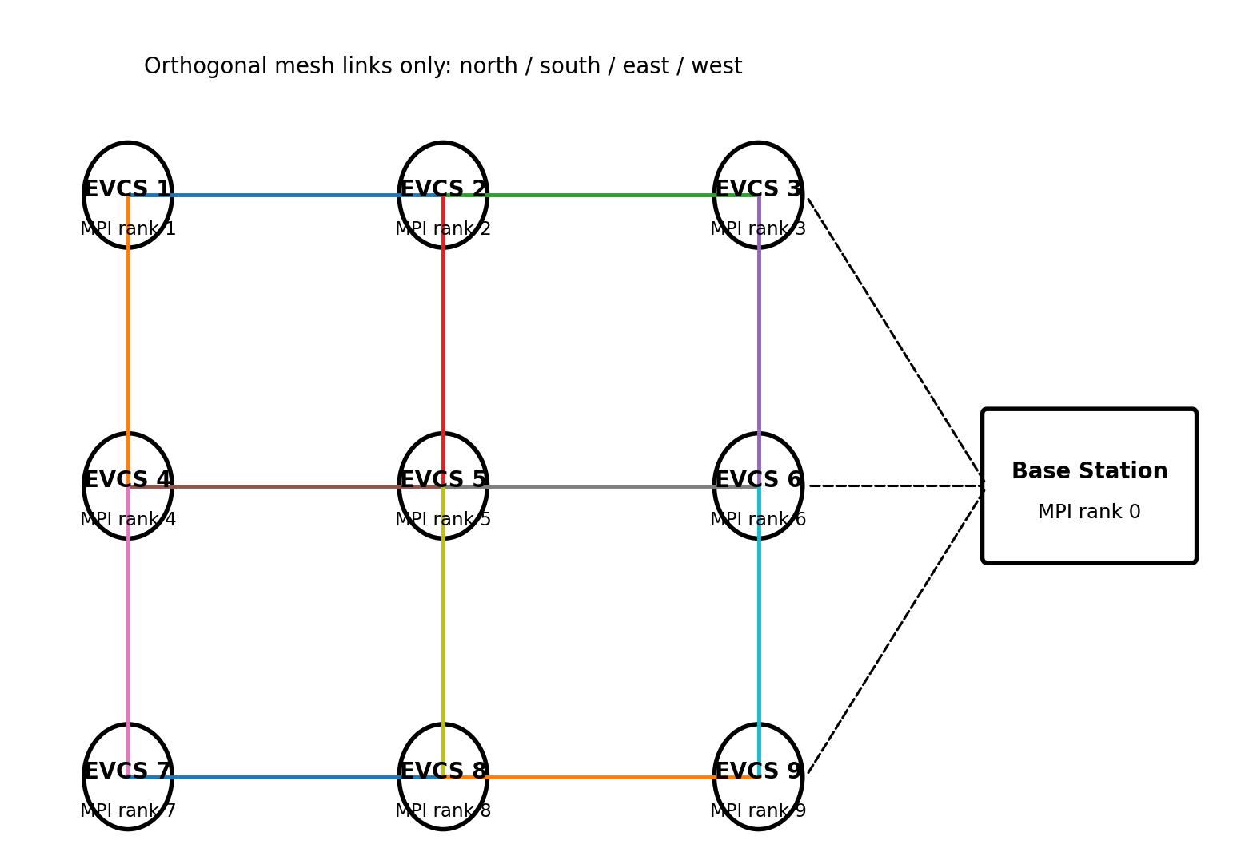
Figure 1. Selected 3 x 3 logical WSN. Solid lines are orthogonal neighbour links; dashed lines illustrate node-to-base-station MPI communication.
- 2-D mesh directly models orthogonal geographic neighbours.
- The specification requires immediate-adjacent node communication [1].
- Neighbour relationships are native to the topology rather than imposed through a hub or arbitrary logical mapping.
- Bounded node degree d <= 4 keeps neighbour fan-out small.
- Mesh link cost is 2(N - sqrt(N)) = O(N), versus O(N^2) for a completely connected network.
- Mesh diameter is 2(sqrt(N)-1) = O(sqrt(N)), which is worse than a hypercube.
- This trade-off is acceptable because the workload is local and geographic realism is the priority.
- Grid coordinates support Manhattan distance d = |r_s-r_j| + |c_s-c_j| for nearest-node redirection.
- Manhattan distance matches the minimum number of orthogonal grid steps.
- Real GPS or road-network distance can replace this metric without changing the MPI architecture.

2. Task 2 - Architecture Design
- Target platform: a cluster of multi-core machines.
- Distributed-memory MIMD uses separate processor/memory pairs connected by an interconnection network.
- Shared-memory MIMD uses multiple processors over a shared address space.
- Hybrid MIMD combines both models [3].
- MPI provides process-level distributed parallelism; OpenMP provides thread-level shared-memory parallelism.

2.1 Hybrid MIMD simulation architecture
- MPI rank 0 models the base station; ranks 1..N each model one EV charging station (EVCS).
- Each EVCS owns its local state and P ChargingPort objects.
- OpenMP threads update ports and aggregate utilisation concurrently.
- Avoiding one MPI process per port reduces unnecessary distributed-memory overhead.
- Parallelism follows the hardware hierarchy: MPI across processes/machines, OpenMP within a process.
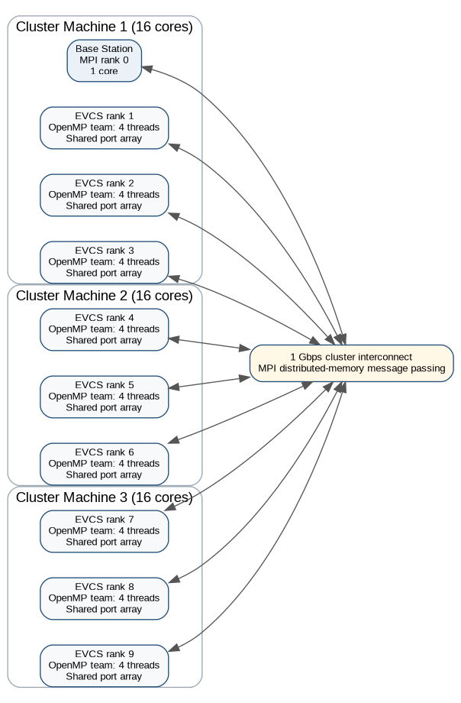
Figure 2. Hybrid deployment example for the 3 x 3 WSN: 10 MPI ranks across three 16-core machines, with four OpenMP threads per EVCS process.
- Figure 2 shows one valid deployment; physical MPI rank placement is not fixed.
- Rank-to-grid coordinates preserve the logical WSN regardless of machine placement.
- Task 3 assumes 1 Gbit/s inter-machine links.
- Even if colocated ranks use faster shared-memory transport, the analysis retains 1 Gbit/s for consistency and conservatism.

2.2 Static software structure
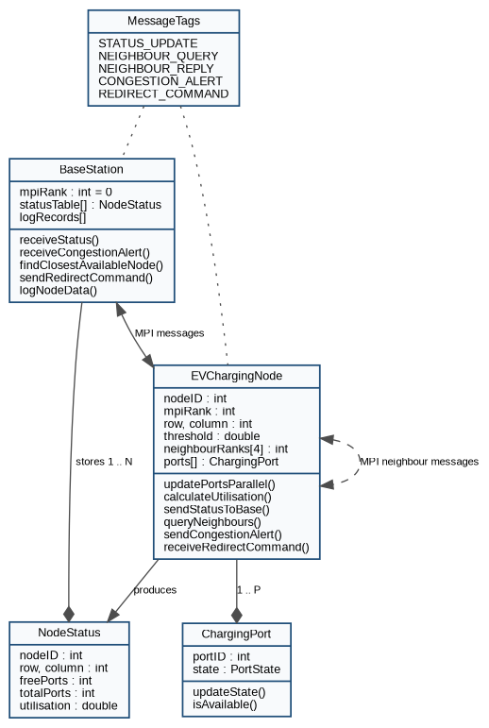
Figure 3. UML-style static structure of the simulation model.
Component | Responsibility
BaseStation | Rank 0; maintains NodeStatus table, logs updates, handles congestion alerts, finds closest available node, sends redirection commands.
EVChargingNode | One object/process per station; owns coordinates, threshold, neighbour ranks and local ports; performs status, neighbour and alert logic.
ChargingPort | Local shared-memory object representing one free/occupied charging port. Port work is partitioned among OpenMP threads.
NodeStatus | Compact status record sent to and stored by the base station. It contains node ID, grid position, free/total ports and utilisation.
MessageTags | Semantic MPI tags that separate status, neighbour-query, neighbour-reply, congestion-alert and redirect traffic.
Table 4. Simulation components and responsibilities.

2.3 Simulation workflow and message passing
- Each EVCS process runs an event loop.
- An OpenMP parallel-for scans or updates the local port array.
- OpenMP reduction safely combines occupied-port counts without a shared-update race or critical-section serialization [5].
- The node calculates utilisation and sends NodeStatus to the base station.
- If utilisation exceeds the threshold, query every valid mesh neighbour.
- Use MPI_Isend/MPI_Irecv to overlap independent neighbour exchanges instead of serial blocking.
- Post expected reply receives, issue neighbour queries, then enter a local MPI progress loop: test outstanding reply receives while probing for and servicing incoming NEIGHBOUR_QUERY messages.
- Complete all non-blocking send requests with MPI_Test/MPI_Wait before their send buffers are reused; send CONGESTION_ALERT only after all required neighbour replies are complete and above threshold.
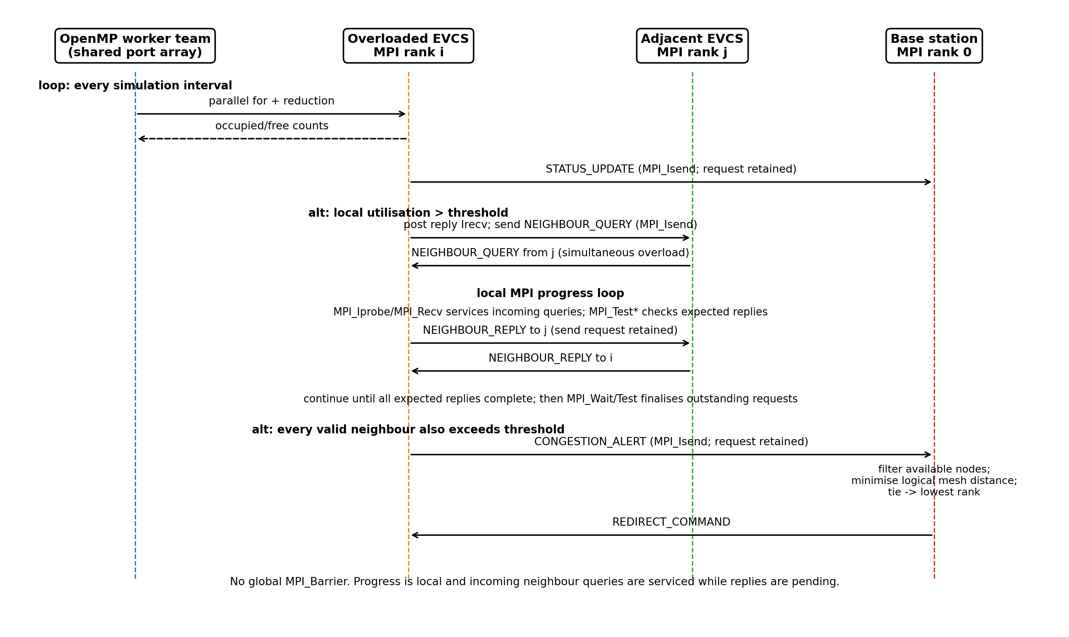
Figure 4. Sequence diagram for one simulation interval, including simultaneous neighbour queries and explicit non-blocking request completion.
- No global MPI_Barrier is used for each interval.
- A global barrier would force fast ranks to wait for the slowest rank.
- Synchronization is local: a node waits only for neighbour data required for its decision while continuing to service incoming neighbour queries.
- This progress rule prevents adjacent overloaded nodes from entering a circular wait and preserves message-passing synchronization without a global barrier [3], [4].

2.4 Message protocol and synchronization
Tag | Direction | Payload fields | Bytes* | MPI behaviour
STATUS_UPDATE | EVCS -> base | NodeStatus: nodeID, row, column, freePorts, totalPorts, utilisation | 28 | MPI_Isend; request retained and completed with MPI_Test/MPI_Wait before buffer reuse
NEIGHBOUR_QUERY | EVCS -> adjacent EVCS | requesterID, simulationRound | 8 | MPI_Isend after posting reply receives; send request retained and completed
NEIGHBOUR_REPLY | Adjacent EVCS -> requester | nodeID, freePorts, totalPorts, utilisation | 20 | Serviced inside progress loop; MPI_Isend reply request retained/completed; requester uses MPI_Irecv + MPI_Test*
CONGESTION_ALERT | EVCS -> base | NodeStatus plus simulationRound | 32 | MPI_Isend; request retained and completed; event-driven at base station
REDIRECT_COMMAND | Base -> EVCS | targetNodeID, targetRow, targetColumn, simulationRound | 16 | Point-to-point response to alerting node; completion handled before response buffer reuse
Table 5. Message-passing protocol used by the architecture.
- Payload sizes assume 4-byte int and 8-byte double fields.
- Sizes exclude MPI/transport headers and implementation-specific padding.
- Use an MPI derived datatype or packed representation to send heterogeneous NodeStatus fields as one logical message.
- For neighbour exchange, do not immediately block in MPI_Waitall. While expected replies are incomplete, use MPI_Iprobe/MPI_Recv to service incoming queries and MPI_Testall/MPI_Testsome to advance outstanding reply receives.
- After the progress condition is satisfied, finalize any remaining non-blocking requests with MPI_Wait/MPI_Waitall. This avoids circular wait when adjacent nodes exceed the threshold simultaneously.
- Every MPI_Isend request is retained until completion is confirmed; its send buffer is not modified or reused earlier [4]. The base station can receive asynchronously with MPI_Iprobe/MPI_ANY_SOURCE and message tags.
- OpenMP reduction synchronizes only local shared-memory work; no cross-process shared state is used.

2.5 Base-station selection algorithm
- The base station stores the latest status for every EVCS rank.
- On CONGESTION_ALERT from source i, keep only candidates with a free port and utilisation at or below the threshold.
- For Cartesian grid coordinates, compute Manhattan distance from the source to every candidate.
d(i,j) = |r_i - r_j| + |c_i - c_j| | (1)
- Select the candidate with minimum distance d.
- Resolve ties using the lowest MPI rank for deterministic, reproducible results.
- Send REDIRECT_COMMAND with the selected node ID and coordinates.
- Baseline search cost is O(N) per alert.
- For very large N, spatial indexing or regional base stations could reduce search cost.

2.6 Machines, cores and bandwidth
- N = charging nodes; P = ports per node; T = OpenMP threads per EVCS; C = usable physical cores per machine.
- Use T = min(P, T_max), not one thread per port.
- MPI processes required: N + 1.
- Approximate physical-core demand: NT + 1 when rank 0 uses one core.
- Bind cores to prevent OpenMP oversubscription.
MPI processes = N + 1 | (2)
Required cores = N T + 1 | (3)
Machines = ceil((N T + 1) / C) | (4)
- 3 x 3 example: N = 9, T = 4, C = 16.
- Requires 10 MPI ranks, 37 cores, and 3 machines.
- Figure 2 placement: machine 1 hosts rank 0 plus EVCS ranks 1-3 (13 cores); machines 2 and 3 host three EVCS ranks each (12 cores).
- Square-mesh undirected links: E = 2(N - sqrt(N)).
- Directed neighbour relationships: 2E = 4(N - sqrt(N)).
- For bandwidth sizing, use a conservative upper bound that independently maximizes each message class per interval; the alert and redirect maxima are not assumed to be a single physically simultaneous network state:
BW_payload = f [N L_status + 4(N-sqrt(N))(L_query + L_reply) + N(L_alert + L_redirect)] x 8 | (5)
- At N = 256 and f = 10 Hz, this conservative payload upper bound is 46,336 bytes/interval, or approximately 3.707 Mbit/s total payload traffic.
- Base-station-bound payload (status + alert + redirect) is approximately 1.556 Mbit/s.
- Both upper bounds are far below 1 Gbit/s under the payload-only model.
- Headers, queueing, processing, contention, and propagation are excluded here and addressed in Task 3.

3. Task 3 - Communication Analysis
- Task 3 analyses every message type on 1 Gbit/s links as charging-node and base-station counts change.
- Separate per-message transmission time from aggregate serialization/service demand.
- Increasing N does not change one fixed message's bit length, but it increases the number of communicating processes.

3.1 Analytical model and message sizes
- Week 5 store-and-forward model: transmission latency is proportional to message length and hop count.
T_tx = (L x H) / B | (6)
- L = message length (bits), H = hop count, and B = channel bandwidth (bits/s) [3].
- For B = 10^9 bit/s and baseline one-hop traffic, H = 1.
- Neighbour traffic is one mesh hop; node-to-base traffic is treated as one cluster-link transmission.
- Queueing, processing, and propagation delays are excluded to match the Week 5 transmission model.
Message | Payload bytes | Bits | One-hop T_tx (us) | Per-message vs N
STATUS_UPDATE | 28 | 224 | 0.224 | O(1)
NEIGHBOUR_QUERY | 8 | 64 | 0.064 | O(1)
NEIGHBOUR_REPLY | 20 | 160 | 0.160 | O(1)
CONGESTION_ALERT | 32 | 256 | 0.256 | O(1)
REDIRECT_COMMAND | 16 | 128 | 0.128 | O(1)
Table 6. One-hop payload transmission time for every message type on a 1 Gbit/s link.

3.2 Scaling with number of charging nodes
- For fixed-size one-hop messages, L, H, and B do not depend on N.
- Per-message payload transmission time therefore remains O(1).
- Figure 5 intentionally shows flat curves; N increases message count, not individual message length.
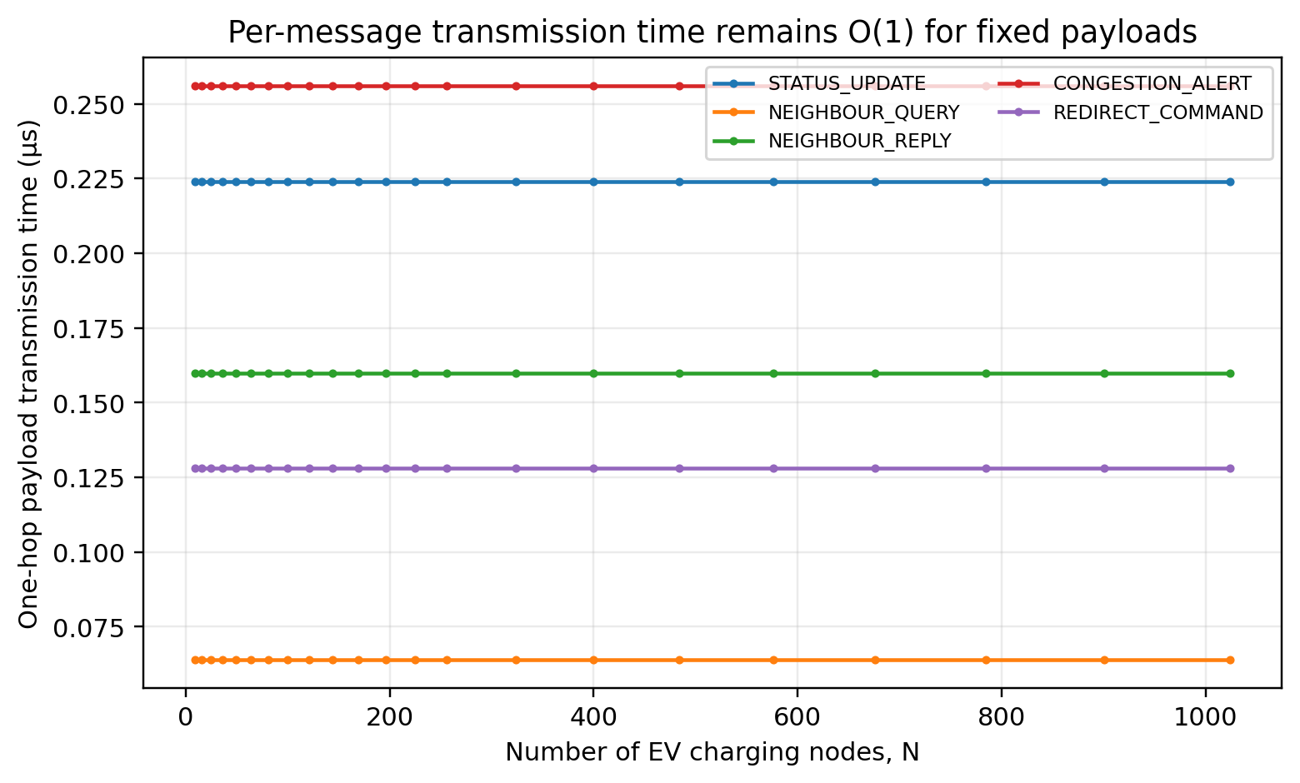
Figure 5. Per-message transmission time versus N. Fixed payload size and H = 1 make each message O(1).
- Square-mesh undirected links: E = 2(N - sqrt(N)).
- Worst-case directed query/reply relationships: 2E = 4(N - sqrt(N)).
- Neighbour query/reply counts therefore grow O(N).
- Periodic status traffic is O(N). Alert and redirect terms are treated as independent O(N) upper bounds for capacity analysis, rather than as one simultaneously reachable traffic state.
- Aggregate payload serialization/service-demand upper bounds:
T_status,total = N L_status / B = O(N) | (7)
T_query,total = 4(N-sqrt(N)) L_query / B = O(N) | (8)
T_reply,total = 4(N-sqrt(N)) L_reply / B = O(N) | (9)
T_alert,total = N L_alert / B = O(N) | (10)
T_redirect,total = N L_redirect / B = O(N) | (11)
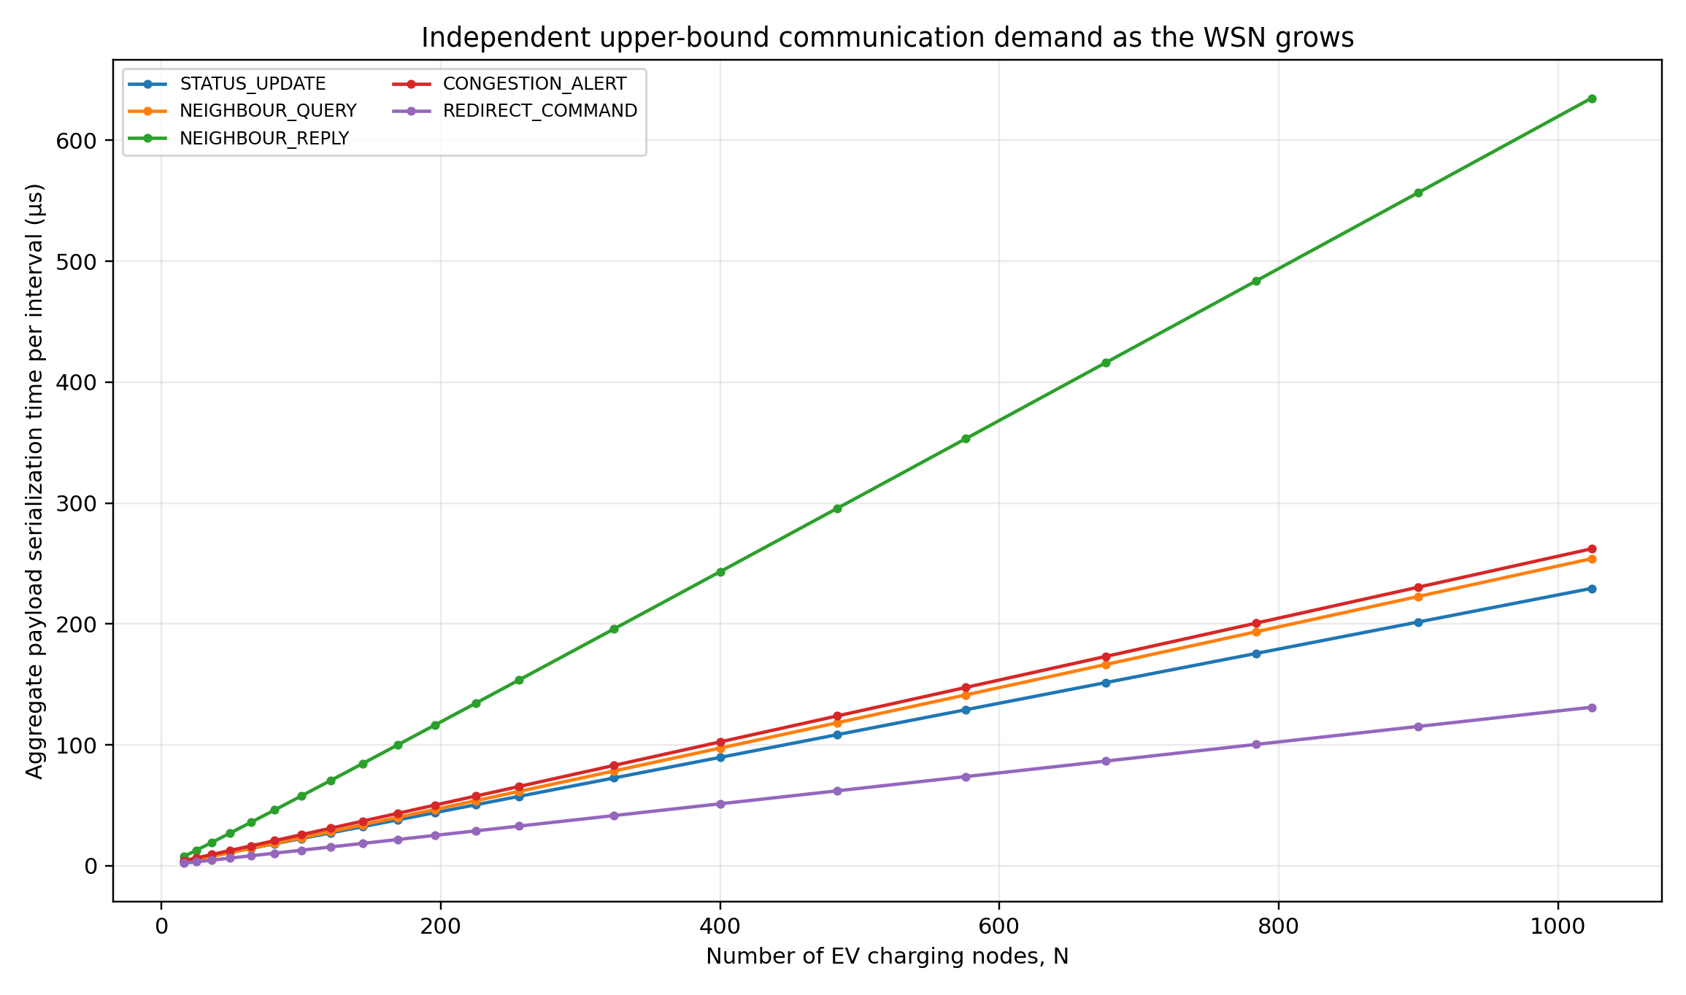
Figure 6. Independent upper bounds on aggregate payload serialization time per simulation interval as N increases. Every message class is O(N) in the large-N limit.
- More nodes do not make one neighbour message slower in the baseline model.
- More active MPI ranks increase aggregate communication and contention potential.
- A single base station receives O(N) status/alert traffic per interval and is the main fan-in point.
- Mesh neighbour scalability remains strong because d <= 4.
- If base-station traffic were routed through the mesh, worst-case distance would be D = 2(sqrt(N)-1) = O(sqrt(N)).
- Store-and-forward worst-case per-message transmission would then scale O(sqrt(N)).
- The baseline uses direct logical node-to-base communication, as allowed by the assessment.
- Multi-hop routing is therefore a future scalability consideration, not the baseline model.

3.3 Scaling with number of base stations
- With fixed payload size, H = 1 and B = 1 Gbit/s, increasing the number of base stations does not change the transmission delay L/B of any individual message type.
- Therefore STATUS_UPDATE, NEIGHBOUR_QUERY, NEIGHBOUR_REPLY, CONGESTION_ALERT and REDIRECT_COMMAND all remain flat as S increases in the baseline transmission model.
- Base-station replication can still reduce aggregate endpoint serialization/service demand for base-station-bound traffic; this is a load-distribution effect, not a reduction in per-message transmission delay.
- With S balanced base stations, aggregate base-station-bound service demand is approximately O(N/S), assuming independent ingress capacity and even assignment.
D_base,service approximately (N/S) L / B = O(N/S) | (12)
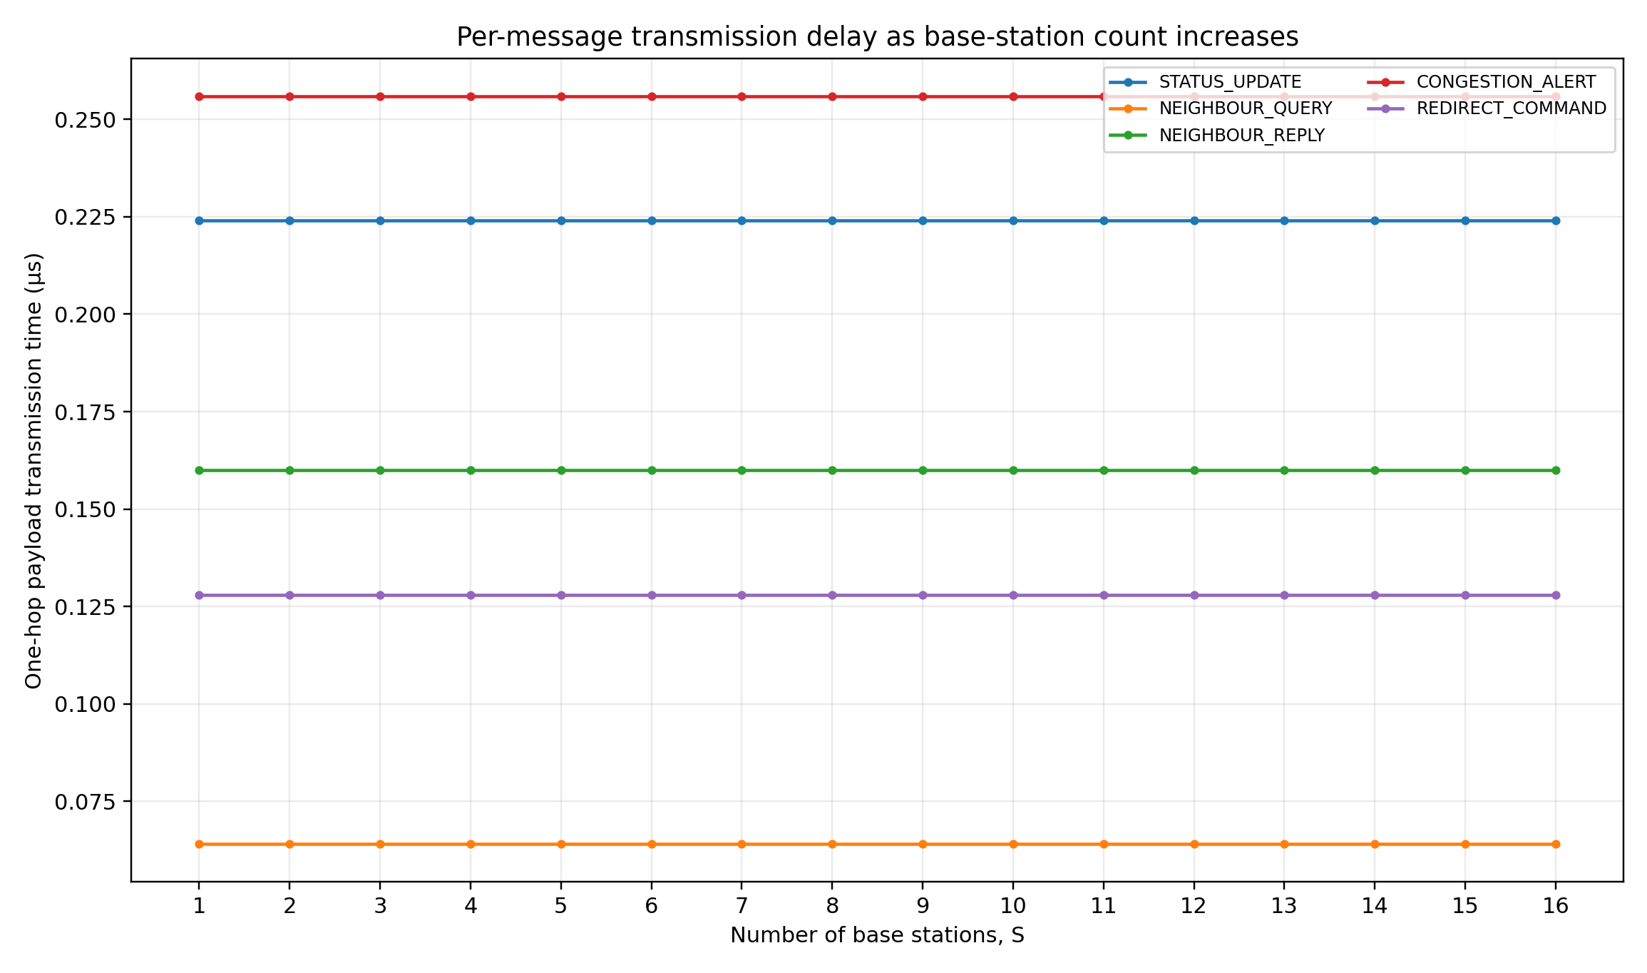
Figure 7. Per-message transmission delay versus number of base stations for N = 256. All five curves remain constant because L, H and B are unchanged.
- Figure 7 directly answers the transmission-delay scaling requirement: adding base stations does not reduce the one-hop serialization time of a fixed-size message.
- STATUS_UPDATE, CONGESTION_ALERT and REDIRECT_COMMAND gain only from distributing aggregate endpoint load across servers; their individual transmission times remain unchanged.
- NEIGHBOUR_QUERY and NEIGHBOUR_REPLY are also unchanged because their payload sizes, hop count and 1 Gbit/s link bandwidth are independent of S.
- Real systems may show lower queueing or processing delay with more base stations, but those effects are outside T_tx = LH/B and are not counted as transmission delay here.
- Base-station synchronization or state partitioning adds coordination overhead and can reduce ideal O(N/S) service-demand scaling.

3.4 Additional sensitivity analysis
- HD analysis includes a third scaling factor beyond N and S [2].
- Reporting/simulation frequency f is a direct communication driver.
- With fixed payload per interval, traffic scales linearly as O(f).
BW_payload(f) = f x Bytes_per_round x 8 = O(f) | (13)
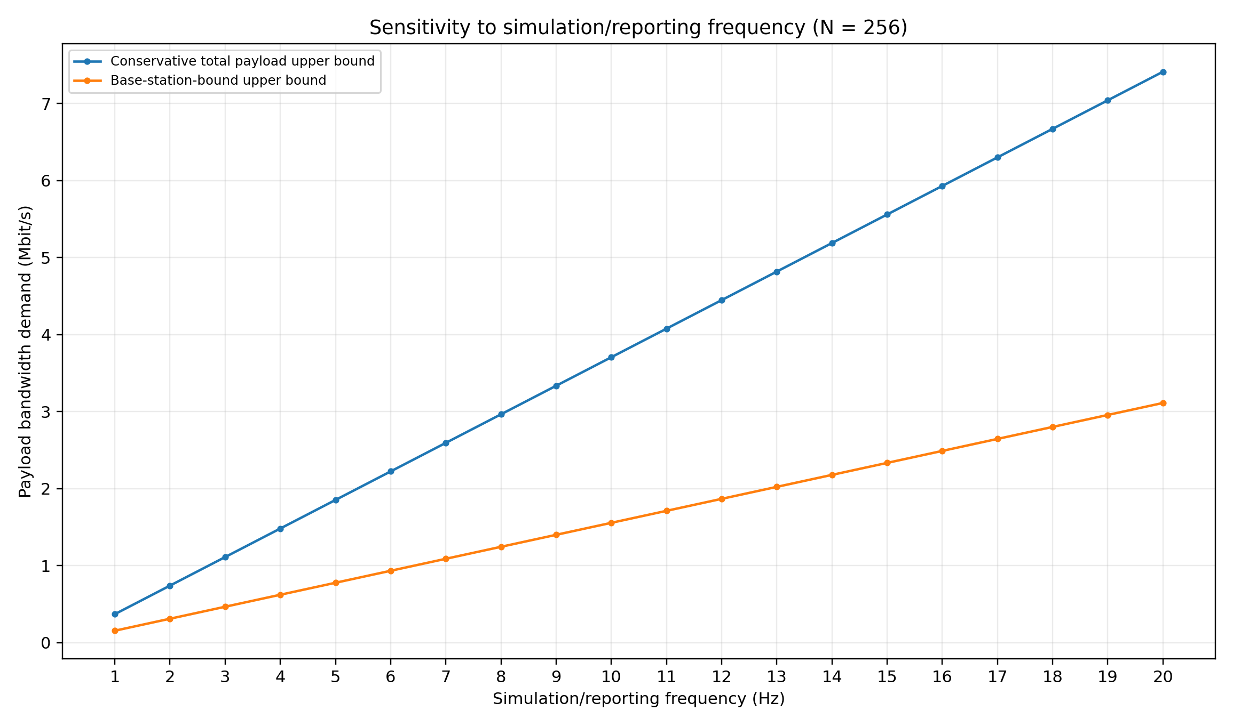
Figure 8. Payload-bandwidth sensitivity to simulation/reporting frequency for N = 256 using the conservative independent message-class upper bound.
- At N = 256, the conservative payload upper bound is 46,336 bytes per interval.
- Traffic is approximately 0.371 Mbit/s at 1 Hz, 3.707 Mbit/s at 10 Hz, and 7.414 Mbit/s at 20 Hz.
- Even the conservative 20 Hz upper bound remains below 1% of a 1 Gbit/s link in the payload-only model.
- Observed latency may be higher because of headers, MPI protocol behaviour, wireless interference, and simultaneous-flow queueing.

3.5 Communication-analysis conclusions
Quantity | Complexity | Reason
Per-message neighbour traffic | O(1) | One hop, fixed payload; bounded node degree.
Per-message node/base traffic | O(1) | Direct logical MPI channel in baseline architecture.
Aggregate status traffic | O(N) | Every EVCS reports once per interval.
Aggregate worst-case neighbour traffic | O(N) | 4(N-sqrt(N)) directed neighbour relationships.
Aggregate alert/redirect upper bounds | O(N) | Each class is independently bounded by at most O(N) messages per interval; maxima are used for capacity sizing, not assumed simultaneous.
Peak base-station load with S servers | O(N/S) | Assumes even partitioning and independent ingress capacity.
Reporting-frequency sensitivity | O(f) | Payload volume per interval is constant; intervals per second increase.
Table 7. Communication-complexity conclusions for the proposed architecture.

Conclusion, Limitations and Future Work
- 2-D mesh best matches immediate geographic adjacency, bounded degree, and O(N) link cost.
- Hybrid MIMD maps WSN components to MPI ranks and port-level work to OpenMP threads.
- Non-blocking neighbour communication overlaps independent exchanges.
- Local synchronization avoids unnecessary global barriers.
- Fixed-size one-hop messages have O(1) transmission time; aggregate traffic grows O(N).
- A single base station is the main fan-in bottleneck.
- With S balanced base stations, aggregate base-station endpoint service demand approaches O(N/S), while every fixed-size one-hop message retains the same transmission delay.
- At N = 256 and 20 Hz, the conservative payload upper bound remains below 1% of 1 Gbit/s.
- Baseline abstractions exclude radio interference, packet loss, failure routing, propagation, MPI headers, queueing, OS scheduling, and detailed road travel distance.
- The base station is modelled as a direct MPI endpoint rather than a multi-hop wireless destination.
- These assumptions keep Task 3 aligned with the specified 1 Gbit/s transmission model.
- Future work: regional base stations, server-status replication, failure-aware routing, measured MPI latency/throughput, GPS/road distance, and dynamic vehicle arrivals.

References
- [1] Monash University, FIT3143 Applied #1 Assessment (Week 6): Distributed Wireless Sensor Network, 2026.
- [2] Monash University, FIT3143 Applied #1 Marking Rubric (Week 6), 2026.
- [3] FIT3143 Parallel Computing, Topic 5: Multiple Instruction Multiple Data and Distributed Memory Architectures, Monash University, 2024. Relevant material: distributed/shared/hybrid MIMD, interconnection-network parameters, topology table, switching, and latency.
- [4] FIT3143 Week 5 Applied Preparation / MPI material, Monash University, 2024. Relevant material: MPI_Send/MPI_Recv, MPI_Isend/MPI_Irecv, MPI_Wait/MPI_Test, and non-blocking message passing.
- [5] FIT3143 Week 3 Lab Preparation, Monash University, 2024. Relevant material: OpenMP shared-memory data environment, parallel-for work sharing, critical sections, and reduction.
- [6] FIT3143 Parallel Computing, Topic 1: Introduction to Parallel Computing, Monash University, 2024. Relevant material: parallel versus distributed computing and MIMD context.
- [7] Consolidated MPI examples supplied with the unit/project sources: rank/size, point-to-point communication, custom MPI datatypes, and MPI_Wtime.

AI Declaration
- Generative AI was used during assessment preparation.
- ChatGPT (OpenAI) assisted with report structuring/editing, interpretation of supplied assessment/rubric/unit materials, topology and architecture refinement, diagram/graph generation, and communication-formula/terminology checks.
- The authors remain responsible for validating technical accuracy and explaining the work without external tools during the presentation and Q&A.
- Relevant AI prompt records should be exported and submitted as a separate PDF if required by the assessment declaration process.
- Declared tool: ChatGPT (OpenAI).
- Purpose: preparation, analysis support, editing, diagram/graph generation, and formatting.
- Assessment scope: Tasks 1-3; presentation Q&A excluded.

