Project 1

Step 1: Create Ec2 instance and name it Jenkins for Identification purpose

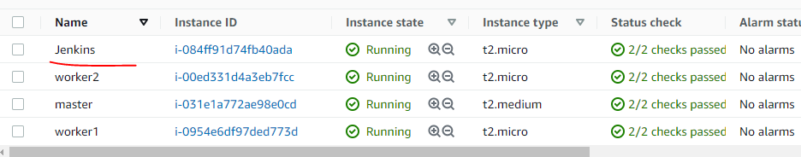

Step 2: connect to ec2 instance using pem key

Step3: Install java

amazon-linux-extras install java-openjdk11 -y

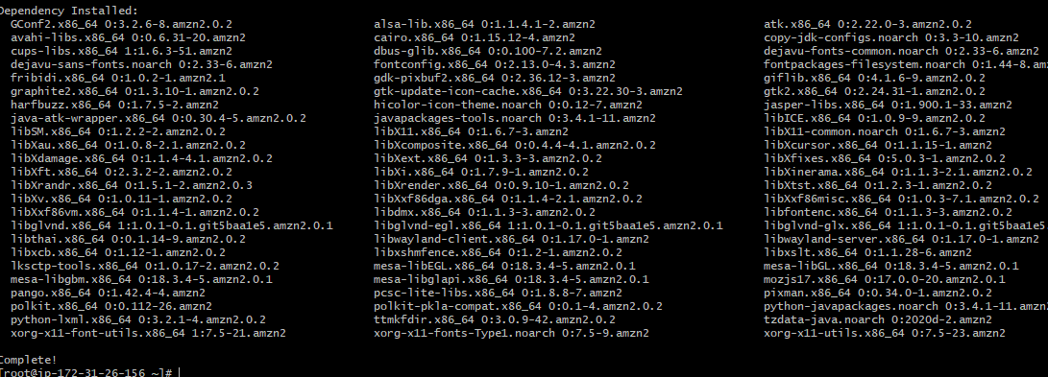

Step 4: Export the Java environment in bash profile as below:

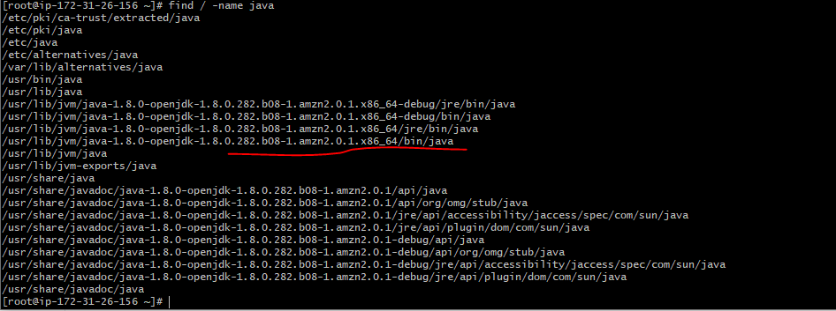

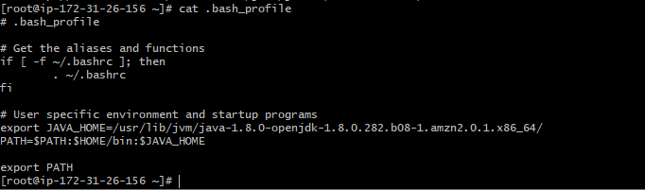

[root@ip-172-31-26-156 ~]# java -version

openjdk version "1.8.0_282"

OpenJDK Runtime Environment (build 1.8.0_282-b08)

OpenJDK 64-Bit Server VM (build 25.282-b08, mixed mode)

[root@ip-172-31-26-156 ~]#

####################################################################################

## **Install Jenkins**

Step 1: Get the latest version of jenkins from <https://pkg.jenkins.io/redhat-stable/> and install

Execute bellow commands:

sudo tee /etc/yum.repos.d/jenkins.repo<<EOF

[jenkins]

name=Jenkins

baseurl=http://pkg.jenkins.io/redhat

gpgcheck=0

EOF

sudo rpm --import https://jenkins-ci.org/redhat/jenkins-ci.org.key

yum install jenkins -y

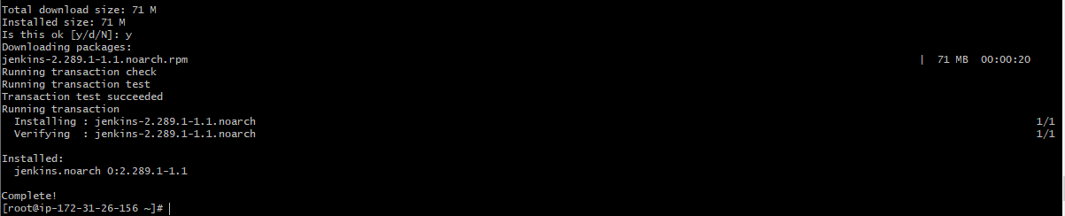

### **Step 2: Start Jenkins**

# Start jenkins service

systemctl start Jenkins

# Setup Jenkins to start at boot,

systemctl enable jenkins

### **Step 3: Accessing Jenkins**

By default jenkins runs at port 8080, You can access jenkins at

http://YOUR-SERVER-PUBLIC-IP:8080

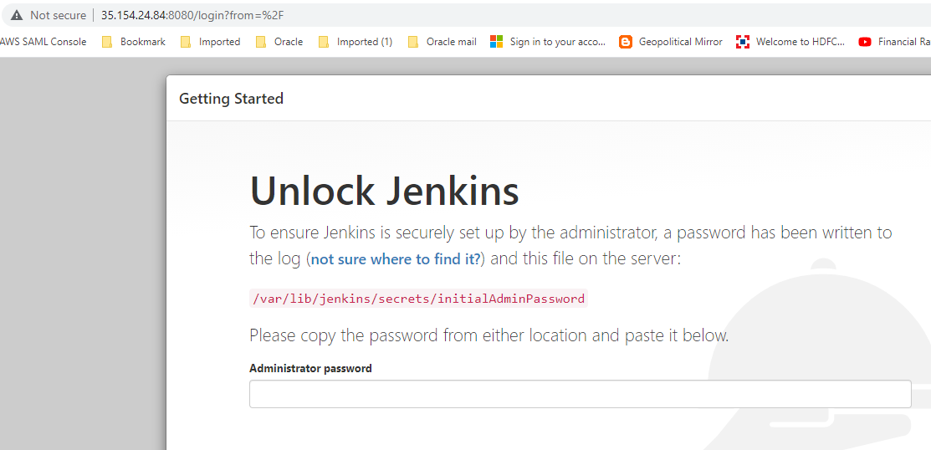

#### **Step 4: Configure Jenkins**

* The default Username is admin
* Grab the default password
* Password Location:/var/lib/jenkins/secrets/initialAdminPassword
* Download suggestd plugin
* Change admin password
  + Admin > Configure > Password
* Configure java path
  + Manage Jenkins > Global Tool Configuration > JDK

Username: admin

Password: admin

### **Step 5: Test Jenkins Jobs**

1. Create “new item”
2. Enter an item name – My-First-Project
   * Chose Freestyle project

3. Description : This is demo project

1. Under the Build section Execute shell: echo "Welcome to Jenkins Demo"

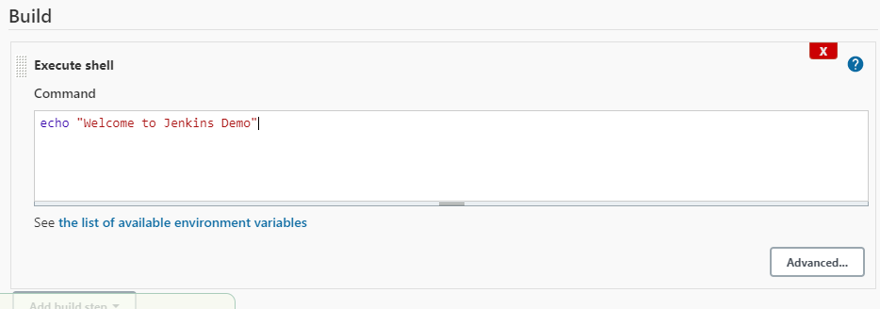

1. Save your job
2. Build job
3. Check "console output"

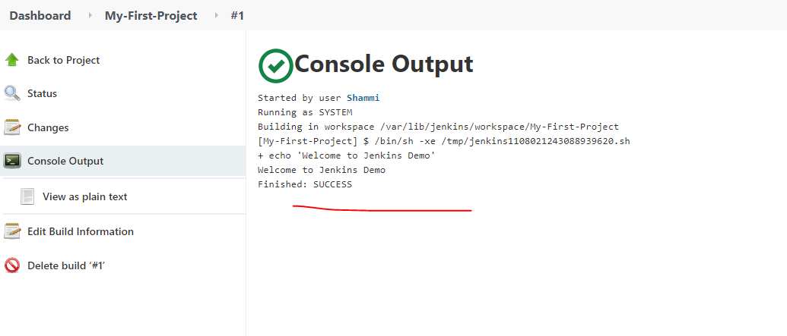

############################################################################################

# **Configure Git pulgin on Jenkins**

# **Git is one of the most popular tools for version control system. you can pull code from git repositories using jenkins if you use the github plugin.**

#### **Prerequisites**

# **Jenkins server**

#### **Install Git on Jenkins server**

# **Install git packages on jenkins server yum install git -y**

#### **Setup Git on jenkins console**

# **Install git plugin without restart**

# **Manage Jenkins > Jenkins Plugins > available > github**

# **Configure git path**

# **Manage Jenkins > Global Tool Configuration > git**

# **Select below 3 and install without restart**

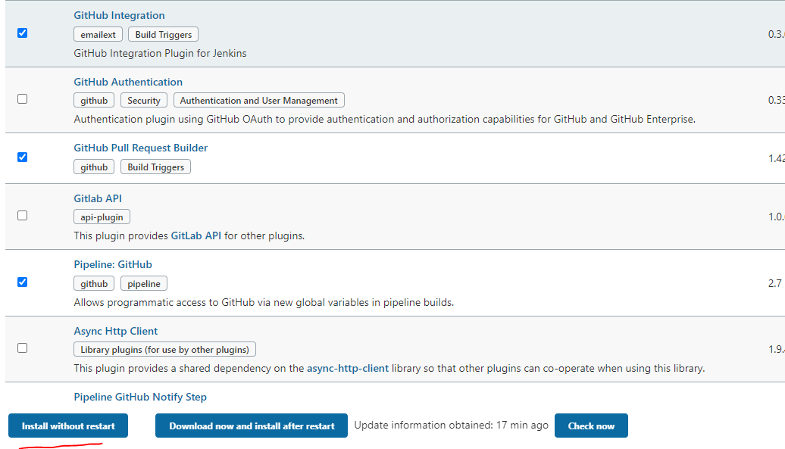

#############################################################################################

**Goto Global Tool Configuration and add JAVA_HOME,GIT and other plugin home accordingly**

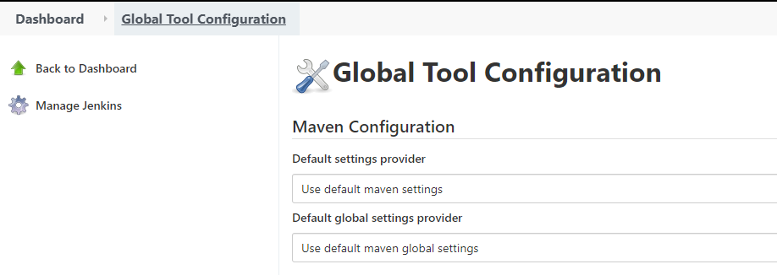

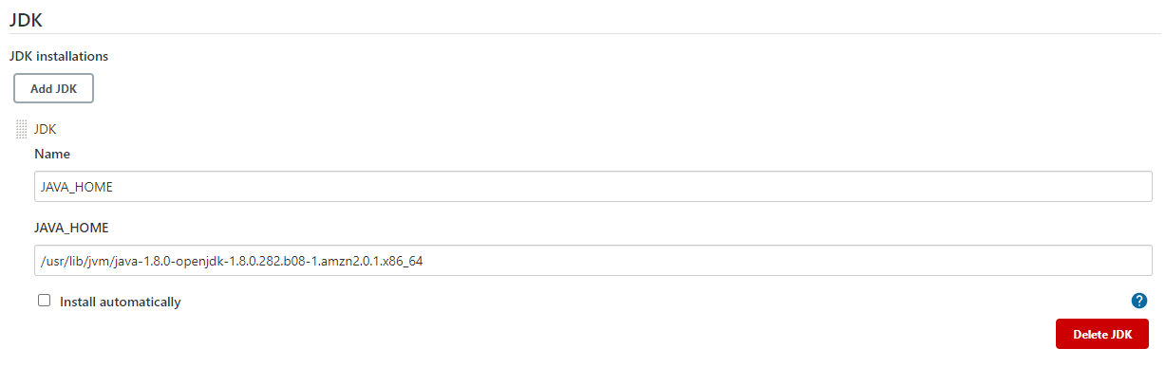

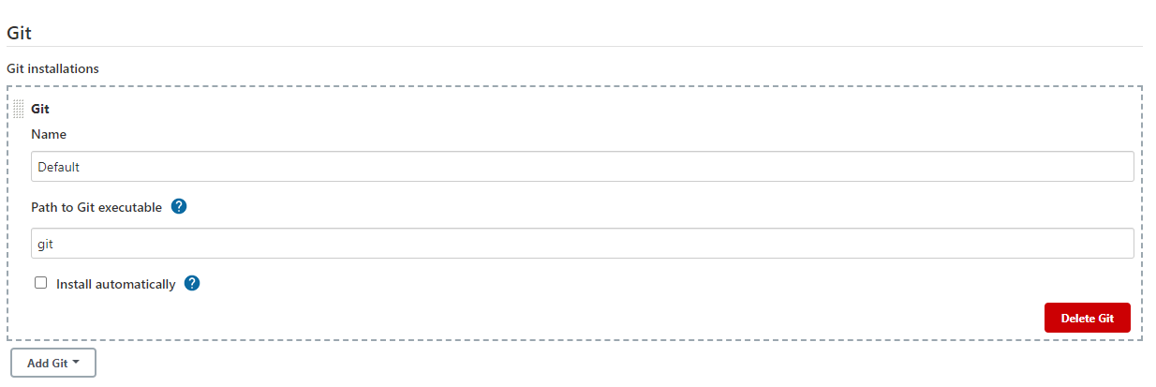

#####################################################################################################################################################

# **Install & configure Maven build tool on Jenkins**

**Step 1:**

mkdir /opt/maven

cd /opt/maven

# downloading Apache Maven 3.8.1

wget <https://dlcdn.apache.org/maven/maven-3/3.8.6/binaries/apache-maven-3.8.6-bin.tar.gz>

tar -xvzf apache-maven-3.8.6-bin.tar.gz

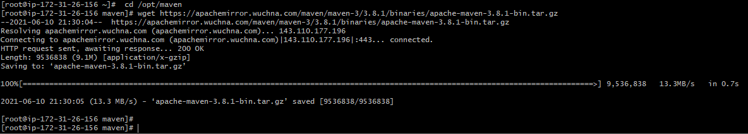

**Step 2:**

Setup M2_HOME and M2 paths in .bash_profile of the user and add these to the path variable

[root@ip-172-31-26-156 ~]# cat .bash_profile

# .bash_profile

# Get the aliases and functions

if [ -f ~/.bashrc ]; then

. ~/.bashrc

fi

PATH=$PATH:$HOME/bin

export PATH

export JAVA_HOME=/usr/lib/jvm/java-11-openjdk-11.0.13.0.8-1.amzn2.0.3.x86_64/

export PATH=$PATH:$HOME/bin:$JAVA_HOME/bin

export M2_HOME=/opt/maven/apache-maven-3.8.6

export M2=$M2_HOME/bin

PATH=$PATH:$HOME/bin:$JAVA_HOME/bin:$M2_HOME:$M2

**Step 3:**

Execute .bash_profile and check maven version

[root@ip-172-31-86-155 ~]# . .bash_profile

[root@ip-172-31-86-155 ~]# mvn -version

**Apache Maven 3.8.6 (84538c9988a25aec085021c365c560670ad80f63)**

Maven home: /opt/maven/apache-maven-3.8.6

Java version: 11.0.13, vendor: Red Hat, Inc., runtime: /usr/lib/jvm/java-11-openjdk-11.0.13.0.8-1.amzn2.0.3.x86_64

Default locale: en_US, platform encoding: UTF-8

OS name: "linux", version: "5.10.118-111.515.amzn2.x86_64", arch: "amd64", family: "unix"

[root@ip-172-31-86-155 ~]#

**Step 4:**

### **Setup maven on Jenkins console**

1. Install maven plugin without restart

* Manage Jenkins > Jenkins Plugins > available > Maven Invoker
* Manage Jenkins > Jenkins Plugins > available > Maven Integration

1. Configure maven path

* Manage Jenkins > Global Tool Configuration > Maven

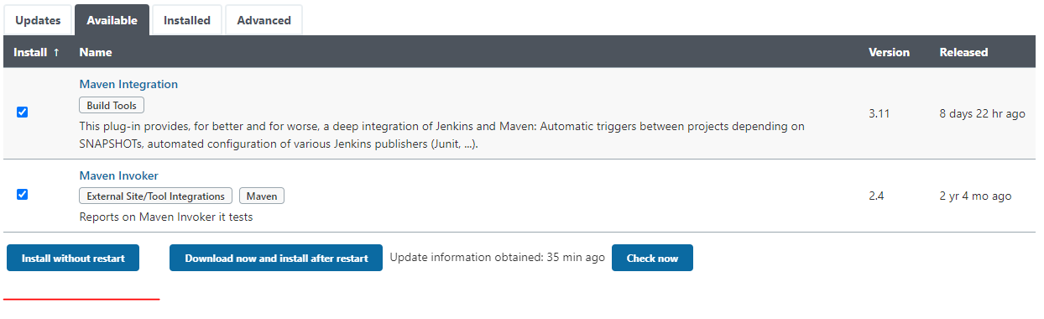

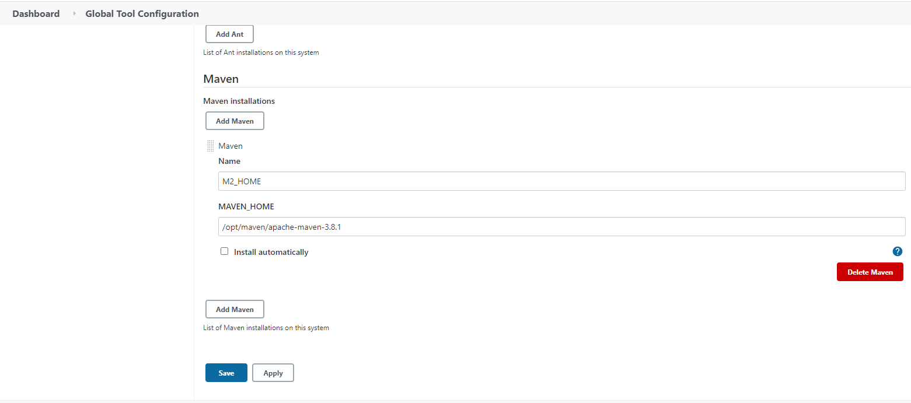

##########################################################################################################################################################################

# **Tomcat installation on EC2 instance**

## **Install Java**

1. We will be using open java for our demo, Get the latest version from <http://openjdk.java.net/install/>yum install java-1.8*

2. Download tomcat packages from <https://tomcat.apache.org/download-80.cgi>

onto /opt on EC2 instance  
 # Create tomcat directory

mkdir /opt/tomcat

wget https://dlcdn.apache.org/tomcat/tomcat-9/v9.0.64/bin/apache-tomcat-9.0.64.tar.gz

tar -xvzf apache-tomcat-9.0.64.tar.gz

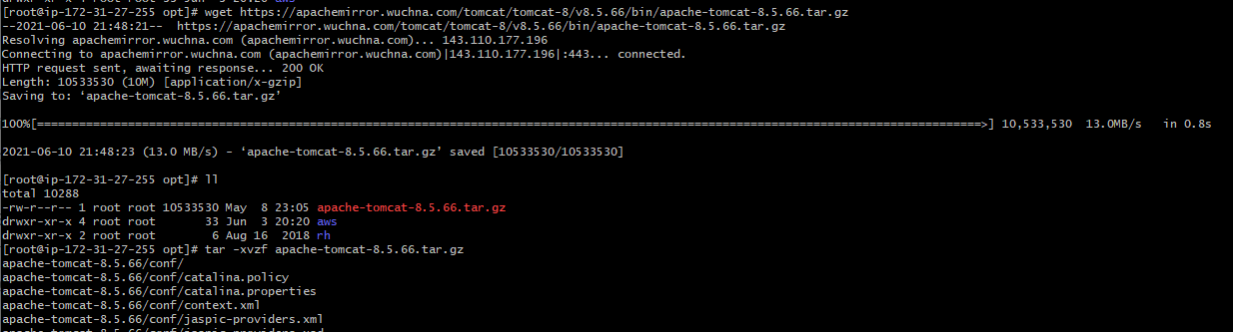

[root@ip-172-31-86-155 bin]# pwd

/opt/tomcat/apache-tomcat-9.0.64/bin

[root@ip-172-31-86-155 bin]# cd /usr/bin

[root@ip-172-31-86-155 bin]# ln -s /opt/tomcat/apache-tomcat-9.0.64/bin/shutdown.sh tomcatdown

[root@ip-172-31-86-155 bin]# ln -s /opt/tomcat/apache-tomcat-9.0.64/bin/startup.sh tomcatstartup

[root@ip-172-31-86-155 bin]#

[root@ip-172-31-27-255 bin]# tomcat

tomcatdown tomcatup

[root@ip-172-31-27-255 bin]# tomcatup

Using CATALINA_BASE: /opt/apache-tomcat-8.5.66

Using CATALINA_HOME: /opt/apache-tomcat-8.5.66

Using CATALINA_TMPDIR: /opt/apache-tomcat-8.5.66/temp

Using JRE_HOME: /usr

Using CLASSPATH: /opt/apache-tomcat-8.5.66/bin/bootstrap.jar:/opt/apache-tomcat-8.5.66/bin/tomcat-juli.jar

Using CATALINA_OPTS:

Tomcat started.

[root@ip-172-31-27-255 bin]#

**Configure Tomcat:**

Access tomcat application from browser on port 8090

* http://<Public_IP>:8090

#search for context.xml

find / -name context.xml

Comment/Remove entry in below files

[root@ip-172-31-27-255 bin]# find / -name context.xml

/opt/apache-tomcat-8.5.66/conf/context.xml

/opt/apache-tomcat-8.5.66/webapps/examples/META-INF/context.xml

/opt/apache-tomcat-8.5.66/webapps/host-manager/META-INF/context.xml

/opt/apache-tomcat-8.5.66/webapps/manager/META-INF/context.xml

[root@ip-172-31-27-255 bin]# vi /opt/apache-tomcat-8.5.66/webapps/host-manager/META-INF/context.xml

[root@ip-172-31-27-255 bin]# vi /opt/apache-tomcat-8.5.66/webapps/manager/META-INF/context.xml

[root@ip-172-31-27-255 bin]#

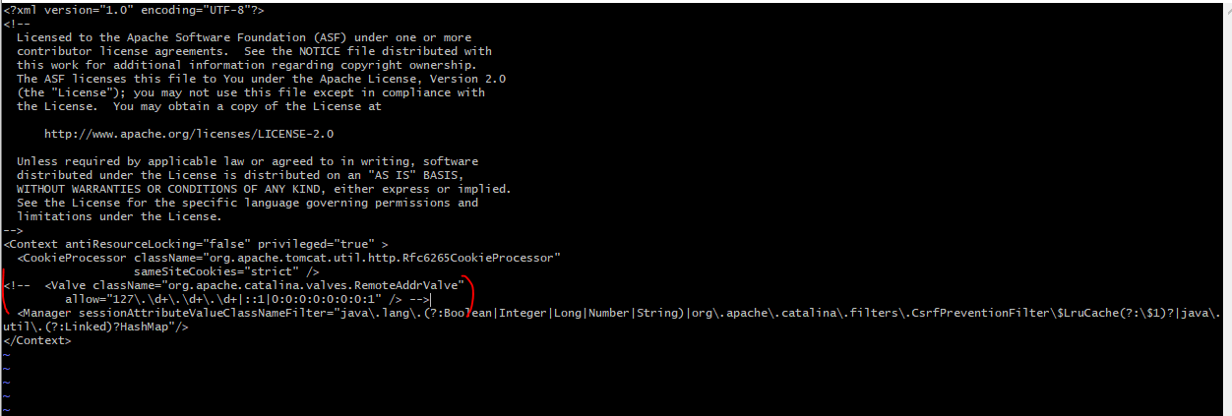

Update users information in the tomcat-users.xml file goto tomcat home directory and Add below users to conf/tomcat-user.xml file

<role rolename="manager-gui"/>

<role rolename="manager-status"/>

<user username="admin" password="admin" roles="manager-gui, manager-status"/>

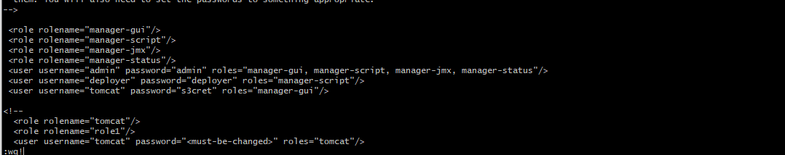

Update server.conf file to change port from 8080 to 9090

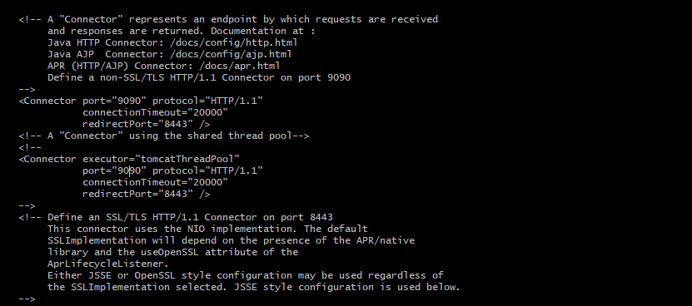

**Restart Tomcat**

[root@ip-172-31-27-255 conf]# vi context.xml

[root@ip-172-31-27-255 conf]# tomcatdown

Using CATALINA_BASE: /opt/apache-tomcat-8.5.66

Using CATALINA_HOME: /opt/apache-tomcat-8.5.66

Using CATALINA_TMPDIR: /opt/apache-tomcat-8.5.66/temp

Using JRE_HOME: /usr

Using CLASSPATH: /opt/apache-tomcat-8.5.66/bin/bootstrap.jar:/opt/apache-tomcat-8.5.66/bin/tomcat-juli.jar

Using CATALINA_OPTS:

[root@ip-172-31-27-255 conf]# tomcatup

Using CATALINA_BASE: /opt/apache-tomcat-8.5.66

Using CATALINA_HOME: /opt/apache-tomcat-8.5.66

Using CATALINA_TMPDIR: /opt/apache-tomcat-8.5.66/temp

Using JRE_HOME: /usr

Using CLASSPATH: /opt/apache-tomcat-8.5.66/bin/bootstrap.jar:/opt/apache-tomcat-8.5.66/bin/tomcat-juli.jar

Using CATALINA_OPTS:

Tomcat started.