**Mydin mitc**

9554041168290 MOUNTAIN DEW PITCH BLACK 250ML



9556135185002 DESA NATURAL MINERAL WATER 500ML

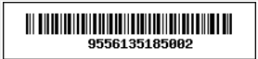

9556166058221 DUTCH LADY PUREFARM STRAWBERRY MILK 1L

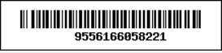

9556196101096 JACK 'N JILL POTATO CRISPS SUPER SPICY



9556196101097 JACK 8i'N JILL POTATO CRISPS SWEET AND SPICY

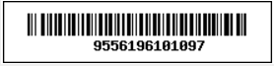

9556196101172 F&N SPRITE 1L



9556196101574 NESTLE DUTCH LADY POWDERED MILK 5KG

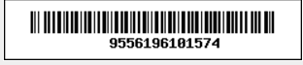

9557029701117 MYRASA JEJARI WAFER PERISA COKLAT 550GM



**Jusco ayer keroh**

9551155443269 F&N STRAWBERRY 1.5L

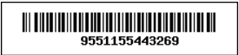

9551254632514 F&N ORANGE 1.5L



9551254645514 F&N GRAPE 1.5L



9554041168290 MOUNTAIN DEW PITCH BLACK 250ML

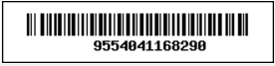

9556135185002 DESA NATURAL MINERAL WATER 500ML



955616605833 'DUTCH LADY PUREFARM FULL CREAM MILK 1L

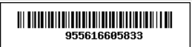

9556196101096 JACK \'N JILL POTATO CRISPS SUPER SPICY

