**CO323 - LAB 01**

**INTRODUCTION TO CISCO PACKET TRACER**

WIJERATHNE E.S.G.

E/18/397

SEMESTER 05

13/10/2022

Assume a situation where you do not have access to the internet and connect your PCs through an RJ45 direct cable connection to share some files.

Figure 01: Network Diagram

1) Connect two PCs through an RJ45 direct cable, as shown above.

a) Assign IP addresses and subnet masks.

We have added IP addresses and subnet masks for the computers using network settings.

Figure 02: Assigning IPs and subnet masks For PC0

Figure 03: Assigning IPs and subnet masks For PC1

b) Open a command prompt in both PCs and try to ping the other. What do you observe? Explain your observations.

We were able to ping other PC from both PCs. According to the IP addresses and subnet masks, both PCs were in the same network.

Network addresses for both IP and subnet configurations: - 192.168.100.0

Figure 04: Ping PC0 from PC1

c) Change the cable to a crossover cable and check the connectivity.

Even though the cable was changed to a crossover cable, the PCs were connected successfully.

Check the following combinations of IP addresses and Subnet masks and explain the results.

|  |  |  |  |
| --- | --- | --- | --- |
| **Case** | **PC0 IP Address** | **PC0 Subnet mask** | **Network Address** |
| 1 | 192.168.200.1 | 24 | 192.168.200.0 |
| 2 | 192.168.200.1 | 16 | 192.168.0.0 |
| 3 | 192.168.100.10 | 28 | 192.168.100.0 |
| 4 | 192.168.100.250 | 28 | 192.168.100.240 |

For all the above cases, **PC1**,

IP address: - 192.168.100.2

Subnet mask: - 255.255.255.0

Therefore, the Network address: - 192.168.100.0

Case 1

PC0 network address: - 192.168.200.0

PC1 network address: - 192.168.100.0

Since two PCs not on the same network, we couldn’t be able to connect.

Figure 05: Ping PC0 from PC1

Case 2

PC0 network address: - 192.168.0.0

PC1 network address: - 192.168.100.0

Since two PCs not on the same network, we couldn’t be able to connect.

Figure 06: Ping PC0 from PC1

Case 3

PC0 network address: - 192.168.100.0

PC1 network address: - 192.168.100.0

Since two PCs are on the same network, we were able to connect.

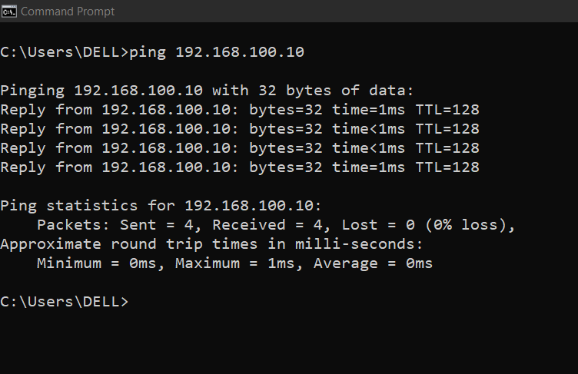

Figure 07: Ping PC0 from PC1

Case 4

PC0 network address: - 192.168.100.240

PC1 network address: - 192.168.100.0

Since two PCs not on the same network, we couldn’t be able to connect.

Figure 08: Ping PC0 from PC1

2) Create the network shown below

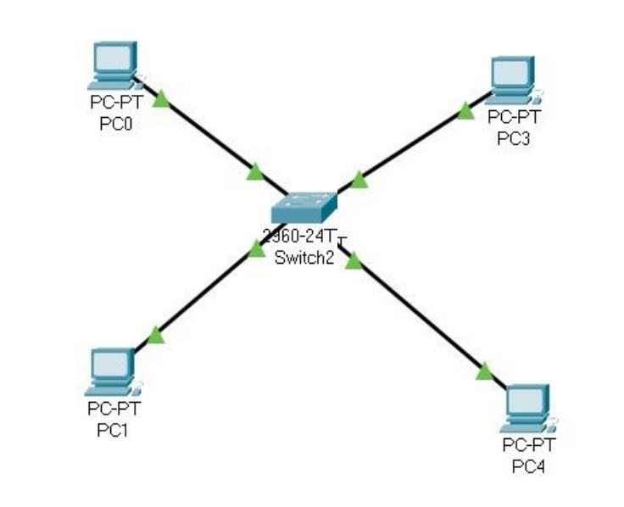

Figure 09: Network Diagram

a) Assign IP addresses and subnet masks appropriately.

Assigned IP addresses and subnet masks.

PC0: - 192.168.100.1 / 24

PC1: - 192.168.100.2 / 24

PC2: - 192.168.100.3 / 24

PC3: - 192.168.100.4 / 24

Therefore, the Network address for all four PCs: - 192.168.100.0

b) Ping each PC separately and explain the observations. Since every PC was in the same network, we could connect with each PC.

Let PC3 was my PC.

Figure 10: Ping PC0, PC1, and PC2 from PC3

c) Try PC0 and PC1 with a different subset mask and a different class of IPs while keeping the other PC configurations the same, then check the connectivity between each PC using ping.

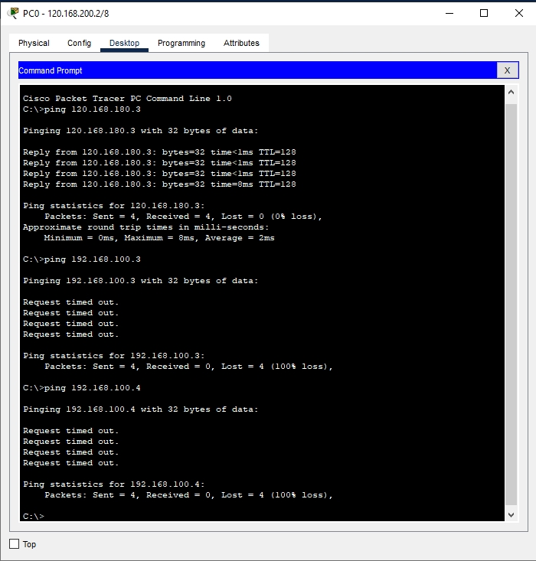

Figure 11: Ping PC1, PC2, and PC3 from PC0

Figure 12: Ping PC0, PC1, and PC2 from PC3

According to the received, we can see that only PCs in the same network can communicate with each other. Therefore, PC0 and PC1 were able to communicate with each other while PC2 and PC3 were communicate.

d) Apply the 1. C IP and Subnet masks configurations to a PC while keeping the other PCs configurations the same and observing the connectivity

PC0 configurations: -

|  |  |  |  |
| --- | --- | --- | --- |
| **Case** | **PC0 IP Address** | **PC0 Subnet mask** | **Network Address** |
| 1 | 192.168.200.1 | 24 | 192.168.200.0 |
| 2 | 192.168.200.1 | 16 | 192.168.0.0 |
| 3 | 192.168.100.10 | 28 | 192.168.100.0 |
| 4 | 192.168.100.250 | 28 | 192.168.100.240 |

Other PCs configurations.

PC1: - 192.168.100.2 / 24

PC2: - 192.168.100.3 / 24

PC3: - 192.168.100.4 / 24

Case 1

Figure 13: Ping PC1, PC2, and PC3 from PC0

Case 2

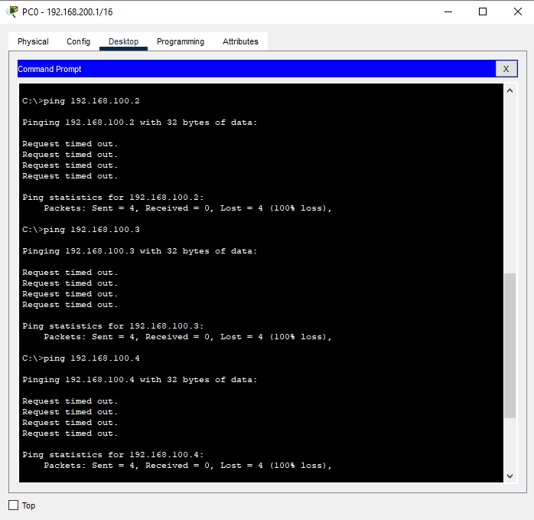

Figure 14: Ping PC1, PC2, and PC3 from PC0

Case 3

Figure 15: Ping PC1, PC2, and PC3 from PC0

Case 4

Figure 16: Ping PC1, PC2, and PC3 from PC0

In cases 1,2, and 4 PCs couldn’t communicate because they are not in the same network.

But in case 3 Ips were in same network and all four PCs were able to communicate.