**CO325 - LAB 02**

**Network Address Translation + Access Control Lists**

WIJERATHNE E.S.G.

E/18/397

SEMESTER 05

23/12/2022

01.

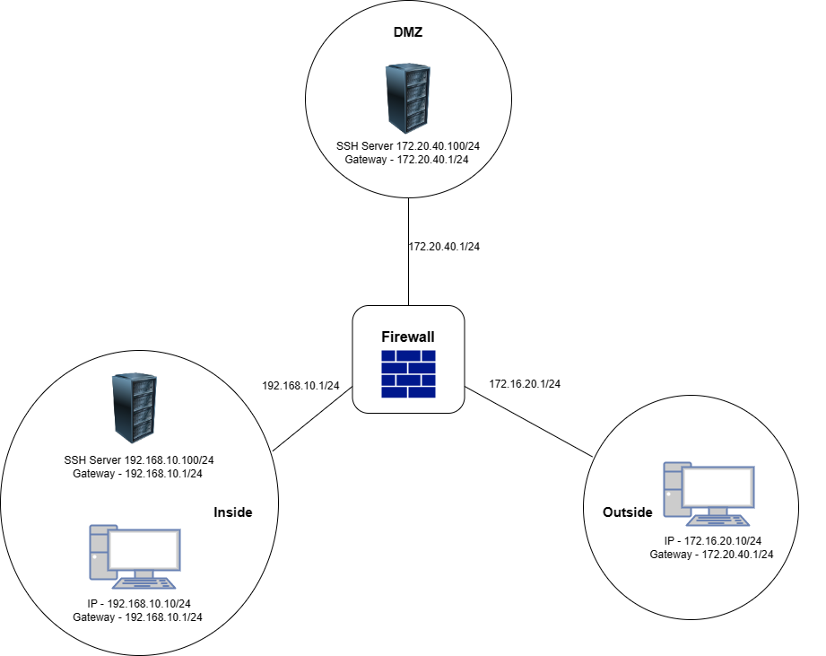

02.

ciscoasa(config)# object network dmz-server

ciscoasa(config-network-object)# host 172.20.40.100

ciscoasa(config)# access-list out2dmz extended permit tcp any object dmz-server eq ssh

ciscoasa(config)# access-list out2dmz extended deny ip any any

ciscoasa(config)# access-group out2dmz in interface outside

ciscoasa(config)# object network dmz-mapped-server

ciscoasa(config-network-object)# host 172.20.40.3

ciscoasa(config)# object network inside-real-server

ciscoasa(config-network-object)# host 192.168.10.100

ciscoasa(config-network-object)# nat (inside,dmz) static dmz-mapped-server

ciscoasa(config)# access-list dmz2in extended permit tcp object dmz-server object inside-real-server eq ssh

ciscoasa(config)# access-list dmz2in extended deny ip any any

ciscoasa(config)# access-group dmz2in in interface dmz

03.

* **For network dmz-server**

ciscoasa(config)# object network dmz-server

* *creating a network object*

ciscoasa(config-network-object)# host 172.20.40.100

* *setting up IP address*

**Giving accesses**

ciscoasa(config)# access-list out2dmz extended permit tcp any object dmz-server eq ssh

* *allow any SSH traffic from the outside to the DMZ SSH Sever*

ciscoasa(config)# access-list out2dmz extended deny ip any any

* *deny all the traffic from the outside to the inside and the DMZ*

ciscoasa(config)# access-group out2dmz in interface outside

* *apply ACL inbound to the external interface*
* **for dmz-mapped-server**

ciscoasa(config)# object network dmz-mapped-server

* *creating a network object*

ciscoasa(config-network-object)# host 172.20.40.3

* *Define IP such that maps to the inside SSH server’s IP address.*

ciscoasa(config)# object network inside-real-server

* *Create network object for inside network SSH server*

ciscoasa(config-network-object)# host 192.168.10.100

* *Setting IP for inside SSH server*

ciscoasa(config-network-object)# nat (inside,dmz) static dmz-mapped-server

* *Using NAT rule which maps inside SSH IP address and DMZ SSHIP address with DMZ- mapped IP address. (So we can access inside SSH server from DMZ*

*SSH server using mapped IP address which is 172.20.30.3)*

**Rules**

ciscoasa(config)# access-list dmz2in extended permit tcp object dmz-server object inside-real-server eq ssh

* *Allows any SSH traffic from DMZ to inside SSH sever.*

ciscoasa(config)# access-list dmz2in extended deny ip any any

* *Deny any other traffic from DMZ to inside*

ciscoasa(config)# access-group dmz2in in interface dmz

* *apply ACL inbound to the external interface*