**DATA VISUALIZATION ASSIGNMENT-SULEIMAN SHAMSUDEEN**

**Lesson 1 Exercise A: Observing and commenting on the use of data visualization in a presentation**

*Provide answers to each of the questions.*

1. *Describe those attributes of Hans Rosling’s presentation that you find particularly effective. Explain why.*

**ANSWER**

**Hans Rosling** is a professor of international health and director of the Gapminder Foundation. This Video is a 2009 report that visualizes (Timeseries) the changes in poverty, Income and life expectancy (Lifespan) by country over 200 years. His presentation of this facts by visuals makes a compelling story, the most effective attributes of Hans presentation are:

1. His use of story telling to show how countries have changed with respect to important world events such as the first and second World war, Spanish Flu epidemic and Great depression
2. The use of bubbles to represent each country and make it look like a race through time to the rich and healthy corner. (showing prosperity)
3. His Demonstration was very effective in making sure his points hit hard.
4. *What questions are being addressed by the presentation?*

**ANSWER**

1. He was able to address how Global health has changed over the years with respect to changes in global events.
2. He also addressed the global evolutionary trend on the quality of life.
3. Questions like What are the biggest obstacles to the quality of life in our world.
4. Can developing countries catch up with the world powers over time .
5. *What data is used to create the visualization?*

**ANSWER**

1. 2009 Global Health Data. Which consist of Data from 1810 to 2009 (approximately 200 years)
2. *What visual cues are used to represent the data?*

**ANSWER**

1. **Bubble Chart**
2. **Motion Picture Animation**
3. **Color Depth and Varying Sizes of Bubbles**
4. **Time Series**

**Lesson 2 Exercise B: Applying the basic principles of design to an Excel chart**

**Fig1 -Excel sheet showing Purchase by Age Distribution**

#### Lesson 3 Exercise C: Using common tools to create different displays types

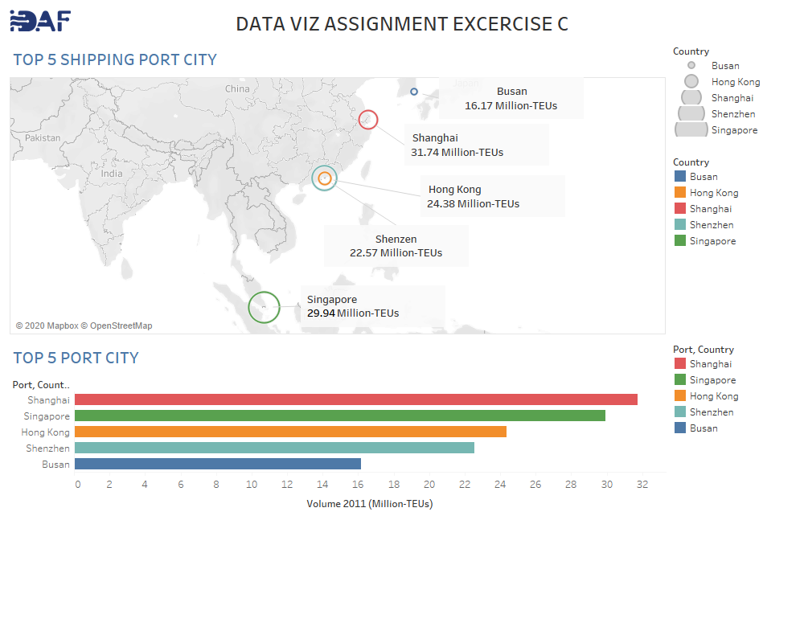

Fig2 :Tableau Dashboard Showing Top Cities and their shipment