Q1 - Give me the list of issues which were commented on 25/May/2023 ?
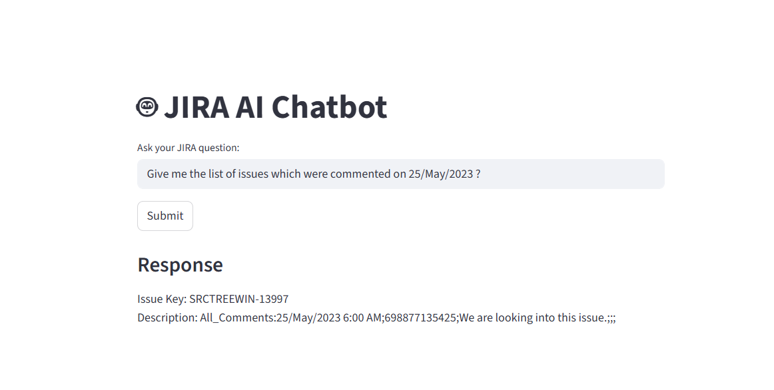
Q2 - Any issue asking to Please upload the image to Google Drive and share the link?
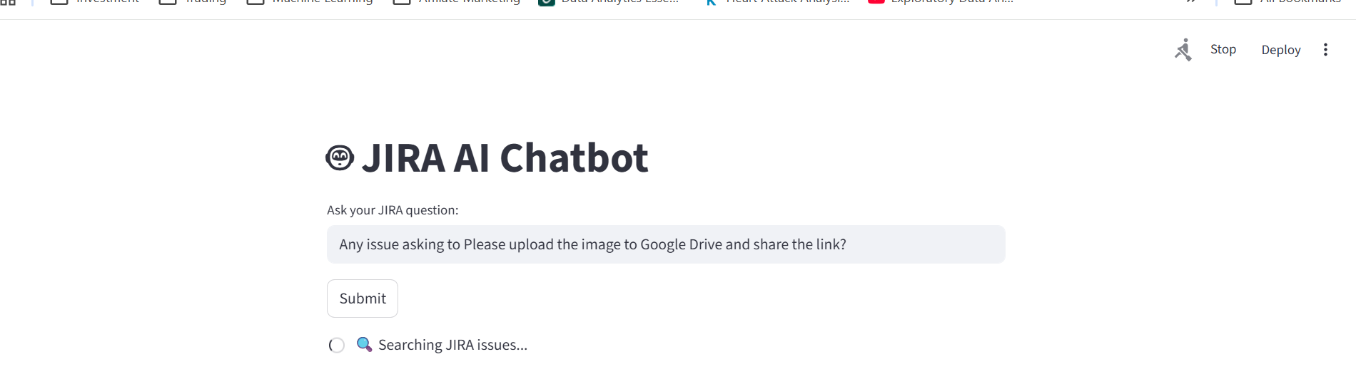

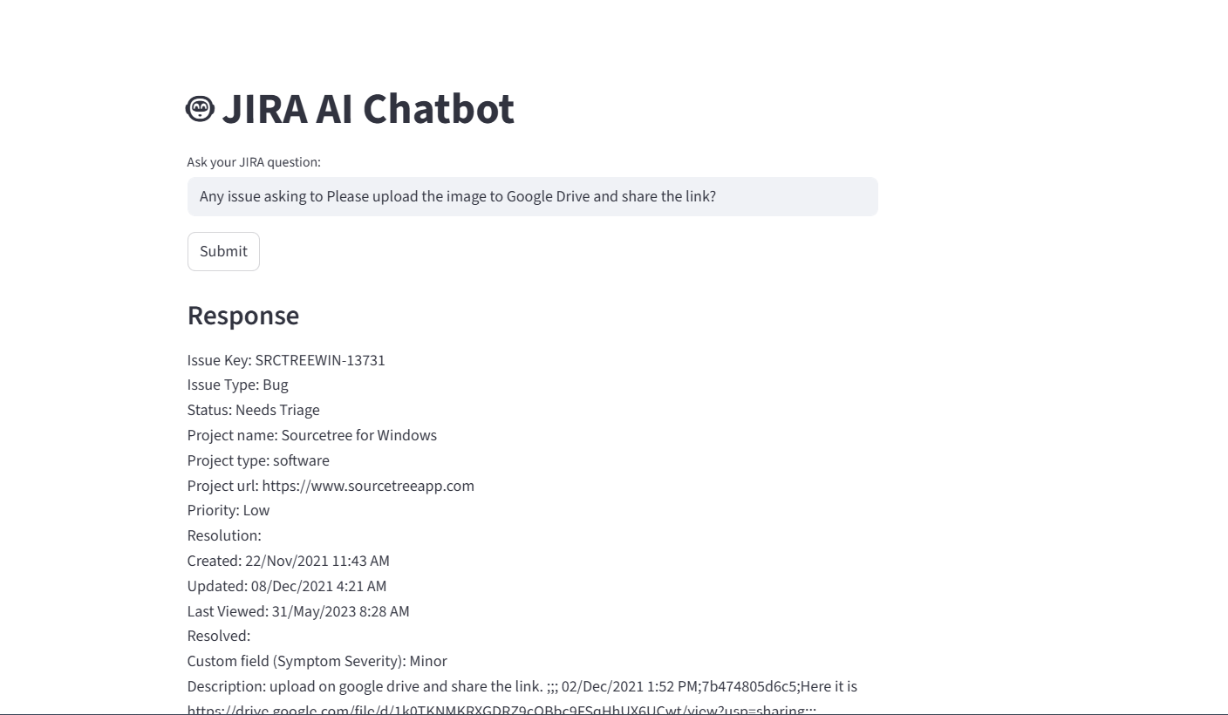

Q3 - Any issue raised App freezes and displays "Not Responding" in titlebar constantly?
If yes , what is the creation date

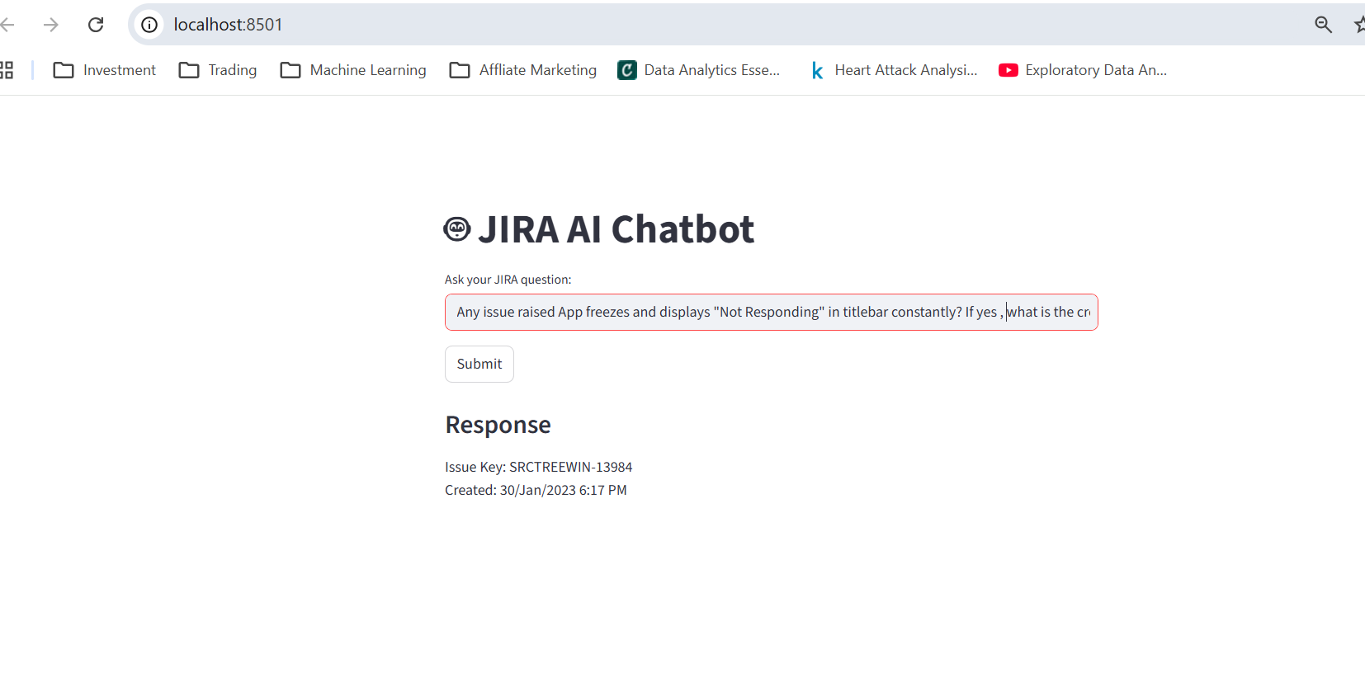

Q4 - What is the current status of issue SRCTREEWIN-14037
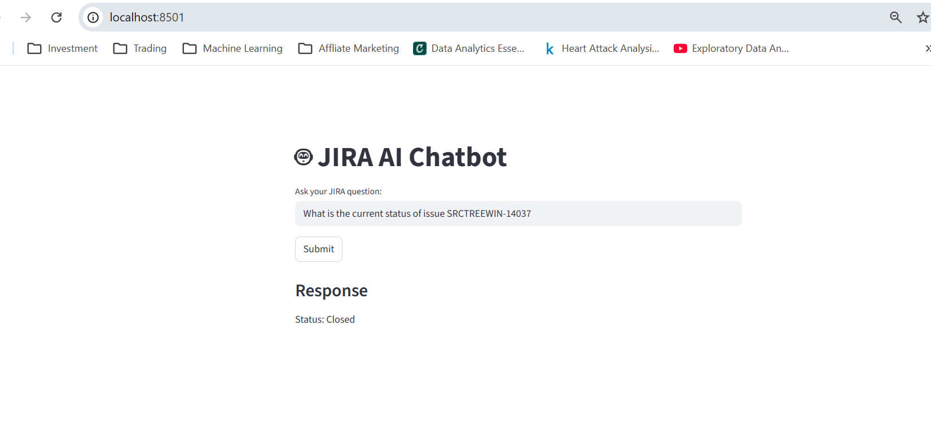

Q5 – Scenario for no issues found
