Q1 - Give me the list of issues which were commented on 25/May/2023 ?

Q2 - Any issue asking to Please upload the image to Google Drive and share the link?
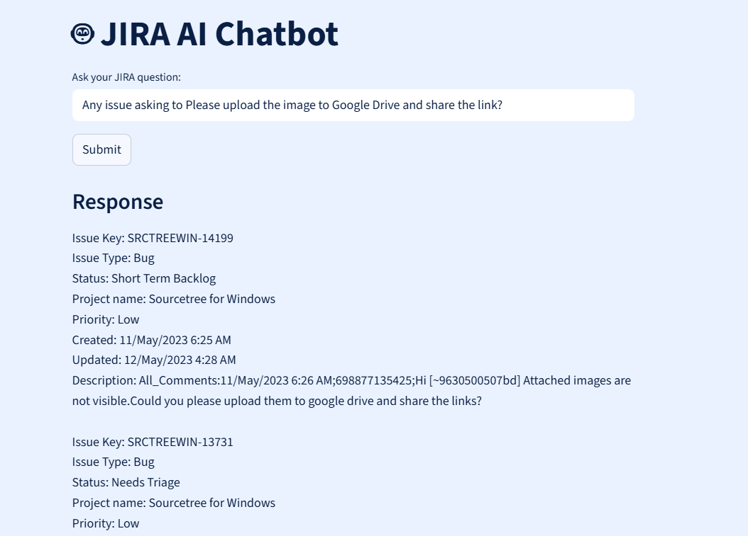

Q3 - Any issue asking to Please upload the image to Google Drive and share the link?
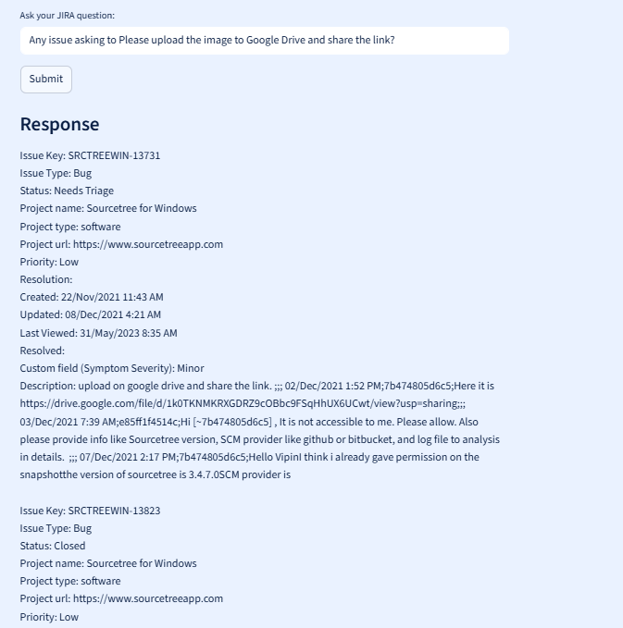

Q4 - What is the current status of issue SRCTREEWIN-14037
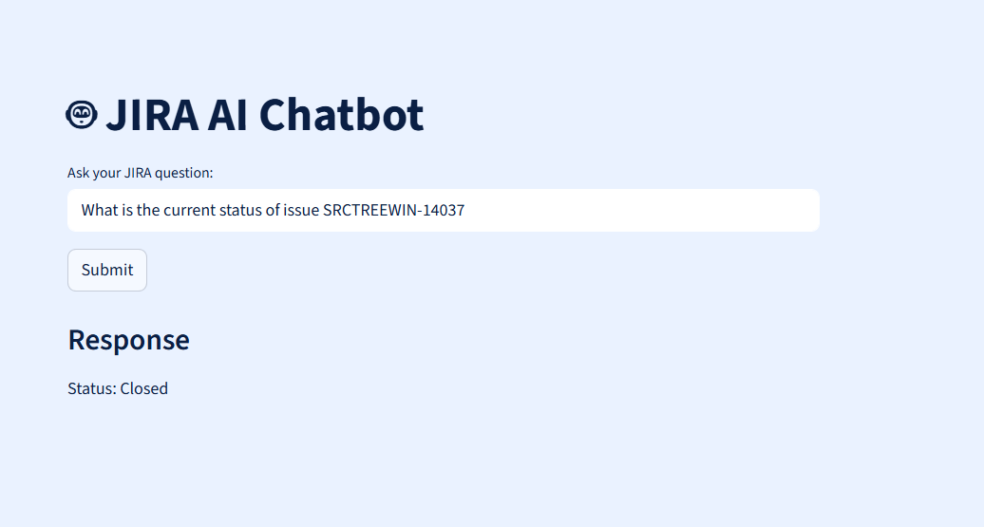

Q5 – What is the reason for stories getting forwarded for last 2 sprints
