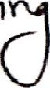
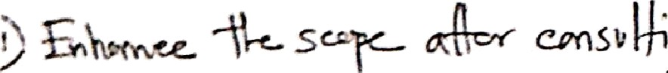
Before the midterm Presentation:
1 confirm that the progress is satisfactory and I am forwarding it for midterm presentation. Signature of the Supervisor:
Date:
Midterm Presentation Feedback:

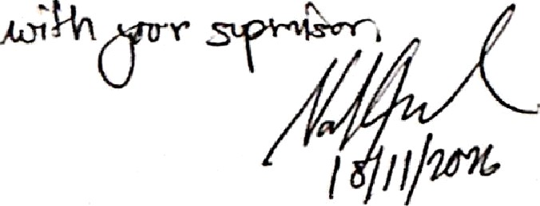

Before the Final Presentation:
I confirm that the project is complete and I am forwarding it for final presentation.

