UTM Computing Proceedings
Innovations in Computing Technology and Applications
Volume: 4 | Year: 2026 | ISBN No. :
CLINK: Smart Outpatient Triage and Scheduling System Web Application
Shams Ahmed Nabil Alshabrawy  Faculty of Computing  Universiti Teknologi Malaysia  Johor Bahru, Malaysia  Nabil20@graduate.utm.my | Dr. Alif Ridzuan Bin Khairuddin  Faculty of Computing  Universiti Teknologi Malaysia  Johor Bahru, Malaysia  alifridzadn@utm.my

Abstract—This paper presents CLINK, a smart outpatient triage and scheduling web application designed to improve patient flow in outpatient departments. The system addresses common healthcare operation problems such as long appointment waiting times, unclear specialist selection, manual triage decisions, and unnecessary emergency department visits by non-emergency patients. CLINK allows patients to register, submit symptoms, receive AI-supported urgency classification, obtain a recommended specialist, and book a suitable appointment slot. Doctors can view assigned cases according to urgency, update consultation status, and manage patient case notes, while administrators manage users, doctor availability, and schedules. The system was developed as a Python Flask web application with HTML, CSS, JavaScript, Jinja2 templates, Flask-Login, Flask-SQLAlchemy, and a locally trained Decision Tree Classifier using scikit-learn, pandas, and NumPy. The implemented system was validated through functional test cases mapped to the defined use cases and requirements.
Keyword: Artificial Intelligence, Appointment Scheduling, Healthcare System, Outpatient Triage, Flask, Decision Tree Classifier
I. Introduction
Outpatient departments are important because they allow patients to receive consultation, diagnosis, follow-up care, and specialist services without being admitted to the hospital. However, outpatient services require a clear process for registration, symptom triage, specialist selection, appointment booking, and communication between patients and medical staff. When these activities are handled manually, the process can become slow and inconsistent, especially in hospitals with a high number of daily visitors.
CLINK was developed to support this workflow through a smart web-based outpatient triage and scheduling system. The system focuses on the early stage of the outpatient journey where patients may not know which specialist they should visit or whether their case is urgent. By allowing patients to enter symptoms and receive AI-supported triage results, CLINK helps guide patients to the correct specialist and appointment priority before the consultation takes place.
The project aims to reduce waiting time, improve referral accuracy, and support doctors with clearer patient case information. The final implementation provides three main user roles: patient, doctor, and administrator. Patients submit symptoms and book appointments, doctors manage and prioritize assigned cases, and administrators configure users and doctor schedules. This integrated structure allows CLINK to act not only as an appointment booking tool, but also as a decision-support and workflow-management system for outpatient services.
II. Problem Background
The main problem addressed by CLINK is the inefficiency of manual outpatient triage and scheduling. In the case study of Al-Jahra Hospital, patients may wait for long periods before receiving appointments, and many patients do not clearly understand which specialist or clinic matches their symptoms. This uncertainty can lead to wrong bookings, repeated visits, rescheduling, and additional administrative work.
Another problem is the pressure placed on emergency departments. Some patients visit the emergency department not because they have a real emergency, but because they need guidance about where to go next or which referral is suitable. This increases congestion and distracts staff from urgent cases. Doctors also face difficulty when urgent and non-urgent cases are not classified consistently before the consultation.
The survey findings in the report also support the need for automation. Patients reported long appointment delays and uncertainty about the correct department, while doctors reported frequent misdirected cases and difficulty distinguishing urgent cases without a standard triage mechanism. These issues show that the problem is not only technical, but also operational because the lack of structured information affects patients, doctors, and administrators at the same time.
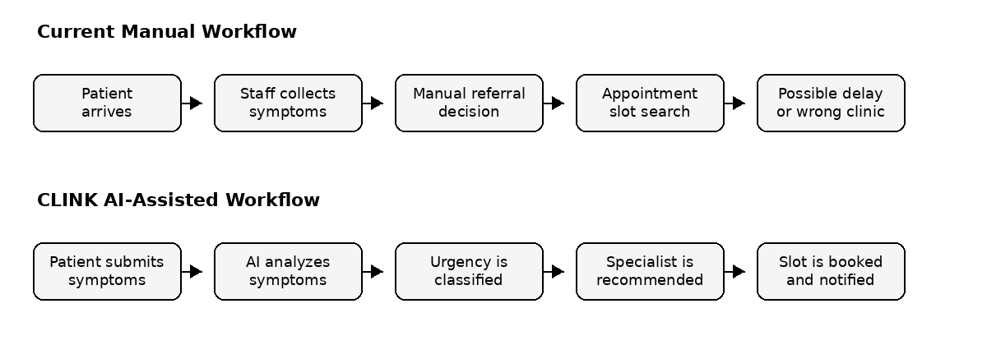
Fig. 1. Current manual workflow and CLINK AI-assisted outpatient workflow.
The workflow comparison highlights the main contribution of CLINK. Instead of depending on repeated manual interpretation of patient symptoms, the system captures the symptoms once, sends them to the triage model, records the result, and uses the result to support specialist recommendation and booking. This reduces duplicated communication between patients, reception staff, and doctors.

A. Existing Systems
Existing appointment platforms mainly provide booking functions. Systems such as Al-Razi, Al-Orf, Qmed Asia, and Pantai Hospital help patients select appointments, but they usually depend on the patient to choose the correct specialist manually. They do not provide AI-based symptom analysis, automatic urgency classification, or integrated doctor prioritization. Therefore, they reduce some front-desk workload but do not fully solve the triage and referral problem.
Table I. Comparison between existing appointment systems and CLINK.
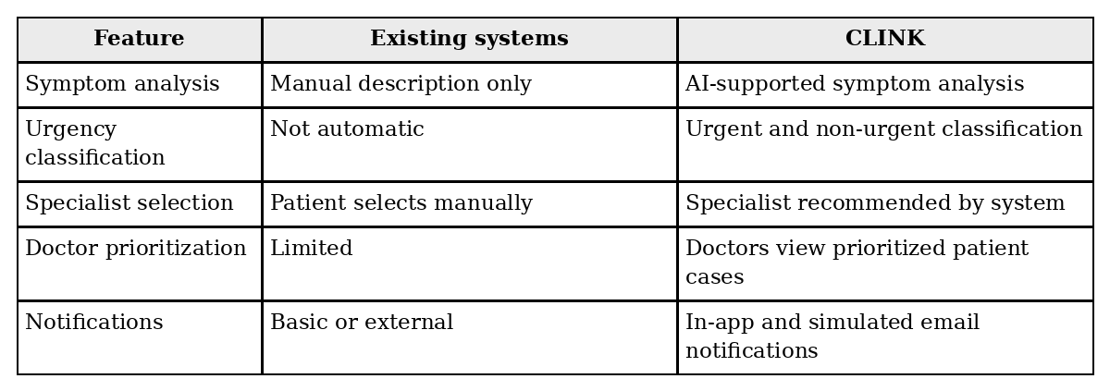
B. Discussion
The comparison shows that CLINK adds intelligence to the outpatient process instead of only digitizing appointment booking. The proposed system is designed to analyse symptoms, classify urgency, recommend a specialist, and generate suitable appointment slots. These functions help patients make better decisions earlier and help doctors focus on cases that require attention first.
C. Tools and Technology Used
The system uses technologies that support a modular web application and a simple local AI pipeline. Python and Flask are used for the backend, HTML, CSS, JavaScript, and Jinja2 are used for the interface, while scikit-learn, pandas, NumPy, and joblib support the machine-learning model.
Table II. Tools and technology used in developing the system.
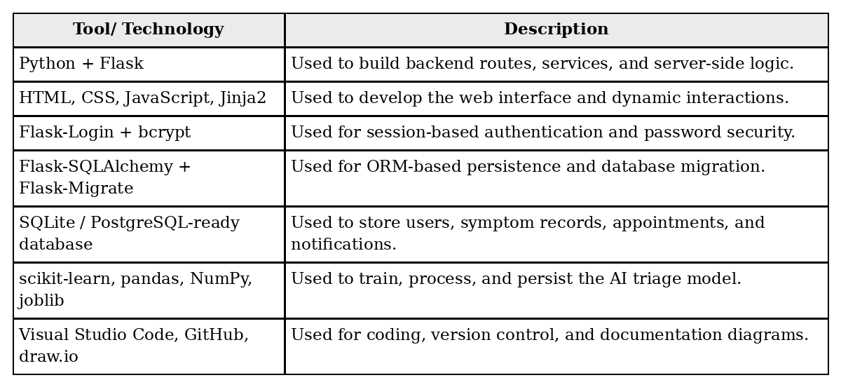
III. Methodology
The development of CLINK followed an Agile methodology. Agile was selected because healthcare-related systems may require refinement after reviewing stakeholder needs, workflow gaps, and testing results. The project was divided into development cycles where each sprint focused on a specific function such as registration, symptom submission, AI triage, appointment booking, notification handling, doctor case management, and administrator control.
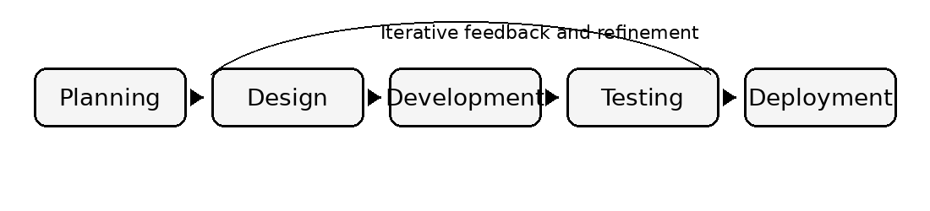
Fig. 2. Agile development workflow applied in CLINK.
This methodology supported continuous validation because each completed module could be reviewed and tested before the next module was implemented. It also reduced risk by allowing functional and technical problems to be detected early during the development cycle.
A. Phases details for the SDLC
Table III. Detailed methodology phases.
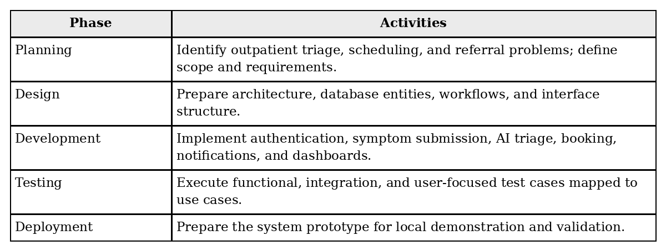
IV. System Requirements and Design
The main stakeholders of CLINK are patients, doctors, and administrators. Patients require an easy way to submit symptoms, view triage results, and book appointments. Doctors require a dashboard that displays assigned cases and supports case status updates. Administrators require management functions for users, doctor availability, and schedules.
A. Use Case Diagram
The use case model shows how the main actors interact with the system. The patient registers, submits symptoms, views triage results, books appointments, and receives notifications. The AI triage component analyses symptoms, classifies urgency, and recommends a specialist. The doctor views patient cases and updates case status, while the administrator manages users and configures schedules.
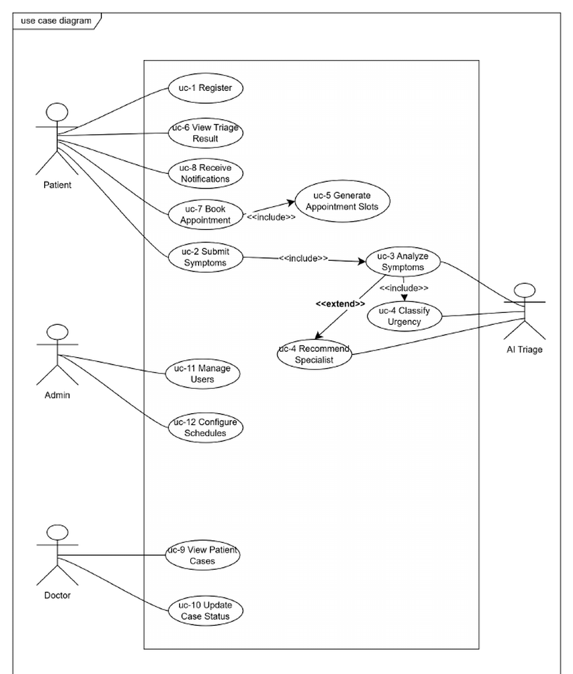
Fig. 3. CLINK use case diagram.
Table IV. Use case description summary.
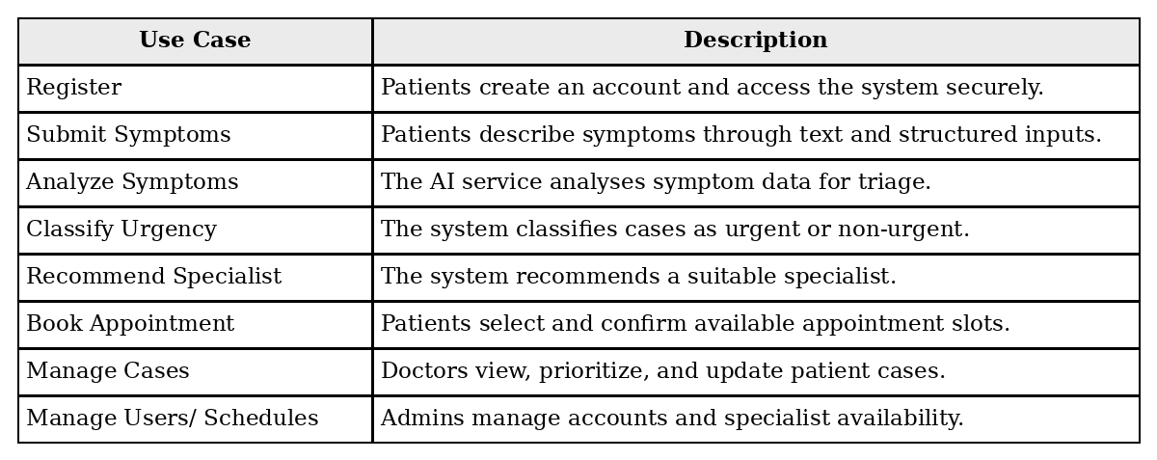
B. Architecture Design
CLINK uses a client-server architecture. The client side contains the patient web interface, doctor dashboard, and administrator interface. The server side handles routing, services, business logic, AI triage processing, appointment scheduling, and notification generation. The data layer stores patient records, doctor information, symptom records, appointments, and notifications.
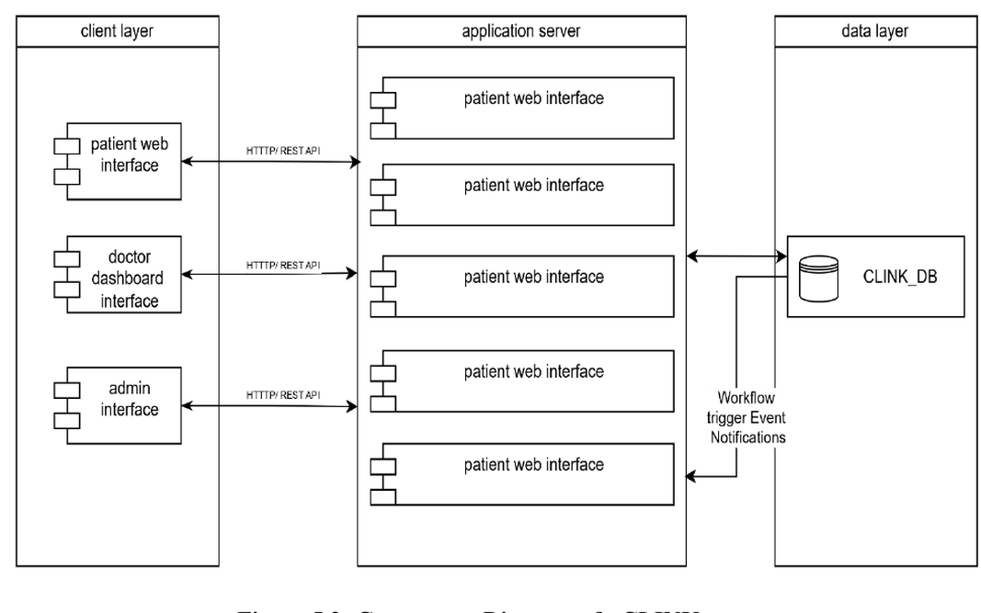
Fig. 4. Component architecture of CLINK.
The backend implementation follows a controller-service-model structure using Flask blueprints, service classes, and SQLAlchemy models. This organization separates user interface handling from business logic and database operations, improving maintainability and allowing each module to be tested more easily.
The design also supports maintainability by keeping each major workflow in a separate module. Authentication, symptom submission, AI triage, appointment scheduling, notifications, doctor case management, and administrator management can be updated independently while still sharing the same data model. This is important for healthcare systems because requirements may change after feedback from staff, patients, or deployment conditions.
C. Database Design
The database design supports the complete outpatient workflow. The main entities include Patient, Doctor, Admin, SymptomRecord, Appointment, and Notification. These entities allow the system to track symptom submissions, AI triage results, doctor assignment, appointment status, and communication events.
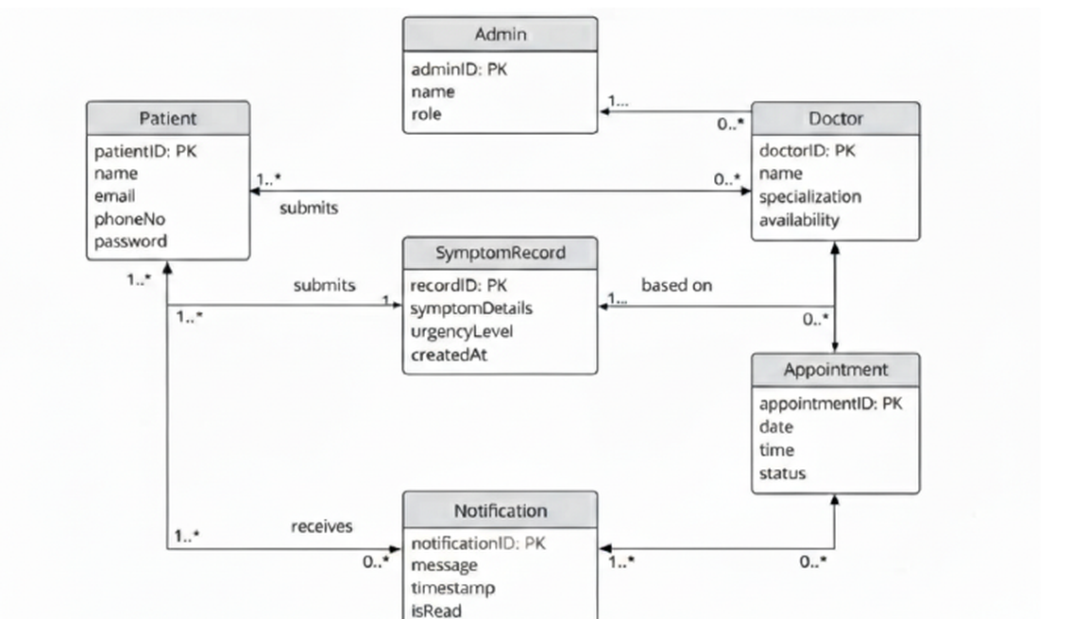
Fig. 5. Entity relationship diagram of the implemented database.

Table V. Data description of CLINK.
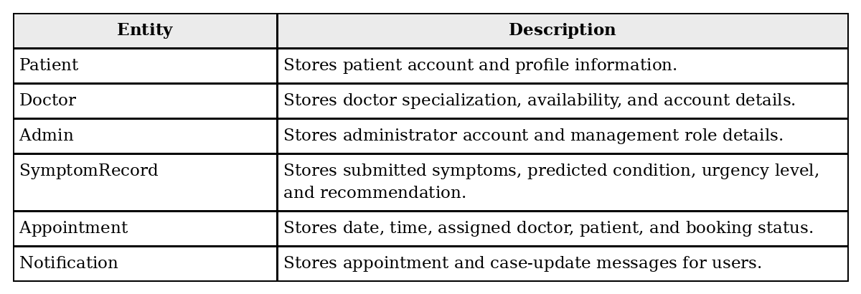
D. Implementation and Testing
1. Authentication and Access Control
The authentication module implements patient registration, patient login, doctor login, and administrator login. User passwords are hashed using bcrypt, and input validation is applied to email, password, name, and phone number fields. Flask-Login manages user sessions, while role-based decorators restrict access to patient, doctor, and administrator routes.
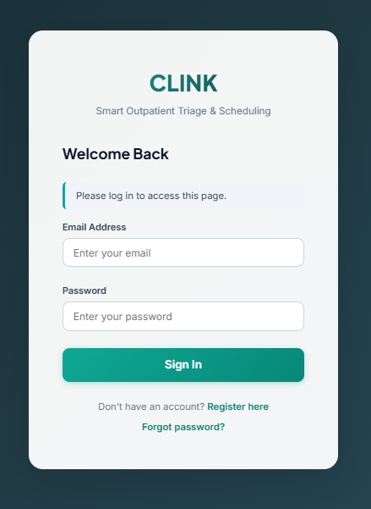

Fig. 6. Component architecture of CLINK.

2. Patient Symptom Submission and AI Triage
The patient module allows a logged-in patient to submit symptoms using free text and structured symptom choices. After submission, the system creates a symptom record with pending analysis status. The AI triage module then encodes the selected symptoms and passes them to a Decision Tree Classifier. The output includes a predicted condition, urgency level, and specialist recommendation. The record is then updated to completed, or marked as failed if the analysis encounters an error.
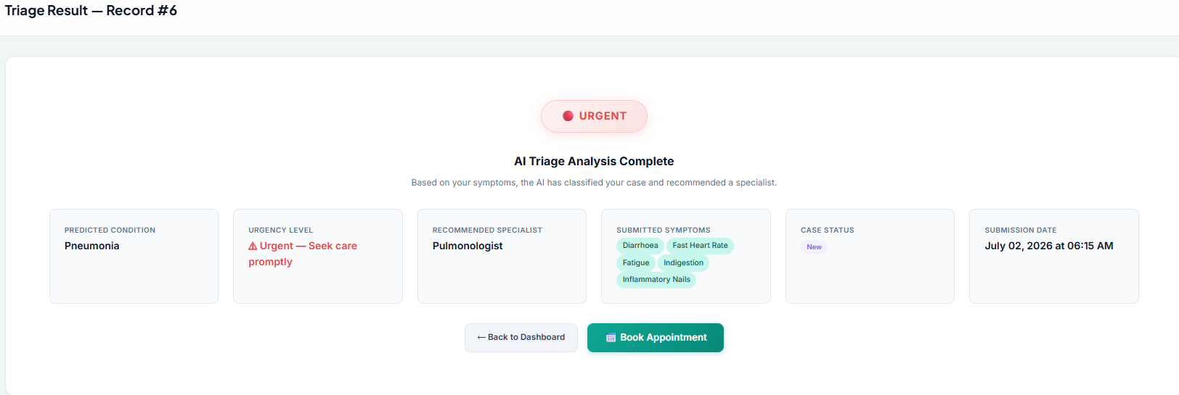
Fig. 7. AI Triage Result
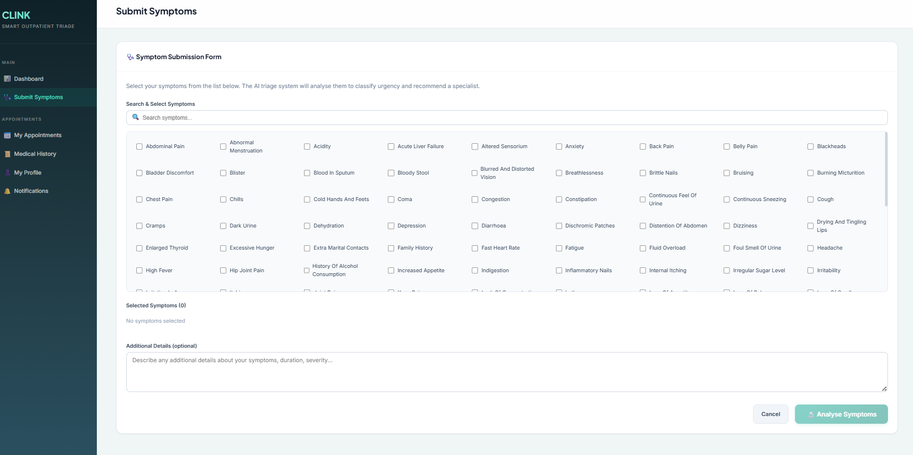
Fig. 8. Patient Symptom Submission and AI Triage
3. Appointment Scheduling and Notifications
After the triage result is generated, the appointment module displays available slots for the assigned doctor and lets the patient select a suitable time. The system checks availability to avoid conflicts. The notification module creates in-app notifications for appointment booking and case status updates. Although the initial design considered an external workflow automation tool, the final implementation keeps notification generation inside the Flask application, making the prototype easier to test and deploy.
4. Doctor and Administrator Modules
Doctors can view assigned cases sorted by urgency, open detailed patient symptoms and AI triage results, update case status, and add consultation notes. Administrators can create and update doctor accounts, deactivate users, configure doctor availability, and manage schedules. These modules support the operational requirements of the outpatient department and improve control over clinical and administrative workflows.
Overall, the implementation reflects the functional requirements defined in the project documentation. Each module is linked to a use case and contributes to the complete patient journey, starting from account access and symptom entry and ending with doctor review, appointment confirmation, and notification updates.
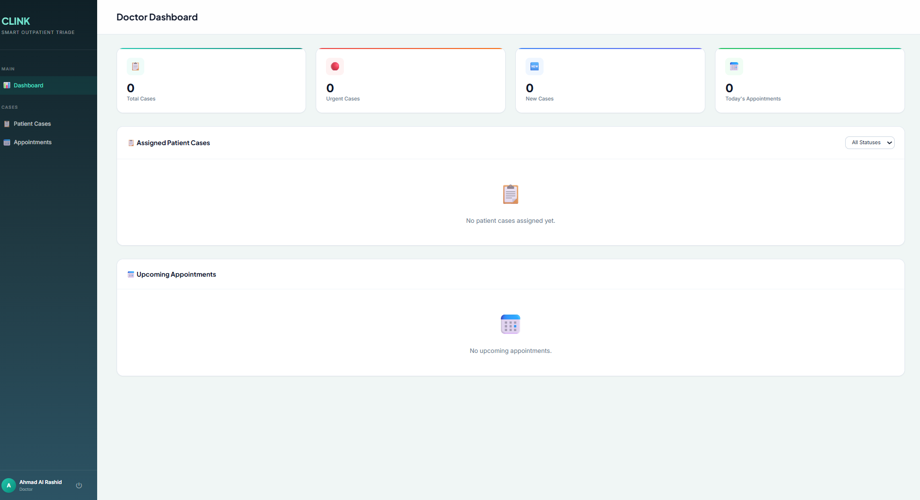
Fig. 9. Doctor Dashboard
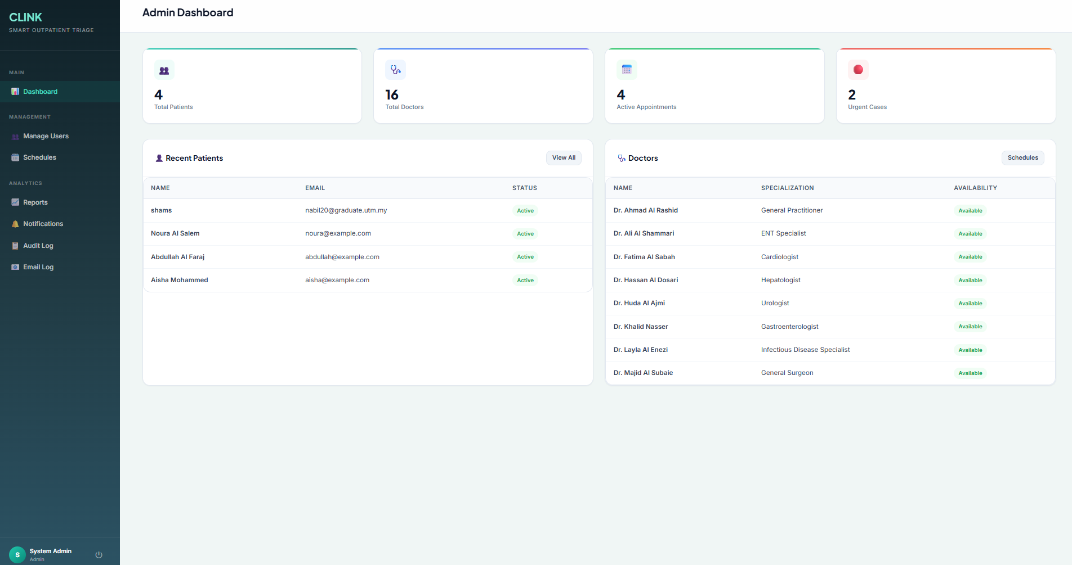
Fig. 10. Administrator Dashboard

5. Testing
Testing was prepared based on the Software Test Documentation and mapped to the system use cases. The tests covered account creation, login validation, symptom submission, AI triage result generation, appointment booking, notifications, doctor case management, and administrator management. The purpose of testing was to confirm that each core function worked according to the defined requirements and handled invalid inputs properly.
Table VI. Summary of tested modules.
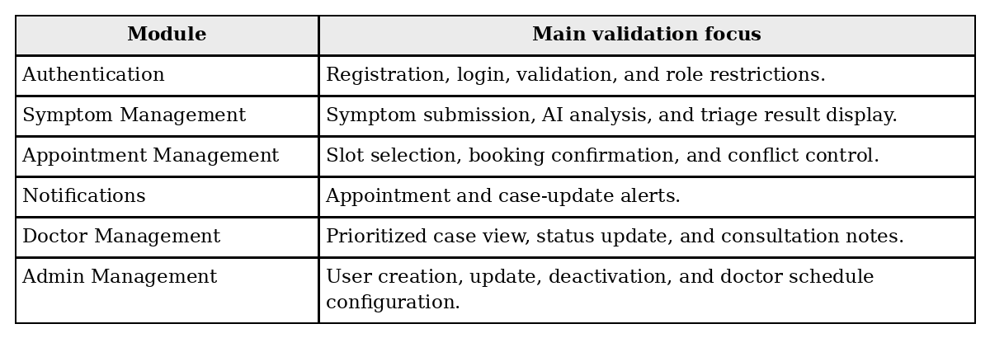
V. Results and Discussion
The test coverage confirms the logical completeness of the implemented prototype because the main workflows are tested from both user and system perspectives. For example, the authentication tests verify that only valid accounts can enter the system and that users are redirected according to role. Symptom-management tests verify that patient input can be recorded, analysed, and returned as a triage result. Appointment tests verify that available slots can be selected and confirmed without breaking the workflow.
From an operational perspective, CLINK improves the outpatient process by making the first decision point more structured. Instead of waiting until a staff member or doctor manually interprets symptoms, the system captures the required information early and stores the AI output with the patient case. This gives doctors a clearer starting point when reviewing the case and gives patients a more direct route to the correct department.
The design also supports administrative visibility. Administrators can manage doctor accounts, availability, and schedules, while doctors can update case status and consultation notes. These features help the system move beyond simple appointment booking and become a small outpatient workflow-management tool.
VI. Conclusion
CLINK demonstrates how an AI-supported web application can improve outpatient triage and scheduling. The system addresses long queues, wrong specialist selection, inconsistent urgency classification, and unnecessary emergency department visits by combining symptom analysis, urgency classification, specialist recommendation, appointment booking, and role-based dashboards. The final implementation provides a working Flask-based prototype with patient, doctor, and administrator modules, a local AI classifier, database persistence, and notification handling.
Future improvements may include integration with electronic medical record systems, a richer clinical dataset for model training, mobile application support, real email/SMS delivery, and predictive analytics for patient flow. These enhancements can make the system more suitable for real healthcare deployment and improve long-term outpatient service efficiency.
References
[1] HT Group, “New Jahra Hospital – Reference Project Overview,” HT Group.
[2] Times Kuwait, “Over 600 Expected Daily Outpatient Visits to the New Jahra Hospital,” 2022.
[3] Alrazi Hospital, “Medical Clinic Services,” Alrazi Hospital Official Website.
[4] P. Kokol, “Agile Software Development in Healthcare: A Synthetic Scoping Review,” Applied Sciences, vol. 12, no. 19, 2022.
[5] S. Ahmad and S. Wasim, “Agile Methodology in Healthcare and Medical Practices: A Narrative Review,” Scholars International Journal of Traditional and Complementary Medicine, vol. 6, no. 8, 2023.
[6] R. S. Pressman and B. R. Maxim, Software Engineering: A Practitioner’s Approach, 9th ed. McGraw-Hill Education, 2019.
[7] E. Topol, “High-Performance Medicine: The Convergence of Human and Artificial Intelligence,” Nature Medicine, vol. 25, 2019.
[8] F. Jiang, Y. Jiang, H. Zhi, et al., “Artificial Intelligence in Healthcare: Past, Present and Future,” Stroke and Vascular Neurology, vol. 2, no. 4, 2017.

