Methodology
1. Overview
This methodology applies deep learning to classify invasive ductal carcinoma (IDC) in histopathology images. Leveraging CNNs and transfer learning, we aim to accurately detect IDC by recognizing patterns in breast tissue images. The process involves data preparation, model architecture design, training with optimization techniques, and performance evaluation. The goal is to create a reliable classifier that can generalize well to unseen samples, supporting rapid and accurate IDC diagnosis.
2. Dataset
The IDC dataset used for this task includes histopathological images labeled as either containing IDC or not. Key steps in preparing this dataset include:
- Data Structure: The images are stored in folders labeled by their class (0 for non-IDC, 1 for IDC).
- Image Characteristics: Each image captures a small region of breast tissue stained to highlight cellular structures, often in RGB format with varying resolutions.
- Data Balance: Given the potential imbalance in IDC vs. non-IDC samples, we analyze class distribution, applying strategies such as data augmentation to address any skew.
The dataset was partitioned into training, validation, and test sets with a stratified split, maintaining class distribution across all subsets to ensure unbiased performance evaluation.
3. Proposed Method
This section describes the specific design and training process of two models: a custom convolutional neural network (CNN) developed specifically for IDC classification and a transfer learning model adapted from a pre-trained network. Each sub-component is detailed below.
3.1 Workflow Diagram
The workflow diagram can be visualized as follows:
- Data Loading: Images are loaded from the dataset with labels indicating IDC presence or absence.
- Data Preprocessing: The images are standardized in size, normalized, and augmented to improve generalization.
- Model Architecture Development:
  - Custom CNN Model: A CNN designed specifically for feature extraction and classification on IDC images.
  - Transfer Learning Model: A pre-trained model fine-tuned for IDC classification.
- Training and Optimization: Models are trained using backpropagation, optimized through SGD with momentum.
- Evaluation: Performance is assessed on the validation set, with metrics such as accuracy, precision, and recall to evaluate effectiveness.
Each stage is interconnected, with results feeding into subsequent steps until model evaluation.
3.2 Data Preprocessing
In this stage, raw images are processed and prepared to ensure that they are suitable inputs for the CNN and transfer learning models.
- Image Resizing: Given that most CNN and transfer learning models (such as ResNet or VGG) accept fixed-size inputs (often 224x224 or 256x256 pixels), each image is resized accordingly. This resizing maintains the aspect ratio where possible, ensuring minimal distortion of the tissue structures.
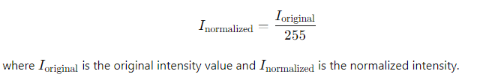
- Normalization: Each pixel intensity is scaled to a [0, 1] range by dividing by 255. This normalization step ensures that all input values are within a standard range, leading
- Data Augmentation: Data augmentation techniques are used to artificially expand the dataset size and improve model generalization. For IDC classification, augmentation strategies included:
  - Random Rotation: Rotates images by a random degree (e.g., ±15 degrees), helping the model learn orientation-invariant features.
  - Flipping: Horizontal and vertical flips are applied to simulate various viewpoints.
  - Zoom and Cropping: Controlled zooms and center crops replicate varying magnifications, improving the model’s robustness to scale changes.
- Class Balance Considerations: If the dataset is imbalanced (i.e., more non-IDC images than IDC images), techniques like upsampling or oversampling can be applied to the minority class. Alternatively, class weights in the loss function can be adjusted to give more importance to underrepresented classes.
3.3 Data Splitting
To ensure that the model’s performance is accurately evaluated, the dataset is divided into three subsets:
- Training Set (70%): Used for optimizing the model’s weights.
- Validation Set (15%): Used to evaluate model performance during training, guiding hyperparameter tuning.
- Test Set (15%): Held out until final evaluation to assess model performance on unseen data.
Stratification ensures that each subset has a balanced distribution of IDC and non-IDC classes.
3.4 Transfer Learning Model
Transfer learning involves adapting a pre-trained model, such as ResNet50 or VGG16, to IDC classification. Here’s the step-by-step process:
- Feature Extraction: In transfer learning, early layers of the pre-trained model are preserved (i.e., frozen). These layers act as generalized feature extractors that have already learned useful low- and mid-level image features (like edges, textures, and simple shapes) from large-scale datasets (e.g., ImageNet).
- Fine-Tuning Layers: For the IDC task, the final classification layers of the pre-trained model are replaced with a custom binary classifier. This involves:
  - Replacing the Fully Connected Layer: The original fully connected (dense) layer of the pre-trained model is replaced with a smaller dense layer with two output units (representing IDC and non-IDC), followed by a sigmoid activation function. The sigmoid activation outputs a probability score:

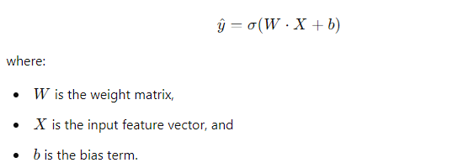
- Training Only the Classifier Layers: Initially, only the new classifier layers are trained while the other layers remain frozen. This ensures that the model quickly learns the specifics of the IDC data without altering the pre-learned general features.
- Fine-Tuning Selected Layers: For improved performance, selected layers in the deeper parts of the pre-trained network (closer to the output) are unfrozen and fine-tuned, allowing the model to adapt high-level feature representations specifically for IDC classification.
3.5 CNN-Based Model
The custom CNN model is designed to process IDC images directly, focusing on building relevant features without using a pre-trained model. Key components of this model include:
- Convolutional Layers: These layers apply filters to extract spatial hierarchies from images. Each filter convolves across the input image to detect patterns:
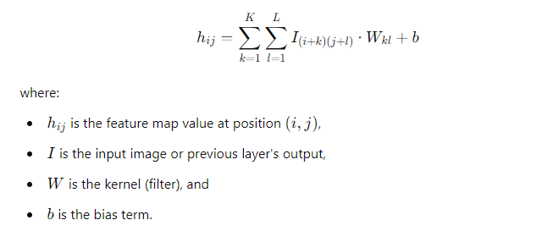
The model may use multiple convolutional layers with different filter sizes to capture a diverse set of patterns, starting from basic edges to more complex tissue features in deeper layers.
- Activation Functions (ReLU): The Rectified Linear Unit (ReLU) activation function is applied after each convolution to introduce non-linearity:
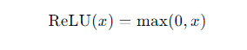

ReLU helps the model learn complex patterns by ensuring that only positive activations pass forward, effectively reducing computation and handling vanishing gradients.
- Pooling Layers (Max-Pooling): Max-pooling layers reduce the spatial dimensions of the feature maps, retaining only the most relevant features. For instance:
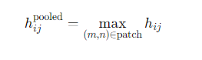

Pooling adds robustness by reducing overfitting and improving the model’s ability to handle image translations and distortions.
- Fully Connected Layers: After the convolutional and pooling layers, the model flattens the feature maps and passes them through fully connected layers, which combine all features to classify the image. The output layer uses a sigmoid activation function to output probabilities for IDC vs. non-IDC classification.
- Regularization Techniques: Dropout layers may be added after the fully connected layers to prevent overfitting by randomly setting a fraction of the activations to zero during training. This prevents co-adaptation of features, improving model generalization.

4. Model Training

4.1 Optimization Algorithm
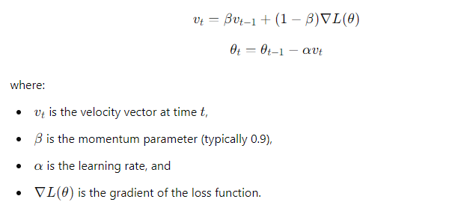
Stochastic Gradient Descent (SGD) with momentum is used to optimize model parameters. Momentum accelerates convergence and reduces oscillations by maintaining a “momentum” vector in the gradient direction:

4.2 Loss Function
Binary cross-entropy loss, ideal for binary classification, was selected:
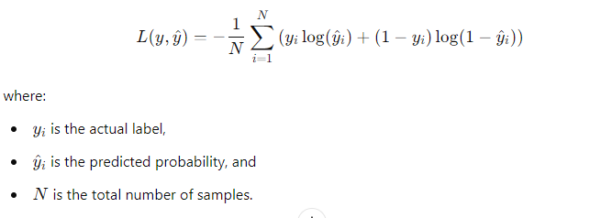

This loss function penalizes incorrect classifications, encouraging the model to output probabilities close to the true labels.
4.3 Training Procedure
Training a deep learning model involves a series of iterative steps that adjust model parameters to minimize the prediction error. Below, we outline each component of this process, including the mathematical foundation and strategies used to ensure effective learning.
1. Forward Propagation
- In forward propagation, each input image passes sequentially through each layer of the model, which applies filters, activations, and pooling to extract features and make a prediction.
- Convolution and Pooling Layers: For CNNs, each convolution layer applies a set of filters (kernels) to extract localized patterns from input images. Each convolution operation can be represented as:
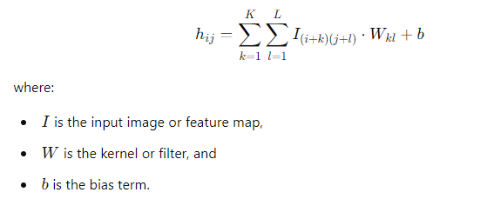

- Activation Functions: Non-linear functions, like ReLU (Rectified Linear Unit), are applied after convolutions to introduce non-linearity. This is essential for modeling complex relationships in data. For ReLU, the function is:

- Output Layer: After passing through several layers, the processed image reaches the output layer, which uses a sigmoid activation function for binary classification, producing a probability score for the IDC class.

2. Backpropagation
- Backpropagation is a method to minimize prediction errors by calculating gradients (partial derivatives) of the loss function with respect to each model parameter. It enables the model to adjust weights and biases toward reducing the error on subsequent predictions.
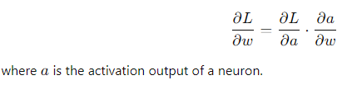
- Gradient Computation: During backpropagation, the gradients of the loss function L with respect to each weight 𝑤 and bias 𝑏 are calculated. For each parameter, the chain rule is applied to calculate how much each parameter contributes to the error:

- Backpropagating through Layers: The error is propagated backward from the output layer to the initial layers, updating weights in each layer to minimize the loss.
3. Parameter Update
- Once gradients are calculated, they are used to update the model parameters using an optimization algorithm. In this case, Stochastic Gradient Descent (SGD) with momentum is employed:
  - SGD Update Rule: Each parameter θ is updated in the direction that reduces the loss:

  - Momentum: Momentum helps smooth out updates by adding a fraction of the previous update to the current one, defined as
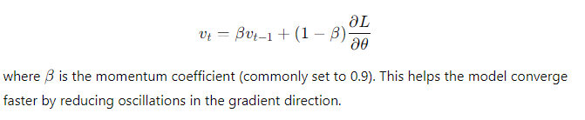
4. Early Stopping
- Purpose: Early stopping monitors the validation loss to prevent overfitting. If validation loss does not improve over a specified number of epochs, training stops to avoid further adjustments that might harm generalization.
- Implementation: During training, the validation loss is checked at the end of each epoch. If it fails to improve over several epochs (determined by a patience parameter), training halts.
- Impact: Early stopping ensures that the model retains its best validation performance, enhancing its ability to generalize to new, unseen data.

4.4 Hyperparameter Tuning
Hyperparameters, unlike model parameters (weights and biases), are manually set and determine the overall behavior of the training process. Effective tuning is essential for optimal model performance. Here’s a breakdown of the hyperparameters tuned for IDC classification:
1. Learning Rate (α)
- The learning rate controls the step size at each update during training. A large learning rate accelerates training but risks overshooting the optimal parameter values. A small learning rate is more precise but can lead to slower convergence or getting stuck in local minima.
- Optimization Process: Learning rate values were tested over a range (e.g., 0.001 to 0.1), selecting the rate that produced the lowest validation loss while maintaining training stability.

2. Batch Size
- The batch size is the number of training samples processed before updating the model’s parameters. Larger batch sizes provide more stable gradient estimates but require more memory, whereas smaller batch sizes introduce more noise but can lead to faster generalization.
- Tuning: The batch size was tested in multiples of 8, commonly in the range of 16 to 128. The chosen batch size balanced memory requirements and convergence speed, maximizing efficiency on the available hardware.

3. Momentum (β)
- Momentum (typically set between 0.8 and 0.99) accelerates convergence in the relevant gradient direction, reducing oscillations across the error landscape. It helps stabilize learning, especially in regions where gradients change direction rapidly.
- Tuning: After experimenting with values between 0.8 and 0.99, a momentum of 0.9 was selected, as it provided a balance between convergence speed and stability.
4. Early Stopping Patience
- The patience parameter specifies the number of epochs to wait before halting training if the validation loss stops improving. Early stopping prevents overfitting, especially when the model starts memorizing rather than generalizing.
- Tuning: Patience was set between 5 and 10 epochs, choosing a value that allowed the model to recover from minor fluctuations but stopped training once overfitting risks increased.
Parameter | Value
Epochs | 29
Batch Size | 32
Optimization Algorithm | SGD
Learning Rate | 0.01
Loss Function | Binary Cross-Entropy

5. Summary
This methodology integrates CNN-based custom architecture with transfer learning, enabling high accuracy in IDC classification. The combination of data preprocessing, augmentation, and careful model training creates a robust framework for classifying IDC in histopathology images, potentially aiding early diagnosis and effective treatment planning.

