Extensions: 2
Shortcuts: 4
Virtualization: 5
Software: 6
Setting up Appimage Applications: 7
Installing Applications from Software Store error: 9
Bluetooth auto start at startup fix: 9

Extensions:
Install extension manager manually:
flatpak remote-add --if-not-exists flathub https://dl.flathub.org/repo/flathub.flatpakrepo
flatpak install flathub com.mattjakeman.ExtensionManager
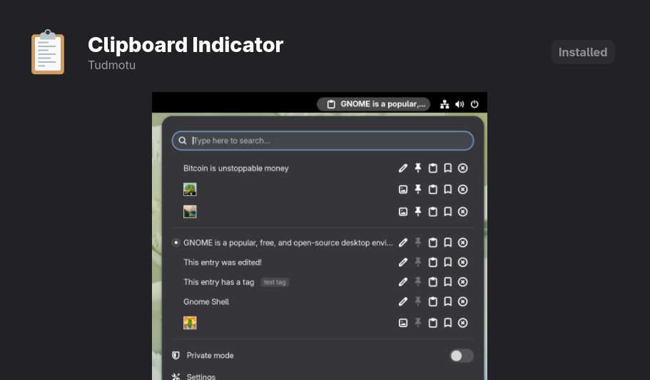

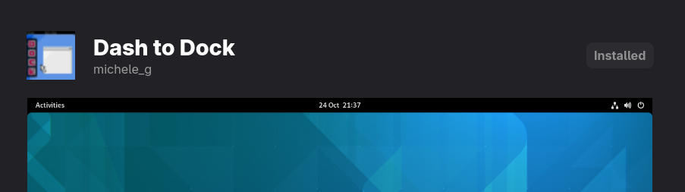
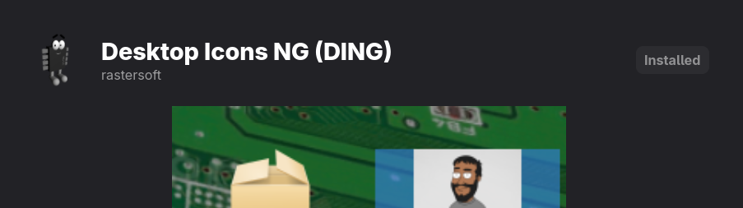
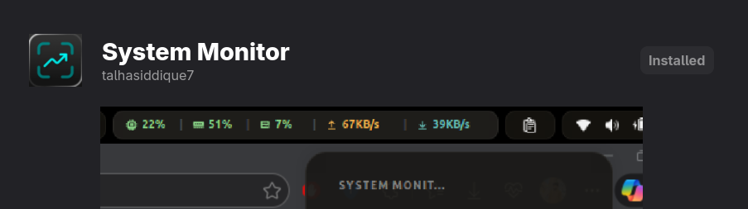

Shortcuts:
To take a screenshot, Press Printscreen Button
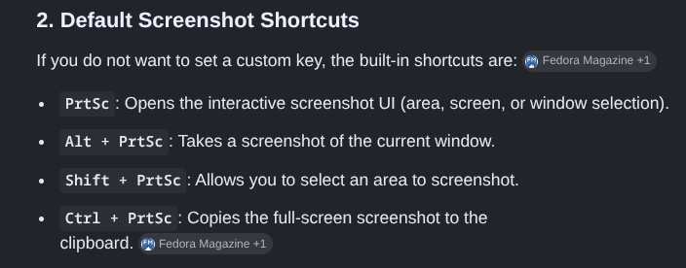
Open Terminal:
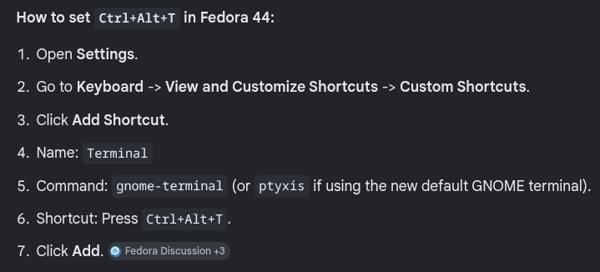
Minimize All windows and go to desktop:
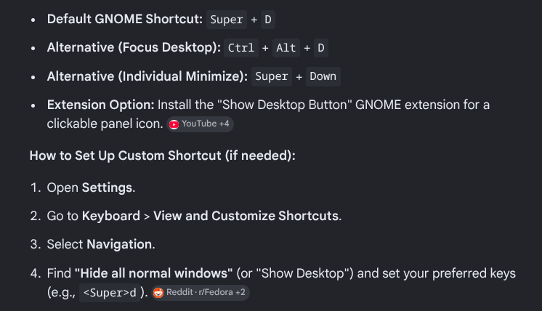

Virtualization:
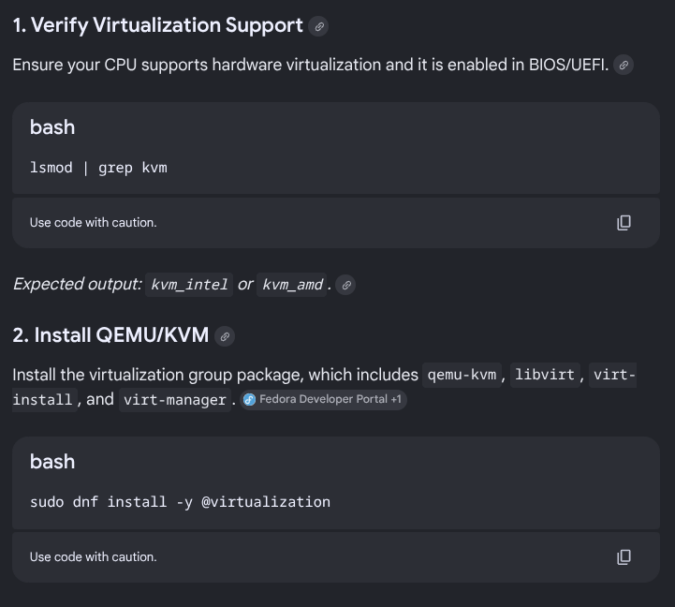
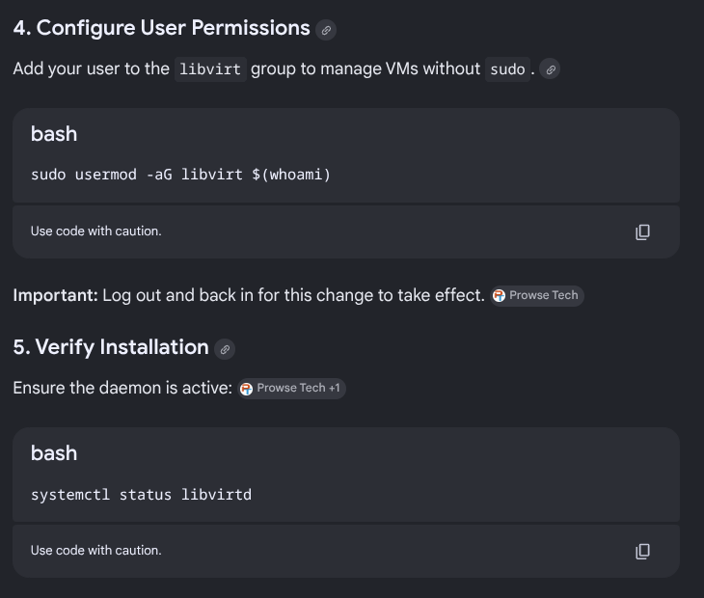
i) Always choose BIOS while creating a new VM.
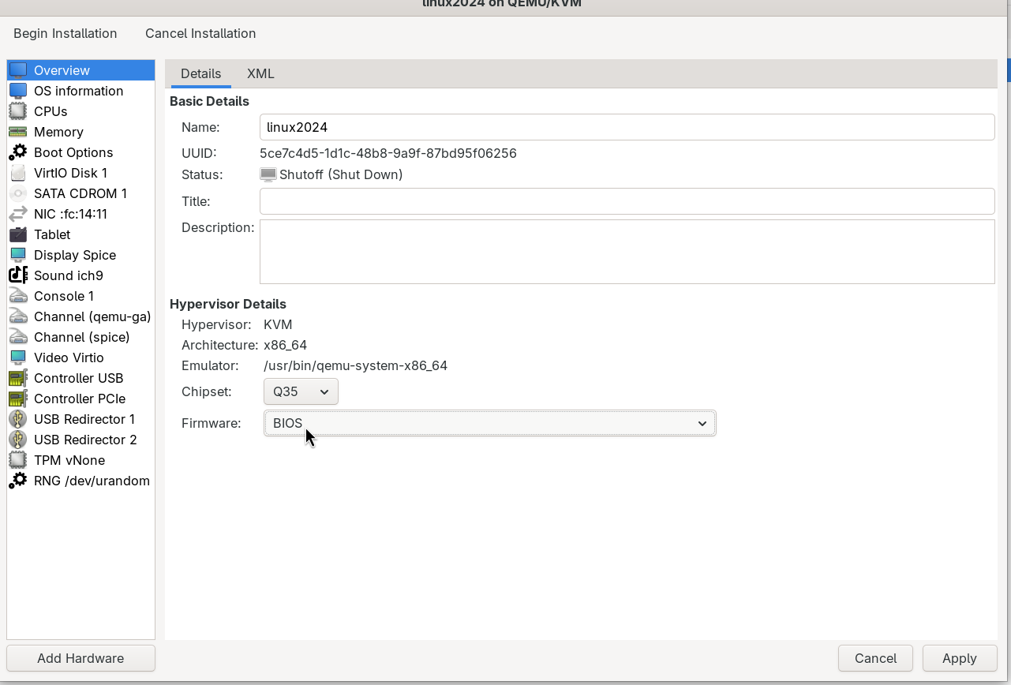

Software:
Brave Browser:
sudo dnf install dnf-plugins-core
sudo dnf config-manager addrepo --from-repofile=https://brave-browser-rpm-release.s3.brave.com/brave-browser.repo
sudo dnf install brave-browser

Firefox Browser:
Sudo dnf install firefox

Setting up Appimage Applications:
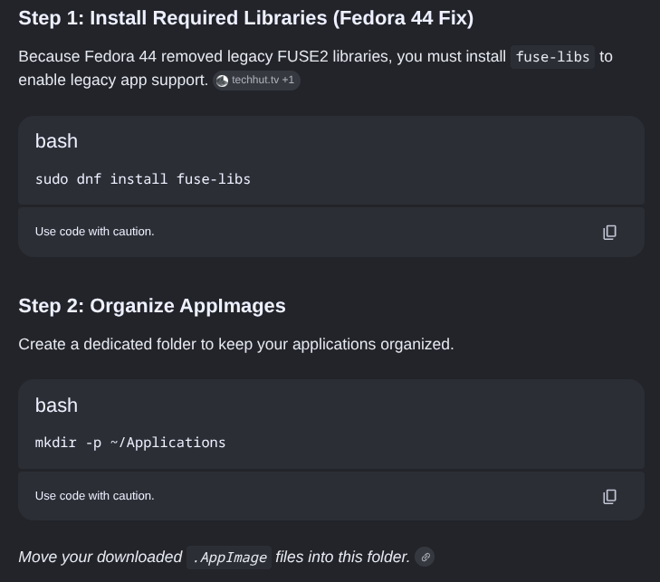
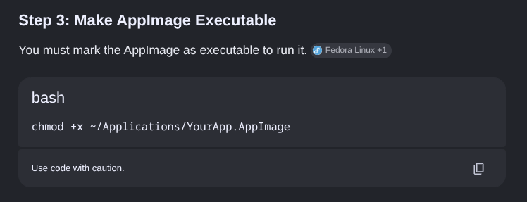
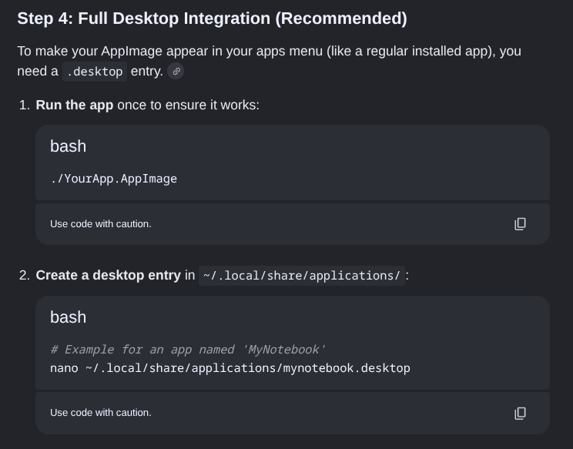
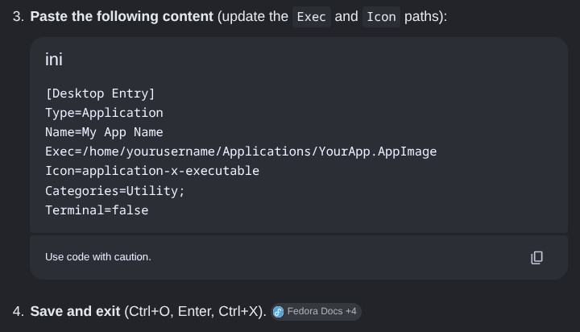
[Desktop Entry]
Type=Application
Name=My App Name
Exec=/home/yourusername/Applications/YourApp.AppImage
Icon=application-x-executable
Categories=Utility;
Terminal=false

Installing Applications from Software Store error:
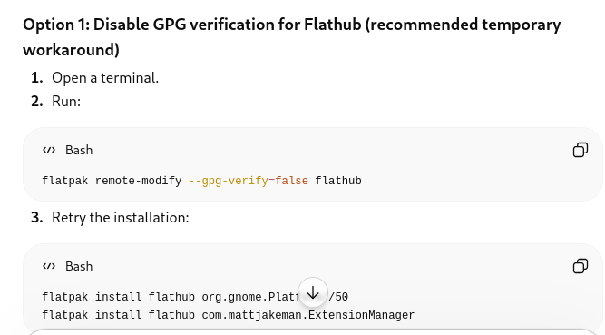
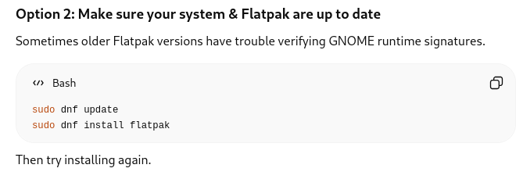
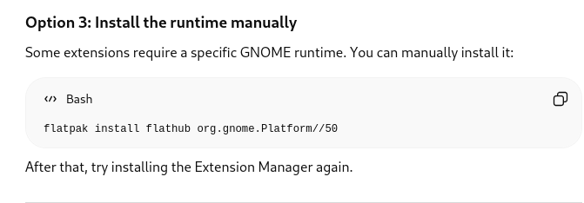

Bluetooth auto start at startup fix:
On Fedora, the most reliable way to stop Bluetooth from being enabled automatically at startup is to disable the Bluetooth service or configure it to remain off after reboot.
