LAB-11

WEB PROGRAMMING

Name: Vinit Yadav

Reg No: 23BCE1767

Q1)

Code:

<!DOCTYPE html>

<html lang="en">

<head>

<meta charset="UTF-8">

<meta name="viewport" content="width=device-width, initial-scale=1.0">

<title>Dynamic Table & Events</title>

</head>

<body>

<style src="styles.css"></style>

<script src="script.js"></script>

</body>

</html>

js

// (i) Create a dynamic table with three rows and three columns

const table = document.createElement("table");

table.border = "1";

for (let i = 0; i < 3; i++) {

let row = table.insertRow();

for (let j = 0; j < 3; j++) {

let cell = row.insertCell();

cell.innerText = `Row ${i + 1}, Col ${j + 1}`;

}

}

document.body.appendChild(table);

// (ii) Change the color of the Button from red to green color on Mouse Over

const button = document.createElement("button");

button.innerText = "Hover me";

button.style.backgroundColor = "red";

button.onmouseover = () => button.style.backgroundColor = "green";

button.onmouseout = () => button.style.backgroundColor = "red";

document.body.appendChild(button);

// (iii) Change the color of the Textbox from green to yellow color on Focus and display a greeting message on Change

const textbox = document.createElement("input");

textbox.type = "text";

textbox.style.backgroundColor = "green";

textbox.onfocus = () => textbox.style.backgroundColor = "yellow";

textbox.onchange = () => alert("Hello, you changed the text!");

document.body.appendChild(textbox);

// (iv) Create an input field and a button to add input text as an <li> item on double click

const inputField = document.createElement("input");

const addButton = document.createElement("button");

addButton.innerText = "Add Item";

const ul = document.createElement("ul");

addButton.ondblclick = () => {

if (inputField.value.trim() !== "") {

let li = document.createElement("li");

li.innerText = inputField.value;

ul.appendChild(li);

inputField.value = "";

}

};

document.body.appendChild(inputField);

document.body.appendChild(addButton);

document.body.appendChild(ul);

// (v) Create two input fields: one for input and another for counting keypresses

const keyInput = document.createElement("input");

const keyCount = document.createElement("input");

keyCount.readOnly = true;

let count = 0;

keyInput.onkeydown = () => {

count++;

keyCount.value = count;

};

document.body.appendChild(keyInput);

document.body.appendChild(keyCount);

Output:

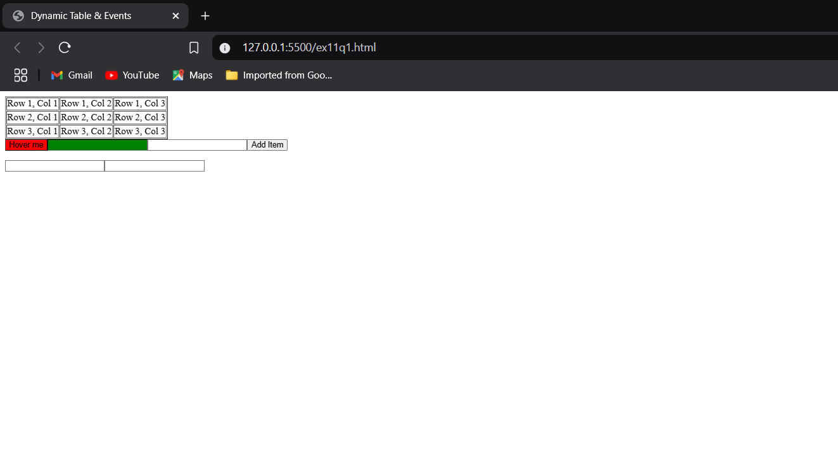

Q2)

Code:

<!DOCTYPE html>

<html lang="en">

<head>

    <meta charset="UTF-8">

    <meta name="viewport" content="width=device-width, initial-scale=1.0">

    <title>23BCE1767</title>

</head>

<body>

    <script>

        let timer;

        let seconds = 0;

        const display = document.createElement("span");

        const startButton = document.createElement("button");

        const stopButton = document.createElement("button");

        const resetButton = document.createElement("button");

        startButton.innerText = "Start";

        stopButton.innerText = "Stop";

        resetButton.innerText = "Reset";

        display.innerText = "0s";

        startButton.onclick= ()=>{

            if (!timer){

                timer = setInterval(()=>{

                    seconds=seconds+0.01;

                    display.innerText=`${seconds}s`

                },10)

            }

        }

        stopButton.onclick = () =>{

            clearInterval(timer);

            timer = null;

        }

        resetButton.onclick = () =>{

            clearInterval(timer);

            timer=null;

            seconds = 0;

            display.innerText=`0s`

        }

        document.body.appendChild(display);

        document.body.appendChild(startButton);

        document.body.appendChild(stopButton);

        document.body.appendChild(resetButton);

        //dob part

        const dobInput = document.createElement("input")

        const dobDisplay = document.createElement("span")

        dobInput.type="date"

        dobInput.onchange = () => {

            if (dobInput.value){

                let birthDate = new Date(dobInput.value)

                let age = new Date().getFullYear() - birthDate.getFullYear();

                dobDisplay.innerText = `\nYour age is ${age}`

            }

        }

        document.body.appendChild(dobInput)

        document.body.appendChild(dobDisplay)

        const textArea = document.createElement("textarea")

        const countDisplay = document.createElement("span")

        countDisplay.innerText=`\nThere are exactly 0 characters in the textarea.`

        textArea.oninput = () =>{

            countDisplay.innerText=`\nThere are exactly ${textArea.value.length} characters in the textarea.`

        }

        document.body.appendChild(document.createElement("br"))

        document.body.appendChild(textArea)

        document.body.appendChild(countDisplay)

    </script>

</body>

</html>

Output:

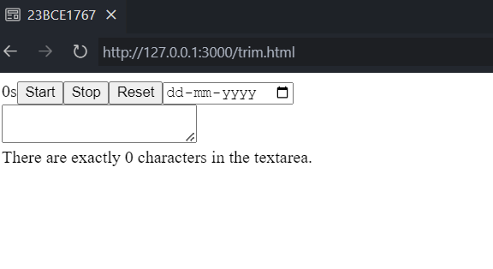

Q3)

Code:

<!DOCTYPE html>

<html lang="en">

<head>

    <meta charset="UTF-8">

    <meta name="viewport" content="width=device-width, initial-scale=1.0">

    <title>23BCE1767</title>

    <link rel="stylesheet" href="styles.css">

</head>

<body>

    <div id="parent">

        <span id="timer">timer</span>

        <form id="signupform">

            <h1>Test JavaScript Form Validation</h1>

            <label>Name:<input id="name" name="name" required></label>

            <label>Address:<input id="address" name="address"></label>

            <label>Zipcode:<input id="zipcode" name="zipcode" required></label>

            <label>Select Country:

                <select id="country" name="country" required>

                    <option value="">Select</option>

                    <option value="India">India</option>

                    <option value="Other">Other</option>

                </select>

            </label>

            <label>Gender:

                <input type="radio" id="male" value="Male" name="gender" required> Male

                <input type="radio" id="female" value="Female" name="gender" required> Female

            </label>

            <label>Preferences:

                <input type="checkbox" id="red" value="Red" name="preferences"> Red

                <input type="checkbox" id="blue" value="Blue" name="preferences"> Blue

                <input type="checkbox" id="green" value="Green" name="preferences"> Green

            </label>

            <label>Phone:<input id="phone" name="phone" required></label>

            <label>E-mail:<input id="email" name="email" type="email" required></label>

            <label>Password:<input id="password" name="password" type="password" required></label>

            <label>Re-enter Password:<input id="verifyPassword" name="verifyPassword" type="password" required></label>

            <label>PAN no:<input id="pan" name="pan" type="text"></label>

            <div id="buttoncontainer">

                <button type="submit">Send</button>

                <button type="reset">Clear</button>

            </div>

        </form>

    </div>

    <script src="script.js"></script>

</body>

</html>

Output:

