Web Programming Lab

Exercise-8

Name – Vinit Yadav

Reg No- 23BCE1767

Task1:

Code:

<!DOCTYPE html>

<html lang="en">

<head>

    <meta charset="UTF-8">

    <meta name="viewport" content="width=device-width, initial-scale=1.0">

    <title>Basic Calculator</title>

</head>

<body>

    <h2>Basic Calculator</h2>

    <script>

        function calculator() {

            let num1 = parseFloat(prompt("Enter the first number:"));

            let num2 = parseFloat(prompt("Enter the second number:"));

            let operation = prompt("Choose an operation (+, -, \*, /, %):");

            let result;

            if (operation === "+") {

                result = num1 + num2;

            } else if (operation === "-") {

                result = num1 - num2;

            } else if (operation === "\*") {

                result = num1 \* num2;

            } else if (operation === "/") {

                if (num2 === 0) {

                    result = "Cannot divide by zero!";

                } else {

                    result = num1 / num2;

                }

            } else if (operation === "%") {

                result = num1 % num2;

            } else {

                result = "Invalid operation!";

            }

            alert("The result is: " + result);

        }

        calculator();

    </script>

</body>

</html>

Output:

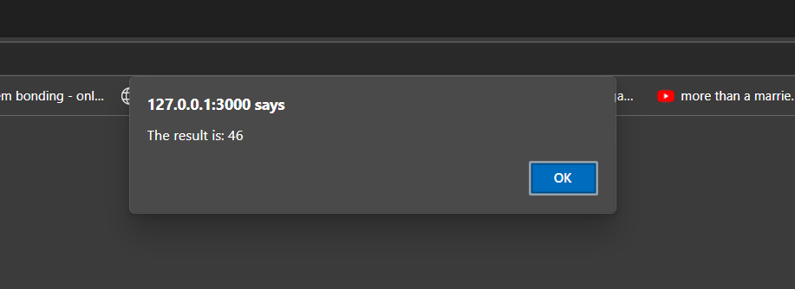

Task 2:

Code:

<!DOCTYPE html>

<html lang="en">

<head>

    <meta charset="UTF-8">

    <meta name="viewport" content="width=device-width, initial-scale=1.0">

    <title>Eligibility to Drive</title>

</head>

<body>

    <h2>Eligibility Check</h2>

    <script>

        function checkEligibility() {

            let age = parseInt(prompt("Please enter your age:"));

            if (age >= 18) {

                alert("You are eligible to drive.");

            } else {

                alert("You are not eligible to drive.");

            }

        }

        checkEligibility();

    </script>

</body>

</html>

Output:

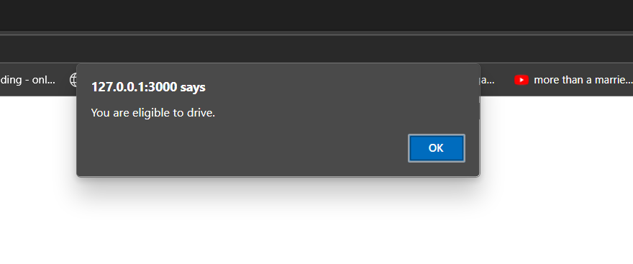

Task 3:

Code:

<!DOCTYPE html>

<html lang="en">

<head>

    <meta charset="UTF-8">

    <meta name="viewport" content="width=device-width, initial-scale=1.0">

    <title>Student Confirmation</title>

</head>

<body>

    <h2>Student Registration</h2>

    <script>

        function checkStudentStatus() {

            let regNumber = prompt("Please enter your registration number:");

            let isStudent = confirm("Are you a student?");

            if (isStudent) {

                alert("You are confirmed as a student. Registration Number: " + regNumber);

            } else {

                alert("You are not a student. Registration Number: " + regNumber);

            }

        }

        checkStudentStatus();

    </script>

</body>

</html>

Output:

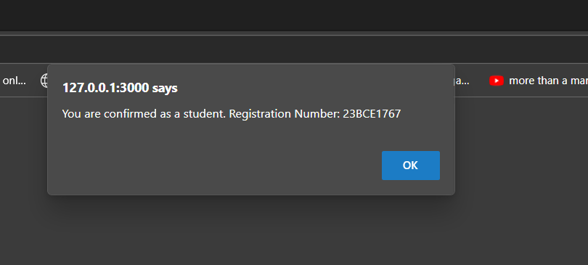

Task 4:

Code:

<!DOCTYPE html>

<html lang="en">

<head>

    <meta charset="UTF-8">

    <meta name="viewport" content="width=device-width, initial-scale=1.0">

    <title>Labour Cost Calculator</title>

</head>

<body>

    <h2>Labour Cost and Total Charge Calculator</h2>

    <script>

        function calculateCost() {

            let ratePerHour = 45;

            let hoursWorked = parseFloat(prompt("Enter the number of hours worked:"));

            let costOfMaterials = parseFloat(prompt("Enter the cost of materials (in Rs.):"));

            let labourCost = ratePerHour \* hoursWorked;

            let totalCharge = labourCost + costOfMaterials;

            alert("Labour Cost: Rs." + labourCost);

            alert("Total Charge: Rs." + totalCharge);

        }

        calculateCost();

    </script>

</body>

</html>

Output:

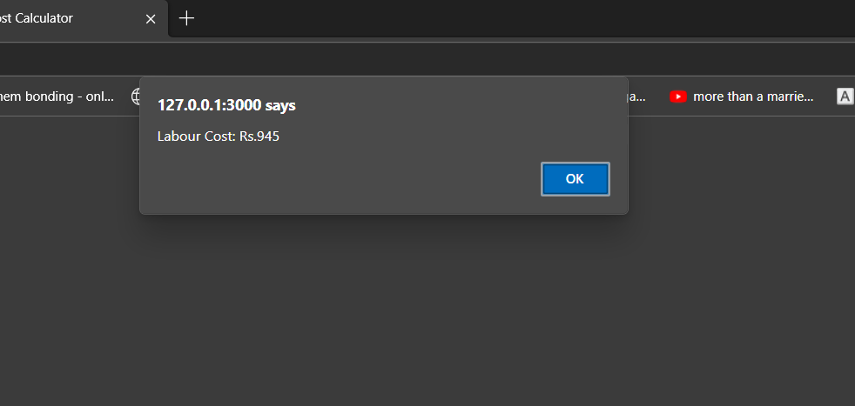

Task 5:

Code:

<!DOCTYPE html>

<html lang="en">

<head>

    <meta charset="UTF-8">

    <meta name="viewport" content="width=device-width, initial-scale=1.0">

    <title>Display Registration and Name</title>

</head>

<body>

    <h1>Enter Registration Number and Name</h1>

    <label for="regNo">Registration Number: </label>

    <input type="text" id="regNo"><br><br>

    <label for="name">Name: </label>

    <input type="text" id="name"><br><br>

    <button onclick="displayInfo()">Display</button>

    <script>

        function displayInfo() {

            var regNo = document.getElementById('regNo').value;

            var name = document.getElementById('name').value;

            document.write('<div style="border: 5px solid red; font-weight: bold; color: black; padding: 20px; width: 300px; margin-bottom: 10px;">' + regNo + '</div>');

            var nameBox = document.createElement('div');

            nameBox.style.border = '2px solid black';

            nameBox.style.fontWeight = 'normal';

            nameBox.style.color = 'red';

            nameBox.style.fontSize = '20px';

            nameBox.style.padding = '15px';

            nameBox.style.width = '300px';

            nameBox.textContent = name;

            document.body.appendChild(nameBox);

        }

    </script>

</body>

</html>

Output:

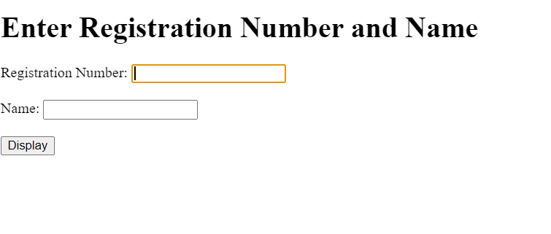

Task 6:

Code:

Html:

<!DOCTYPE html>

<html lang="en">

<head>

    <meta charset="UTF-8">

    <meta name="viewport" content="width=device-width, initial-scale=1.0">

    <title>Circus Ticket Booth</title>

    <style>

        body {

            font-family: Arial, sans-serif;

            padding: 20px;

        }

        .container {

            margin-bottom: 20px;

        }

        label, input, button {

            margin: 5px;

        }

        #totalAmount {

            margin-top: 10px;

        }

    </style>

</head>

<body>

    <h1>Welcome to the Circus Ticket Booth</h1>

    <div class="container">

        <label for="adultTickets">Adult Tickets (₹20 each): </label>

        <input type="number" id="adultTickets" min="0" value="0">

    </div>

    <div class="container">

        <label for="childTickets">Child Tickets (₹10 each): </label>

        <input type="number" id="childTickets" min="0" value="0">

    </div>

    <div class="container">

        <button onclick="calculateTotal()">Total</button>

    </div>

    <div id="totalAmount">

        <label>Total Amount: ₹</label>

        <input type="text" id="totalAmountDisplay" readonly>

    </div>

    <script src="ex8qq1.js"></script>

</body>

</html>

js:

function calculateTotal() {

    var adultTickets = document.getElementById('adultTickets').value;

    var childTickets = document.getElementById('childTickets').value;

    adultTickets = parseInt(adultTickets);

    childTickets = parseInt(childTickets);

    var adultPrice = 20;

    var childPrice = 10;

    var totalAmount = (adultTickets \* adultPrice) + (childTickets \* childPrice);

    document.getElementById('totalAmountDisplay').value = totalAmount;

}

Output:

