**# lecture 2 queries: (lab 1)**

1.select * from emp;

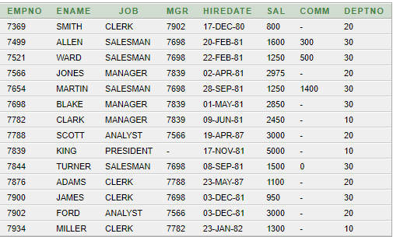

2.select distinct ename from emp;

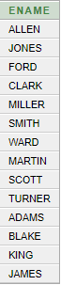

3.select ename , sal , sal+500 "Bonus" from emp;

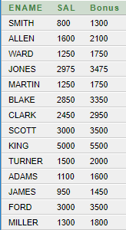

4.select ename , sal , sal*12 "Annual" from emp;

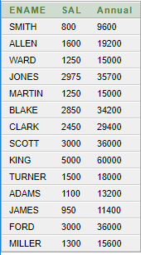

5.select ename , sal , sal+comm as Commision from emp;

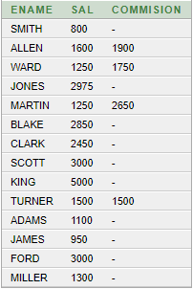

6.select ename , sal from emp where sal>=3000;

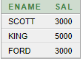

7.select ename as name , sal salary from emp;

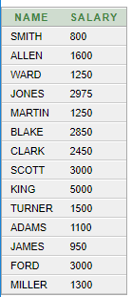

8.select ename||' '||job "Name and Job" from emp;

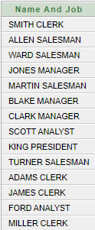

**Lab 1 Exercise:**

1.select ename , deptno from emp;

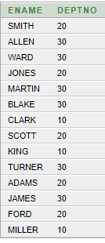

2.select job from emp where deptno = 30;

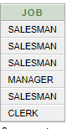

3.select loc "Location" from dept where deptno = 30;



4.select ename , empno from emp where comm>0;

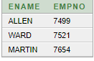

5.select ename , deptno from emp where ename like '%A%';

