1. Checking the git version



2. Set config values

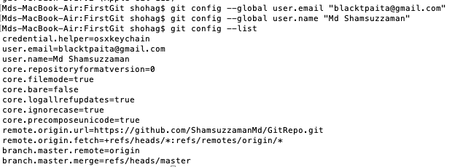

3. git help

git help config

git config --help

git add –help

4. At a glance

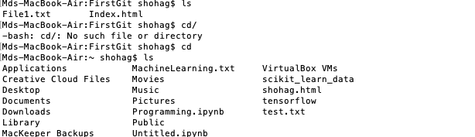

4. Repository initialization



5. git Status



6. git Touch and status

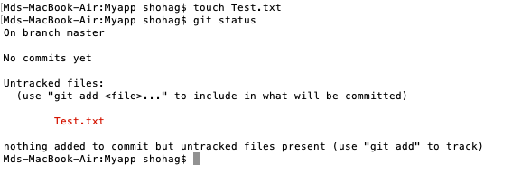

7. git add and status

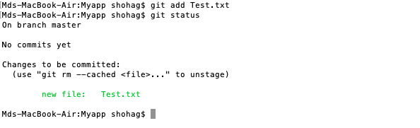

8. git commit and status

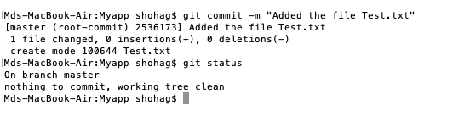

9. Another file and update

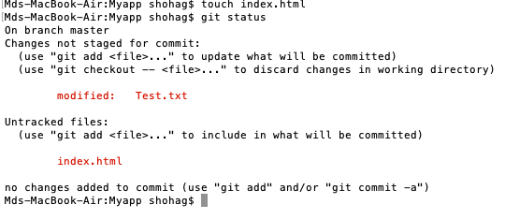

10. Updating the files and modification

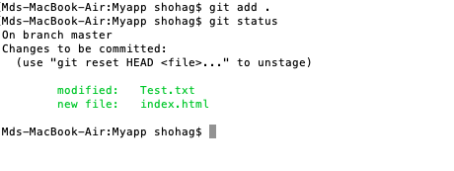

11. Updating the files and modification

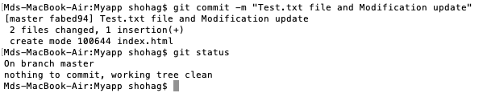

12. Remote repository in github



13. git push

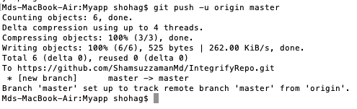

14. git log

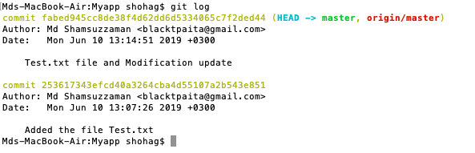

15. git branch



16. git checkout



17. Addition of new file and pushing

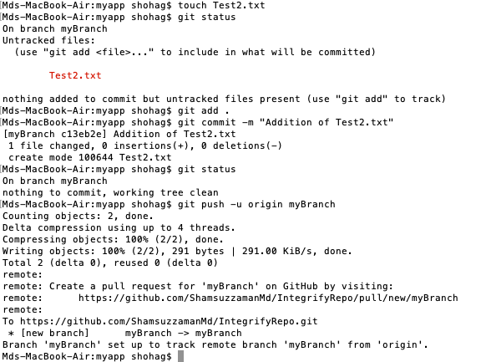

18. merge

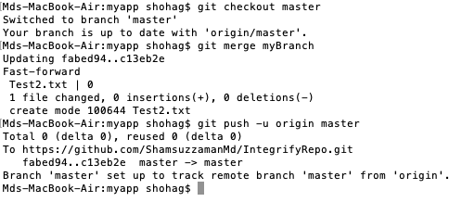

19. delete



20. git tag

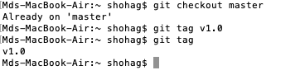

21. annotated tag

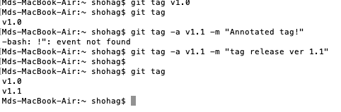

22. tag showing

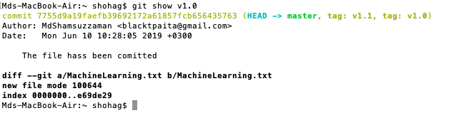

23. All tags with v1 or .



24. git clone

