Cognizant - DN 4.0 Deep Skilling Stage

Design Patterns and Principles

Shamyukthaa P

**Exercise 1: Implementing the Singleton Patterns**

package com.cts;

public class Logger {

private static Logger instance;

private Logger() {

System.out.println("Logger Instance has been created");

}

public static Logger getInstance() {

if(instance==null) {

instance = new Logger();

}

return instance;

}

public void log(String message) {

System.out.println("Log: "+message);

}

}

package com.cts;

public class SingletonTest {

public static void main(String[] args) {

Logger logger1 = Logger.getInstance();

Logger logger2 = Logger.getInstance();

logger1.log("Application began");

logger2.log("Performing tasks");

if(logger1==logger2) {

System.out.println("Only one instance is created");

}

else {

System.out.println("Different Logger instances exist");

}

}

}

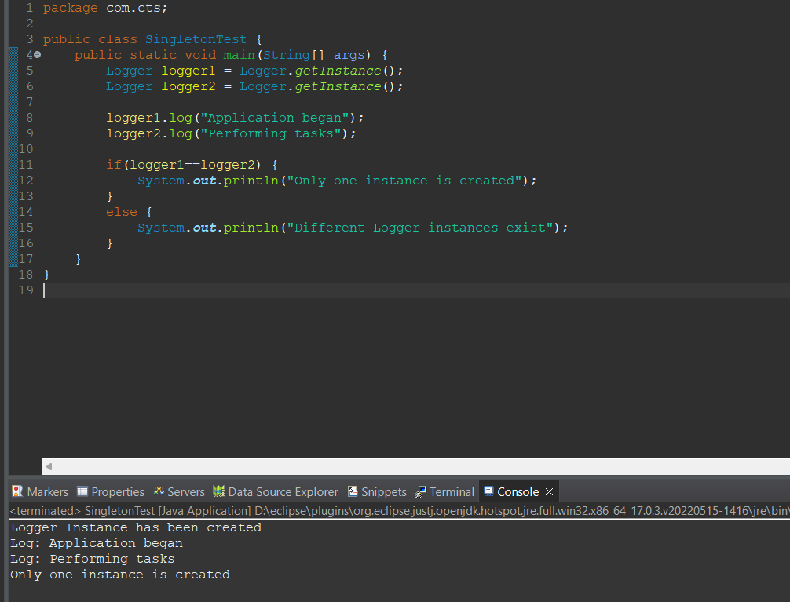

**Exercise 2: Implementing the Factory Method Pattern**

package com.cts;

//interface implementation

public interface Document {

void open();

}

package com.cts;

public class Excel implements Document {

*@Override*

public void open() {

// **TODO** Auto-generated method stub

System.out.println("Opening a Excel document");

}

}

package com.cts;

public class Pdf implements Document {

*@Override*

public void open() {

System.out.println("Opening a pdf document");

}

}

package com.cts;

public class Word implements Document {

public void open() {

System.out.println("Opening a Word document");

}

}

//Implementing FactoryMethod

package com.cts;

public abstract class DocumentFactory {

public abstract Document createDocument();

}

package com.cts;

public class ExcelFactory extends DocumentFactory{

public Document createDocument() {

return new Excel();

}

}

package com.cts;

public class PdfFactory extends DocumentFactory{

public Document createDocument() {

return new Pdf();

}

}

package com.cts;

public class WordFactory extends DocumentFactory {

*@Override*

public Document createDocument() {

return new Word();

}

}

//Test Class

package com.cts;

public class FactoryMethodTest {

public static void main(String[] args) {

DocumentFactory wordFactory = new WordFactory();

Document wordDoc = wordFactory.createDocument();

wordDoc.open();

DocumentFactory pdfFactory = new PdfFactory();

Document pdfDoc = pdfFactory.createDocument();

pdfDoc.open();

DocumentFactory excelFactory = new ExcelFactory();

Document excelDoc= excelFactory.createDocument();

excelDoc.open();

}

}

