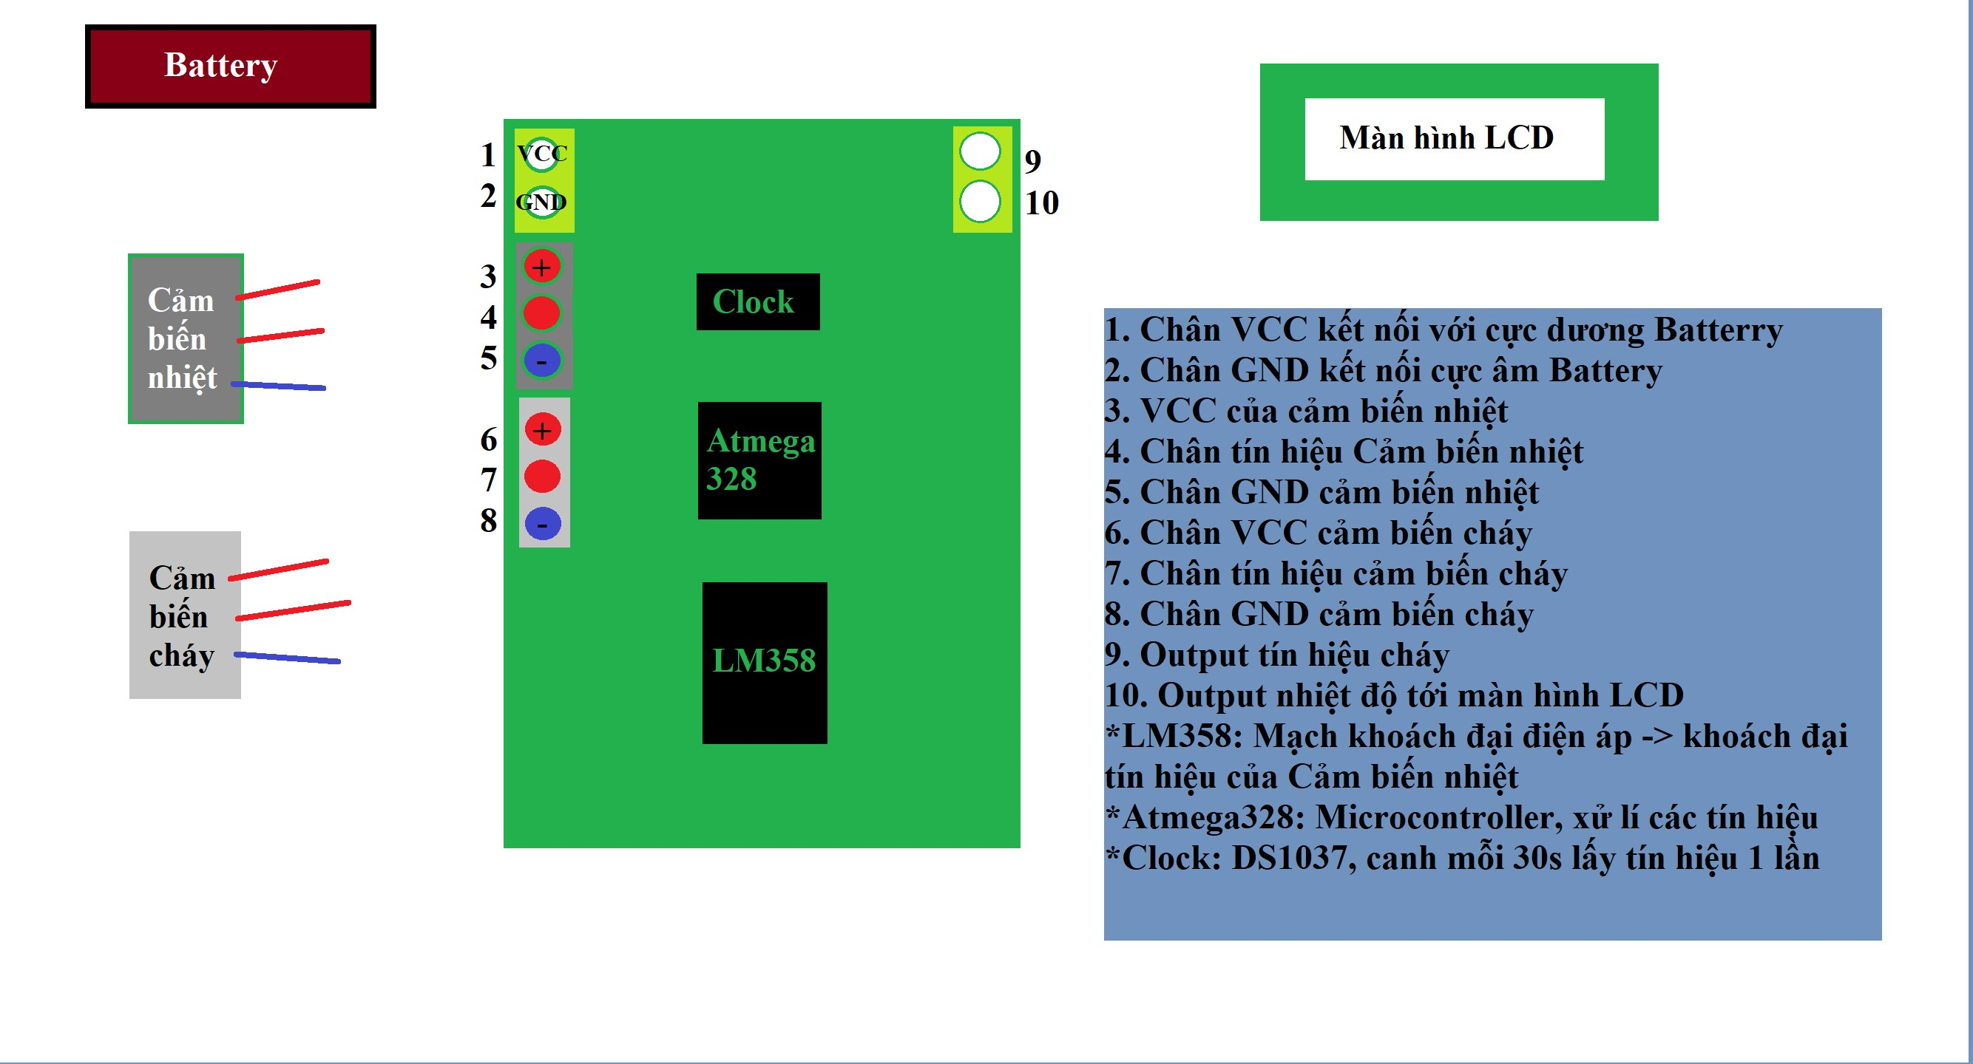

**2112711 Nguyễn Thanh Tùng**

**2111869 Lê Chánh Nguyên**

**2013037 Danh Sơn Hà**

**SPECIFICATION**

**Mechanical**

Size: Diam 15mm Height: 20mm

Weight: 900g

**Environmental**

Operating temparature: -20 - 60oC

Storage temparature: -40 - 65oC

Humidity: 5 - 95%Rel

**Power**

**External Power Supply**

Input

Input Voltage: 9 12V

Input Current: 280 mA

**Internal Battery (Rechargeable)**

Chemistry: Lithium Ion

Terminal Voltage: 9V

Capacity 280 mAh

**Sensor Power Output**

Output Voltage: 3.3 5V

Output Current: ?

**Digital Output**

Output Voltage: 3.3 5V

Output Current: ?

**Clock**

**DS1307Z+**

Accuracy(0oC to 70oC) ? ?ppm

Communication: 2-Wire

**Fire Dectection Sensor:**

**Lm393 Fire Detection Infrared Sensor Circuit**

Detect flame range: 760 1100nm

Capability: >= 15mA

Operating Voltage: 3.3 5V

**Temparature Sensor:**

**PT100** **type A**

lenght: 1.5M

temperature detection : -50 ~ 200oC

**Microcontroller:**

**ATMega328**

Peripherals: Brown-out Detec t/ Reset, HLVD, POR, PWM, WDT

Number of I /O: 14

Program Memory Size: 32KB

Program Memory Type: FLASH

EEPROM Size: 1KB

RAM Size: 2K

Voltage – Supply (Vcc/Vdd): 4.2 V ~ 5.5 V

Data Converters: A/D 6 x 10bit

Oscillator Type: Internal

Operating Temperature: -40°C ~ 85°C

Package / Case: 28-SOIC (0.295″, 7.50mm Width)