CISC7204 - Assignment 02: Preliminary Project Proposal
Course: CISC7204 Data Science and Data Visualization
Member A (Me): Shan LeTian / mc666322
Member B: Tian YaDi / mc664840

=====================================================================

Part 1: Preliminary Project Proposal - Ideation

1. Region and Domain Category
Region: Global / North America
Domain Category: Entertainment / Movie Industry

2. Research Question
How do movie genres, user activity levels, and the year in which a rating was given affect the ratings users assign on MovieLens — and how can an interactive dashboard help analysts explore these patterns?

3. Links to available datasets
Link 1 (Direct Download):
https://files.grouplens.org/datasets/movielens/ml-latest-small.zip
Link 2 (Official Website):
https://grouplens.org/datasets/movielens/

- Optional Image
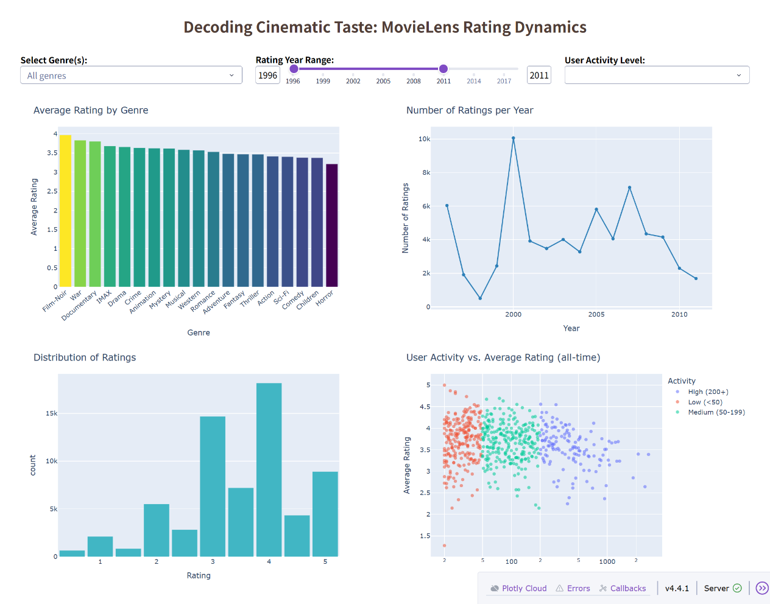
Figure 1: MovieLens Interactive Dashboard
— Average Rating by Genre, Ratings Count per Year, Rating Distribution, and User Activity vs. Average Rating

5. Written Justification
We chose MovieLens as the subject because movie recommendation is one of the most practical and engaging applications of data science. Streaming platforms such as Netflix and YouTube rely heavily on user rating and viewing data to personalize content, and the MovieLens dataset is a clean, well-documented reflection of exactly this kind of user–item interaction data. With ~100,000 ratings covering ~9,700 movies and 610 users between 1996 and 2018, the dataset is small enough to process quickly with Pandas, yet rich enough (ratings, genres, timestamps, user IDs) to support genuine multi-dimensional analysis.
We chose to deliver our visualization as an interactive Dash dashboard rather than a set of static charts, because the research question itself is inherently exploratory: the answer depends on the joint effect of genre, user activity, and time. A single static bar chart, like the one submitted previously (Figure 1: Top Movie Genres by Average Rating), can only show one slice of this picture — the ranking of genres by average rating — and cannot let a reader see how that ranking changes when a user restricts the year range, excludes low-activity users, or focuses on a subgenre. The dashboard addresses this directly by offering three linked controls (a multi-select genre filter, a year-range slider, and a user-activity selector) that dynamically update four coordinated charts: a bar chart of average rating by genre, a line chart of rating counts per year, a histogram of the rating distribution, and a scatter plot of user activity versus average rating. Together, these four views allow an analyst to test hypotheses in real time — for example, whether high-activity users are systematically harsher or more generous raters, or whether certain genres received significantly higher average ratings in earlier decades. This directly answers our research question while also demonstrating the practical value of data-driven tools to support real-world analytical decision-making in the entertainment business.

=====================================================================

Part 2: Project Proposal Guideline

1. Project Topic Name
Topic Name: Decoding Cinematic Taste — An Interactive Dashboard for MovieLens Rating Dynamics
Title & Question: "Exploring MovieLens: How do genres, user activity, and time affect user ratings?" How do user rating behaviors and genre preferences on MovieLens vary across different user activity levels and over time?

2. Project Purpose
Outcomes: This project directly aligns with the course learning outcomes by walking through a complete, end-to-end data-science workflow — data acquisition, EDA, feature engineering, visualization, and interactive product design — on a real-world dataset. It also connects to our future career paths in data analytics, business intelligence, or data science, where the ability to deliver insight as a usable tool (not just a static report) is a key differentiator.
Skills: In this project we will practice a full stack of practical data-science skills. Working in Python with Pandas, we will download, merge, clean, and reshape the relational MovieLens tables (ratings.csv, movies.csv, tags.csv), which will strengthen our ability to manipulate real-world tabular data efficiently. Using Plotly Express and Plotly Graph Objects, we will build clear, interactive charts that support hover, zoom, and legend controls, learning how to choose the right visual encoding for each analytical question. With Dash, we will design a complete UI layout and wire three input controls (genre multi-select, year-range slider, user-activity multi-select) to four coordinated outputs through a single @app.callback, while also learning to handle edge cases such as empty data after filtering. Finally, through data storytelling, we will practice deciding what to show, what to hide, and how to guide a reader from an initial question through exploration to a concrete insight — a skill that is as important in professional analytics work as coding itself.
Knowledge: Through this project we will gain practical familiarity with three interconnected areas of data science. First, we will develop a working understanding of recommendation-system fundamentals, including user–item matrices, the way user preference is captured through ratings, and how a user's activity level affects the reliability of their ratings as a signal. Second, we will explore Exploratory Data Analysis (EDA) in an interactive form, learning how dynamic aggregation, cross-filtering, and visual correlation testing allow an analyst to test hypotheses in real time rather than through a single static chart. Third, we will build awareness of macro-level trends in the film industry — how genre popularity, rating volume over time, and differences between user cohorts shape the way audiences engage with cinema — and we will see how these trends can be surfaced directly through an interactive dashboard rather than buried in a spreadsheet.

3. Project Tasks
Task 1: Data Preparation
Download ml-latest-small.zip from GroupLens.
Load ratings.csv, movies.csv, and tags.csv with Pandas.
Merge ratings and movies on movieId; extract year from title; convert timestamp to datetime and derive rating_year.
Compute per-user aggregates (n_ratings, avg_rating) and derive an activity label (Low / Medium / High).
Deliverable: ml-latest-small/ local folder + a cleaned pandas DataFrame ready for the dashboard.

Task 2: Exploratory Data Analysis
Examine rating distribution, genre distribution, ratings count per year, and user-activity distribution.
Draft 3–5 candidate insights to be exposed through the dashboard.
Deliverable: A short EDA notebook (eda_movielens.ipynb) plus a bullet list of the 3–5 key patterns that the dashboard should highlight.

Task 3: Dashboard Design & Development
Build movielens_dashboard.py with Dash.
Layout: title bar → control panel (genre multi-select, year range slider, user-activity multi-select) → 2×2 chart grid.
Implement a single @app.callback that filters the DataFrame and regenerates four Plotly figures:
- Average Rating by Genre (bar chart, colored by mean rating)
- Number of Ratings per Year (line chart, markers)
- Distribution of Ratings (histogram, 10 bins)
- User Activity vs. Average Rating (scatter, log-x, colored by activity level)
Handle empty-data edge case with a friendly message rather than a blank grid.
Deliverable: A fully running movielens_dashboard.py that opens at http://127.0.0.1:8050/.

Task 4: Evaluation, Packaging, and Reporting
Run through the checklist (below) against the deployed dashboard.
Capture screenshots: default view, filtered view, and (optional) empty-data view.
Write a short report (README.md + final report) summarizing the dashboard's design rationale, the 2–3 key patterns it reveals, and the limitations.
Deliverable: movielens_dashboard.py, requirements.txt, README.md, screenshots, and a 1–2 page written report.

- Project Criteria for Success
Characteristics of Successful Product:
The dashboard runs without errors and launches cleanly (python movielens_dashboard.py → app reachable on port 8050).
The UI provides three input controls (genre, year range, activity level) and four responsive charts arranged in a 2×2 grid.
Each chart uses an appropriate visualization type for its question:
  - bar chart for categorical comparisons (genre),
  - line chart for time trends,
  - histogram for distribution shape,
  - scatter for correlation between two continuous variables.
Charts update correctly when filters change, and the empty-data case is handled gracefully.
The dashboard visibly answers the research question — for example, a reader can compare genre preferences across user-activity cohorts and observe how rating volume changes across years.
The written report and README explain what the dashboard reveals and why those findings matter for the movie industry.
Code is clearly commented, and dependencies are documented in requirements.txt.

Checklist:
□ Data is downloaded, merged, and cleaned correctly.
□ All three input controls (genre, year range, activity) work.
□ All four charts display and respond to filters.
□ Empty-data state shows a helpful message, not a crash.
□ At least three screenshots are captured (default / filtered / empty).
□ README.md explains how to run the dashboard.
□ Final report contains Introduction, Data, Methods, Results, and Conclusion sections.
□ Git/GitHub history is clean and meaningful.

5. Project Collaboration Issues (For Team of 2)
Expected Division of Work:
Member A (Data & Dashboard Engineering): Responsible for dataset acquisition, cleaning, merging, and building the Dash app (layout, callback, four charts). Delivers movielens_dashboard.py and dashboard screenshots (Task 1 & Task 3).
Member B (Modeling & Report): Responsible for EDA, identifying the 2–3 key patterns, writing the README.md, and drafting the final written report (Task 2 & Task 4).
Note: Both members will conduct peer reviews on each other's work prior to final submission.

Ground Rules:
Weekly sync (in person or via a shared Teams/WeChat group) to track progress.
Use a shared GitHub repository for code, screenshots, and notes.
Every commit must have a clear message; every deliverable must be reviewed by the other partner before merging.
Raise blockers early — if one member is stuck for more than a day, escalate to the partner immediately rather than at deadline.

Group Structure:
Project Coordinator (Member A): Manages the project schedule, tracks milestones (Data Ready / Dashboard v1 / Report Draft / Final Submission), and ensures deadlines are met.
Project Scribe, Progress Tracker & Project Liaison (Member B): Records meeting minutes, updates the task board (GitHub Projects or a shared spreadsheet), and handles official communications with the instructor and teaching assistants.

