CISC7204 - Assignment 01: Preliminary Project Proposal
Course: CISC7204 Data Science and Data Visualization
Member B (Me): Shan LeTian / mc666322
Member A: Tian YaDi / mc664840

=====================================================================

Part 1: Preliminary Project Proposal - Ideation

1. Region and Domain Category
Region: Global / North America
Domain Category: Entertainment / Movie Industry

2. Research Question
How do movie genres, user tags, and the year a movie was released affect the ratings users give? Can we build a simple model to predict what rating a user will give to a movie they have not seen yet?

3. Links to available datasets
Link 1 (Direct Download):
https://files.grouplens.org/datasets/movielens/ml-latest-small.zip
Link 2 (Official Website):
https://grouplens.org/datasets/movielens/

- Optional Image
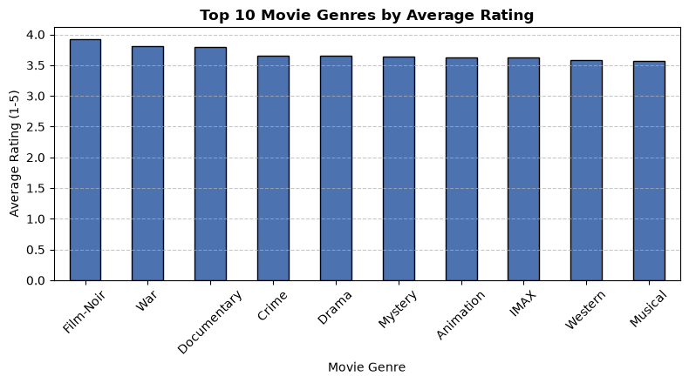
Figure 1: Top Movie Genres by Average Rating

5. Written Justification
We chose this topic because movie recommendation is a highly practical and engaging application of data science. Major streaming platforms like Netflix and YouTube rely heavily on user rating and viewing data to personalize content. By analyzing the MovieLens dataset, we can understand the key factors driving user movie evaluations and learn how data-driven techniques solve real-world problems in the entertainment business.
Furthermore, this dataset is clean and well-structured in simple CSV files, allowing us to spend less time on basic data tidying and more time on analysis, visualization, and predictive modeling. The included visualization (Figure 1: Top Movie Genres by Average Rating) directly addresses our first research question by demonstrating how user perceptions vary across different film categories. For instance, comparing average ratings across genres visually highlights distinct preference patterns, confirming that movie genre is a critical feature influencing user ratings and validating our modeling direction.

=====================================================================

Part 2: Project Proposal Guideline

1. Project Topic Name
Topic Name: Movie Recommendation Based on User Ratings
Title & Question: Predicting Movie Ratings: How do movie features affect user ratings, and can we predict future ratings based on past behavior?

2. Project Purpose
Outcomes: This project directly aligns with our course learning outcomes by allowing us to execute the full data science pipeline (data preparation, EDA, feature engineering, and predictive modeling) on a real-world dataset, preparing us for future studies and career paths in data analytics.
Skills: We will practice using Python (Pandas) to merge and process relational tables, Matplotlib/Seaborn to generate informative visualizations, and Scikit-learn to train baseline and recommendation models.
Knowledge: We will gain practical experience with recommendation system concepts, user-item matrix representations, and evaluating model accuracy using Root Mean Square Error (RMSE).

3. Project Tasks
Task 1: Data Preparation
Download the dataset and load ratings.csv, movies.csv, and tags.csv using Pandas.
Merge datasets and handle missing values. Extract and convert timestamps into readable release/rating years.
Deliverable: Cleaned dataset ready for analysis.

Task 2: Data Exploration (EDA)
Analyze overall rating distributions and examine average ratings across different movie genres.
Create visual charts showing key trends and patterns.
Deliverable: At least 3 clear charts with concise interpretations.

Task 3: Modeling & Recommendation
Split dataset into training and testing sets.
Build a simple baseline model (predicting overall mean rating) and a collaborative filtering / regression model to predict ratings.
Deliverable: A fully working Python Jupyter Notebook containing the modeling workflow.

Task 4: Evaluation and Reporting
Evaluate and compare model performance using RMSE.
Draft a final report explaining insights and model efficacy.
Deliverable: Final Jupyter Notebook and written report.

- Project Criteria for Success
Characteristics of Successful Product:
Code runs without errors and is clearly commented.
Visualizations directly address and answer our research questions.
The recommendation model outperforms the baseline model (lower RMSE).
The final report provides a structured, clear data story.

Checklist:
[ ] Data is cleaned and merged correctly.
[ ] At least 3 visualizations are included.
[ ] Model evaluation numbers (RMSE) are shown and explained.
[ ] The final report has an Introduction, Data, Methods, Results, and Conclusion section.

5. Project Collaboration Issues (For Team of 2)
Expected Division of Work:
Member A (Data & Analysis): Responsible for downloading the dataset, cleaning data, merging tables, and creating exploratory charts (Task 1 & Task 2).
Member B (Modeling & Report): Responsible for baseline and recommendation modeling, RMSE evaluation, and writing the final report (Task 3 & Task 4).
Note: Both members will conduct peer reviews on each other's work prior to final submission.

Ground Rules:
Hold regular meetings to track progress.
Utilize a shared GitHub repository for code management and version control.
Proactively raise issues when stuck to ensure smooth project progression.

Group Structure:
Project Coordinator (Member A): Manages the overall project schedule and ensures all task deadlines are met.
Project Scribe, Progress Tracker & Project Liaison (Member B): Records meeting minutes, updates task progress, and handles official communications with the instructor and teaching assistants.

