Web Programming Languages

CSC-XXX
Semester 6th
Name: Muhammad Rooshan Rizwan
ID Number: 18975 / IU04-0123-0441
Department of Computer Science
IQRA University, Karachi

LAB 13:
PBL:
CODE:
Create Operation (Insert Product):
<!DOCTYPE html>
<html lang="en">
<head>
<meta charset="UTF-8">
<title>Add Product</title>
</head>
<body>

<h2>Add New Product</h2>

<form action="process.php" method="post">

<label>Product Name:</label>
<input type="text" name="product_name" required>
<br><br>

<label>Price:</label>
<input type="number" name="price" step="0.01" required>
<br><br>

<label>Quantity:</label>
<input type="number" name="quantity" required>
<br><br>

<button type="submit">Add Product</button>
</form>

</body>
</html>

(Prepared Statement – INSERT):
<?php
$conn = new mysqli("localhost", "root", "", "prestate.final");

$product_name = $_POST['product_name'];
$price = $_POST['price'];
$quantity = $_POST['quantity'];

$stmt = $conn->prepare(
"INSERT INTO products (product_name, price, quantity) VALUES (?, ?, ?)"
);

$stmt->bind_param("sdi", $product_name, $price, $quantity);
$stmt->execute();

header("Location: displayproduct.php");
exit;
?>
Read Operation:
<?php
$conn = new mysqli("localhost", "root", "", "prestate.final");

$stmt = $conn->prepare("SELECT * FROM products");
$stmt->execute();

$result = $stmt->get_result();
$data = $result->fetch_all(MYSQLI_ASSOC);
?>

<!DOCTYPE html>
<html>
<head>
<title>Products</title>
</head>

<body>

<a href="product.html" class="btn btn-primary">Create</a>

<table class="table table-bordered table-striped mt-3">
<tr>
<th>ID</th>
<th>Product Name</th>
<th>Price</th>
<th>Quantity</th>
<th>Action</th>
</tr>

<?php foreach ($data as $row) { ?>
<tr>
<td><?php echo $row['id']; ?></td>
<td><?php echo $row['product_name']; ?></td>
<td><?php echo $row['price']; ?></td>
<td><?php echo $row['quantity']; ?></td>
<td>
<a href="edit.php?product_id=<?php echo $row['id']; ?>">Edit</a> |
<a href="delete.php?product_id=<?php echo $row['id']; ?>">Delete</a>
</td>
</tr>
<?php } ?>
</table>

</body>
</html>
Edit Operation:
<?php
$id = $_GET['product_id'];

$conn = new mysqli("localhost", "root", "", "prestate.final");

$stmt = $conn->prepare("SELECT * FROM products WHERE id=?");
$stmt->bind_param("i", $id);
$stmt->execute();

$result = $stmt->get_result();
$data = $result->fetch_assoc();
?>

<!DOCTYPE html>
<html>
<head>
<title>Edit Product</title>
</head>
<body>

<h2>Edit Product</h2>

<form action="update.php" method="post">
<input type="hidden" name="id" value="<?php echo $data['id']; ?>">

Product Name:
<input type="text" name="product_name" value="<?php echo $data['product_name']; ?>"><br><br>

Price:
<input type="text" name="price" value="<?php echo $data['price']; ?>"><br><br>

Quantity:
<input type="text" name="quantity" value="<?php echo $data['quantity']; ?>"><br><br>

<button type="submit">Update</button>
</form>

</body>
</html>
(Prepared Statement – UPDATE):
<?php
$conn = new mysqli("localhost", "root", "", "prestate.final");

$id = $_POST['id'];
$name = $_POST['product_name'];
$price = $_POST['price'];
$qty = $_POST['quantity'];

$stmt = $conn->prepare(
"UPDATE products SET product_name=?, price=?, quantity=? WHERE id=?"
);

$stmt->bind_param("sdii", $name, $price, $qty, $id);
$stmt->execute();

header("Location: displayproduct.php");
exit;
?>
(Prepared Statement – DELETE):
<?php
$id = $_GET['product_id'];

$conn = new mysqli("localhost", "root", "", "prestate.final");

$stmt = $conn->prepare("DELETE FROM products WHERE id=?");
$stmt->bind_param("i", $id);
$stmt->execute();

header("Location: displayproduct.php");
exit;
?>
SCREENSHOT:
Product Entry Form:
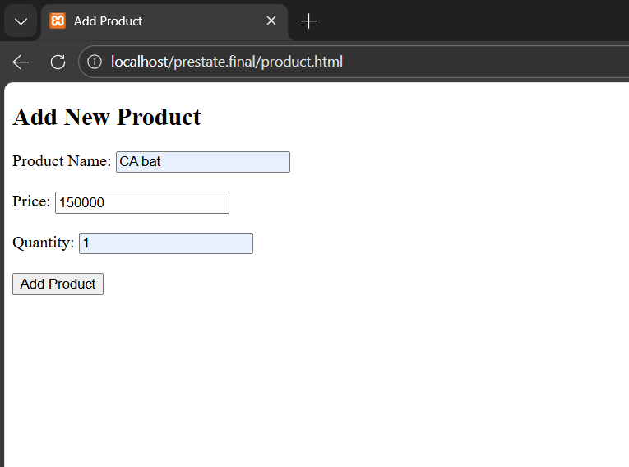
Product Added Successfully Using Prepared Statement:
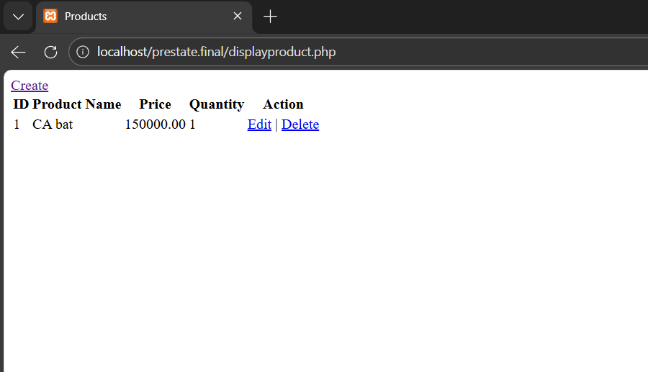
Edit Product Form:
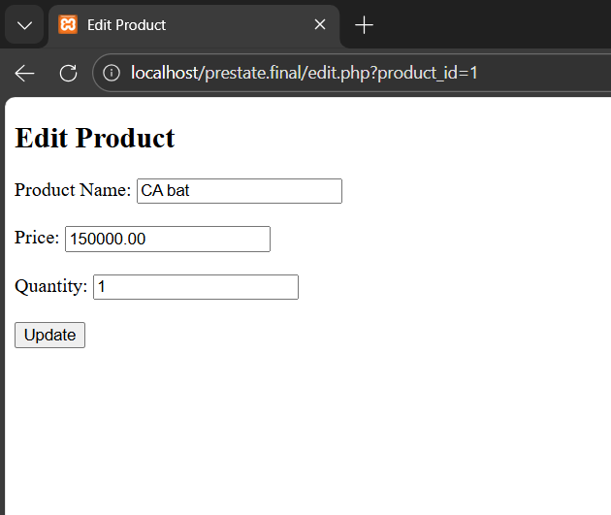
Product Updated Successfully:
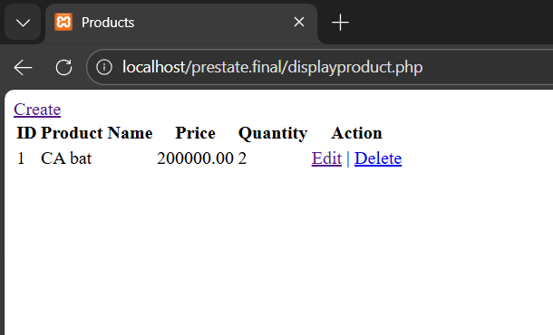
Product Deleted from Database:
