SESSION - 67
Two advantages of helm charts
1. package manager
2. templatise manifest files

What are the important files in helm charts
Chart.yaml
values.yaml
templates

helm upgrade --install <name> . --> expects Chart.yaml in current directory
helm status <name>
helm rollback <name> --> 1 revision back
helm uninstall <name>

helm repo add <URL>
helm update
helm install name <location

Ingress Controller(AWS Application LoadBalancer)
=====================
Use terraform and build application
ALB Listener --> Rule --> Target Group --> VM
ALB Listener --> Rule --> Target Group --> Container/Pod

low resources, fast provisioning, fast scaling

Service: LoadBalancer --> Classic LoadBalancer (legacy). We can't extend this to multiple applications. It is not intelligent

We prefer ALB, it is intelligent highly available and scalabe. It can read URL, headers, etc and forward the traffic to different targetgroups

cart.daws84s.site --> forward to cart targetgroup

m.facebook.com --> mobile

icici.com
netbanking.icici.com --> netbanking targetgroup
corporatebanking.icici.com --> cb targetgroup

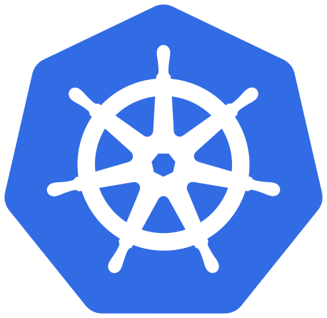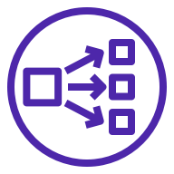
A Kubernetes controller for Elastic Load Balancers



AWS Load Balancer Controller
AWS Load Balancer Controller is a controller to help manage Elastic Load Balancers for a Kubernetes cluster.
- It satisfies Kubernetes Ingress resources by provisioning Application Load Balancers.
- It satisfies Kubernetes Service resources by provisioning Network Load Balancers.
This project was formerly known as "AWS ALB Ingress Controller", we rebranded it to be "AWS Load Balancer Controller".
AWS ALB Ingress Controller was originated by Ticketmaster and CoreOS as part of Ticketmaster's move to AWS and CoreOS Tectonic. Learn more about Ticketmaster's Kubernetes initiative from Justin Dean's video at Tectonic Summit.
AWS ALB Ingress Controller was donated to Kubernetes SIG-AWS to allow AWS, CoreOS, Ticketmaster and other SIG-AWS contributors to officially maintain the project. SIG-AWS reached this consensus on June 1, 2018.

Support Policy
Currently, AWS provides security updates and bug fixes to the latest available minor versions of AWS LBC. For other ad-hoc supports on older versions, please reach out through AWS support ticket.# Ingress Controller

Create a directory k8-ingress
readme.MD
### OIDC provider
trust and authentication provider
REGION_CODE=us-east-1
CLUSTER_NAME=roboshop-dev
ACC_ID=315069654700
eksctl utils associate-iam-oidc-provider \
--region $REGION_CODE \
--cluster $CLUSTER_NAME \
--approve
### Download IAM Policy
curl -o iam-policy.json https://raw.githubusercontent.com/kubernetes-sigs/aws-load-balancer-controller/v2.13.4/docs/install/iam_policy.json
### Create IAM Policy
aws iam create-policy \
--policy-name AWSLoadBalancerControllerIAMPolicy \
--policy-document file://iam-policy.json
### Create IAM Role and K8 ServiceAccount.
Mapping between IAM ROle and K8 Service account
eksctl create iamserviceaccount \
--cluster=$CLUSTER_NAME \
--namespace=kube-system \
--name=aws-load-balancer-controller \
--attach-policy-arn=arn:aws:iam::$ACC_ID:policy/AWSLoadBalancerControllerIAMPolicy \
--override-existing-serviceaccounts \
--region $REGION_CODE \
--approve
### Install Load balancer controller drivers
helm repo add eks https://aws.github.io/eks-charts
helm install aws-load-balancer-controller eks/aws-load-balancer-controller -n kube-system --set clusterName=$CLUSTER_NAME --set serviceAccount.create=false --set serviceAccount.name=aws-load-balancer-controller

--> kubectl get pods
--> REGION_CODE=us-east-1
--> eksctl utils associate-iam-oidc-provider \
--region $REGION_CODE \
--cluster $CLUSTER_NAME \
--approve
--> curl -o iam-policy.json https://raw.githubusercontent.com/kubernetes-sigs/aws-load-balancer-controller/v2.13.4/docs/install/iam_policy.json
--> aws iam create-policy \
--policy-name AWSLoadBalancerControllerIAMPolicy \
--policy-document file://iam-policy.json
--> ACC_ID=315069654700
--> eksctl create iamserviceaccount \
--cluster=$CLUSTER_NAME \
--namespace=kube-system \
--name=aws-load-balancer-controller \
--attach-policy-arn=arn:aws:iam::$ACC_ID:policy/AWSLoadBalancerControllerIAMPolicy \
--override-existing-serviceaccounts \
--region $REGION_CODE \
--approve

IAM --> Roles, permissions, etc.
K8 --> It is independent platform as a service. K8 has its own RBAC. Why should we integrate K8 RBAC and IAM. Because AWS services should have IAM permissions to create/manage other services. to create AWS services from K8 resources K8 SA should integrate with AWS IAM Role.

--> helm repo add eks https://aws.github.io/eks-charts
--> kubectl get sa
--> kubectl get sa -n kube-systems
--> helm install aws-load-balancer-controller eks/aws-load-balancer-controller -n kube-system --set clusterName=$CLUSTER_NAME --set serviceAccount.create=false --set serviceAccount.name=aws-load-balancer-controller
Pods are the smallest deployable units in kubernates.
--> kubectl get sa -n kube-systems (drivers are rubbubg)

Ingress controller --> Ingress
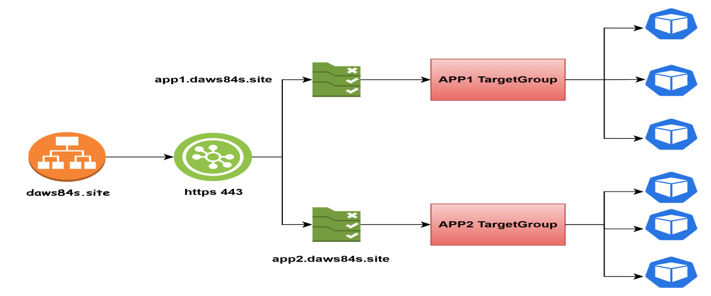
app1/Dockerfile
FROM nginx
RUN rm -rf /usr/share/nginx/html/index.html
RUN echo "<h1>Hi, I am from APP-1</h1>" > /usr/share/nginx/html/index.html

app2/Dockerfile
FROM nginx
RUN rm -rf /usr/share/nginx/html/index.html
RUN echo "<h1>Hi, I am from APP-2</h1>" > /usr/share/nginx/html/index.html

--> Push and pull the code
--> cd app1/
--> docker build -t shan2324/app1:v1 .
--> cd app2/
--> docker build -t shan2324/app2:v1 .
--> docker login -u shan2324
--> docker push shan2324/app2:v1
--> docker push shan2324/app1:v1

app1/manifest.yaml
apiVersion: apps/v1
kind: Deployment
metadata:
name: app1
# deployment labels
labels:
purpose: ingress
project: roboshop
app: app1
spec:
replicas: 2
# These are the labels replica set use to create pod replicas, this should match pod labels
selector:
matchLabels:
purpose: ingress
project: roboshop
app: app1
# This is pod definition
template:
metadata:
labels:
purpose: ingress
project: roboshop
app: app1
spec:
containers:
- name: app1
image: shan2324/app1:v1
---
apiVersion: v1
kind: Service
metadata:
name: app1
labels:
purpose: ingress
project: roboshop
app: app1
spec:
selector:
purpose: ingress
project: roboshop
app: app1
ports:
- protocol: TCP
port: 80 # service port
targetPort: 80 # container port
---
apiVersion: networking.k8s.io/v1
kind: Ingress
metadata:
name: app1
annotations:
alb.ingress.kubernetes.io/listen-ports: '[{"HTTPS": 443}]'
alb.ingress.kubernetes.io/certificate-arn: arn:aws:acm:us-east-1:315069654700:certificate/806e53c3-3894-49ff-96c7-fbd7c3b753ff
alb.ingress.kubernetes.io/scheme: internet-facing
alb.ingress.kubernetes.io/target-type: ip
alb.ingress.kubernetes.io/group.name: joindevops
spec:
ingressClassName: alb
rules:
- host: "app1.daws-shankran.site"
http:
paths:
- pathType: Prefix
path: "/"
backend:
service:
name: app1
port:
number: 80 # app1 service port

app2/manifest.yaml
apiVersion: apps/v1
kind: Deployment
metadata:
name: app2
# deployment labels
labels:
purpose: ingress
project: roboshop
app: app2
spec:
replicas: 2
# These are the labels replica set use to create pod replicas, this should match pod labels
selector:
matchLabels:
purpose: ingress
project: roboshop
app: app2
# This is pod definition
template:
metadata:
labels:
purpose: ingress
project: roboshop
app: app2
spec:
containers:
- name: app2
image: shan2324/app2:v1
---
apiVersion: v1
kind: Service
metadata:
name: app2
labels:
purpose: ingress
project: roboshop
app: app2
spec:
selector:
purpose: ingress
project: roboshop
app: app2
ports:
- protocol: TCP
port: 80 # service port
targetPort: 80 # container port
---
apiVersion: networking.k8s.io/v1
kind: Ingress
metadata:
name: app2
annotations:
alb.ingress.kubernetes.io/listen-ports: '[{"HTTPS": 443}]'
alb.ingress.kubernetes.io/certificate-arn: arn:aws:acm:us-east-1:315069654700:certificate/806e53c3-3894-49ff-96c7-fbd7c3b753ff
alb.ingress.kubernetes.io/scheme: internet-facing
alb.ingress.kubernetes.io/target-type: ip
alb.ingress.kubernetes.io/group.name: joindevops
spec:
ingressClassName: alb
rules:
- host: "app2.daws-shankran.site"
http:
paths:
- pathType: Prefix
path: "/"
backend:
service:
name: app2
port:
number: 80 # app2 service port

--> Go to acm (aws certificate manager) --> certificates
--> request certificate --> request public certificate
--> Domain Names --> *.daws-shankran.site
--> app1.daws-shankran.site
--> app2.daws-shankran.site
--> request --> view certificate
--> create records
--> validation completed, certificate came
--> certificate information given through annonatations.
--> cd ../app1
--> git pull
--> kubectl apply -f manifest.yaml
--> kubectl get pods
--> kubectl get svc
--> kubectl get ingress
--> kubectl get pods -n kube-system
--> kubectl logs log-name -n kube-system
--> kubectl describe ingress app1
--> kubectl get ingress
--> kubectl describe ingress ingress-wildcard-host
--> cd ../app2
--> kubectl apply -f manifest.yaml
--> error not thrown may be you can improve ingress controller to thorown an error if someone forget to give ingressive class name.
--> you can raise issue
--> who’s adding here -- service
--> route 53 --> hosted zones --> daws-shankran.site --> create record --> define simple record --> name=app1 --> record type=A --> value/route traffic = alias to application --> default --> define simple record
--> name=app2 --> record type=A --> value/route traffic = alias to application --> default --> define simple record
--> kubectl delete ingress app1 app2
--> cd ../app2
--> kubectl apply -f manifest.yaml
--> EC2 - load balancer --> file name --> check tags
--> kubectl delete ingress app2
--> cd ../app2
--> kubectl apply -f manifest.yaml
--> tags group name

--> cd ../app1
--> kubectl apply -f manifest.yaml
--> edit hosted zones app1 and app2 --> add load balancer
--> What is ingress (interview que)
Ans)) ingress is a resource in kubernates that can create the rules.
ingress is used to expose the application tool internet you can create host based rules.
--> we are using ingress controller, ALB as ingress controller we are configured ingress resource. We are created load balancer and we are using rules and target groups through ingress resource.

--> check output.
--> we are using ingress controller in projects our applications to the outside world. You can create ingress resource we used annotations to communicate with AWS services.
-->

