SESSION - 70

SA

====

-> Access the internal workloads by communication k8 API. SA can have role and rolebinding

-> SA can fetch secrets, create ALB, any AWS service based on the role attached

1. Make sure OIDC provider exists, creates trust and federation between IAM and others

2. Create a policy

3. We can create IAM Role and attach policy.

4. We can create SA and give IAM role in annotation

or

Create SA and role through eksctl command

5. Provide sa in the pod spec.

fetch secrets

==============

follow above steps

1. Make sure secrets exists and SA have access through role and policy

2. Create initcontainer that fetch the secret and write to the volume. init container should have volume mounts to persist.

3. emptyDir is required to share the storage between containers in pod.

4. mount the same volume to the main container and access it..

5. before running command in container we need to read the secret and make it as env variable

6. now we can delete the file and start the container

--> Requests coming from load balancer.

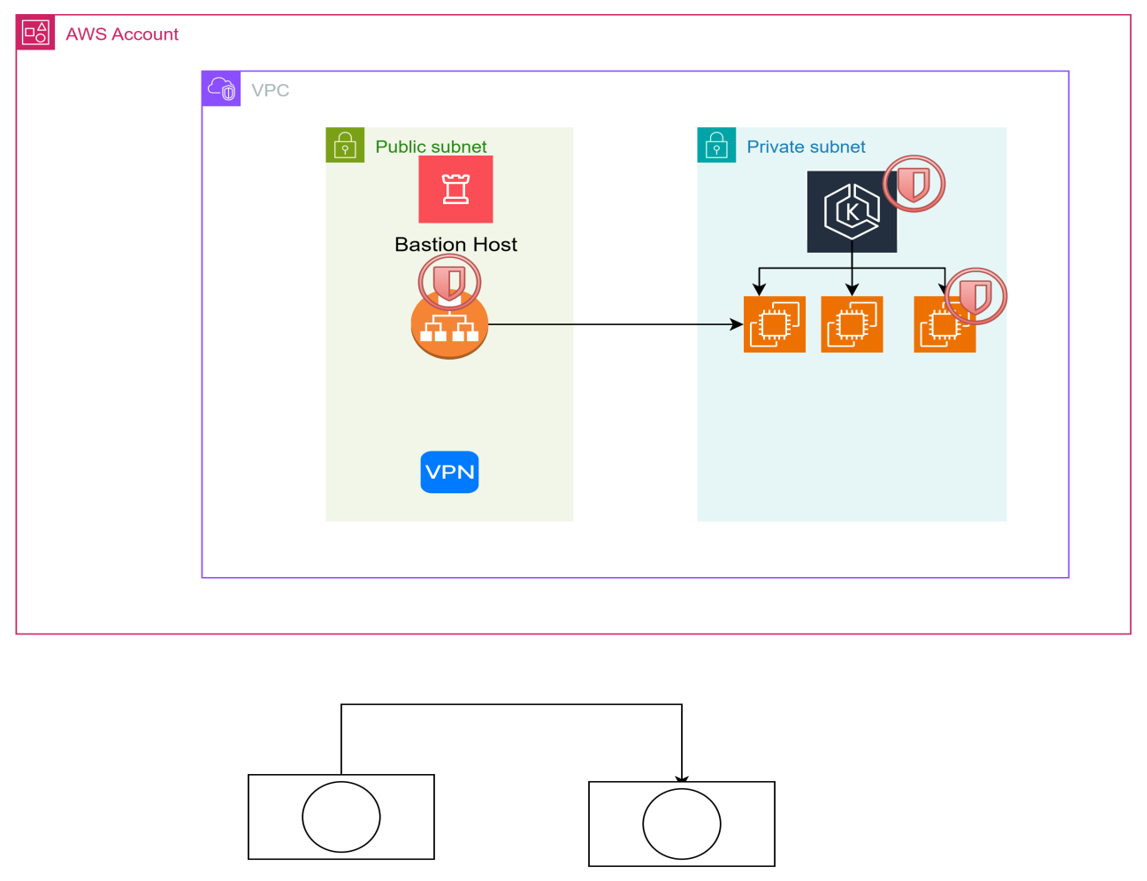

--> create a directory terraform-aws-eks

**00-vpc/main.tf**

module "vpc" {

source = "git::https://github.com/daws-84s/terraform-aws-vpc.git?ref=main"

project = var.project

environment = var.environment

public_subnet_cidrs = var.public_subnet_cidrs

private_subnet_cidrs = var.private_subnet_cidrs

database_subnet_cidrs = var.database_subnet_cidrs

is_peering_required = true

}

/* output "vpc_ids" {

value = module.vpc.public_subnet_ids

} */

**00-vpc/parameters.tf**

resource "aws_ssm_parameter" "vpc_id" {

name = "/${var.project}/${var.environment}/vpc_id"

type = "String"

value = module.vpc.vpc_id

}

resource "aws_ssm_parameter" "public_subnet_ids" {

name = "/${var.project}/${var.environment}/public_subnet_ids"

type = "StringList"

value = join(",", module.vpc.public_subnet_ids)

}

resource "aws_ssm_parameter" "private_subnet_ids" {

name = "/${var.project}/${var.environment}/private_subnet_ids"

type = "StringList"

value = join(",", module.vpc.private_subnet_ids)

}

resource "aws_ssm_parameter" "database_subnet_ids" {

name = "/${var.project}/${var.environment}/database_subnet_ids"

type = "StringList"

value = join(",", module.vpc.database_subnet_ids)

}

**00-vpc/variables.tf**

variable "project" {

default = "roboshop"

}

variable "environment" {

default = "dev"

}

variable "public_subnet_cidrs" {

default = ["10.0.1.0/24", "10.0.2.0/24"]

}

variable "private_subnet_cidrs" {

default = ["10.0.11.0/24", "10.0.12.0/24"]

}

variable "database_subnet_cidrs" {

default = ["10.0.21.0/24", "10.0.22.0/24"]

}

**00-vpc/provider.tf**

terraform {

required_providers {

aws = {

source = "hashicorp/aws"

version = "5.98.0"

}

}

backend "s3" {

bucket = "latest-84s-remote-state-dev"

key = "roboshop-dev-vpc"

region = "us-east-1"

encrypt = true

use_lockfile = true

}

}

provider "aws" {

# Configuration options

region = "us-east-1"

}

--> cd /c/devops/daws-84s/repos/terraform-aws-eks/00-vpc

**--> terraform init -reconfigure**

**--> terraform plan**

**--> terraform apply -auto-approve**

1. **sg/data.tf**

data "aws_ssm_parameter" "vpc_id" {

name = "/${var.project}/${var.environment}/vpc_id"

}

1. **sg/locals.tf**

locals {

vpc_id = data.aws_ssm_parameter.vpc_id.value

}

1. **sg/parameters.tf**

resource "aws_ssm_parameter" "ingress_alb_sg_id" {

name = "/${var.project}/${var.environment}/ingress_alb_sg_id"

type = "String"

value = module.ingress_alb.sg_id

}

resource "aws_ssm_parameter" "eks_control_plane_sg_id" {

name = "/${var.project}/${var.environment}/eks_control_plane_sg_id"

type = "String"

value = module.eks_control_plane.sg_id

}

resource "aws_ssm_parameter" "eks_node_sg_id" {

name = "/${var.project}/${var.environment}/eks_node_sg_id"

type = "String"

value = module.eks_node.sg_id

}

resource "aws_ssm_parameter" "bastion_sg_id" {

name = "/${var.project}/${var.environment}/bastion_sg_id"

type = "String"

value = module.bastion.sg_id

}

resource "aws_ssm_parameter" "vpn_sg_id" {

name = "/${var.project}/${var.environment}/vpn_sg_id"

type = "String"

value = module.vpn.sg_id

}

1. **sg/provider.tf**

terraform {

required_providers {

aws = {

source = "hashicorp/aws"

version = "5.98.0"

}

}

backend "s3" {

bucket = "latest-84s-remote-state-dev"

key = "roboshop-dev-sg"

region = "us-east-1"

encrypt = true

use_lockfile = true

}

}

provider "aws" {

# Configuration options

region = "us-east-1"

}

1. **sg/main.tf**

module "ingress_alb" {

#source = "../../terraform-aws-securitygroup"

source = "git::https://github.com/daws-84s/terraform-aws-securitygroup.git?ref=main"

project = var.project

environment = var.environment

sg_name = "ingress-alb"

sg_description = "for ingress alb"

vpc_id = local.vpc_id

}

module "bastion" {

#source = "../../terraform-aws-securitygroup"

source = "git::https://github.com/daws-84s/terraform-aws-securitygroup.git?ref=main"

project = var.project

environment = var.environment

sg_name = var.bastion_sg_name

sg_description = var.bastion_sg_description

vpc_id = local.vpc_id

}

module "vpn" {

#source = "../../terraform-aws-securitygroup"

source = "git::https://github.com/daws-84s/terraform-aws-securitygroup.git?ref=main"

project = var.project

environment = var.environment

sg_name = "vpn"

sg_description = "for vpn"

vpc_id = local.vpc_id

}

module "eks_control_plane" {

#source = "../../terraform-aws-securitygroup"

source = "git::https://github.com/daws-84s/terraform-aws-securitygroup.git?ref=main"

project = var.project

environment = var.environment

sg_name = "eks_control_plane"

sg_description = "for eks_control_plane"

vpc_id = local.vpc_id

}

module "eks_node" {

#source = "../../terraform-aws-securitygroup"

source = "git::https://github.com/daws-84s/terraform-aws-securitygroup.git?ref=main"

project = var.project

environment = var.environment

sg_name = "eks_node"

sg_description = "for eks_node"

vpc_id = local.vpc_id

}

resource "aws_security_group_rule" "ingress_alb_https" {

type = "ingress"

from_port = 443

to_port = 443

protocol = "tcp"

cidr_blocks = ["0.0.0.0/0"]

security_group_id = module.ingress_alb.sg_id

}

resource "aws_security_group_rule" "bastion_laptop" {

type = "ingress"

from_port = 22

to_port = 22

protocol = "tcp"

cidr_blocks = ["0.0.0.0/0"]

security_group_id = module.bastion.sg_id

}

#VPN ports 22, 443, 1194, 943

resource "aws_security_group_rule" "vpn_ssh" {

type = "ingress"

from_port = 22

to_port = 22

protocol = "tcp"

cidr_blocks = ["0.0.0.0/0"]

security_group_id = module.vpn.sg_id

}

resource "aws_security_group_rule" "vpn_https" {

type = "ingress"

from_port = 443

to_port = 443

protocol = "tcp"

cidr_blocks = ["0.0.0.0/0"]

security_group_id = module.vpn.sg_id

}

resource "aws_security_group_rule" "vpn_1194" {

type = "ingress"

from_port = 1194

to_port = 1194

protocol = "tcp"

cidr_blocks = ["0.0.0.0/0"]

security_group_id = module.vpn.sg_id

}

resource "aws_security_group_rule" "vpn_943" {

type = "ingress"

from_port = 943

to_port = 943

protocol = "tcp"

cidr_blocks = ["0.0.0.0/0"]

security_group_id = module.vpn.sg_id

}

resource "aws_security_group_rule" "eks_control_plane_eks_node" {

type = "ingress"

from_port = 0

to_port = 0

protocol = "-1"

source_security_group_id = module.eks_node.sg_id

security_group_id = module.eks_control_plane.sg_id

}

resource "aws_security_group_rule" "eks_node_eks_control_plane" {

type = "ingress"

from_port = 0

to_port = 0

protocol = "-1"

source_security_group_id = module.eks_control_plane.sg_id

security_group_id = module.eks_node.sg_id

}

resource "aws_security_group_rule" "eks_control_plane_bastion" {

type = "ingress"

from_port = 443

to_port = 443

protocol = "tcp"

source_security_group_id = module.bastion.sg_id

security_group_id = module.eks_control_plane.sg_id

}

resource "aws_security_group_rule" "eks_node_bastion" {

type = "ingress"

from_port = 22

to_port = 22

protocol = "tcp"

source_security_group_id = module.bastion.sg_id

security_group_id = module.eks_node.sg_id

}

resource "aws_security_group_rule" "eks_node_vpc" {

type = "ingress"

from_port = 0

to_port = 0

protocol = "-1"

cidr_blocks = ["10.0.0.0/16"]

security_group_id = module.eks_node.sg_id

}

1. **sg/variables.tf**

variable "project" {

default = "roboshop"

}

variable "environment" {

default = "dev"

}

variable "bastion_sg_name" {

default = "bastion"

}

variable "bastion_sg_description" {

default = "created sg for bastion instance"

}

1. **sg/sg.yaml**

- name: Roboshop SG and Rules

security_groups:

- DB:

- mongodb

- redis

- mysql

- rabbitmq

- APP:

- catalogue

- user

- cart

- shipping

- payment

- BACKEND_ALB:

- FRONTEND:

- FRONTEND_ALB:

- VPN:

- BASTION:

mongodb:

- name: mongodb_vpn

purpose: mongodb should accept traffic on 22,27017 from vpn

- name: mongodb_catalogue

purpose: mongodb should accept traffic on 27017 from catalogue

- name: mongodb_user

purpose: mongodb should accept traffic on 27017 from user

redis:

- name: redis_vpn

purpose: redis should accept traffic on 22,5679 from vpn

- name: redis_user

purpose: redis should accept traffic on 5679 from user

- name: redis_cart

purpose: redis should accept traffic on 5679 from cart

mysql:

- name: mysql_vpn

purpose: mysql should accept traffic on 22,3306 from vpn

- name: mysql_shipping

purpose: redis should accept traffic on 3306 from shipping

rabbitmq:

- name: rabbitmq_vpn

purpose: rabbitmq should accept traffic on 22,5672 from vpn

- name: rabbitmq_payment

purpose: redis should accept traffic on 5672 from payment

catalogue:

- name: catalogue_vpn

purpose: catalogue should accept traffic on 22 from vpn

- name: catalogue_backend_alb

purpose: catalogue should accept traffic on 8080 from backend_alb

**--> terraform init**

**--> terraform plan**

**--> terraform apply -auto-approve**

1. **bastion/data.tf**

data "aws_ami" "joindevops" {

owners = ["973714476881"]

most_recent = true

filter {

name = "name"

values = ["RHEL-9-DevOps-Practice"]

}

filter {

name = "root-device-type"

values = ["ebs"]

}

filter {

name = "virtualization-type"

values = ["hvm"]

}

}

data "aws_ssm_parameter" "bastion_sg_id" {

name = "/${var.project}/${var.environment}/bastion_sg_id"

}

data "aws_ssm_parameter" "public_subnet_ids" {

name = "/${var.project}/${var.environment}/public_subnet_ids"

}

**20-bastion/locals.tf**

locals{

ami_id = data.aws_ami.joindevops.id

bastion_sg_id = data.aws_ssm_parameter.bastion_sg_id.value

public_subnet_id = split ("," , data.aws_ssm_parameter.public_subnet_ids.value)[0]

common_tags = {

Project = var.project

Environment = var.environment

Terraform = "true"

}

}

--> Check git hub account and add remaining scripts.

**--> terraform init**

**--> terraform plan**

**--> terraform apply -auto-approve**

1. **acm/locals.tf**

locals {

common_tags = {

Project = var.project

Environment = var.environment

Terraform = "true"

}

}

**60-acm/main.tf**

resource "aws_acm_certificate" "daws84s" {

domain_name = "*.${var.zone_name}"

validation_method = "DNS"

tags = merge(

local.common_tags,

{

Name = "${var.project}-${var.environment}"

}

)

lifecycle {

create_before_destroy = true

}

}

resource "aws_route53_record" "daws84s" {

for_each = {

for dvo in aws_acm_certificate.daws84s.domain_validation_options : dvo.domain_name => {

name = dvo.resource_record_name

record = dvo.resource_record_value

type = dvo.resource_record_type

}

}

allow_overwrite = true

name = each.value.name

records = [each.value.record]

ttl = 60

type = each.value.type

zone_id = var.zone_id

}

resource "aws_acm_certificate_validation" "daws84s" {

certificate_arn = aws_acm_certificate.daws84s.arn

validation_record_fqdns = [for record in aws_route53_record.daws84s : record.fqdn]

}

--> Check git hub account and add remaining scripts.

**--> terraform init**

**--> terraform plan**

**--> terraform apply -auto-approve**

**70-frontend-alb/locals.tf**

locals {

vpc_id = data.aws_ssm_parameter.vpc_id.value

public_subnet_ids = split ("," , data.aws_ssm_parameter.public_subnet_ids.value)

ingress_alb_sg_id = data.aws_ssm_parameter.ingress_alb_sg_id.value

acm_certificate_arn = data.aws_ssm_parameter.acm_certificate_arn.value

common_tags = {

Project = var.project

Environment = var.environment

Terraform = "true"

}

}

**70-frontend-alb/variables.tf**

variable "project" {

default = "roboshop"

}

variable "environment" {

default = "dev"

}

variable "zone_id" {

default = "Z032558618100M4EJX8X4"

}

variable "zone_name" {

default = "daws84s.site"

}

--> Check git hub account and add remaining scripts.

**--> terraform init**

**--> terraform plan**

**--> terraform apply -auto-approve**

1. You create LB from K8

2. You create LB outside of K8 and provide the info to K8

--> This is part of infra, road balancer is a not of EKS cluster.

--> you create it and then let kubernates can connect

**80-eks/data.tf**

data "aws_ssm_parameter" "vpc_id" {

name = "/${var.project}/${var.environment}/vpc_id"

}

data "aws_ssm_parameter" "private_subnet_ids" {

name = "/${var.project}/${var.environment}/private_subnet_ids"

}

data "aws_ssm_parameter" "eks_control_plane_sg_id" {

name = "/${var.project}/${var.environment}/eks_control_plane_sg_id"

}

data "aws_ssm_parameter" "eks_node_sg_id" {

name = "/${var.project}/${var.environment}/eks_node_sg_id"

}

**80-eks/locals.tf**

locals {

vpc_id = data.aws_ssm_parameter.vpc_id.value

eks_node_sg_id = data.aws_ssm_parameter.eks_node_sg_id.value

eks_control_plane_sg_id = data.aws_ssm_parameter.eks_control_plane_sg_id.value

private_subnet_ids = split ("," , data.aws_ssm_parameter.private_subnet_ids.value)

common_tags = {

Project = var.project

Environment = var.environment

Terraform = "true"

}

}

**80-eks/main.tf**

module "eks" {

source = "terraform-aws-modules/eks/aws"

version = "~> 21.0" # this is module version

name = "${var.project}-${var.environment}"

kubernetes_version = "1.33"

addons = {

coredns = {}

eks-pod-identity-agent = {

before_compute = true

}

kube-proxy = {}

vpc-cni = {

before_compute = true

}

metrics-server= {}

}

# Optional

endpoint_public_access = false

# Optional: Adds the current caller identity as an administrator via cluster access entry

enable_cluster_creator_admin_permissions = true

vpc_id = local.vpc_id

subnet_ids = local.private_subnet_ids

control_plane_subnet_ids = local.private_subnet_ids

create_node_security_group = false

create_security_group = false

security_group_id = local.eks_control_plane_sg_id

node_security_group_id = local.eks_node_sg_id

# EKS Managed Node Group(s)

eks_managed_node_groups = {

/* blue = {

# Starting on 1.30, AL2023 is the default AMI type for EKS managed node groups

ami_type = "AL2023_x86_64_STANDARD" # user name is ec2-user

instance_types = ["m5.xlarge"]

min_size = 2

max_size = 10

desired_size = 2

} */

# iam_role_additional_policies = {

# AmazonEBS = "arn:aws:iam::aws:policy/service-role/AmazonEBSCSIDriverPolicy"

# AmazonEFS = "arn:aws:iam::aws:policy/service-role/AmazonEFSCSIDriverPolicy"

# AmazonEKSLoad = "arn:aws:iam::aws:policy/AmazonEKSLoadBalancingPolicy"

# }

green = {

# Starting on 1.30, AL2023 is the default AMI type for EKS managed node groups

ami_type = "AL2023_x86_64_STANDARD" # user name is ec2-user

instance_types = ["m5.xlarge"]

min_size = 2

max_size = 10

desired_size = 2

iam_role_additional_policies = {

AmazonEBS = "arn:aws:iam::aws:policy/service-role/AmazonEBSCSIDriverPolicy"

AmazonEFS = "arn:aws:iam::aws:policy/service-role/AmazonEFSCSIDriverPolicy"

AmazonEKSLoad = "arn:aws:iam::aws:policy/AmazonEKSLoadBalancingPolicy"

}

/* taints = {

upgrade = {

key = "upgrade"

value = "true"

effect = "NO_SCHEDULE"

}

} */

}

}

tags = merge(

local.common_tags,

{

Name = "${var.project}-${var.environment}"

}

)

}

Create amazon elastic kubernates

--> create EKS cluster

--> Check git hub account and add remaining scripts.

**--> terraform init**

**--> terraform plan**

**--> terraform apply -auto-approve**