CS4416

Project

Sean Barrett 15124126 (Report)

Martin Vaughan 16158431 (Report)

Brian Shanahan 17218829 (SQL)

Daniel Clarke 18249736 (SQL)

College Management Database

For our project, we decided to make a College Management Database. Our database serves to handle all the data a college may have, whether it has to do with students, courses, etc. In a real-life scenario, this database could be used by faculties in a college to access and manage the information of students, staff, modules, courses and departments.

Information such as student/staff IDs, first names, last names, addresses and emails can be accessed by faculties in the college to find information regarding students or staff. More data about modules, courses and departments can be accessed in the database such as their code, name and description. Modules are linked to their course and courses are then linked to their department in the college.

Students are linked to the course they are enrolled in. Staff are linked to the modules they teach. An example of how this database could be used in a college is faculties could run queries in the database to return what students are enrolled in what course. You can then see what modules the students are taking by looking at what modules are taught in the course.

Entity Relationship Diagram

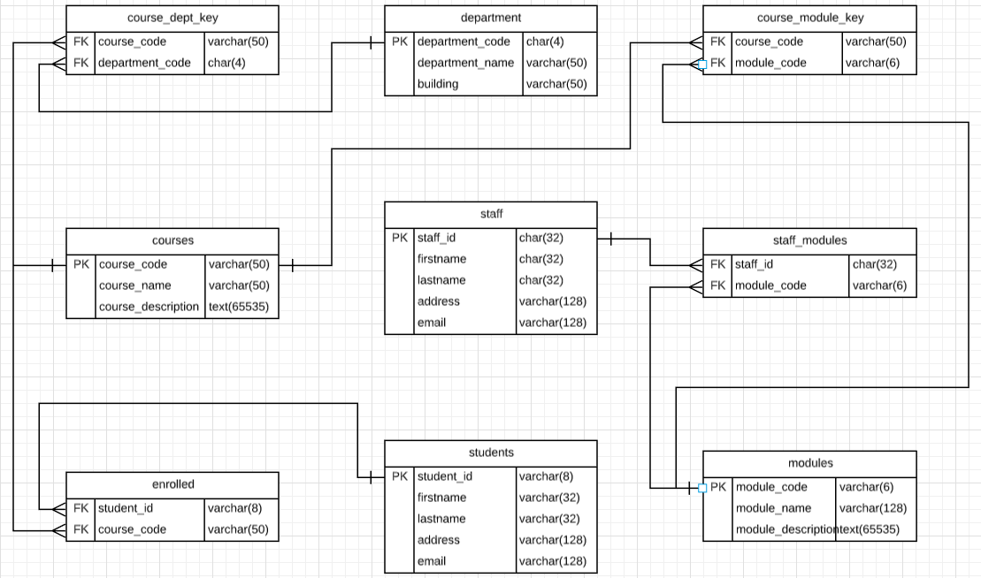

College Management Database Tables

The tables in our database are in 3NF because they are in 1NF(The intersection of each row and column contains one and only one value) and 2NF(Every non-key attribute is fully functionally dependent on the primary key) and no non-key attribute is transitively dependent on the primary key.

**students**

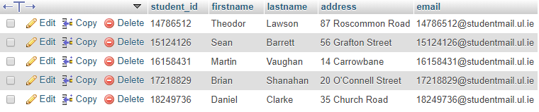

**staff**

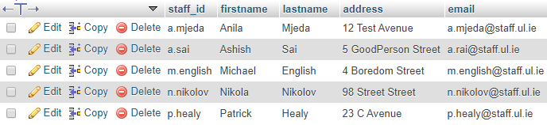

**courses**

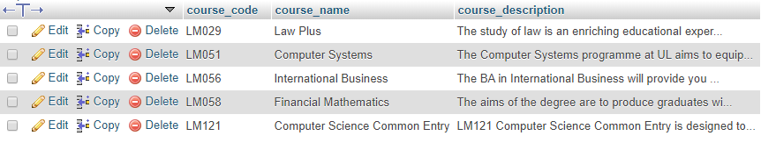

**modules**

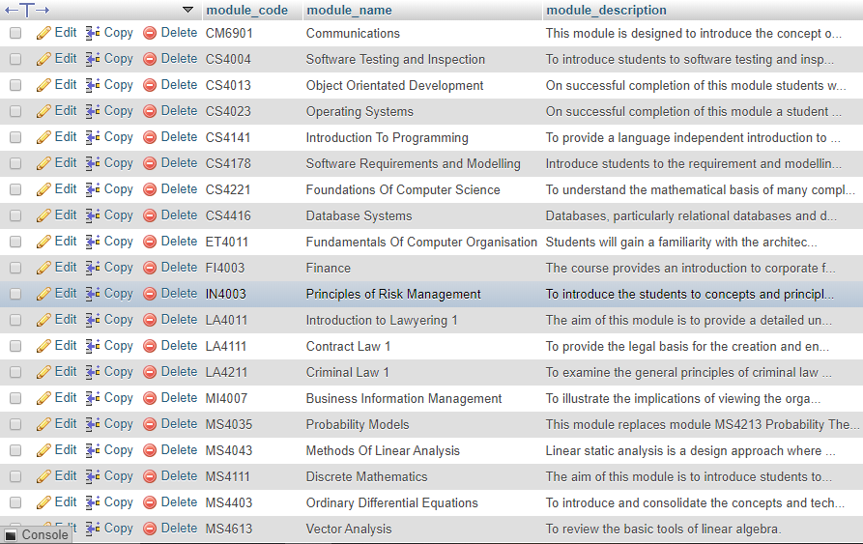

**department**

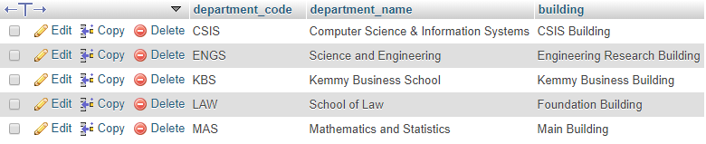

**enrolled**

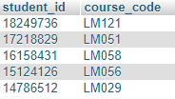

**staff_modules**

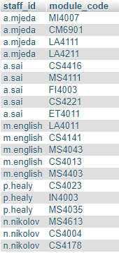

**course_module_key**

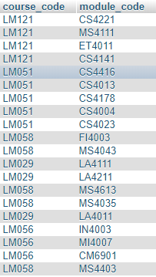

**course_department_key**

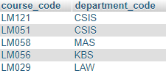

Functional Dependencies

**students:**

student_id -> firstname

student_id -> lastname

student_id -> address

student_id -> email

**staff:**

staff_id -> firstname

staff_id -> lastname

staff_id -> address

staff_id -> email

**courses:**

course_code -> course_name

course_code -> course_description

**modules:**

module_code -> module_name

module_code -> module_description

**departments:**

department_code -> department_name

department_code -> building

Views

**views1:**

The justification of views1 is that it returns the first name and last name of a student doing a specified course. This is useful as it allows faculty in a college to find students that are doing a specified course.

**views2:**

The justification of views2 is that it returns the course name, course code and course description to the user. This is useful as it allows faculty in a college to pull a specified course from the database to see the name, code and a description of the course.

**views3:**

The justification of views3 is that it returns the first name, last name, ID, email and address of staff. This is useful because it allows faculty in a college to get the information of staff currently working in the college.

Triggers

Our first trigger stores into an audit table when a student is deleted. It stores an edit ID, the students details and the time and date of deletion. This is important because if a student is deleted accidentally there is evidence of when it happened and also the students data can be retrieved.

Procedures

Our stored procedures are important as they stop users from accessing sensitive data. Instead of showing the code we do not want to be accessed, the return parameter is stored in memory and will only return data we allow. This means people cannot access sensitive information such as staff addresses, or other students emails. This is important as this can prevent SQL injection attacks which can be a common attack.

Functions

Functions are important in our database as they can be reused over time for accessing or manipulating data in our database. This is extremely important for a database like ours if we want to add students, delete students or change courses which is so common in the workplace of our database. Our functions provide an easy way to carry out these tasks.