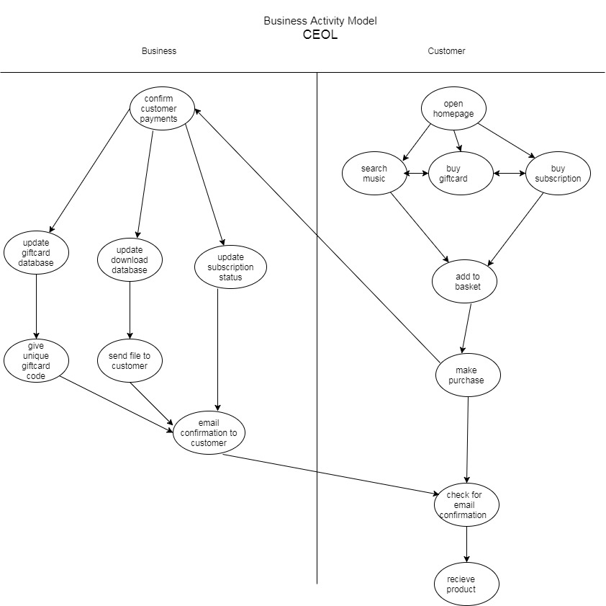

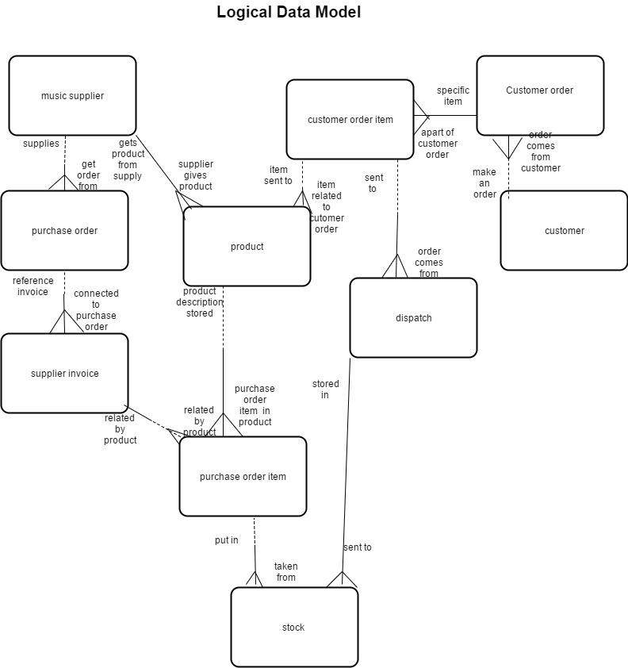.

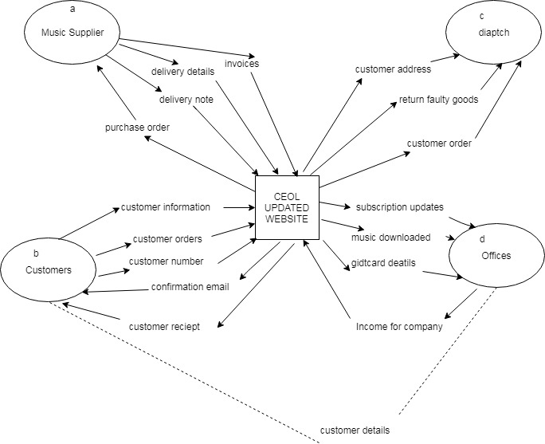

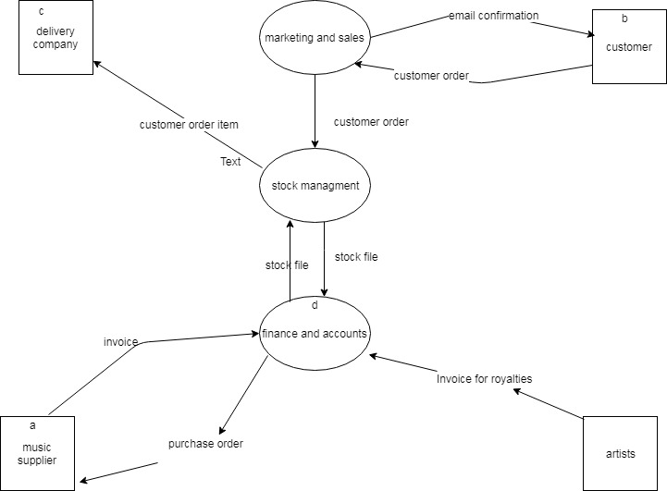

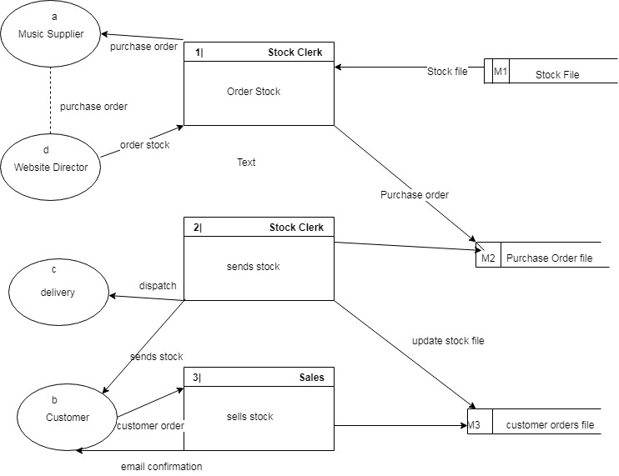

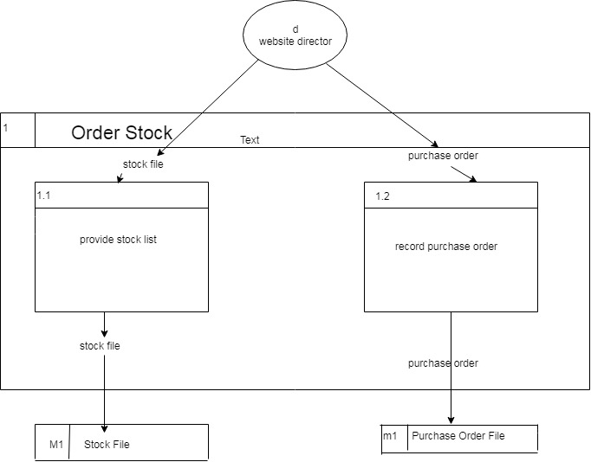

Function (1.1 eg)

Check Delivered Goods

This function is essential as the company CEOL order in CD’S etc from suppliers and if any are damaged or missing they must return or inform the supplier. The function is carried out by employees who take care of the delivery. Any stock that is not up to standard will be recorded on the returns file.

Function 2

Send Purchase Order

This is carried out by the P.O Clerk, this function is also essential as without a purchase order to suppliers CEOL would not have any stock to sell to customers, what is contained on the purchase order is essential and each purchase order must be updated on purchase order file.

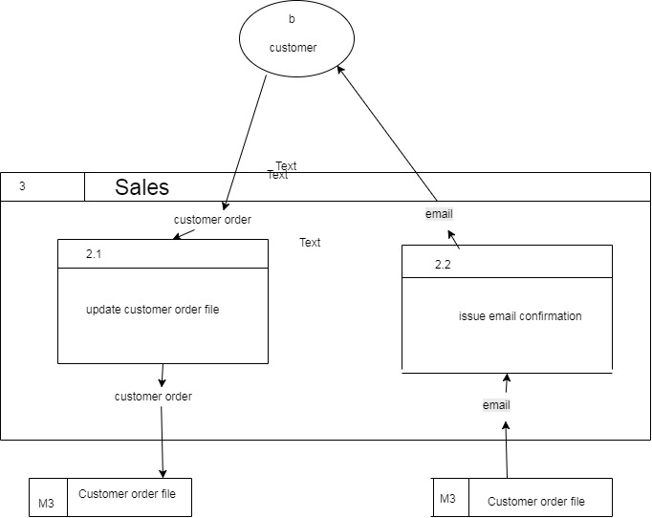

|  |  |  |  |  |
| --- | --- | --- | --- | --- |
| From | To | Data Flow Name | Data Content | comments |
| Supplier | Warehouse | Sends Stock | Contains phyial CD’S,records,usb’s music files | The supplier can give a limit on the time it takes to accept returns |
| P.O Clerk | Supplier | Purchase Orders | P.O number  Supplier Name  Supplier Address  Depot Name  Required date  Required time  Stock listed  Product prices  Company address  Company name | A purchase order can contain many lines. |

|  |
| --- |
| External Entity Description |

|  |  |  |
| --- | --- | --- |
| ID | Name | Description |
| a | Music Supplier | The supplier to which CEOL buys music for their website. Managers order through purchase order based on customer demand. |

|  |  |  |  |  |  |  |  |
| --- | --- | --- | --- | --- | --- | --- | --- |
| ENTITY DESCRIPTION | | | | | | | |
| Entity Name: Customer Order | | | | | | | |
| Description: A request for purchase | | | | | | | |
| Attribute | | | Primary key | | | Foreign key | Mandatory/optional |
| Customer order number  Customer order item  Customer order status  Customer name  Customer email | | | yes | | |  | M  M  O  M  M |
| Must/may be | Either/or | Link phrase | | One & only one/  One or more | | | Entity Name |
| May  must |  | Contain  Result in | | One or more  One and only one | | | Customer order item  Delivery |
| Entity Volumes Max. 15000 Min 6000 average 10000 | | | | | | | |
| user | | | | | Access | | |
| Stock Clerk  P.O Clerk  Supplier | | | | | Read, Modify  Read,Create,Delete  Read | | |
| Growth Rate 15% | | | | | | | |
| Archiving Customer orders should be kept in online files for up to 2 years after last online order has been made. | | | | | | | |