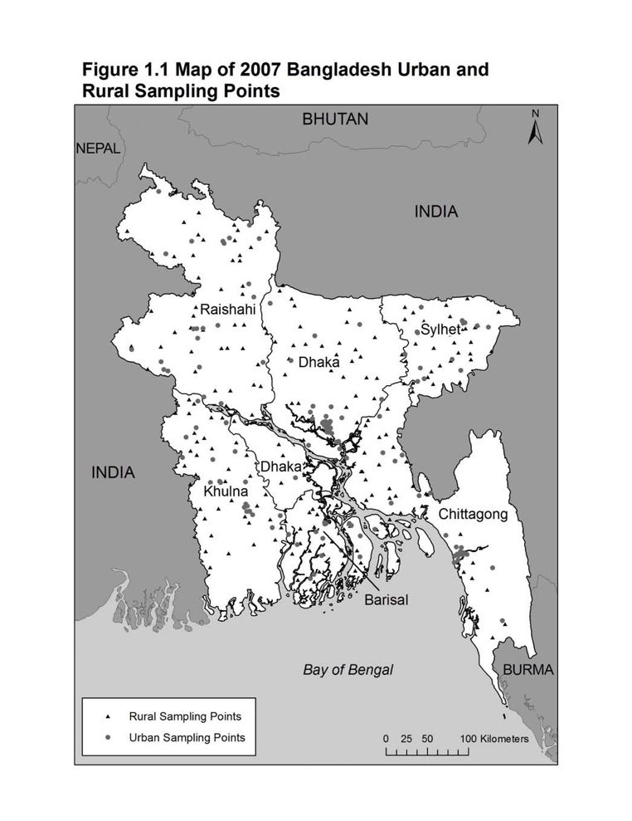

The survey utilized a multistage cluster sample based on the 2001 Bangladesh Census and was designed to produce separate estimates for key indicators for each of the **six divisions** of the country—Barisal, Chittagong, Dhaka, Khulna, Rajshahi and Sylhet.

Rural:

* with probability proportional to PSU size;
* 227 rural PSUs
* 7,125 interviews

Urban:

* be over-sampled
* Subdivided into three strata:

statistical metropolitan areas (SMAs);

municipality areas;

other urban areas.

* 8134 urban PSUs
* 4,360 interviews
* Administratively, Bangladesh is divided into six Divisions. In turn, each Division is divided into Zilas; each Zila is divided into Thanas; each Thana is divided to Unions; each Union to Wards and each Ward to Villages. An EA is a group of small villages, or a village, or a part of a large village.
* These divisions allow the country as a whole to be easily separated into rural and urban areas. The urban areas were further classified into three groups. Table A.1 shows the distribution of the residential households by division and by type of residence.

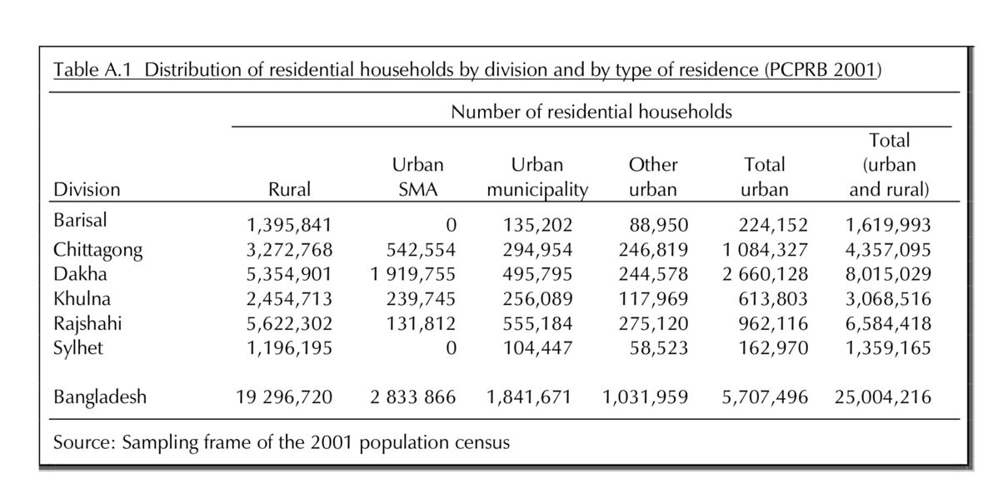

**II. Migration Variable Description:**

**MV101**

De facto region of residence. Region in which the respondent was interviewed. Codes are country-specific. For de jure region of residence, see MV139.

**MV102**

De facto type of place of residence. Type of place of residence where the respondent was interviewed as either urban or rural. Note that this is not the respondent's own categorization, but was created based on whether the cluster or sample point number is defined as urban or rural. See also MV134. For de jure type of place of residence, see MV140.

**MV104**

Number of years the respondent has lived in the village, town, or city where he was interviewed. Visitors to the community are coded 96.

**III. 2011 population survey Results for Comparison**

* **Religion:** Muslims make up almost 90 % of the population of Bangladesh, Hindus account for about 9 percent, and others constitute the remaining 1 percent. (BBS, 2011)

|  |  |  |  |  |  |  |  |  |  |
| --- | --- | --- | --- | --- | --- | --- | --- | --- | --- |
| Division | Area (Sq.km.) 2011 | Household | Population | | | No. of City Corporation | Urban Area Variation (Area in Sq.km) | | |
| **Both Sex** | **Male** | **Female** | **2011** | **2001** | **Variation (%)** |
| Barisal Div | | 665.69 | 301538 | 1361943 | 688342 | 673601 | 25 | 665.69 | 630.82 | 5.53 |
| Chittagong Div. | | 2462.29 | 1414985 | 6905480 | 3543401 | 3362079 | 60 | 2462.29 | 3251.63 | (-)24.28 |
| Dhaka Div. | | 2093.47 | 3580687 | 15584835 | 8346667 | 7238168 | 86 | 2093.47 | 2998.6 | (-)30.19 |
| Khulna Div. | | 1104.36 | 667283 | 2822121 | 1437867 | 1384254 | 37 | 1104.36 | 1261.8 | (-)12.48 |
| Rajshahi Div. | | 1193.04 | 773947 | 33170221 | 1687220 | 1629802 | 60 | 1193.04 | 1253.98 | (-)4.86 |
| Sylhet Div. | | 475.65 | 279373 | 1462711 | 756276 | 706435 | 20 | 475.65 | 417.76 | 13.86 |
| Bangladesh Total | | 8867.42 | 7502040 | 33563183 | 17529792 | 16033391 | 316 | 8867.42 | 10711.89 | (-)17.22 |