

FROM PHANTOM JIANGHU TO
AXIE WUXIA
A product proposal — a shipped prototype as the fastest road to an Axie adventure RPG
Concept · Game Design · Online PK | Proposal v1.0 · 2026

Table of Contents
Right-click the table and choose “Update Field” to refresh page numbers.

Executive Summary 3
The Prototype Advantage 3
Concept 5
World & Story 5
Tone & Positioning 6
Game Design 7
Core Loop 7
Classes & the Triangle 7
Cards, Ascension & Companions 8
Economy & Accounts 9
Online Play — PK & Shared Bosses 10
The Encounter Model 10
Shared World Boss 11
Online PK — the Arena 11
Architecture & Anti-Cheat 12
Balance & Live-Ops Tooling 13
Production Plan 14
Risks & Next Steps 15

Executive Summary
This proposal recommends building the next Axie title — an open-world action RPG with the working title Axie Wuxia — by migrating a finished, production-tested prototype rather than starting from zero. The prototype is Giang Hồ Huyễn Ảnh (Phantom Jianghu), a browser-based wuxia action RPG that is live today: it has real-time combat, eight explorable zones, 75 learnable combat arts, a ten-stage ascension system, pets and mounts, AI-driven NPCs, player accounts with cloud saves and a cross-player leaderboard, bilingual support, and a built-in test harness.
Every one of those systems survives the migration. What changes is the skin: the wuxia world becomes Lunacia, the hero becomes a playable Axie, the martial-arts library becomes a body-part card library, and the cultivation realms become canon Axie ascension. On top of that foundation, this proposal adds the one thing the prototype deliberately lacks: online encounters — shared world bosses and matchmade 1v1 arena PK — delivered through a lightweight “encounter server” that leaves each player’s world private and single-player.
The result: an Axie adventure RPG whose hardest engineering problems are already solved and running in production, whose remaining work is content, art, and a well-bounded online layer. This document covers the concept, the game design, the online PK/boss architecture, and the production plan.

The Prototype Advantage
Prototypes are usually thrown away. This one should not be — because it is not a demo, it is a shipped game. The table below lists what already exists and works today, and what each system becomes under the Axie skin:
Working system (prototype) | Becomes in Axie Wuxia | Migration cost
Real-time top-down combat: aim, dodge, jump, 5-slot skill bar, auto-fight | Unchanged — the core feel of the game | None
8 zones, level-gated, safe/PK rules, gates, dungeon portals | 8 regions of Lunacia, same layout | Rename + re-art
7 sects on a Five-Elements counter wheel | 9 Axie classes on the canon class triangle | Content + 2 new classes
75 learnable arts + 30 fusion combos, mastery to Lv120 | Body-part card library + combo cards | Rename + re-tag
10 cultivation realms, lightning tribulations, 8 meridians × 20 nodes | Ascension stages, Ascension Trials, Instinct Channels | Rename
Pets (seal elites), mounts (8 tiers), wings, cloaks, forge +11, 4 set lines | Companion Axies, rideables, charms, Elder sets | Rename + re-art
AI NPCs with chat, gifts, sparring, sworn bonds, romance | Wandering Axies — identical systems, new voice | Rewrite personas
Accounts: Google + Ronin wallet, cloud saves, leaderboard | Unchanged — Ronin login is already native | None
Offline progression (“seclusion”), world calendar, seasons | “Nesting” — same math, new name | Rename
Test mode: 24 console commands, /max, /boss, /realm, /npc… | Unchanged — the balance-testing harness | None
Bilingual VN/EN engine with verification pipeline | EN-first authoring, VN as translation | Pipeline flip
Roughly two-thirds of the prototype migrates by renaming; the remaining third is art, audio, and story rewriting. No core system needs to be re-engineered. That is the entire economic argument of this proposal: the riskiest, longest-lead-time engineering — combat feel, persistence, AI NPCs, account infrastructure — is already done and battle-tested.
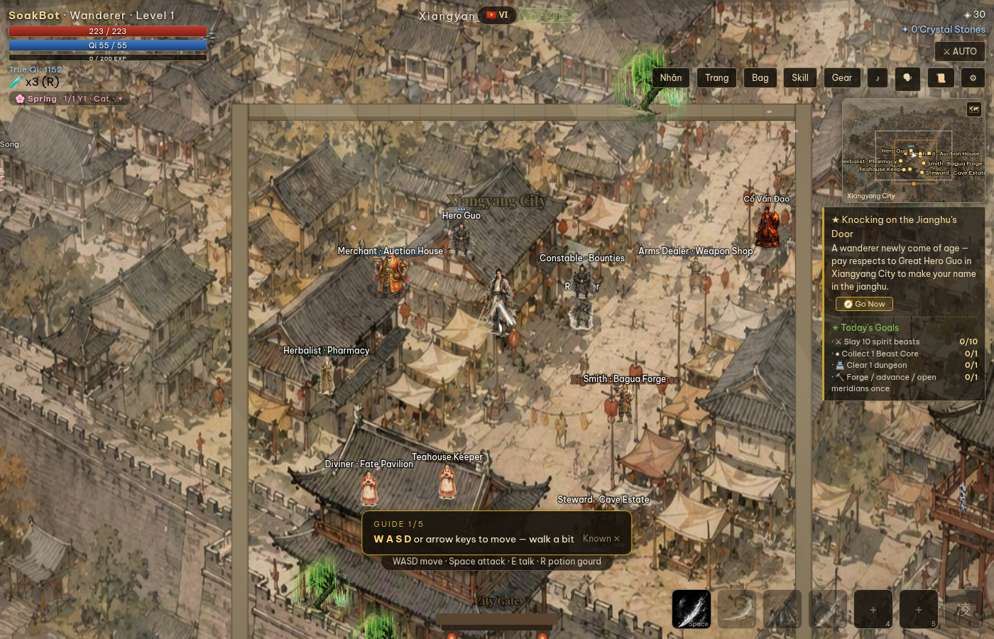
Figure 1: The prototype running today — open world, mobs, gates, HUD, minimap (current wuxia build)
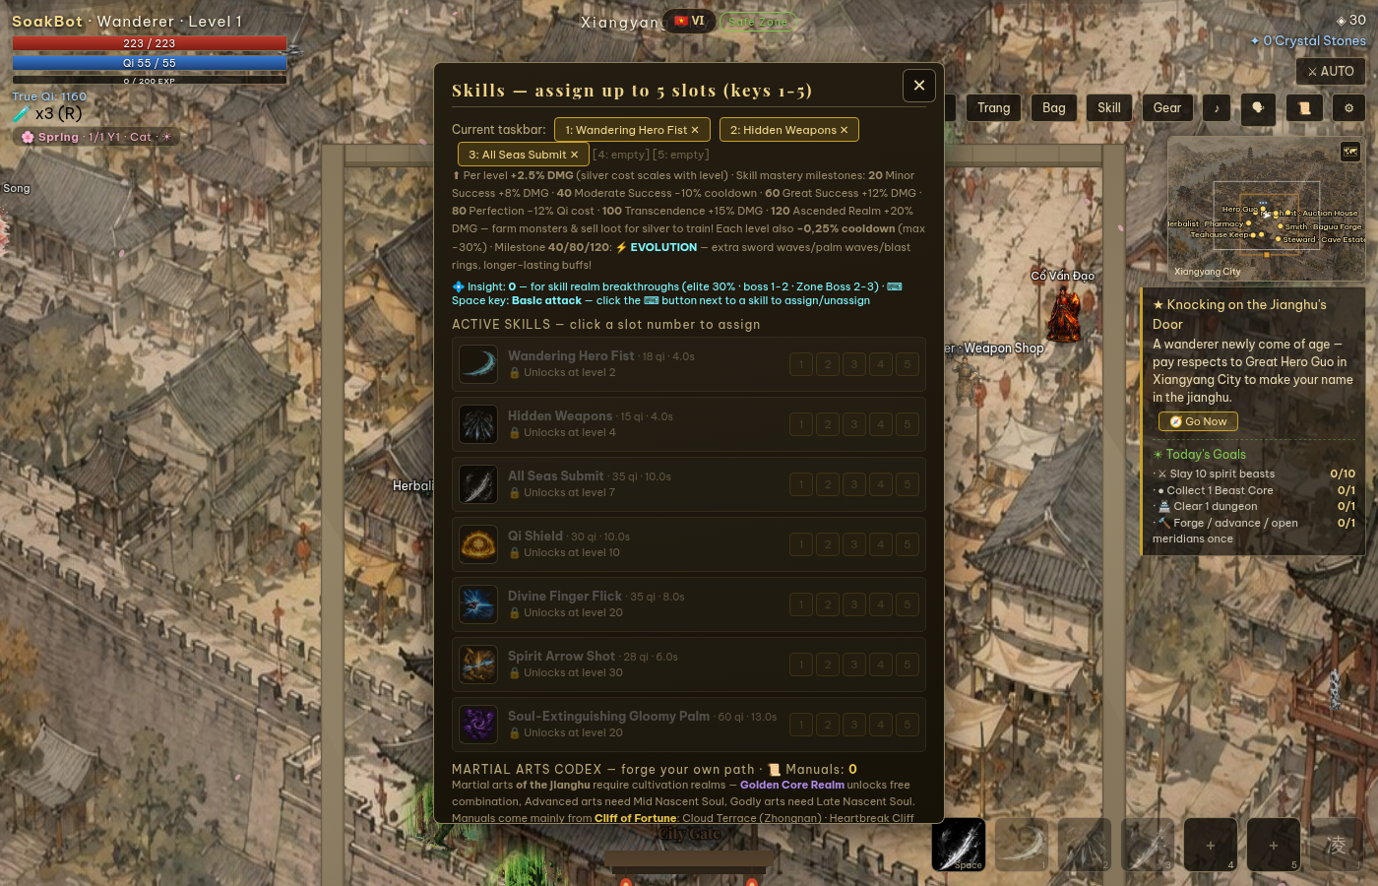
Figure 2: The skill system that becomes the Axie card library — 75 arts, mastery levels, 5-slot action bar

Concept

World & Story
Axie Wuxia keeps the prototype’s story skeleton — an orphan hero, a threatened homeland, five seals, one final title — and re-tells it in the Axie universe:
“Long ago the world-egg Atia hatched, and its first light became the Axies of Lunacia. But beneath the old forests, the Chimeras — twisted creatures born from Atia’s discarded shells — have begun to break the Five Sigils that bind them. You are a young Axie of Petalshade Isle. The night the Gloam Marauders raid your village, the Elder sends you across the strait to Lunaris City with a single charge: find your class, grow strong, and stand where the Sigils fail.”
The player journeys through eight regions of Lunacia — from the safe petals of the starting isle to the free-PK Stormgate Pass at the frontier — breaks a Sigil in each, and earns the game’s final title: Lunacia’s Number One Trainer.

Tone & Positioning
Axie already has a card battler (Origins) and a shared-world MMO in development. Axie Wuxia occupies the open niche: a single-player-first open-world action RPG — story, bosses, AI companions, offline progression — with optional online encounters layered on top. The tone shifts from the prototype’s tragic wuxia war story to cozy-but-threatened adventure: real stakes, warm voice, collectible charm. You play an Axie, not a human trainer — class chosen at the ceremony that replaces the prototype’s sect ceremony.
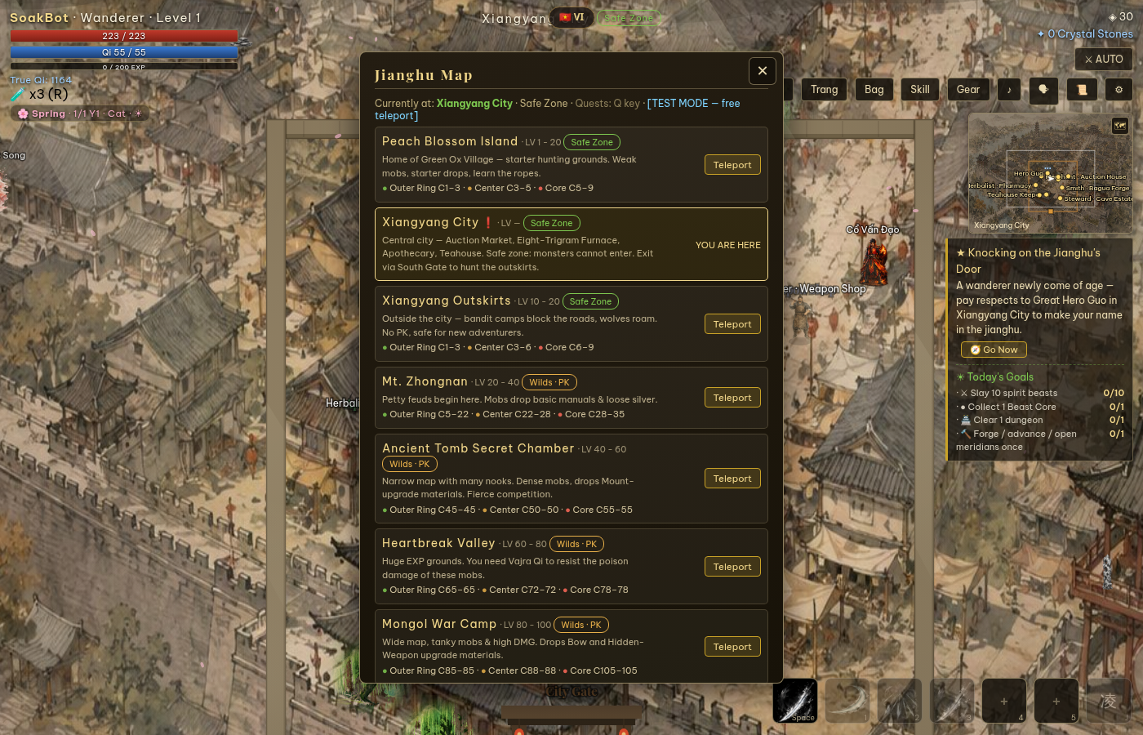
Figure 3: The world map screen — eight level-gated zones, ready to become regions of Lunacia

Game Design

Core Loop
1. Explore — travel the eight regions, meet Wandering Axies, catch pets and steeds.
2. Fight — real-time combat against Chimera packs, zone Wardens, and the daily Overlord world boss.
3. Ascend — spend Anima to climb ten Ascension stages, each gated by an Ascension Trial; unlock trial-reward arts and the double jump, then Starflight beyond stage 9.
4. Gear up — forge to +11, hunt Hoard Chests, complete Elder sets, socket jewels.
5. Socialize — befriend NPCs (chat, gifts, sparring, sworn bonds), duel other players, climb the leaderboard.

Classes & the Triangle
Nine canon classes in three groups; group advantage deals +15% damage around the triangle: Wild (Plant, Reptile, Dusk) → Tide (Aquatic, Bird, Dawn) → Savage (Beast, Bug, Mech) → Wild. Each class is a joinable in-world faction with two signature arts and a home region — a direct re-skin of the prototype’s seven sects, plus two new classes (Bug, Dawn) built on existing skill archetypes.

Cards, Ascension & Companions
The 75 arts become cards bound to classes and body parts (horn, mouth, back, tail, eyes, ears), mastered to level 120 with Card Pages; mastering pairs unlocks 30 Combo Cards. Ascension renames cultivation 1:1, including the lightning trials. Companions — three battle pets sealed from weakened elites, eight mount tiers — stay mechanically identical with Axie-flavored names and skins.

Economy & Accounts
All currencies remain off-chain soft currencies at launch (Starbits, Anima, Essence…), with Ronin wallet login already integrated — an on-chain mapping (cosmetics, collectibles) is a later, optional decision. Accounts, cloud saves, and the leaderboard carry over unchanged; offline progression (“Nesting”) keeps Axies growing while the player is away.

Online Play — PK & Shared Bosses

The Encounter Model
The prototype is single-player at its core: every world simulates locally in the player’s browser. Rather than rebuild it as an MMO, Axie Wuxia adopts the encounter model — private worlds, synchronous encounters:
❖ Each player’s world stays private and client-side — exploration, farming, quests, NPCs need no server at all.
❖ The server wakes only for encounters: a scheduled shared world boss, or a matchmade 1v1 arena duel. Each encounter is an ephemeral WebSocket room that exists for minutes, then dissolves.
❖ This bounds the server workload to a handful of entities per room (2 players, or N players + 1 boss) — a small VPS handles hundreds of concurrent encounters, and 99% of playtime costs zero server bandwidth.

Shared World Boss
The prototype’s four-hourly world boss becomes the Overlord’s Descent — the community event of Axie Wuxia. When the event opens, players who enter the Warden Altar join a shared boss room: the server drives a single boss entity (HP pool, target selection, skill telegraphs), each client renders the fight and reports its damage, and the server validates contributions against range, cooldown, and damage-cap rules before pooling them. Rewards and leaderboard credit are granted by contribution when the boss falls. Simulating one boss server-side is light work — the full world simulation never leaves the client.

Online PK — the Arena
Open-world PK conflicts with private worlds, so player-versus-player combat is delivered as the Arena: a matchmade 1v1 duel in an instanced coliseum. Players queue from any city; the lobby pairs them and opens a duel room. During the fight, each client streams position and actions (~15 Hz) through the server, which relays them, sanity-checks cooldowns/ranges/damage, and referees the result (knockout, timeout, disconnect). The opponent is rendered client-side with interpolation, reusing the prototype’s existing NPC rendering path. Outcomes feed a dedicated PK leaderboard and win-streak titles.

Architecture & Anti-Cheat
❖ Lobby API (matchmaking, event schedule) rides the existing Hono/tRPC backend; encounter rooms run on a small Node WebSocket service beside it, behind nginx on one VPS.
❖ Client-authoritative movement with server-side validation: rate limits, cooldown checks, range and damage caps, full fight logs for review. This accepts the same trust level the prototype’s leaderboard already uses — sufficient for launch, with a path to deeper server authority later.
❖ Results are reported to the account API and persisted; nothing about saves, inventory, or progression changes.
Rollout: M1 — shared world boss (highest community value, lowest complexity); M2 — arena matchmaking and 1v1 duels; M3 — PK seasons, spectating, and team formats if the community asks for them.

Balance & Live-Ops Tooling
A live game lives or dies by iteration speed. Axie Wuxia inherits the prototype’s test harness — a console that can set any level, realm, gear tier, or boss state in seconds — and adds three tools:
❖ Balance config — every stat table (skills, mobs, bosses, gear) extracted to one balance.json shared by client and server: tune, save, refresh, test — no rebuild.
❖ DPS meter — a test-mode overlay showing damage-per-second, time-to-kill, and incoming damage, turning balance testing from feel into measurement.
❖ Fight telemetry — every boss room and duel logs damage, skill usage, and outcomes to the database; win rates and time-to-kill by class become a weekly tuning report.
Two operators can balance the entire game with these three tools — the same harness that was used to build and verify the prototype itself.

Production Plan
Phase | Scope | Notes
0 | Approval & naming freeze | This proposal + the companion Migration Design Document; open decisions resolved
1 | Language flip | Re-author all strings English-first; invert the translation engine to EN→VN; verification suite green
2 | Classes & cards | 9 classes on the triangle; 75 cards tagged by class and body part; class ceremony replaces sect ceremony
3 | World & story | Regions, Sigils, quests, titles, NPC personas, calendar, economy names; new four-page intro
4 | Art & audio | Modular Axie avatar (body + 6 parts), zone re-art, Chimera skins, class icons; full original OST — the current soundtrack is commercial wuxia music and cannot ship
5 | Online encounters | Encounter server: shared world boss (M1), then arena PK (M2)
6 | Polish & launch | Balance pass with telemetry, guides, branding, production launch on owned infrastructure
Phases 1–3 are text-and-data work on a running game and ship incrementally behind the existing deployment pipeline. Phase 4 is the long pole and runs in parallel once the avatar part system is specified. Phase 5 is well-bounded: two encounter types, one WebSocket service.

Risks & Next Steps
❖ Art volume is the dominant cost — mitigated by the modular avatar (one rig, swappable parts) and by reusing every animation the prototype already has.
❖ Encounter sync fairness — mitigated by server validation, damage caps, and fight logs; deeper server authority is a documented upgrade path, not a rewrite.
❖ Scope discipline — the proposal deliberately excludes open-world shared presence; adding it later is possible, but nothing in this plan depends on it.
Next steps: approve this proposal and the companion Migration Design Document, resolve the open decisions listed there (class roster, final title, on-chain scope, art route, save policy), and the naming map freezes — Phase 1 begins immediately after.
The prototype already proves the game is fun to play and feasible to run. Axie Wuxia is not a bet on unbuilt technology; it is a re-dressing of a working production, plus one carefully bounded online layer. That is the fastest credible road to a new Axie title.


The prototype ships. The legend scales.
Axie Wuxia — an adventure RPG built on a game that already works.
Proposal v1.0 · 2026

