**Programming**

**Title**

|  |  |
| --- | --- |
| **Student(s)** | SHABNAM REZAEI |
| **Student Number** | 5298191 |
| **Course** | Database Concepts and Applications |
| **Session** |  |
| **Teacher** |  |
| **Date** | 2022-09-05 |

**1. List all the dogs and male turtles.**

SELECT species, sex FROM animals

WHERE species='dog' OR (species='turtle' AND sex='M')

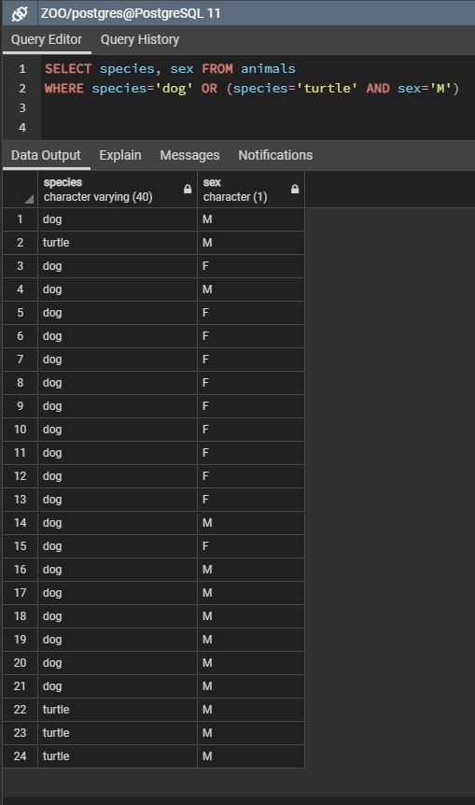

**2. List all the female cats and female dogs.**

SELECT species, sex FROM animals

WHERE (species='dog' OR species='cat') AND sex='F'

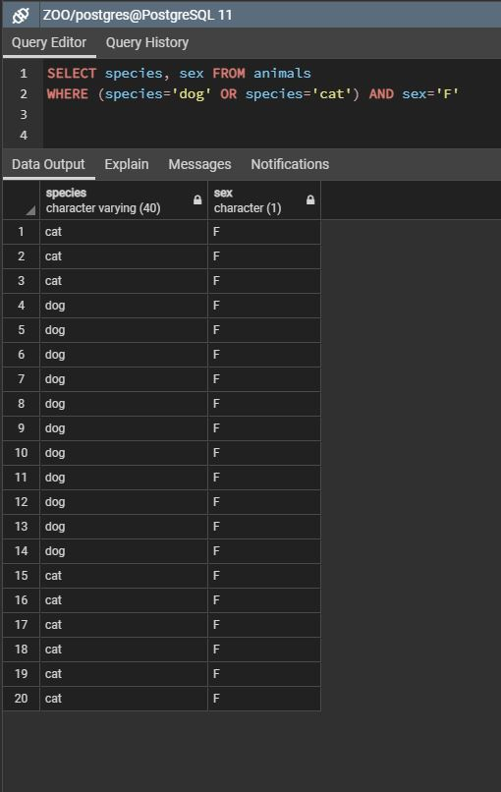

**3. List all the female dogs and the oldest turtle (name, sex, specie, dob).**

SELECT name, sex, species, dob FROM animals

WHERE (species='dog' AND sex='F') OR (species='turtle' AND dob < timestamp '2013-03-15 14:56:00');

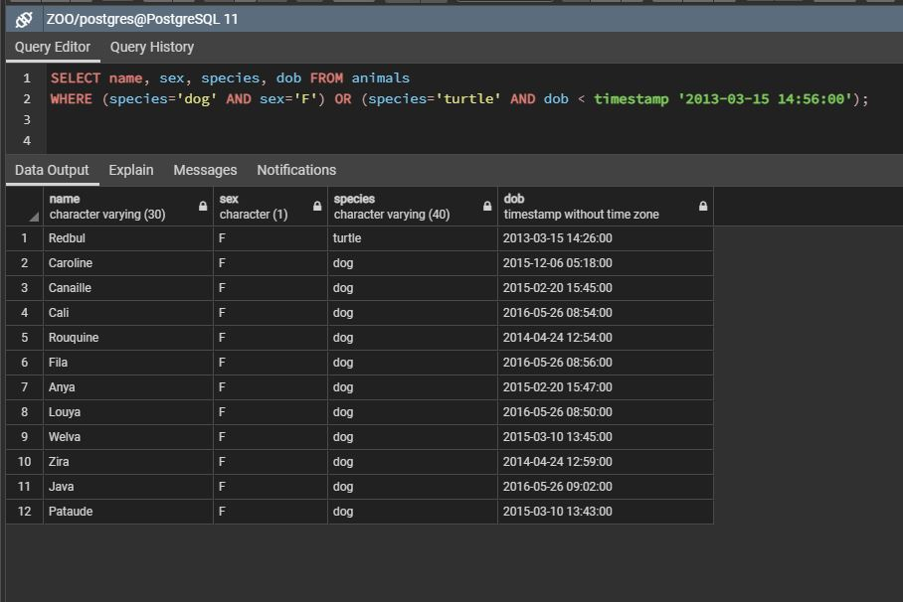

**4. List the animals born in 2007 (specie, name and date of birth).**

SELECT name, species, dob FROM animals

WHERE timestamp '2017-01-01 00:00:00'<= dob AND dob<= timestamp '2018-01-01 00:00:00';

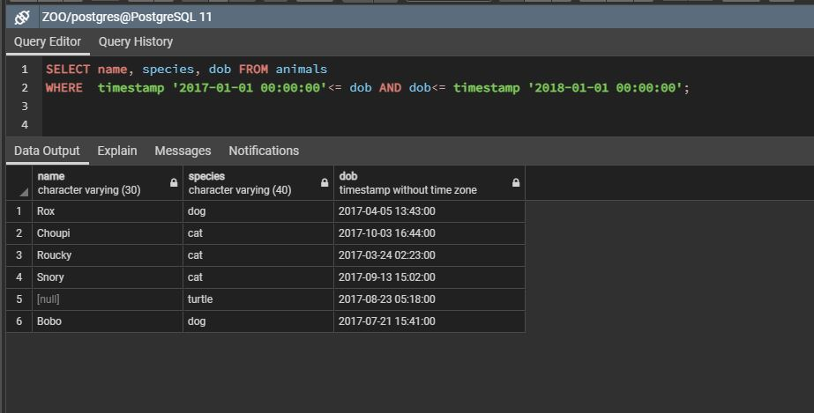

**5. List the animals with any comments attached to their name (name, specie, comments).**

SELECT name,species,comments FROM animals

WHERE comments IS NOT NULL;

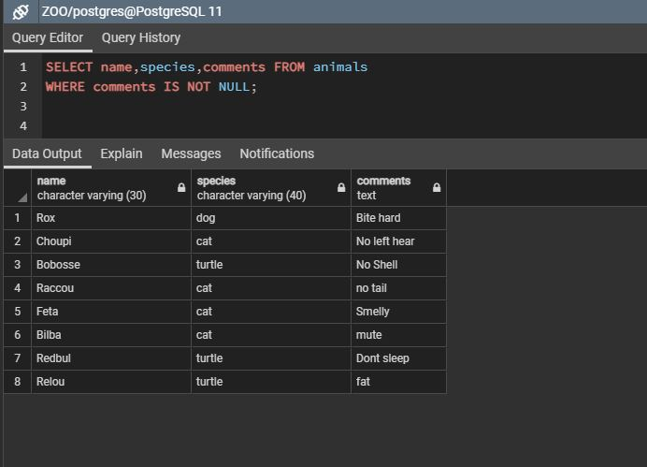

**6. List the 5 oldest animals (name, specie, date of birth).**

SELECT name,species,dob FROM animals

ORDER BY dob ASC LIMIT 5;

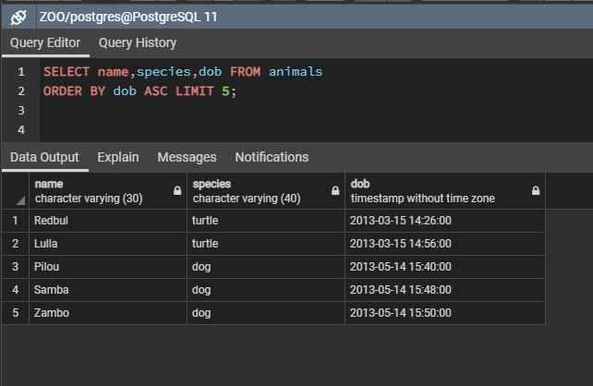

**7. List the 5 youngest animals (name, dob).**

SELECT name,dob FROM animals

ORDER BY dob DESC LIMIT 5;

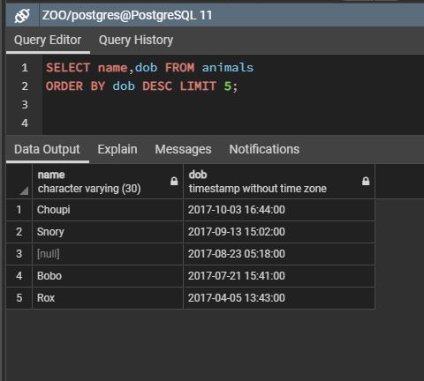

**8. List all the animals who's name starts with 'b'.**

SELECT name,species FROM animals

WHERE name ILIKE 'b%';

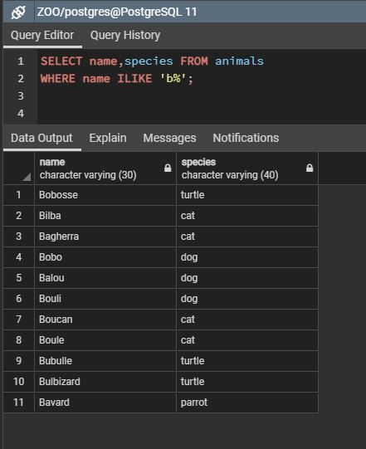

**9. List all the males except for the dogs and the cats.**

SELECT species,sex FROM animals

WHERE sex='M' AND (species != 'dog' AND species != 'cat');

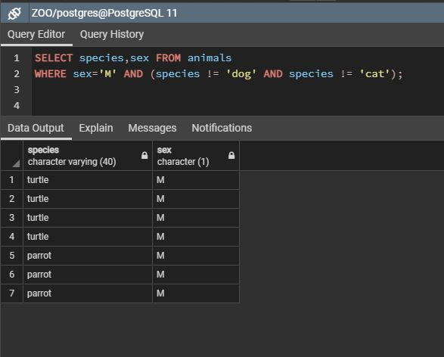

**10. List all the female cats born between 2007 and 2009.**

SELECT species,sex,dob FROM animals

WHERE sex='F' AND species = 'cat' AND (dob BETWEEN '2007-01-01 00:00:00' AND '2008-01-01 00:00:00');

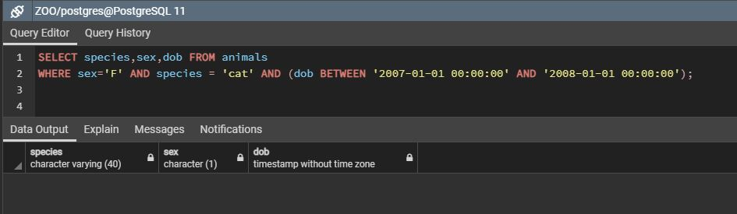

**11. List all the animals who's name ends with a and was born in 2009 and who's not a male.**

SELECT name,sex,dob FROM animals

WHERE sex!='M' AND name ILIKE 'a%' AND (dob BETWEEN '2009-01-01 00:00:00' AND '2010-01-01 00:00:00');

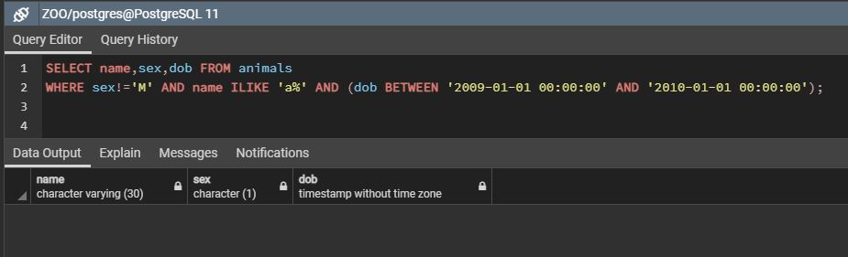

**12. List of 2 female turtles sort their name from z-a.**

SELECT name,sex,species FROM animals

WHERE species = 'turtle' AND sex='F'

ORDER BY name DESC

LIMIT 2;

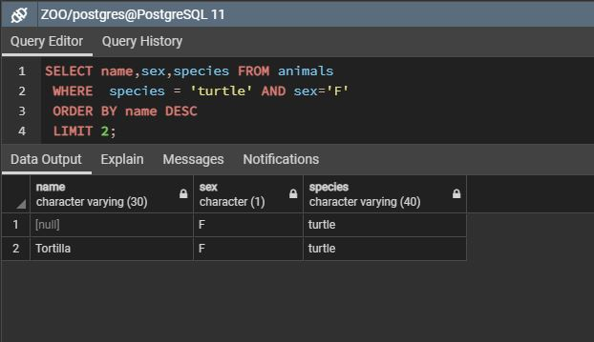

**13. Update all the "perrot" to "parrot".**

UPDATE animals

SET species = 'parrot'

WHERE species = 'perrot';

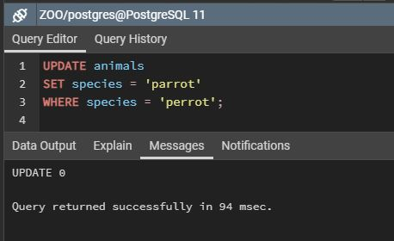

**14. List of the animal called 'Bouli', parrot with comments and all the female born before 2008 (name, sex).**

SELECT name,species,sex,dob,comments FROM animals

WHERE name ='Bouli' OR (species='parrot' AND comments IS NOT NULL) OR (sex='F' AND dob < timestamp '2015-01-01 00:00:00');

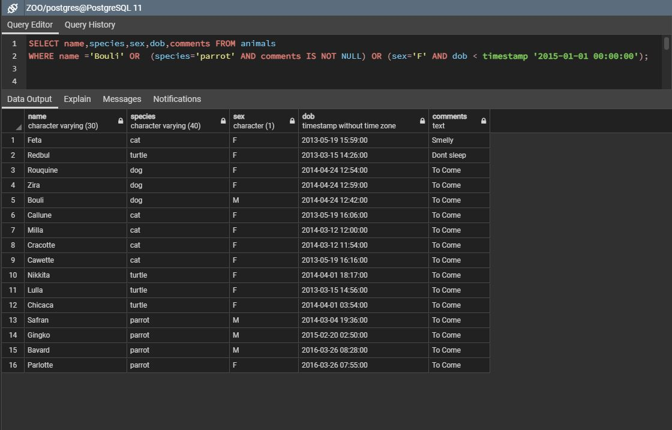

**15. Change all the "NULL" comments to "To Come"!**

UPDATE animals

SET comments = 'To Come'

WHERE comments IS NULL;

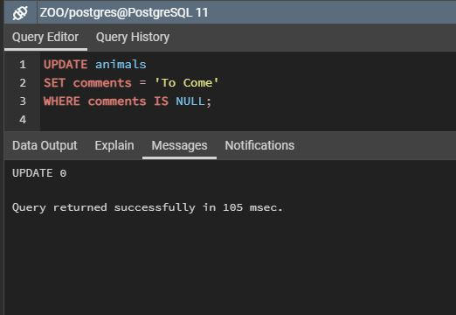

**16. How many species exist in total?**

SELECT COUNT (DISTINCT species)FROM animals;

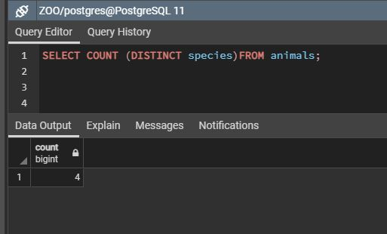

**17. Surprise me with a cool query!**