**Assignment 01 BITI 3413 Natural Language Processing**

|  |  |
| --- | --- |
| **Name** | **Matric** |
| Suthareesanan A/L Saravanan | B032320096 |
| Dreshya A/P Ravi Chandran | B032320029 |

**2a) Visualizing frequent words using Wordcloud**

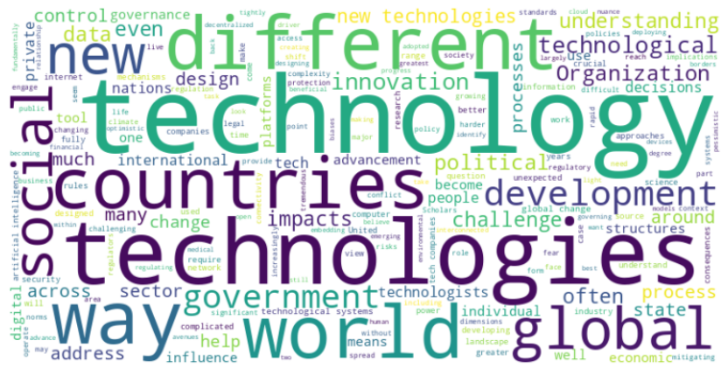

**2b)** **Top 20 Unigrams, Bigrams and Trigrams**

2c)

**2d) Generate word-embedding and visualize**

