Backend:
- The SQL Agent did not fetch all the essential fields
- SQL Agent already sent the right data to the Inventory Management Agent, but the agent still saying it is incorrect.
- Context length reaching its limit when there are lot of data.
- Supervisor agent calling the same agent again even though task completed (temp fixed).
- Chat continuation problem where the supervisor agent give answer based on the last answer while we need a new answer.
- Update the restock recommended quantity using ROP
- Shows the inventory levels for all products across different stores.
- We can try to reduce runtime by coding the tool call ourselves
- Streaming: cancellation no working
- Supervisor not evaluate the agents’ response, just focuses on the agent calling.
- Sometime agent will reach recursion limit
- Streaming: reflection from the supervisor agent with correctness_check: no will crash the stream.
- Request restock plan sometime will involve sales analyst agent as well.
- SQL Agent running slow during the last llm call as the agent need to process too much data from the query execution result
- Sometime tool call will be looking like this: tool_call>
- Wont redirect to Inventory Management Agent, after the retrieving data from the SQL Agent

Frontend:
- After correctness_check: no will mess up the output
- Not able to cancel execution of the multi-agent
- Error: return Command(goto=f"{agent_names_map[parse_required_follow_up(reflection_output)]
- Time not updating when workflow completed

https://smith.langchain.com/public/052a8ce5-7265-45ba-a607-4d0a8a68d8a5/r
https://smith.langchain.com/public/f9d4e289-b741-4b4f-8d4d-7a01f71f854e/r
sql + inventory
https://smith.langchain.com/public/ea664e08-3983-4973-9d44-5ce7e412705b/r
7b
https://smith.langchain.com/public/3b27afac-eb41-45b7-8372-0ac507769cec/r

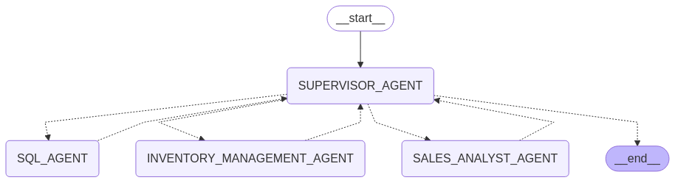
Qwen3-4b
SQL Agent
What are the top 15 products sold in store S002 during the first day of January 2022?
https://smith.langchain.com/public/cdeb8bc8-9636-4ac7-80b1-e016f8e972aa/r

Inventory Management agent
What should we restock for the store S002 during the end of January 2022?
https://smith.langchain.com/public/2558ffbc-64fa-4f73-b418-cb714d0b44c6/r
https://smith.langchain.com/public/3f598074-ffb1-4fa2-a56d-50ac3c776d43/r
https://smith.langchain.com/public/8c566973-2148-49d6-9de3-590008d9a78f/r

Sales Analyst agent
Can you give me a summary of the sales performance for Store S001 in January 2022?
https://smith.langchain.com/public/f2f250b0-ba74-4eea-88af-5845836ad8bd/r
What are the total sales for toys category inside store S001 in the month of January 2022?
https://smith.langchain.com/public/b278927a-70fb-4c5f-aefd-ee5520cf82fd/r

All agents in work
"Can you help me create the restock plan for Store S001 at the end of February 2022, and also the sales analysis on the same month?"
https://smith.langchain.com/public/fb3a19d6-55ff-4720-9742-50ebbf0e6232/r
https://smith.langchain.com/public/07bc73e8-d31a-4410-876b-8d84f51b50d1/r

Can you help me create the restock plan for Store S001 at the end of January 2022, and also the sales analysis on the same month?
https://smith.langchain.com/public/9ef5beee-1860-46c5-b867-8285704c531f/r

Transformer
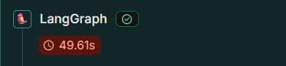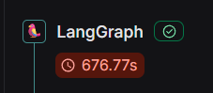
vLLM
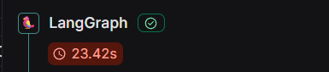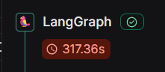
Reflection:
Inject Reflection in Supervisor Agent to check response from the SQL Agent
https://smith.langchain.com/public/070a1a34-b19a-4772-84ad-70acb8d4409b/r

Smooth run with no incorrect response from the agent
https://smith.langchain.com/public/5111a38b-c229-46d9-92f5-15d3f934953a/r
https://smith.langchain.com/public/b30057f9-ace8-4368-9b6c-00791eb1a4fb/r
https://smith.langchain.com/public/dbffd032-dd16-41d9-9c95-24ab58260dda/r
Supervisor corrected sql agent through reflection:
HumanMessage(content="What are the top 10 products sold in store S002 during the first day of January 2022?")
https://smith.langchain.com/public/0fc97ba5-8c22-43b0-b574-3e9dfce926e8/r
https://smith.langchain.com/public/5ee6ce05-3cce-40b9-933e-f99134561509/r

Supervisor corrected sql agent (all agents in action):
https://smith.langchain.com/public/57746b2c-d6f2-4181-bfa0-ec5397c067d2/r
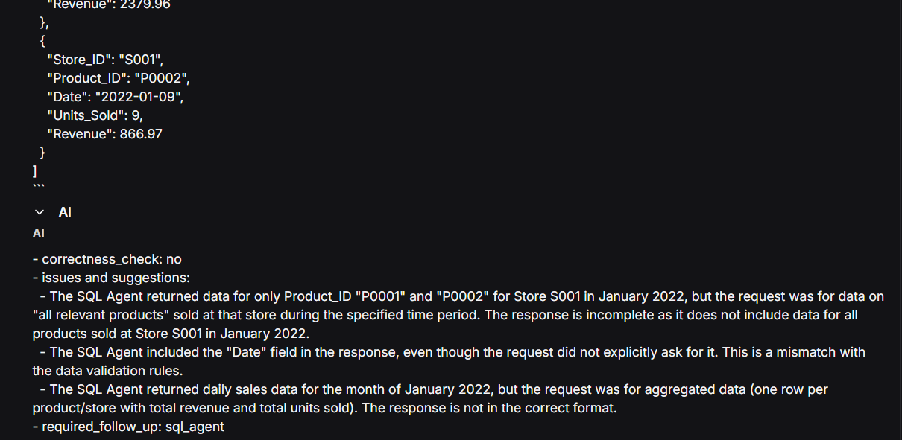
https://smith.langchain.com/public/67804642-4b12-4195-aebd-9f714a635602/r

From Natural Language to SQL: Approaches and Challenges in Text2SQL
https://toashishagarwal.medium.com/from-natural-language-to-sql-approaches-and-challenges-in-text2sql-d1252ff86321
Next-Generation Database Interfaces: A Survey of LLM-based Text-to-SQL
https://arxiv.org/pdf/2406.08426
Self-Reflection in LLM Agents: Effects on Problem-Solving Performance
https://arxiv.org/pdf/2405.06682
Positive Experience Reflection for Agents in Interactive Text Environments
https://arxiv.org/pdf/2411.02223
Reflexion: Language Agents with Verbal Reinforcement Learning
https://arxiv.org/pdf/2303.11366

Docker + vLLM + OpenAI
https://github.com/aneeshjoy/vllm-windows?tab=readme-ov-file
How do I speed up my AI agent?
https://blog.langchain.dev/how-do-i-speed-up-my-agent/
Evaluation concepts
https://docs.smith.langchain.com/evaluation/concepts

What is the restock plan for the store S001 during the end of January 2022?
No anomalies runtime
https://smith.langchain.com/public/9fa70821-1185-40df-9a02-267274cd43d0/r

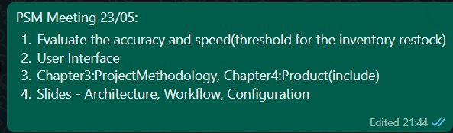

Ways to evaluate the agents (https://www.youtube.com/watch?v=_QozKR9eQE8&ab_channel=LangChain):
- LLM Judge where it will look compare the result from agents with the ground truth, and determine the correctness of it.
- Check for the trajectory of the agents, to see whether the flow between the agents are correct and specifically we can look for any extra steps/unmatched steps by comparing the trajectory during evaluation to the expected trajectory.

https://smith.langchain.com/o/72a23be0-1a7c-46bd-b1d9-934d02fccd9f/datasets/ce7cb8b0-bee6-43cf-9664-25969a5cbb83/compare?selectedSessions=402ef5f1-37fe-4644-831b-f720c903497d&baseline=undefined

Evaluating time performance according to number of data rows involve.
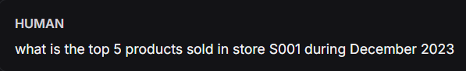
Time taken(s): 78, 71, 76, 69
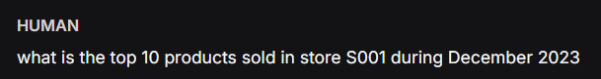
Time taken(s): 109, 105, 98, 105

RESTOCK PLANNING:
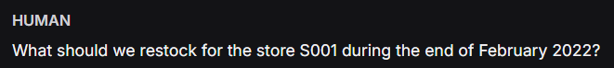
For (5) Products:
Time taken(s): 53, 42, 42, 43, 54 (average: 46.8)
For (10) Products:
Time taken(s): 63, 49, 64, 51, 48 (average: 55.0)
For (20) Products:
Time taken(s): 79, 79, 65, 66, 75 (average: 72.8)
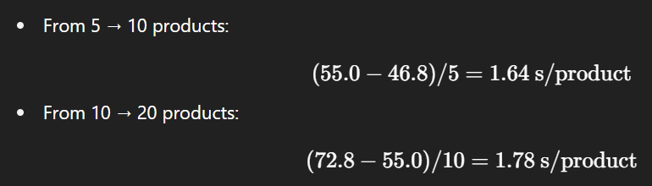
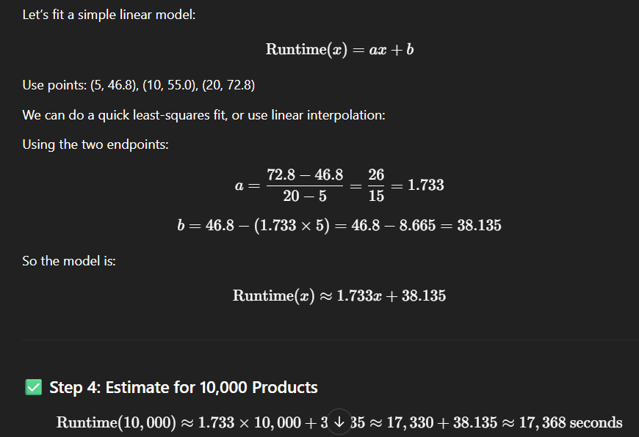
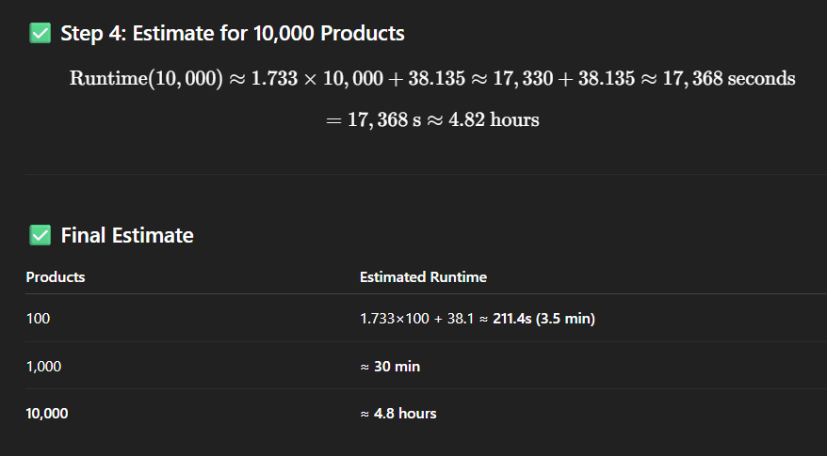

SALES ANALYSIS:
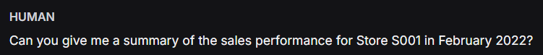
For (5) Products:
Time taken(s): 61, 68, 61, 66, 65 (average: 64.2)
For (10) Products:
Time taken(s): 93, 80, 81, 85, 83 (average: 84.4)
For (20) Products
Time taken(s): 126, 126, 127, 119, 126 (average: 124.8)
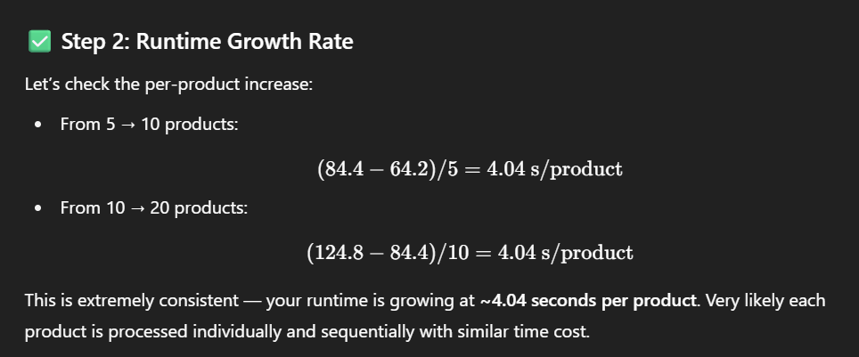
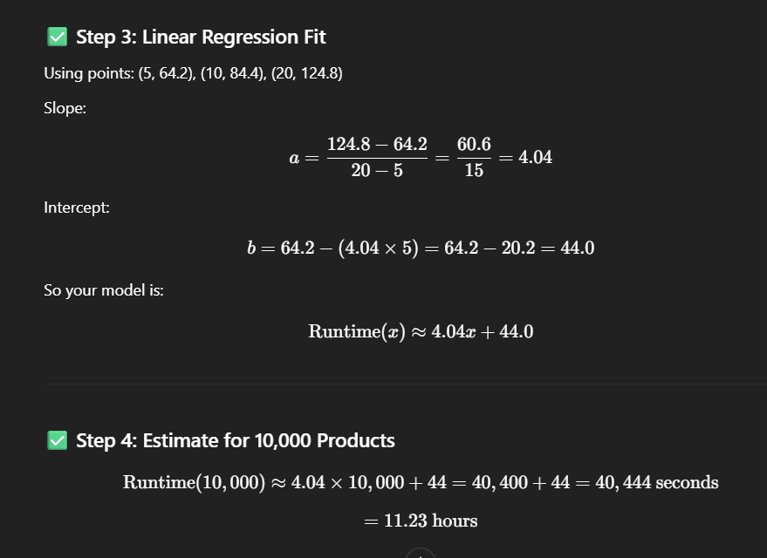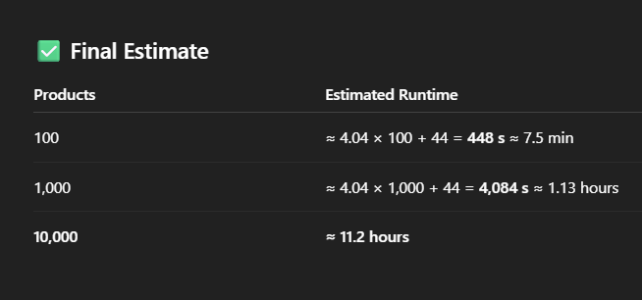

Improved latency (restock and sales analysis together):
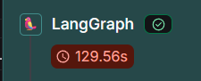
https://smith.langchain.com/public/7ffeab6b-048a-4fb2-868a-43b6be5ccbae/r

Prompts:
Can you give me a summary of the sales performance for Store S001 for current month
can you compare the sales of that store with store S002
help me generate the restock plan for store S001 during the end of this month
can you help me retrieve the top 10 products sold during the last day of dec2023 in that store?
which product category has the most sales in store S001 during December2023

