LITTLE TWINS AUGUST SALES SQL QUERIES
- KPI’s:

- Total Revenue:
SELECT
ROUND(SUM(Net_Sales),2) AS Total_Revenue
FROM LittleTwins_August_Sales;

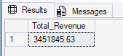

- Average Order Value:
SELECT
ROUND (
SUM(Net_Sales) * 1.0 / COUNT (DISTINCT Transaction_ID),
2) AS Avg_Transaction_Value
FROM LittleTwins_August_Sales;

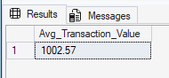

- Total Quantity Sold:
SELECT
SUM(Quantity) AS Total_Quantity_Sold
FROM LittleTwins_August_Sales;

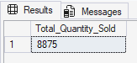

- Total Transaction:

SELECT
COUNT (DISTINCT Transaction_ID) AS Total_Transactions
FROM LittleTwins_August_Sales;

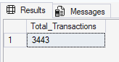

- Average Items Per Transaction:
SELECT
ROUND (
SUM(Quantity) * 1.0 / COUNT(Transaction_ID),
2) AS Avg_Item_Per_Transaction
FROM LittleTwins_August_Sales;

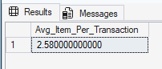

CHART REQUIREMENTS
- Busiest Days & Times
- Daily Trend:
SELECT
CAST(Transaction_Date AS DATE) AS Transaction_Day,
COUNT(DISTINCT Transaction_ID) AS Total_Transactions,
ROUND(
SUM(Net_Sales),
2) AS Total_Revenue
FROM LittleTwins_August_Sales
GROUP BY CAST(Transaction_Date AS DATE)
ORDER BY Transaction_Day;

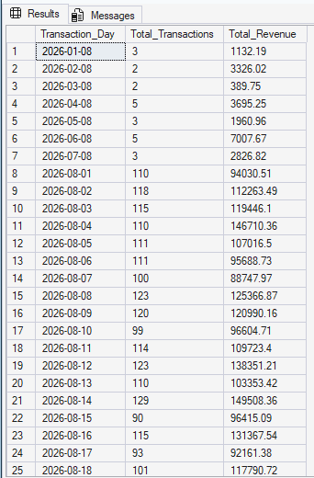
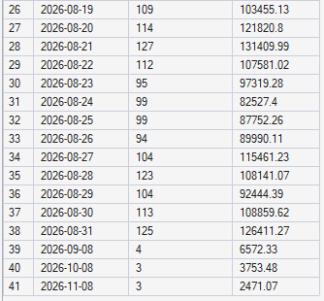

- Hourly Trend:
SELECT
DATEPART(HOUR, Transaction_Time) AS Transaction_Hour,
COUNT(DISTINCT Transaction_ID) AS Total_Transactions,
ROUND(SUM(Net_Sales), 2) AS Total_Revenue
FROM LittleTwins_August_Sales
WHERE DATEPART(HOUR, Transaction_Time) BETWEEN 8 AND 22
GROUP BY DATEPART(HOUR, Transaction_Time)
ORDER BY Transaction_Hour;

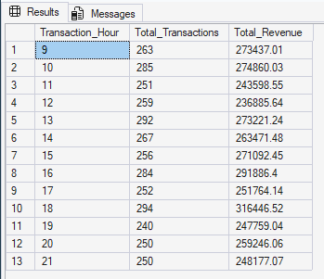
- Category & Product Performance:
- Sales by Product Category (%)
SELECT
Category,
ROUND(
SUM(Net_Sales) * 100.0 /
( SELECT
SUM(Net_Sales)
FROM LittleTwins_August_Sales),
2)AS Percentage_of_Sales
FROM LittleTwins_August_Sales
GROUP BY Category
ORDER BY Percentage_of_Sales DESC;

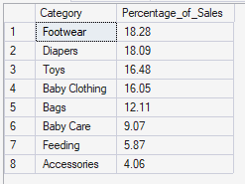

- Total Quantity Sold by Product
SELECT
Category,
SUM(Quantity) AS Total_Quantity_Sold
FROM LittleTwins_August_Sales
GROUP BY Category
ORDER BY Total_Quantity_Sold DESC;

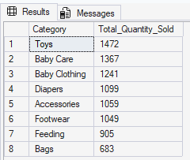
- Top 5 Best Sellers

SELECT TOP 5
Product,
SUM(Quantity) AS Total_Quantity_Sold,
ROUND(SUM(Net_Sales), 2) AS Total_Revenue
FROM LittleTwins_August_Sales
GROUP BY Product
ORDER BY Total_Quantity_Sold DESC;

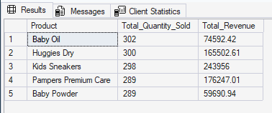

- Bottom 5 Slow Movers:

SELECT TOP 5
Product,
SUM(Quantity) AS Total_Quantity_Sold,
ROUND(SUM(Net_Sales), 2) AS Total_Revenue
FROM LittleTwins_August_Sales
GROUP BY Product
ORDER BY Total_Quantity_Sold ASC;

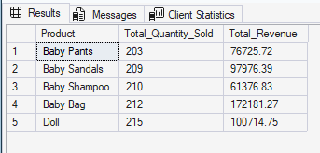

- Customer & Payment Demographics:
- Payment Mode Preferences
SELECT
Payment_Mode,
COUNT(DISTINCT Transaction_ID) AS Total_Transaction,
ROUND(
COUNT(DISTINCT Transaction_ID)* 100.0/
(SELECT COUNT(DISTINCT Transaction_ID)
FROM LittleTwins_August_Sales),2
) AS Percent_Share
FROM LittleTwins_August_Sales
GROUP BY Payment_Mode
ORDER BY Total_Transaction DESC;

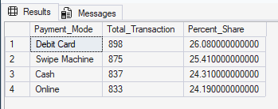

- Customer Location Insights:
SELECT
Customer_Location,
ROUND(
SUM(Net_Sales),2
) AS Total_Revenue
FROM LittleTwins_August_Sales
GROUP BY Customer_Location
ORDER BY Total_Revenue DESC;

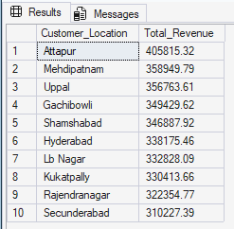
- Gender & Age Demographics:
SELECT
Customer_Gender,
CASE
WHEN Customer_Age BETWEEN 18 AND 25 THEN '18-25'
WHEN Customer_Age BETWEEN 26 AND 35 THEN '26-35'
WHEN Customer_Age BETWEEN 36 AND 45 THEN '36-45'
WHEN Customer_Age BETWEEN 45 AND 55 THEN '46-55'
ELSE '55+'
END AS Age_Bracet,
SUM(Net_Sales) AS Total_Revenue
FROM LittleTwins_August_Sales
GROUP BY Customer_Gender,
CASE
WHEN Customer_Age BETWEEN 18 AND 25 THEN '18-25'
WHEN Customer_Age BETWEEN 26 AND 35 THEN '26-35'
WHEN Customer_Age BETWEEN 36 AND 45 THEN '36-45'
WHEN Customer_Age BETWEEN 46 AND 55 THEN '46-55'
ELSE '55+'
END
ORDER BY Total_Revenue DESC;

