**DevOps Jenkins**

Event: 02/02/2025

Participants: shandeeps.22msc@kongu.edu

# Objective

The objective of this process is to **automate the deployment of an enhanced Nginx-powered website** by executing a shell script. This ensures a seamless setup and delivery of a modern, responsive, and visually appealing web page with the following key goals:

1. **Automated System Update & Installation:**

○ Ensure the server environment is up to date by running apt update and apt upgrade.

○ Start and manage the Nginx service automatically.

1. **Website Deployment & Configuration:**

○ Deploy an enhanced HTML-based website with modern UI/UX features.

○ Integrate CSS animations and AOS (Animate on Scroll) for better user interaction.

○ Implement a clean, responsive layout with improved styling, navigation, and accessibility.

1. **Automation & Error Reduction:**

* 1. Automate the process of copying the website files to the Nginx root directory (/var/www/html/).

○ Ensure the default Nginx page (index.nginx-debian.html) is updated with the latest version.

○ Restart Nginx to apply changes, ensuring the website is live without manual intervention.

1. **Scalability & Maintainability:**

* 1. Provide a structured and scalable deployment method for future modifications.

○ Ensure the website is easily upgradable without requiring extensive manual configuration.

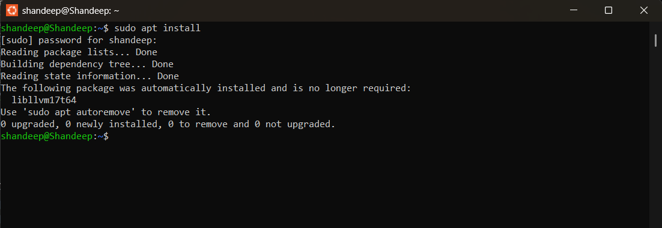

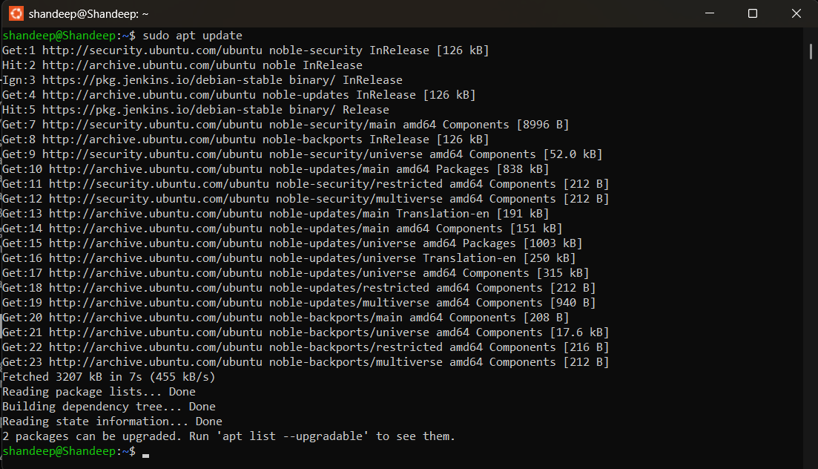

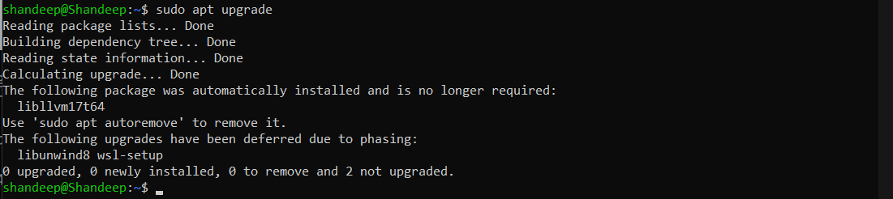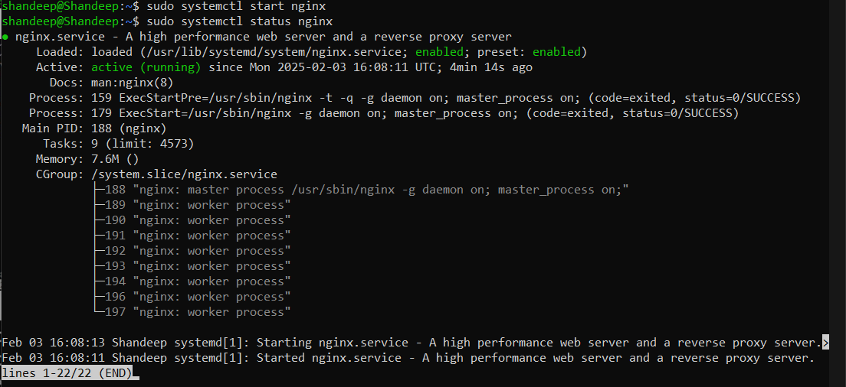 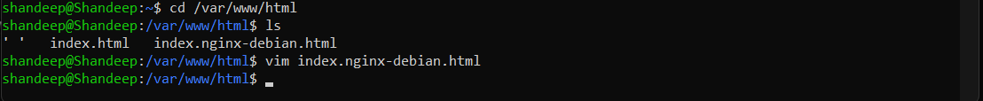

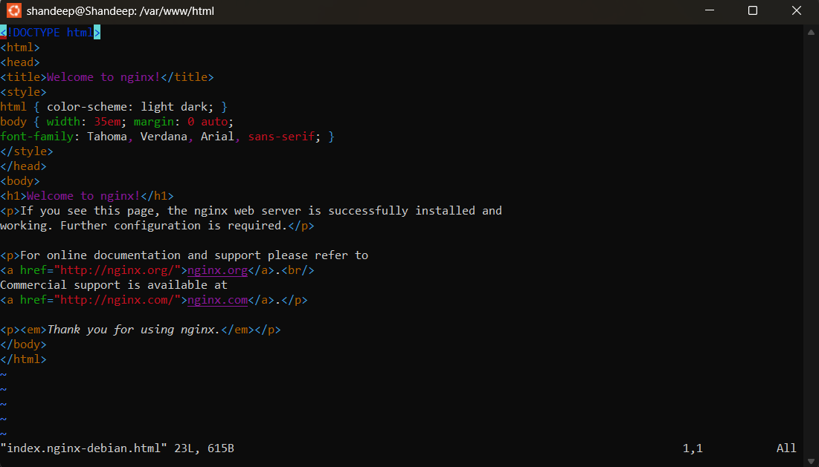

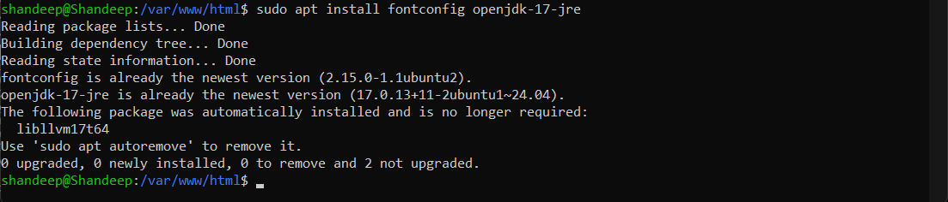 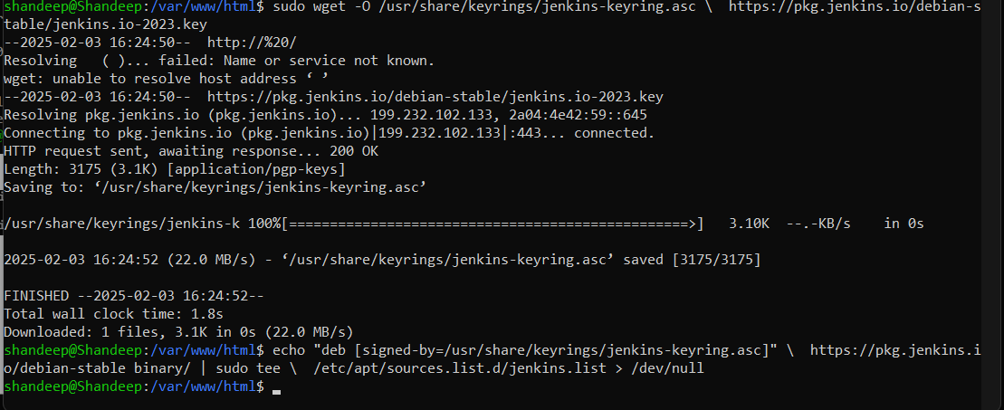

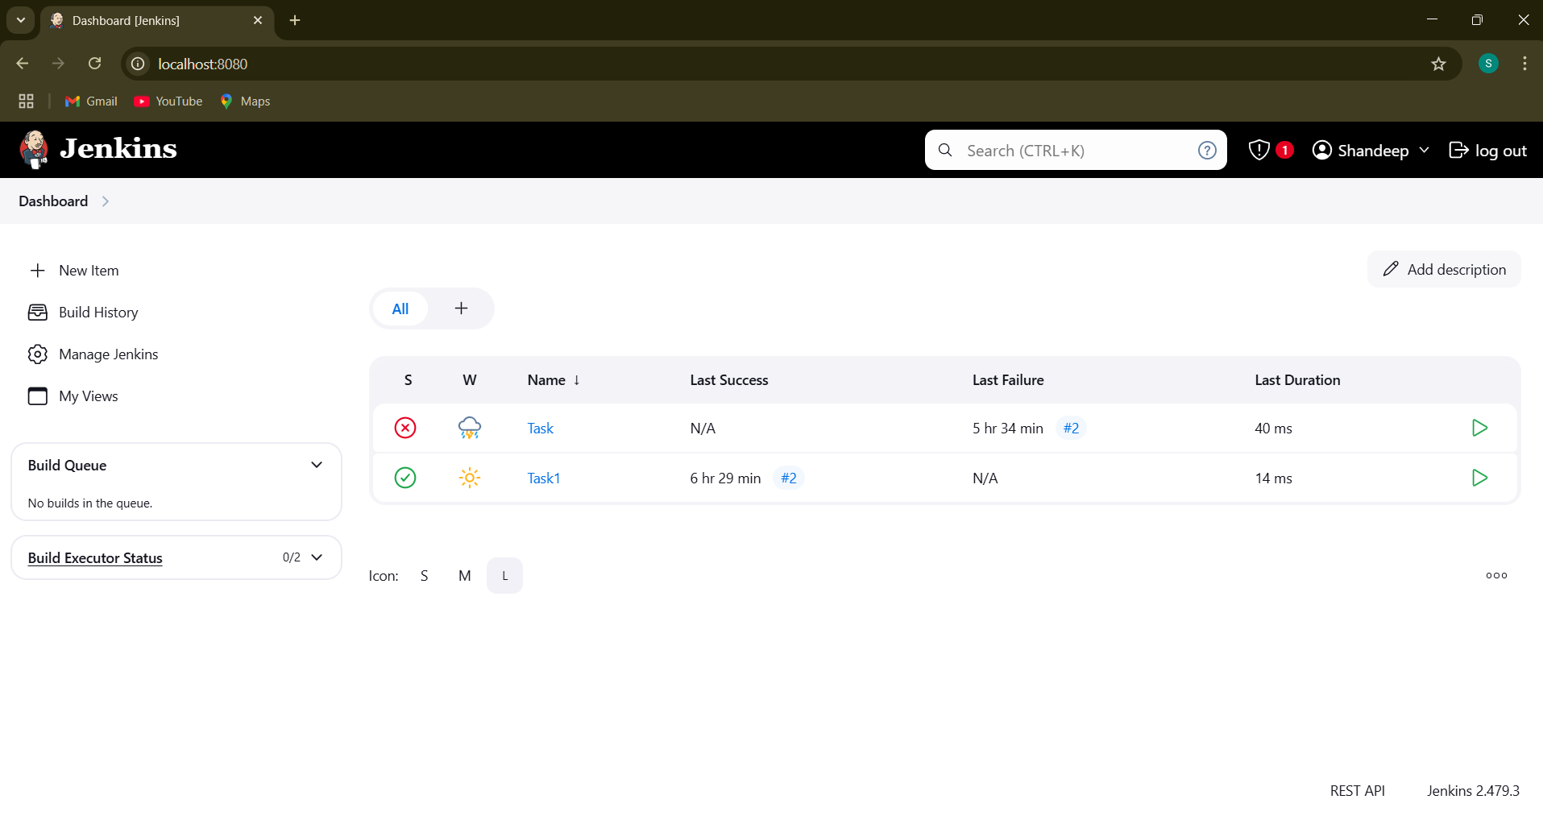

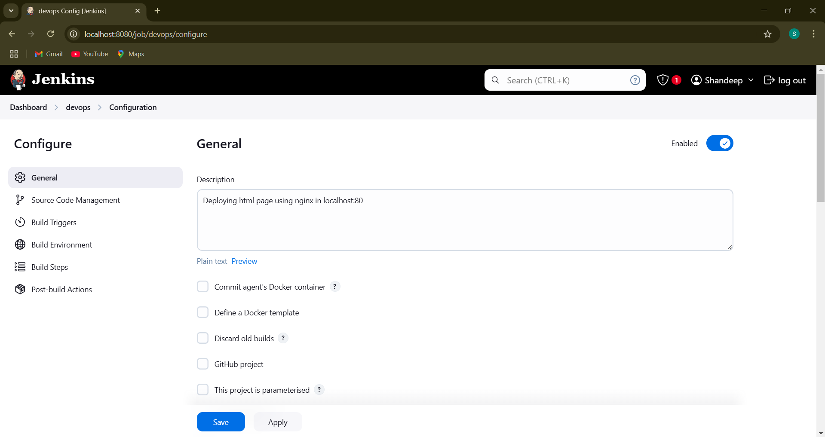

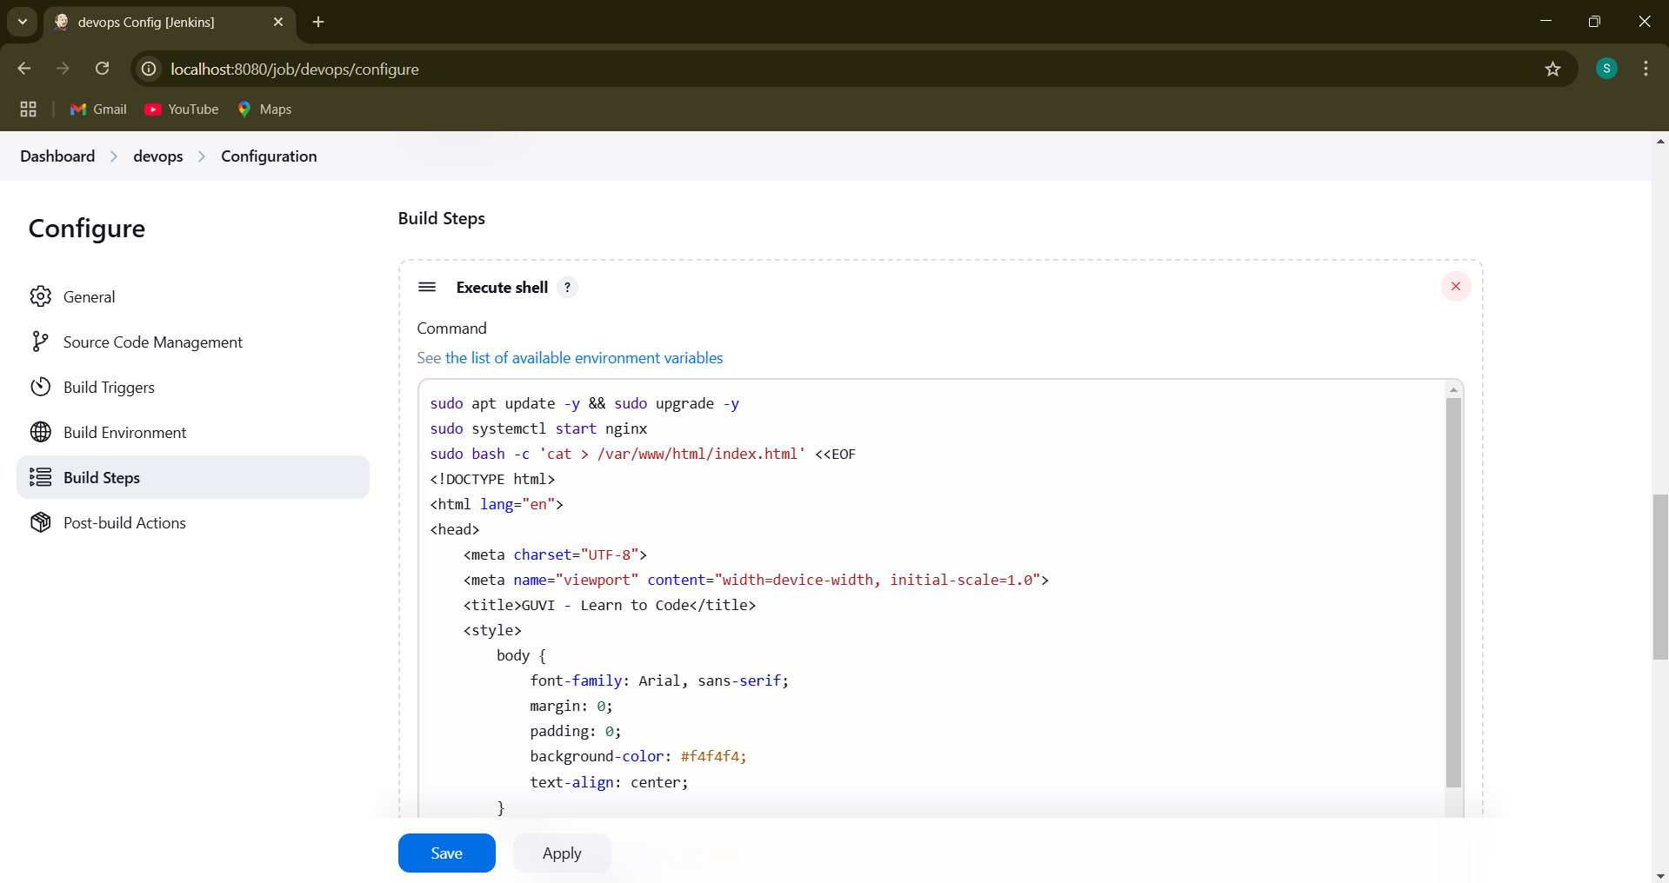

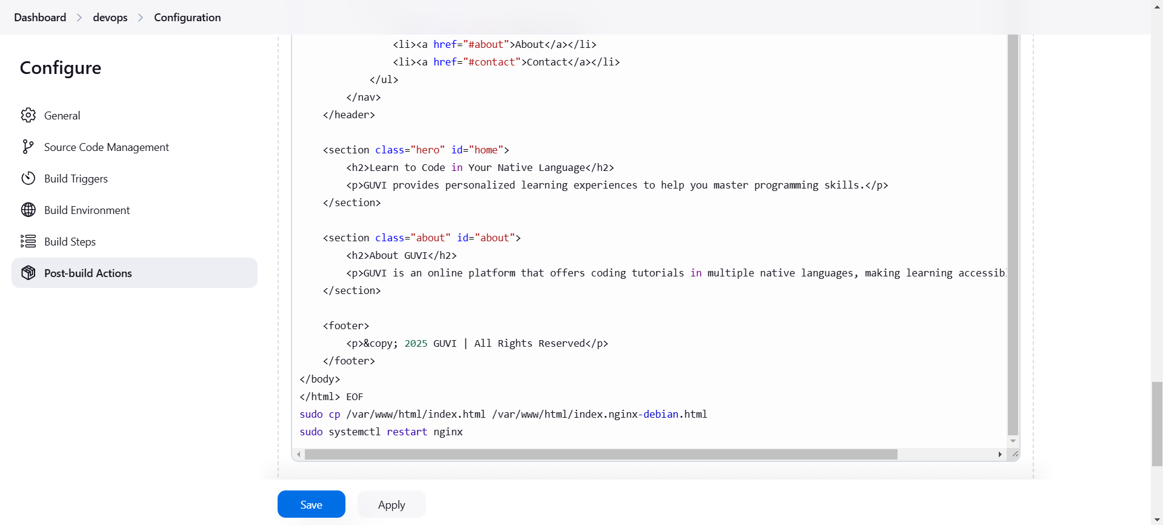



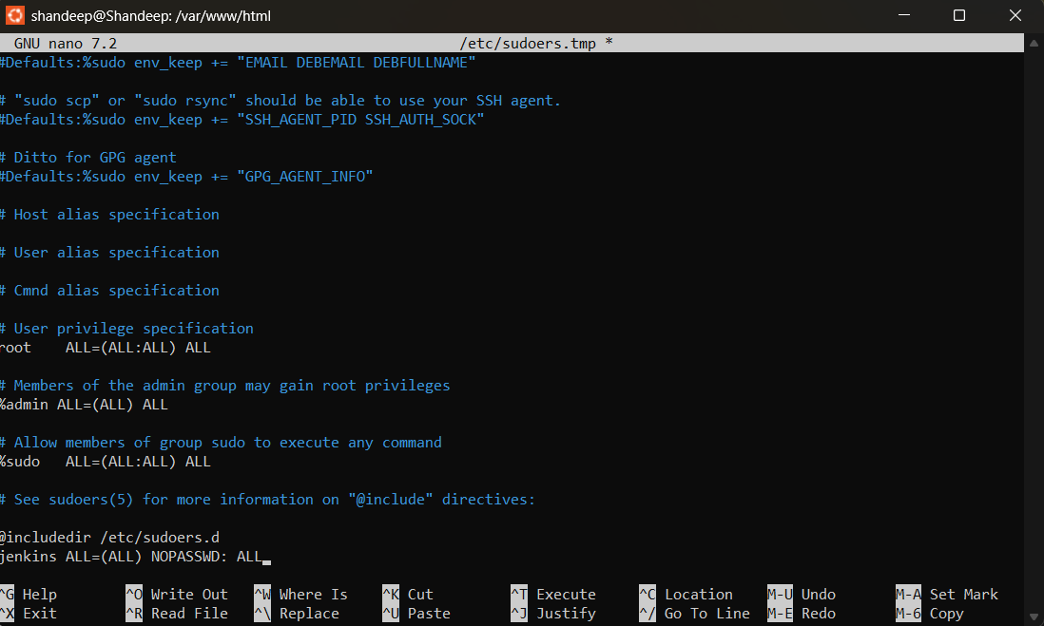

**Ctrl + X and Y and Press Enter**

To have jenkins freestyle tasks to run without sudo control & restart the jenkins to apply those changes



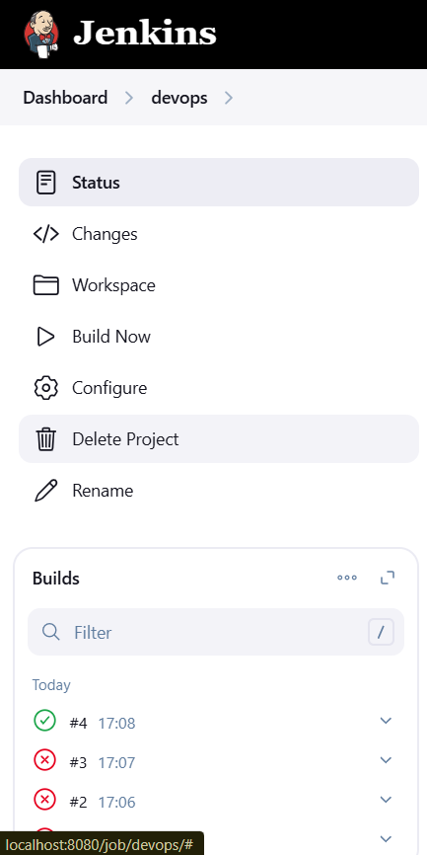

**Open Browser and enter localhost:80 and press enter to view your locally deployed static webpage through jenkins**

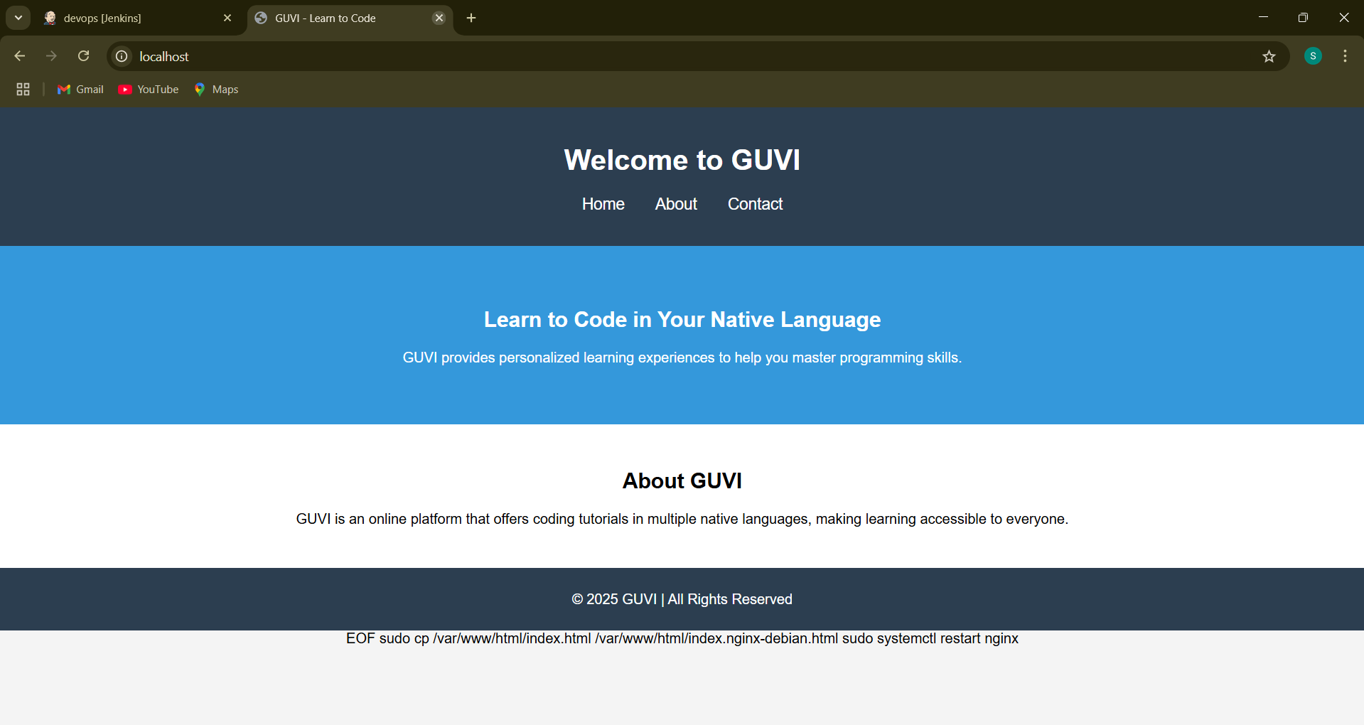

# Console Output

