FORWARD DEPLOYED ENGINEER | CANDIDATE ASSIGNMENT

Make the commute
feel dependable again
MoveInSync Employee App | Play Store ratings diagnosis & action plan
Review snapshot: 2014-03-14 to 2026-10-11 • Collected 2026-10-13
DO FIRST: reply to negative reviews today; investigate OTP/login first. If all 123 OTP-primary low-rated reviews became 4 stars, the 365-day written mean would rise +0.116; a crude equal-weight whole-listing bridge is only about +0.003 points (not a forecast).
3.77/5  30-DAY WRITTEN MEAN  n = 243 reviews | 27.2%  ONE-STAR SHARE  Latest 30-day window | 1.4%  1–2 STAR REPLY RATE  1/73 replied | 124  OTP / LOGIN MENTIONS  14.7% of 843 low-rated reviews

THE DECISION
The priority is to make the commute experience reliable, not to chase a higher star rating. Start by replying to recent negative reviews, then investigate sign-in and app-access failures. Reviews are useful clues, but app, booking and transport data should confirm the problem before the team commits to a fix.

The first three moves
ORDER | MOVE | WHAT TO DO
01 | Reply and route | Assign a daily owner for 1–2 star reviews; give people a real support path and escalate safety reports the same day.
02 | Protect the core journey | Audit OTP/session delivery and reproduce the app-opening / installation-verification failures on affected device and OS combinations.
03 | Remove uncertainty | Make booking status explicit, compare planned vs actual pickups and route performance, and never block app use behind a rating prompt.

Listing context (captured 2026-10-13): 4.3/5; 1.15L reviews (rounded India listing display). This is a rounded public listing snapshot, not an exact downloadable rating count. The written-review sample below is a separate, self-selected text dataset.
01 / What the rating data says
The store score tends to move slowly. Recent written reviews offer a more immediate view of what employees are reporting, although this sample has important limits.
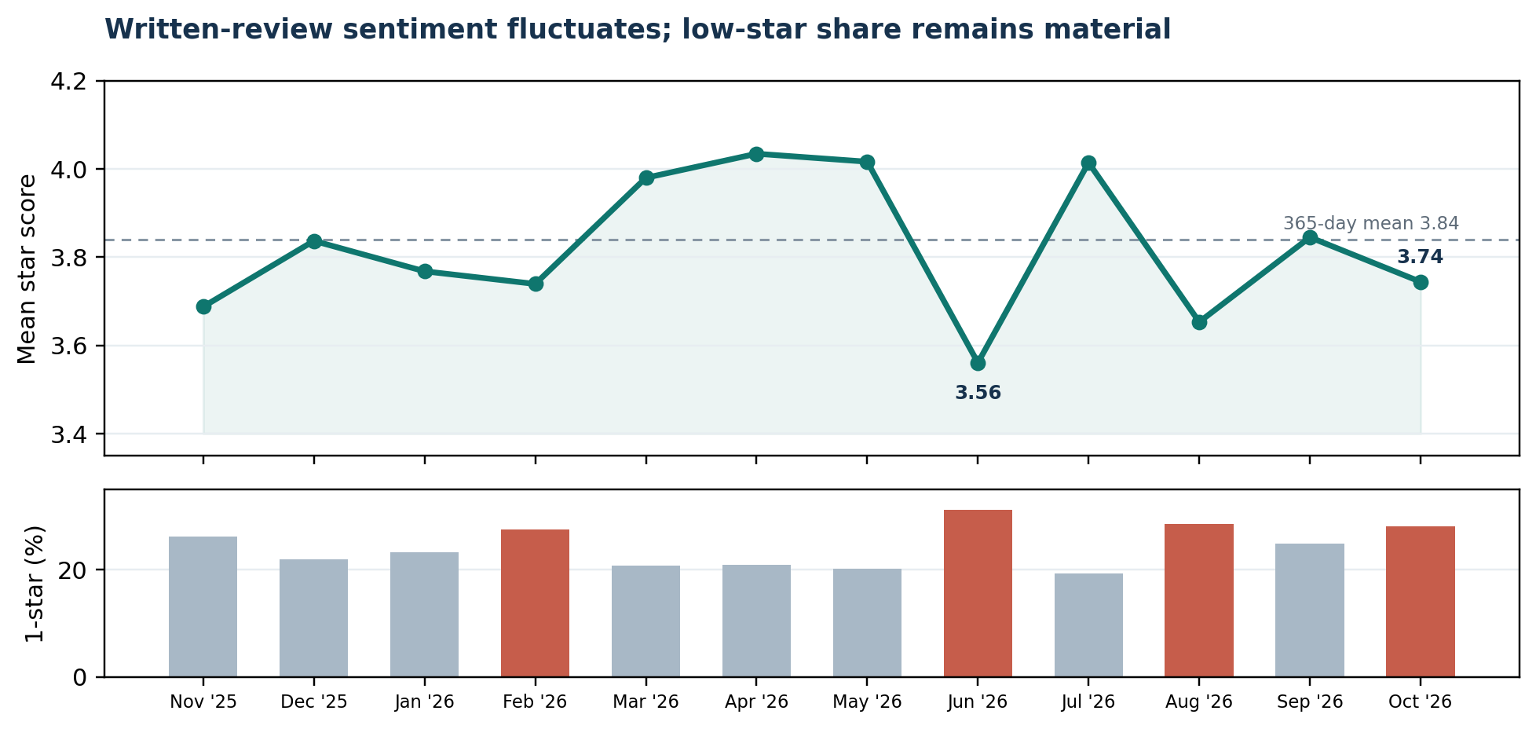
Monthly written-review mean and one-star share, Nov 2025–Oct 2026. October is partial through 11 Oct.
Window | Reviews | Mean score | 1 star | 1–2 star replies
Last 30 days | 243 | 3.77/5 | 27.2% | 1/73 (1.4%)
Last 90 days | 721 | 3.81/5 | 24.7% | 2/205 (1.0%)
Last 365 days | 2,848 | 3.84/5 | 24.0% | 29/769 (3.8%)

WHY THE STORE SCORE LOOKS HIGHER THAN THE WRITTEN REVIEWS
The official India listing displayed 4.3/5 and 1.15L reviews (rounded India listing display) when checked on 2026-10-13; the latest 365-day written-review sample averages 3.84/5 and all 24,315 collected texts average 3.61/5. These are different measures: Google says the displayed Play rating is weighted toward recent ratings, most raters do not necessarily write text, this sample is self-selected and English-only, and reviews older than 365 days average 3.58/5. The main warning sign is the lower 30-day mean (3.77) compared with the 90-day (3.81) and 365-day (3.84) means. Month-to-month figures vary, so this is not proof of a steady decline. Context: iOS displays 4.7/5 from 60k ratings, versus Android 4.3/5 - a 0.4-star gap that supports investigating Android auth/install/launch friction, but is not proof of Android causality. The text-row/listing-count ratio (~21%) is only a rough scale comparison, not a measured coverage rate.

INTERPRETATION
27.2% of the latest 30-day written reviews are one star. Investigate dips alongside release history and operational context rather than assuming a cause.

Platform version context (not a causal claim): 105 review rows carry Android review metadata label `12.19.0` (mean 3.62/5; 31.4% one star). A third-party Android listing tracker showed `12.20.0` as the available Android version on 12 Oct 2026, while the Apple App Store release history showed iOS `10.50.0` around 6 Oct. These appear to be separate Android and iOS release-numbering sequences; the 12.19.0 reviews likely refer to a preceding Android build, but confirm against Play Console rollout metadata before tying a spike to a release.
Appendix A pairs dated public review excerpts (without reviewer profile details) with suggested engineering and operations tickets. The excerpts show what people reported, not independently verified incidents.
02 / What low-rated reviews mention
This section looks at 843 one-, two- and three-star reviews from the latest 365 days. They help flag issues worth investigating, but they cannot tell us how often those problems occur across all trips.
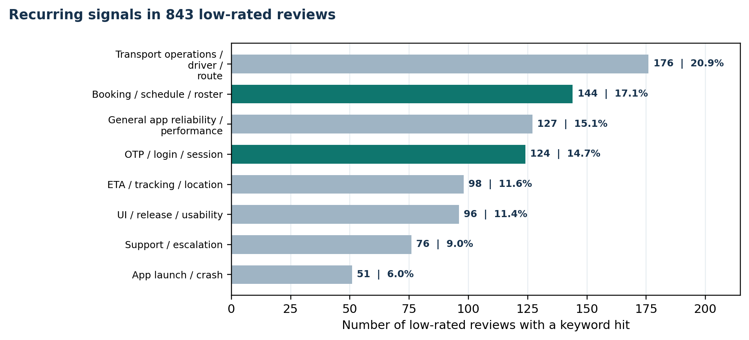
Keyword matches across low-rated reviews. A review can mention more than one issue, so the percentages overlap and should not be added together.
Largest primary themes (one label per review; selected categories)
Primary theme | Reviews | Share of low-rated set | Suggested owner
OTP / login / session | 123 | 14.6% | App + authentication backend
Booking / schedule / roster | 111 | 13.2% | Product + backend
ETA / tracking / location | 86 | 10.2% | Product + routing infrastructure + operations
General app reliability / performance | 73 | 8.7% | App engineering
Transport operations / driver / route | 71 | 8.4% | Transport operations + vendor management
UI / release / usability | 52 | 6.2% | Product + design + app engineering
Support / escalation | 43 | 5.1% | Customer support + transport desk

Other labelled primary themes: App launch / crash: 39 (4.6%); Rating prompts / notifications: 32 (3.8%); Install verification / Play Store error: 15 (1.8%); Policy / permission prompts: 10 (1.2%); Safety / security: 9 (1.1%).
DO NOT DISCARD THE UNMATCHED BUCKET
179 reviews (21.2%) have no primary-theme match; 132 contain three words or fewer. Longer comments are in output/manual_review_queue.csv for manual review. No match means the rules missed the wording, not that the complaint is unimportant.

What stands out
- Login and OTP complaints can stop an employee before the commute even starts: 124 reviews mention authentication. Check actual OTP delivery and verification rates before changing providers or retry logic.
- Booking and ETA need separate checks. 144 reviews mention booking or scheduling, while 98 mention tracking, location or ETA. Compare the first with booking outcomes and the second with actual pickup times.
03 / Which fix has the largest possible rating impact?
The scenarios below show how the mean of the same 2,848 written reviews would change under specific assumptions. They are not forecasts of how the public Play Store score would respond to an engineering fix.
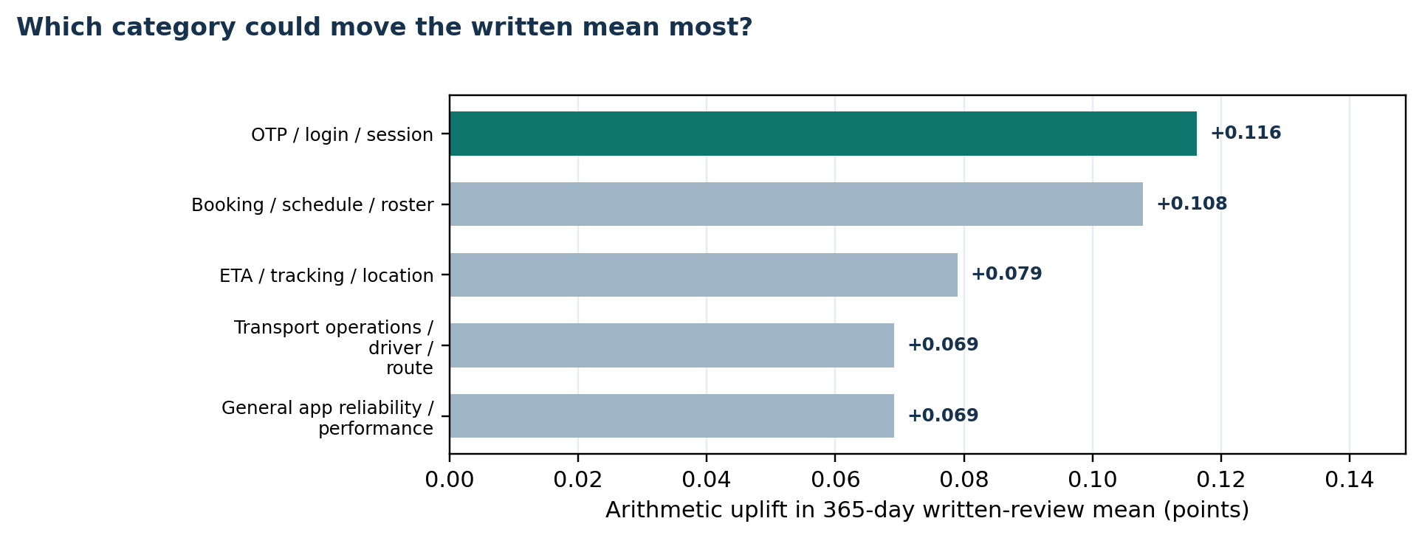
Counterfactual change in the 365-day written-review mean if every low-rated review in one primary-theme group were changed to 4 stars.
Primary theme | n low-rated | Uplift if all to 4★ | Sample mean after | Uplift if all to 5★
OTP / login / session | 123 | +0.116 | 3.95 | +0.159
Booking / schedule / roster | 111 | +0.108 | 3.94 | +0.147
ETA / tracking / location | 86 | +0.079 | 3.91 | +0.109
General app reliability / performance | 73 | +0.069 | 3.90 | +0.095
Transport operations / driver / route | 71 | +0.069 | 3.90 | +0.094
UI / release / usability | 52 | +0.046 | 3.88 | +0.064

THE UPPER BOUND
The 365-day written-review mean is 3.84/5. If every one of the 843 one-to-three-star reviews in that sample became 4 stars, the arithmetic mean would be 4.64; if every one became 5 stars, 4.94. This intentionally extreme scenario assumes all low-rated reviewers change their score and all other ratings remain fixed. It is not a forecast, and it does not calculate the public Play Store score.

Where the journey is losing the most stars
Mapped journey stage | Primary-tag reviews | Share of all low-rated | Points needed to reach 4★
Self-booking & roster | 195 | 23.1% | 522
Onboarding & access | 148 | 17.6% | 391
Cross-flow app reliability | 112 | 13.3% | 302
Tracking & ETA | 86 | 10.2% | 225
Pickup, ride & route operations | 71 | 8.4% | 197

Among reviews that could be assigned to a journey stage, self-booking and roster issues form the largest group. The 179 unmatched reviews are not included in this ranking, and none of these counts should be read as incident rates. Appendix B lists every primary theme and shows the hypothetical result if its current 1–3-star reviews became 4 or 5 stars. The largest actionable single-theme scenario is OTP/login: the written mean would rise by +0.116 if all 123 primary-theme reviews moved to 4 stars (3.84 to 3.95), with every other score unchanged.
04 / Which complaints are chronic, and which are spiking?
Each month's percentages use that month's 1–3-star written reviews as the denominator. Since the number of reviews changes, smaller months should be interpreted with extra care.
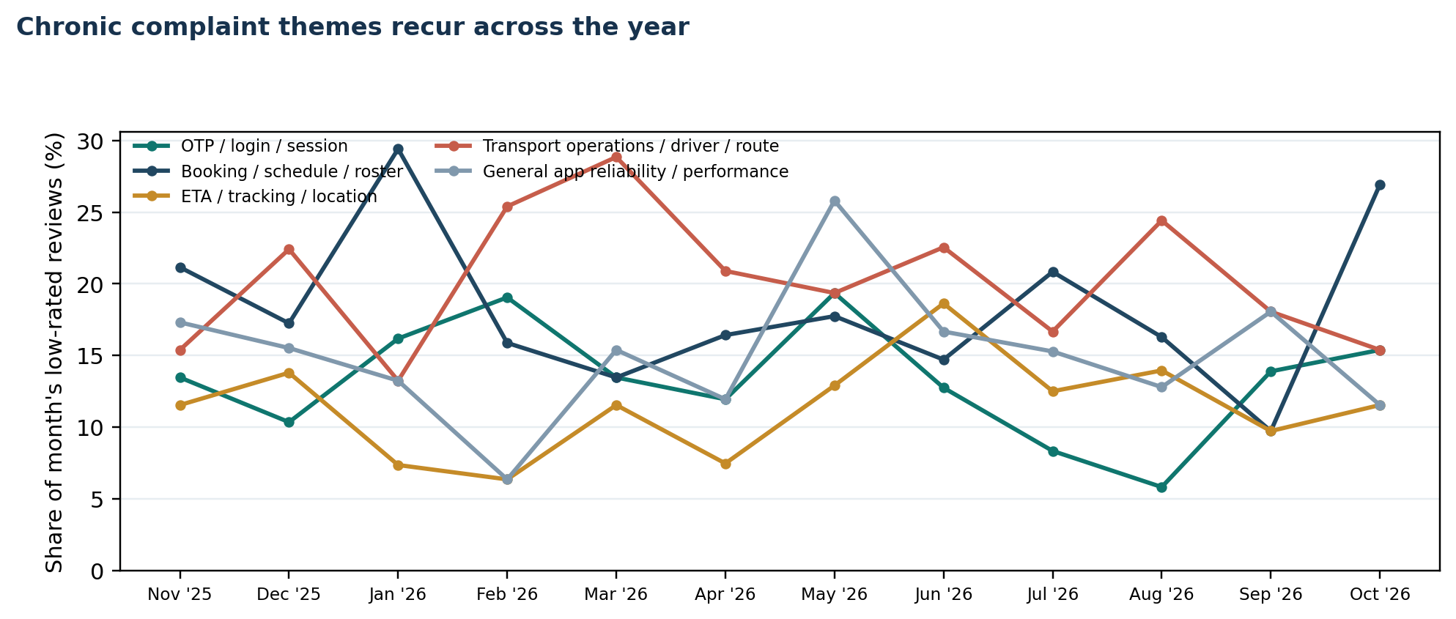
Multi-label mention share among each month's low-rated written reviews, Nov 2025–Oct 2026. Reviews may appear in multiple themes; October is partial through 11 Oct.
Theme (multi-label mentions) | Months present | Peak month in sample
OTP / login / session | 12/12 months | 2026-05: 12/62 (19.4%)
Booking / schedule / roster | 12/12 months | 2026-01: 20/68 (29.4%)
ETA / tracking / location | 12/12 months | 2026-06: 19/102 (18.6%)
Transport operations / driver / route | 12/12 months | 2026-03: 15/52 (28.8%)
General app reliability / performance | 12/12 months | 2026-05: 16/62 (25.8%)
Support / escalation | 12/12 months | 2026-05: 9/62 (14.5%)

Two spikes stand out for follow-up: app launch/crash mentions peaked in 2026-08 at 14/86 low-rated reviews (16.3%), while installer/Play Store-error mentions peaked in 2026-08 at 5/86 (5.8%). Review metadata shows Android label `12.19.0`; a third-party Android tracker showed `12.20.0` as available on 12 Oct 2026. These are directionally compatible as prior/current Android releases, unlike iOS `10.50.0`, which belongs to the Apple listing. Confirm exact Android build and rollout dates in Play Console before associating a spike with a release.
CHRONIC VS SPIKE
OTP, booking, ETA, transport operations, broad reliability and support mentions appear in all 12 sampled months - treat them as chronic monitoring lanes. App-launch complaints appear in 11/12 months and peaked in August; installer errors are less persistent and also peaked in August, making them a focused spike to investigate first. These patterns describe what appears in written reviews; they are not confirmed incident rates.

05 / A response gap the team can close now
Public replies are not a substitute for fixing the product, and a missing reply does not prove that a support case is still open. They do show whether the team is acknowledging low ratings on the store listing.
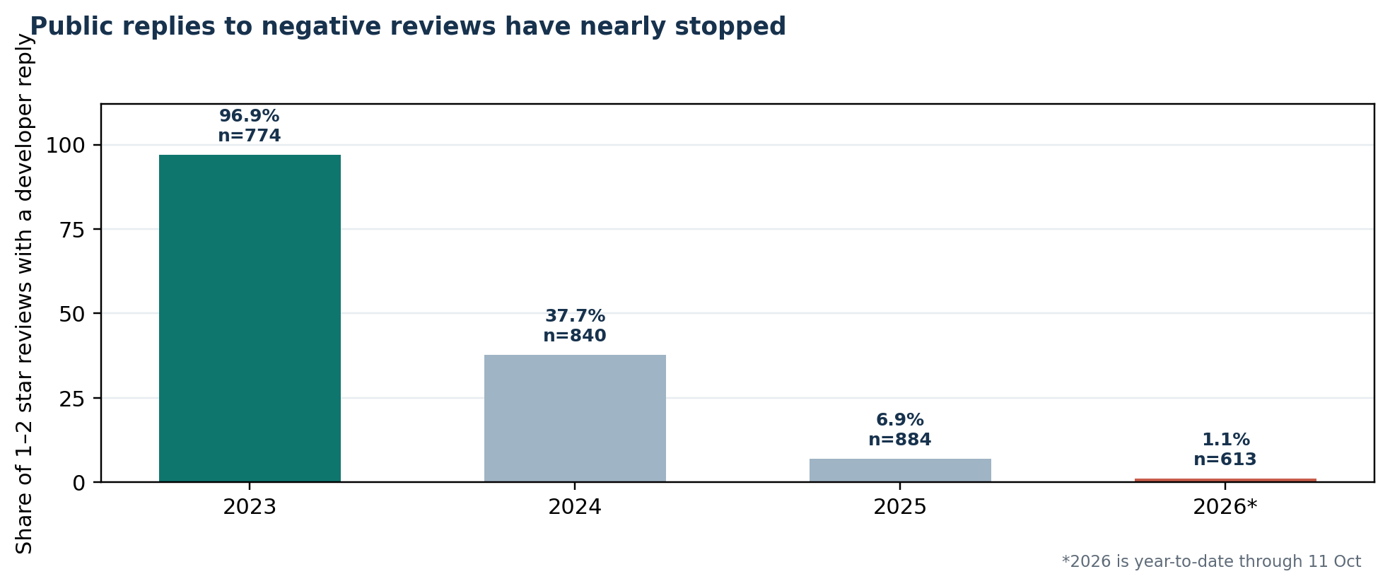
Developer replies among 1–2 star reviews by calendar year. 2026 is year-to-date through 11 Oct.
Year | 1–2 star reviews | Replies | Reply rate | Period
2023 | 774 | 750 | 96.9% | Full year
2024 | 840 | 317 | 37.7% | Full year
2025 | 884 | 61 | 6.9% | Full year
2026 | 613 | 7 | 1.1% | Year to date

THE OPERATING MOVE
The public reply rate in this snapshot dropped from 96.9% in 2023 to 1.1% in 2026 year-to-date. Start with the newest unanswered reviews and use a useful template plus a real support route. Track reply rate separately from issue resolution; public review data cannot tell us whether a complaint was resolved privately.

For the latest 30 days, only 1 of 73 one- and two-star reviews had a developer reply (1.4%). Over 90 days it was 2 of 205 (1.0%); over 365 days, 29 of 769 (3.8%).
06 / The first seven days
This order reflects likely impact on employees, the strength of the available evidence, and how quickly the team can act. Use it as a starting point; review counts are not incident rates.
TODAY  1.4% replied  in 30 days | Restart the low-star response loop  Do next: Assign one daily owner. Reply to the newest 1–2 star reviews with a specific next step and support/ticket route; escalate any safety or harassment report the same day.  Owner: Customer Success + Support  Measure: Reply coverage and response time in the support workflow; track case resolution separately.

DAYS 1–2  124 mentions | Instrument and fix OTP / session failures  Do next: Break down OTP delivery, verification and session expiry by provider/carrier, device and time of day. Reproduce morning login failures; add safe resend/fallback only after checking the failure mode.  Owner: Authentication backend + Android  Measure: Baseline delivery/verification success and login failure rate; set an SLO with engineering once baseline is known.

DAYS 1–2  54 primary tags | Reproduce app-opening and installer errors  Do next: Use Android vitals and crash/ANR traces. Reproduce the 'not installed' message and post-update launch failure across affected device/OS combinations; verify installer/integrity checks rather than guessing at the cause.  Owner: Android engineering  Measure: Launch success, crash-free / ANR sessions, and install-verification error count by release/device.

WEEK 1  111 primary  tags (13.2%) | Make booking state impossible to misread  Do next: Show confirmed, waitlisted and cancelled as explicit states. Fix contradictory 'trip not booked' pushes; explain cancellation/no-show consequences before confirmation and add a dispute route.  Owner: Product + Design + Backend  Measure: Booking success/failure, contradictory notifications, waitlist disputes and no-show appeals.

WEEK 1  98 mentions | Validate ETA and live tracking  Do next: Join predicted pickup ETAs to actual arrival timestamps for a representative sample of routes, shifts and vendors. Report median and P90 error; check tracking availability and map freshness separately.  Owner: Routing + Transport Operations  Measure: Median/P90 ETA error, share of trips with live tracking available, late-pickup rate.

07 / The next sprint and how to measure it
For the next sprint, focus on the steps employees depend on most: booking a ride, finding the pickup, and boarding on time.
NEXT SPRINT  176 mentions | Reduce repeat late-cab and route failures  Do next: Group complaints by route, shift, vendor, site and pickup window. Compare planned vs actual pickup, journey time and route detours; review the largest recurring clusters with the transport desk and vendor, then assign corrective actions.  Owner: Transport Operations + Vendor Management + Routing  Measure: Late-pickup rate, P90 delay, excess journey time, and repeat complaints per route/vendor.

NEXT SPRINT  76 mentions | Give employees a visible issue path  Do next: Add 'Report an issue' on the trip screen with issue type, ticket reference, current status and routing to the employee's transport desk. Keep driver/no-show complaints distinct from app bugs.  Owner: Product + Support + Operations  Measure: Issue-submission completion, first-response time, resolution rate and reopened cases.

NEXT RELEASE  42 mentions | Remove forced-rating friction  Do next: Make post-ride rating optional and skippable. Never gate booking, OTP access or viewing trip details behind a rating. Keep rating requests separate from safety or issue reporting.  Owner: Product + Android  Measure: Task completion and rating-prompt dismissal; forced-rating complaints should trend toward zero.

EVERY RELEASE  Guardrail | Use staged rollout and release notes  Do next: Roll out gradually. At a defined checkpoint, inspect crash/ANR telemetry and recent review signals. A version with at least 30 reviews and mean below 3.50 is an investigation trigger, not an automatic rollback rule.  Owner: Engineering + Release  Measure: Crash/ANR changes, version sample size, release timing and validated defects.

30-day scorecard
Workstream | Public-review baseline | 30-day measure
Response loop | 1.4% reply coverage in latest 30 days | Target ≥80% of 1–2 star reviews receive a useful public reply within 48h; verify timing in the team's response workflow.
Login / OTP | 124 of 843 low-rated reviews contain a keyword match | Capture a baseline by provider/device first, then set a delivery/verification SLO.
Booking state | 111 primary labels | Track booking success, waitlist clarity and disputes in product telemetry.
ETA / tracking | 98 keyword matches | Baseline median/P90 ETA error and tracking freshness from actual trips.
Support resolution | 76 keyword matches | Track first response, time to resolution and repeat complaints; public replies alone are insufficient.
Transport ops | 176 keyword matches | Track late pickups and P90 delay by route/vendor; review recurring detours and repeat complaints.

08 / Method, limits and reproducibility
The recommendations are only useful if the team can see what the evidence supports and what still needs checking.
Scope and source
This analysis uses a saved snapshot of 24,315 public, English-language written reviews from the India Play Store listing for com.moveinsync.ets, dated 2014-03-14 to 2026-10-11. On 2026-10-13, the live listing showed 4.3/5 and 1.15L reviews (rounded India listing display). The displayed count is rounded, and rerunning the analysis on the saved CSV does not refresh the live listing data.
Sources: Google Play listing | Google Play rating methodology | iOS App Store listing | Android version context (AppBrain) | Checked 2026-10-13; displayed values are dated captures.
Analysis method
- Python and pandas validate timestamps and star scores; compute 30-, 90- and 365-day windows anchored to the latest review timestamp; calculate monthly trends, response rates, and recent-version summaries.
- The classifier uses ordered regular-expression rules with word boundaries for risky terms. It reports (1) one primary theme per review for mutually exclusive shares and (2) multi-label keyword matches so secondary issues are visible. Overlapping mention percentages must not be added.
- The primary classifier did not assign a theme to 179 (21.2%) reviews; 132 of these are three words or fewer. An AI-assisted semantic review examined 55 longer comments from the original unmatched set. It helped turn 8 specific signals into repeatable rules and regression tests. Another 47 comments remain unmatched because the wording is too vague to classify safely. In a separate fixed, prediction-blind 100-review model-assisted adjudication sample, the rule-based primary label agreed on 82% of reviews (Wilson 95% interval 73%-88%; macro-F1 0.76). The sample was single-pass and not independently double-coded, so this is a directional quality check rather than a certified benchmark.
- The suite includes 32 classifier regression tests, 8 snapshot/integrity/metric/privacy/replay/score-bridge checks, and 3 alert tests (43 automated tests in total).
What this analysis cannot tell us
- Reviews are self-selected; they do not represent every employee, commute, device or region, and theme counts are not incident rates. The dataset was collected with lang=en for the India listing. Hindi and other regional-language reviews were not separately scraped or counted, so their patterns may differ.
- The India Google Play listing displayed 4.3 stars and 1.15L reviews on 13 Oct 2026; the rounded public count is not an exact rating denominator. The India iOS listing displayed 4.7/5 from 60k ratings on the same date. This is directional context only: platform populations, app versions and rating systems differ, so it is not a controlled comparison.
- The 100-review model-assisted validation sample had 82% exact agreement (95% Wilson interval 73%-88%); it was single-pass, not independently double-coded, and per-theme precision/recall varies. The complete per-theme 4-star/5-star sensitivity table is in Appendix B and output/theme_impact_scenarios.csv. These are counterfactual arithmetic, not forecasts.
- Public reviews cannot prove root cause or establish that version 12.19.0 caused lower ratings. The 12.19.0 review label is consistent with the Android release series (a third-party tracker showed 12.20.0 available on 12 Oct); 10.50.0 is the iOS App Store version, a separate numbering sequence. Validate exact Android production build and rollout timing in Play Console before interpreting a spike. Validate launch issues against Android vitals, login against authentication logs, booking against booking outcomes, ETA against actual pickup timestamps, and route issues against vendor and operations data.
- Developer reply presence is not the same as support response time or case resolution. The submitted review dataset retains only a reply-present flag, not reviewer profile data or raw developer-response text.
Reproduce the snapshot analysis
python -m pip install -r requirements.txt
python moveinsync_ratings_monitor.py --csv reviews.csv --output-dir output
python build_report.py
python -m unittest -v
Collecting new reviews requires internet access, and new results may differ from this saved snapshot. The repository includes a weekly GitHub Actions workflow (Monday at 08:00 India time) and a manual run option. Once the repository is published, its owner must enable Actions and grant `contents: write` permission so the workflow can update the aggregate history file. The owner still needs to verify the first live run, scraper access and GitHub permissions. Alerts should trigger an investigation, not an automatic rollback.
A / Tickets a team could pick up tomorrow
These tickets turn public review comments into work the team can investigate. Use internal telemetry to reproduce each issue before treating the suspected cause as confirmed.
Proposed ticket | Evidence (public review excerpts) | Reproduction / suspected area | Owner / acceptance criteria
P0 · OTP/login reliability | “app is not sending otp” (6 Oct 2026)  “Unable to login ... Mobile Otp and Email OTP options are not working” (9 Sep 2026) | Reproduce sign-in via SMS and email across a small device/carrier matrix; record send, delivery, verification and expiry events. Suspected: auth backend/provider integration/session handling. | Owner: Auth backend + Android. Acceptance: end-to-end tests for both channels; instrument success and latency; >=98% successful verification within 60s over a 7-day pilot or documented baseline/target agreed with engineering; visible recovery path for failures.
P0 · App won't open after update | “whenever i update this app, i am not able to open the app again, I need to uninstall and reinstall again” (9 Oct 2026)  “installed and uninstalled... still not working... open and close automatically” (29 Sep 2026) | Update from the prior production version without clearing data on affected supported devices/OS versions; inspect launch/crash logs and the install-source verification result. Suspected: update migration, installer integrity or startup crash. | Owner: Android engineering. Acceptance: update-path regression test; no false 'not installed from Play Store' response in supported Play-installed builds; launch success and crash-free sessions tracked by version/device; proposed >=99.5% crash-free-session guardrail.
P0 · Booking state and waitlist clarity | “it just books you without informing if he's on waitlist or not” (8 Oct 2026)  “schedules that I booked did not show up... when I try to book again it's already showing duplicate schedule” (18 May 2026) | Submit a booking with capacity constrained, reload the schedule and inspect notifications; tap/retry after a slow response. Suspected: state propagation, booking idempotency and push-copy mismatch. | Owner: Product + Backend. Acceptance: every booking displays Confirmed / Waitlisted / Cancelled consistently; waitlist is disclosed before leaving flow; retry cannot duplicate booking; contradictory 'trip not booked' push is covered by automated tests.
P1 · ETA and live tracking accuracy | “The GPS tracking system is very slow, and the pickup and drop timings are frequently incorrect.” (1 Jul 2026)  “google maps always shows 3x the time shown in moveinsync app” (8 Oct 2026) | For representative shifts/routes, capture predicted pickup ETA at fixed intervals and compare with actual vehicle arrival; log location freshness. Suspected: map-feed freshness, ETA model inputs or routing latency. | Owner: Routing + Platform + Operations. Acceptance: median and P90 absolute ETA error dashboard; stale-location indicator and data freshness logging; agree target after a one-week baseline; regression alert when P90 error materially worsens.
P1 · Late cab / poor routing escalation | “cab is never assigned on time...always late” (25 Mar 2026)  “Daily showing wrong routes and High travel time.” (4 Jun 2026) | Join planned route, pickup and actual arrival logs by shift, site and vendor; review recurring late pickups and detours with the transport desk. Suspected: route/pooling constraints, allocation policy or vendor execution. | Owner: Transport Ops + Vendor Management + Routing. Acceptance: weekly lateness and P90 delay by route/vendor; owner assigned for the worst repeat clusters; ticket or corrective action and due date recorded; exclude app-only fixes where operations caused the delay.

Quotes are shortened only where an ellipsis appears, and dates come from the saved review snapshot. These are proposed tickets, not confirmed incidents. Treat the acceptance criteria as starting targets and adjust them after measuring a telemetry baseline.

B / Full counterfactual uplift by primary theme
The table below includes every primary-theme group. The ranking assumes that all 1–3-star reviews in a group became 4 stars; the 5-star column shows a separate, more extreme scenario.
Rank¹ | Primary theme | n low | Δ if →4★ | Mean if →4★ | Δ if →5★
1 | OTP / login / session | 123 | +0.116 | 3.95 | +0.159
2 | Booking / schedule / roster | 111 | +0.108 | 3.94 | +0.147
3 | ETA / tracking / location | 86 | +0.079 | 3.91 | +0.109
4 | General app reliability / performance | 73 | +0.069 | 3.90 | +0.095
5 | Transport operations / driver / route | 71 | +0.069 | 3.90 | +0.094
6 | UI / release / usability | 52 | +0.046 | 3.88 | +0.064
7 | Support / escalation | 43 | +0.043 | 3.88 | +0.058
8 | App launch / crash | 39 | +0.037 | 3.87 | +0.051
9 | Rating prompts / notifications | 32 | +0.029 | 3.87 | +0.041
10 | Install verification / Play Store error | 15 | +0.012 | 3.85 | +0.017
11 | Policy / permission prompts | 10 | +0.009 | 3.84 | +0.013
12 | Safety / security | 9 | +0.009 | 3.84 | +0.012
— | No specific detail / other | 179 | +0.179 | 4.01 | +0.242

¹ Rank excludes ‘No specific detail / other’, because it is a residual bucket rather than a fixable product theme. All figures use the same 2,848-review 365-day written-review denominator. For each row, existing 1–3-star scores in that one primary theme are replaced with 4 or 5; all other scores are held constant. This is arithmetic sensitivity, not an expected lift, causal estimate or prediction of the public Play Store rating. Theme definitions and counts are generated from the same classifier output to avoid brief/report drift.
Use this ranking as one input to prioritisation, not as the decision by itself. A safety issue, a blocked employee journey, stronger evidence, lower implementation cost or clearer operational ownership may deserve attention before a theme with a larger calculated uplift. The 100-review classifier check and the unmatched queue also show where uncertainty remains.

