MOVEINSYNC | FDE CANDIDATE ASSIGNMENT

What should MoveInSync fix first?
A decision brief based on 24,315 public written reviews • Snapshot collected 13 Oct 2026
DO FIRST: reply to negative reviews today; investigate OTP/login first. If all 123 OTP-primary low-rated reviews became 4 stars, the 365-day written mean would rise +0.116; a crude equal-weight whole-listing bridge is only about +0.003 points (not a forecast).
3.77/5  LAST 30 DAYS  n=243 written reviews | 27.2%  ONE STAR  Share in last 30 days | 1.4%  PUBLIC REPLIES  1/73 recent 1–2 star reviews | 1.1%  2026 YTD REPLIES  vs 96.9% in 2023

THE RECOMMENDATION
Do not run a campaign to solicit better stars. Treat the reviews as a signal that employees need a more dependable commute journey: access the app, sign in, know whether a trip is confirmed, trust the pickup ETA, and reach a human when something fails.

Act in this order
WHEN | MOVE | NEXT ACTION
TODAY | Restore public response coverage | Only 1 of 73 recent 1–2 star reviews received a developer reply. Assign a daily owner, offer a real support route, and escalate safety reports the same day.
DAYS 1–2 | Audit login and app access | 124 low-rated reviews contain login/OTP terms. Reproduce OTP/session and post-update launch/install issues; validate against authentication logs and Android vitals.
WEEK 1 | Clarify booking and ETA | 144 reviews mention booking/scheduling and 98 mention ETA/tracking/location. Make confirmed/waitlisted/cancelled states explicit and validate ETA against actual pickups.
WEEK 1 | Triage route and pickup failures | 176 reviews contain transport/driver/route signals. Group by route, shift and vendor; compare planned vs actual pickup and P90 delays; assign follow-up to operations and vendors.
NEXT RELEASE | Remove forced-rating friction | Make post-ride feedback skippable and never block booking or trip details behind a rating. It is less frequent than login problems, but a relatively small fix for a directly reported blocker.

Why the headline rating is not the whole story
On 2026-10-13, the India Play listing showed 4.3/5 and 1.15L reviews (rounded India listing display). The written-review sample averages 3.84/5 over the latest 365 days and 3.61/5 across all collected years. These figures measure different things: Google weights the Play rating toward recent ratings, while this self-selected, English-language text sample includes older reviews. The 30-day written mean (3.77) is below the 90-day and 365-day means, although monthly results vary. iOS shows 4.7/5 from 60k ratings, compared with Android at 4.3/5. The 0.4-star gap is worth investigating, but it does not prove that the platform caused the difference.
PLATFORM CLUE: Android 4.3 vs iOS 4.7 (0.4★ gap). Investigate Android OTP/install/launch friction; this comparison is directional, not causal.
Potential impact if low-rated primary-theme reviews improved to 4 stars
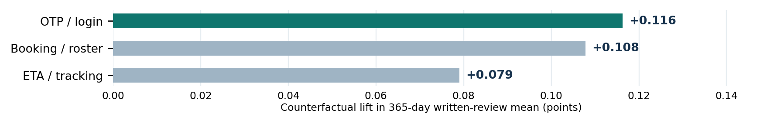
Extreme arithmetic sensitivity on the 365-day written-review mean; not a promised result.
Rough store-score bridge (equal-weight arithmetic, not a forecast): if those exact 123 OTP reviews alone gained the missing star points to reach 4, the whole-listing mean would move about +0.003; OTP + booking together, about +0.006, using ~115,000 as a rounded denominator. The true Play display is recency-weighted and the public count is rounded; at one-decimal display precision it would likely still show 4.3.
Method: Python/pandas and word-boundary rules; 43 tests passed. The 82% agreement is model-assisted, not independent human validation. A fresh scrape and remote Actions run remain pending. Reviews point to issues to check, not proven causes.

