**Bookstore App**

Technologies to be used:

1. AngularJS
2. Bootstrap for styling

Create a Bookstore App’s client side component which looks like below:

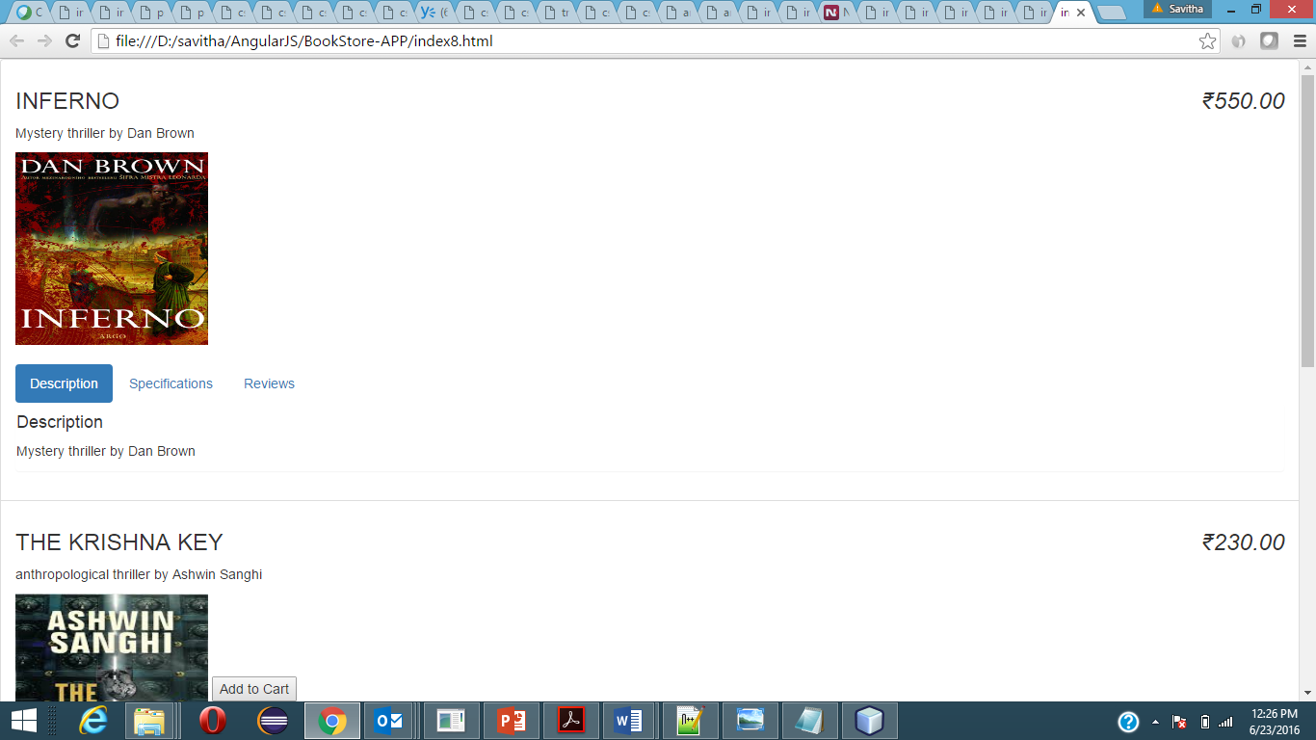

**Details/Requirements:**

1. All book details are stored in the data store, which is an array [an array of objects]
2. The page shows list of books as above with details like Title, description, image of the book.
3. Price of the book should be shown towards the right side. Currency should be Indian Rupee(INR)
4. If the book is ‘sold out’, then the button “add to cart” should not be visible for that book (E.g.: For the “Inferno” book above, the “add to cart” button is not visible.
5. If the book ‘cannot be purchased’, then it should not get listed at all in this listing (E.g.: Data store has details of the book called ‘Secret of the Nagas’ which is not listed here at all because it cannot be purchased).

**Additional Requirements:**

1. Every book should also have the below tabs just aligned below the book image

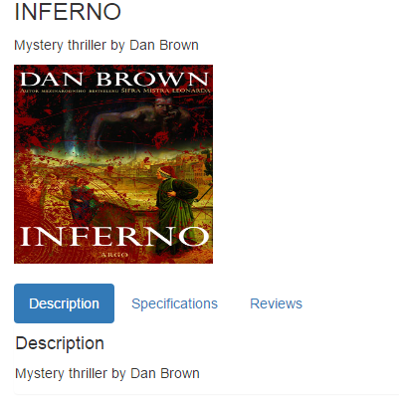

* Description tab: Should have a short description about the book.
* Specifications tab: Should contain the specifications about the book like hardbound/paperback, No. of pages etc.,
* Reviews tab: Should look like below:

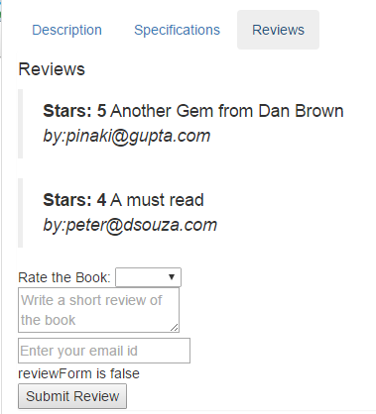

1. Reviews tab should already show reviews by other readers as above.
2. Should also allow the current user to enter the review about the book like:
   1. Rate the Book: A drop down should show rating as 1 star, 2 star etc., till 5 stars.
   2. Short review of the book
   3. Email id

(All above details are mandatory. If the data entered into the fields are invalid, the text area or text box should be shown with a red border and (reviewForm status should be set as false) and only on successful validation, the review form should be set as true and further allowed to submit the form. Upon successful submission the review details should get appended to the already existing list of reviews for that book.

Sample states of the review form looks like below:

Success form:

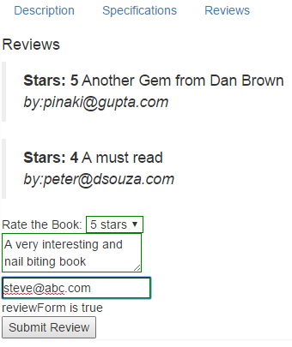

Invalid form entry (note the red border and the reviewForm status shown as false

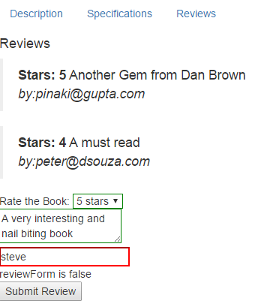

Successful entry should append the review details to the existing list of Reviews.

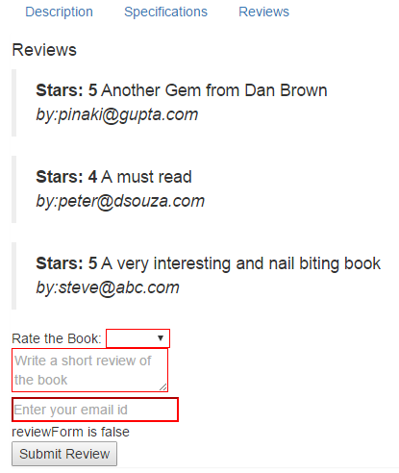

Any other requirements:

1. All given requirements should be incorporated. (No omissions)
2. Any additions that adds value to the look & feel, logic and validations are welcome.

**References/Tutorials:**

1. You can visit the official website of Angular JS

<https://angularjs.org/> and click on the button “Learn Angular in your browser for free!” to access and learn through a well-structured Angular JS step by step tutorial.

