EcoRevive V1 – Entity-Relationship Diagram
ER Diagram and Database Structure Description
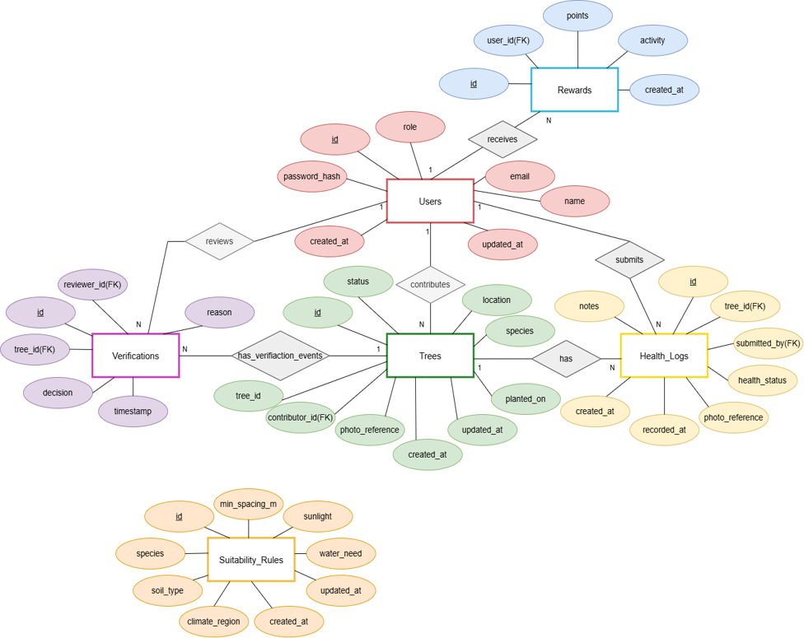
Figure 1: EcoRevive V1 Entity-Relationship Diagram

1. Overview
The ER diagram represents the database structure of the EcoRevive application. It defines the major entities, their attributes, primary and foreign keys, and the relationships between them.

2. Entities
- Users – Stores application user information such as name, email, password, role, and timestamps.
- Trees – Stores records of planted trees, including species, location, status, planting date, and contributor.
- Rewards – Stores reward points and user activity records.
- Verifications – Stores tree verification and review records.
- Health_Logs – Stores the health monitoring history of trees.
- Suitability_Rules – Stores species-specific environmental and plantation suitability rules.

3. Relationships
Entity 1 | Relationship | Entity 2 | Cardinality
Users | receives | Rewards | 1 : N
Users | contributes | Trees | 1 : N
Users | reviews | Verifications | 1 : N
Trees | has verification events | Verifications | 1 : N
Users | submits | Health_Logs | 1 : N
Trees | has health logs | Health_Logs | 1 : N

4. Primary and Foreign Keys
Each entity uses an id attribute as its primary key. Foreign keys establish the connections between related entities as follows:
Entity | Foreign Key | References
Rewards | user_id | Users.id
Trees | contributor_id | Users.id
Verifications | tree_id | Trees.id
Verifications | reviewer_id | Users.id
Health_Logs | tree_id | Trees.id
Health_Logs | submitted_by | Users.id

5. Suitability Rules
The Suitability_Rules entity is independent in Version 1 of the system. It contains information such as species, soil type, minimum spacing, sunlight, water requirements, and climate region. No foreign-key relationship is defined between Suitability_Rules and Trees in V1.

6. ER Diagram Notation
Notation | Meaning
Rectangle | Entity
Oval | Attribute
Diamond | Relationship
Underlined attribute | Primary Key
FK label | Foreign Key
1 : N | One-to-many relationship

EcoRevive V1

