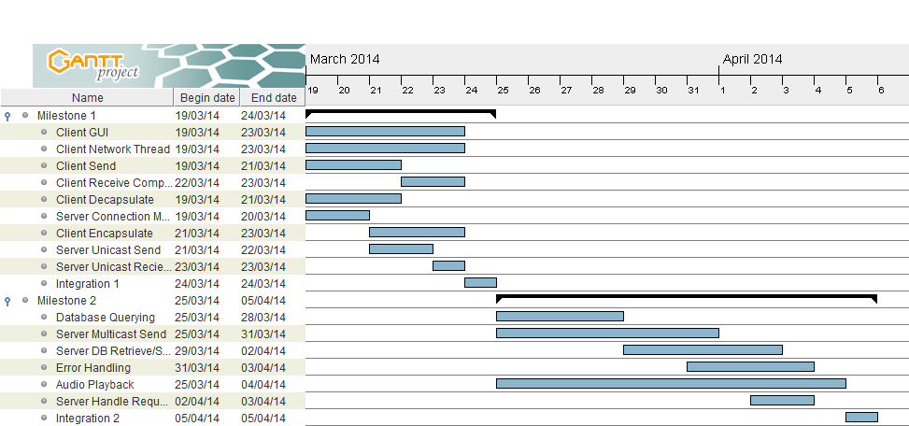
Comm Audio

GANTT Chart Planning for Comm Audio
Jobs to the left, timeline up top.

