Architecture model
Date | Version | Description | Author
2/4/2026 | 1.0 | Multi-layered archetecture | Jamie S
2/4/2026 | 1.0 | 3-tier client-server architecture | Ayati P
2/5/2026 | 1.0 | Model-View-Controller (MVC) Architecture | Waldo T

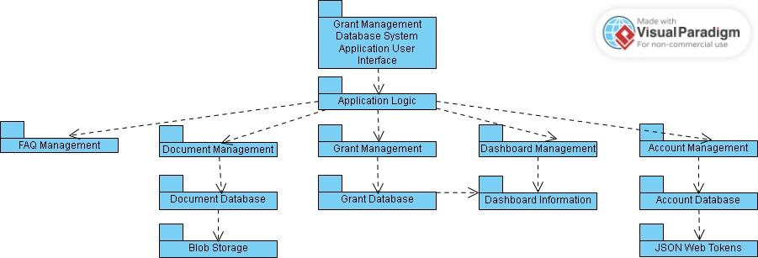

Selected Architecture
The selected architecture was the multi-layered archetecture. This archetecture is known for each layer communicating only with the layer below it, creating a system where a complex system can be depicted by superposing layers at increasing levels of abstraction.
Justification of Selection
- Epic-Cure Grant Management Database System Application User Interface.
  - Allows for user interaction with the application and manages what is presented to them on their device.
- Application Logic

  - Allows for all logic to be processed from the other architectural components.
- FAQ Management
  - Allows for information on the FAQ page to be added, changed, or removed.
- Document Management
  - Allows for documents to be added, changed, or removed.
- Document Database
  - Allows for the storage of all document information.
- Blob Storage
  - Allows documents to be stored in PDF, Word, and other formats.
- Grant Management
  - Allows for grants to be added, changed, or removed.
- Grant Database
  - Allows for grant information to be stored.
- Dashboard Management
  - Allows for real-time updates to dashboard information and timely notifications.
- Dashboard Information
  - Allows for the retreival of information from the grant database.
- Account Management
  - Allows for the creation, deletion, and loging in/logging out of accounts and the assignment of roles to those accounts.
- Account Database
  - Allows for the secure storage of account information.
- JSON Web Tokens
  - Allows for the secure transmission of account information.

Choices Rationale
The biggest design principle considered when creating the architecture model was the expected layering of all the architectural components. It was decided that the pyrimid structure would be the neatest and simplest way to depict all the components while still maintaining layering because of how the shape would naturally allow the arhitectual components to lay in a layered order. However, the model was not without its critical issues and trade-offs. The multi-layer model is meant to describe only the services of the project, not allowing for specifics of the project. But, the multi-layer archetecture was an archetecture that applied to the project and a simple way to depict the core services of the project, so it was included.

Software Requirements and Objectives Affecting Architecture
The databases, Blob Storage, and JSON Web Tokens are all provided by third-party software, so they had to be included in and thus affected the architecture model. JSON Web Tokens was also included in the architecture do to its importance to account security within the application.

3-Tier Client-Server Architecture:
In the 3-tier client-server architecture, all communication flows through the application tier, meaning that the client and database tiers cannot directly communicate with each other. This separation ensures security, maintainability, and scalability for the grant management system. The architecture focuses on three main components:

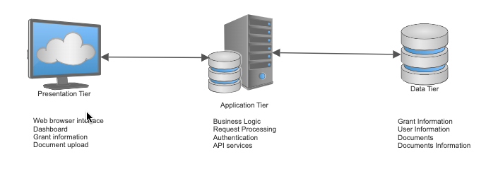
Client/Web Server - Top level tier, also referred to as the presentation tier. Displays information to and collects information from the client. It runs on any web browser for this project. The user interface is developed with UI-friendly coding languages.
Application Server - Middle tier, also known as the logic tier. Can be used for adding, modifying, or updating data in the data tier. Our application uses Node.js.
Database Server - Backend of the application, also known as the data tier. Data received from the application tier is stored and managed here, including user accounts, grant applications, uploaded documents, and document related information. For our project, we utilized a relational database management system with PostgreSQL, which provides robust data integrity through foreign key constraints and supports complex queries needed for grant management operations.
Model-View-Controller (MVC) Architecture:
In the model view controller architecture, the system is split up into three distinct components. This is to organize different components and make sure that the user interface layer is separate from other parts of the system. The model component is for data storage and retrieval through a database. The view component allows for user input and displays data to user. The controller allows for user interaction with the view and model.
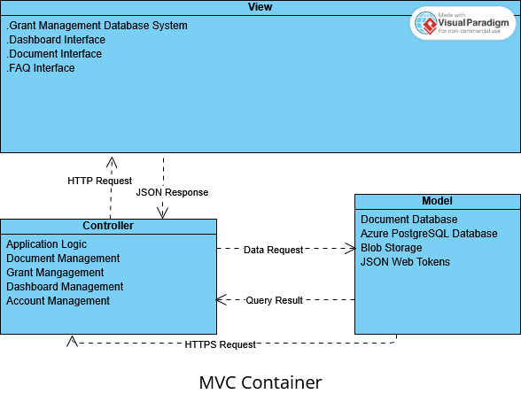

View – This component allows for data to be shown to the user from the model. The grant management database system, dashboard, document and FAQ sections are viewable to the user. The user can also interact with and input data for the document section, which changes the documents displayed by the dashboard.
Controller - Is used for adding, modifying, or updating grants. The model is called to read and write data from the controller. Application grants, document management, grant management, dashboard management, and account management all involve creating and modifying existing data. Our application communicates using Node.js.
Model – With this component, data is received, stored, and managed here. This includes user accounts, grant applications, uploaded documents, and document related information. When the controller calls the model for tasks such as retrieving data, the model returns information, which the controller uses to update data in view component. The model includes Azure Database for PostgreSQL, Azure blob storage for managing all uploaded files, and Wen Tokens for validating users

