Deliverable 4B
3-Tier Client-Server Architecture:
In the 3-tier client-server architecture, all communication flows through the application tier, meaning that the client and database tiers cannot directly communicate with each other. This separation ensures security, maintainability, and scalability for the grant management system. The architecture focuses on three main components:

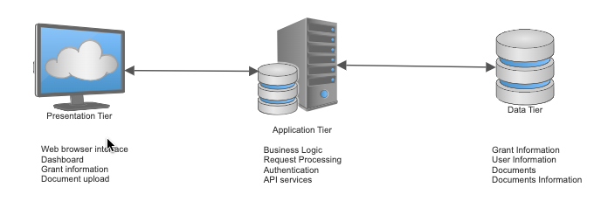
Client/Web Server - Top level tier, also referred to as the presentation tier. Displays information to and collects information from the client. It runs on any web browser for this project. The user interface is developed with UI-friendly coding languages.
Application Server - Middle tier, also known as the logic tier. Can be used for adding, modifying, or updating data in the data tier. Our application uses Node.js.
Database Server - Backend of the application, also known as the data tier. Data received from the application tier is stored and managed here, including user accounts, grant applications, uploaded documents, and document related information. For our project, we utilized a relational database management system with PostgreSQL, which provides robust data integrity through foreign key constraints and supports complex queries needed for grant management operations.

