User Interface Design
Use Case: Upload a grant-related document
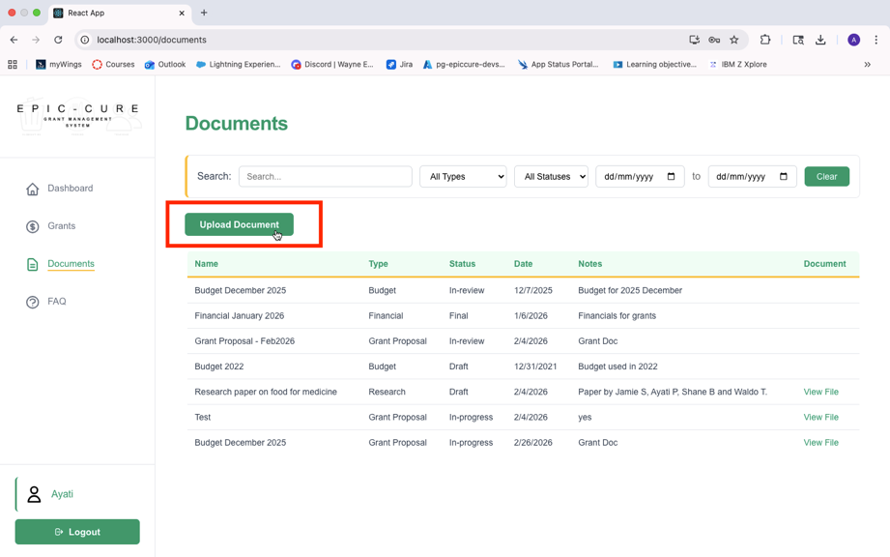
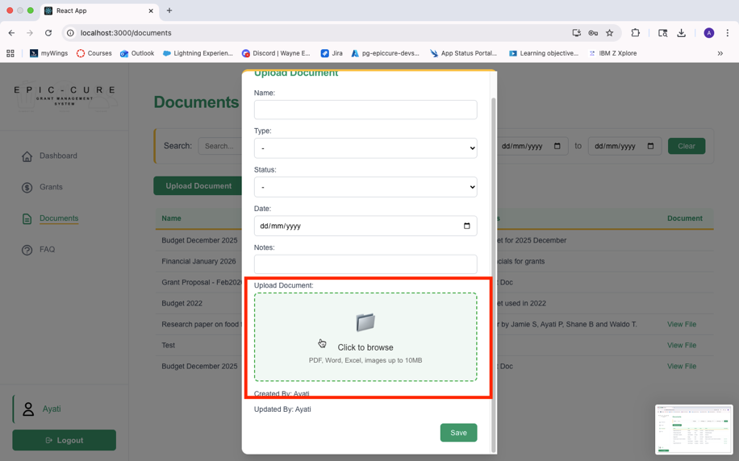
For the upload document features, the both the grant writer and the admin can upload a document by navigating to the documents page and clicking the upload document button. Once the upload document popup opens, enter all the relevant details and “click to browse” to select a document.
Developed by: Ayati Pandey
Use Case: Delete outdated or incorrect documents
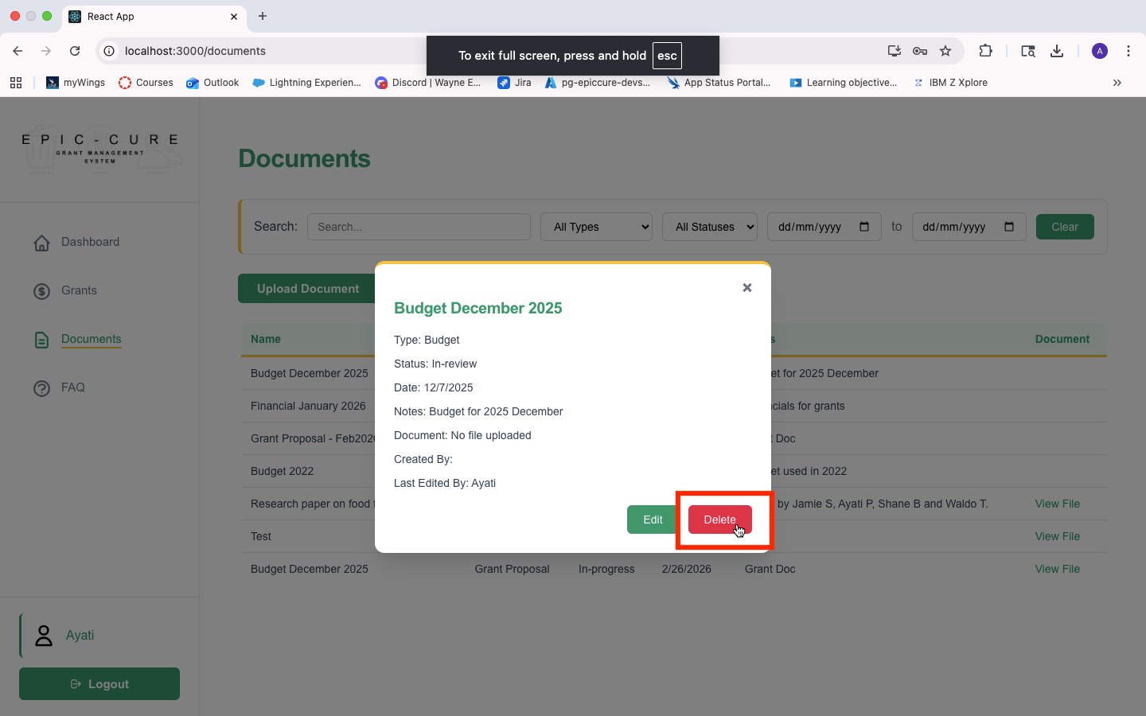
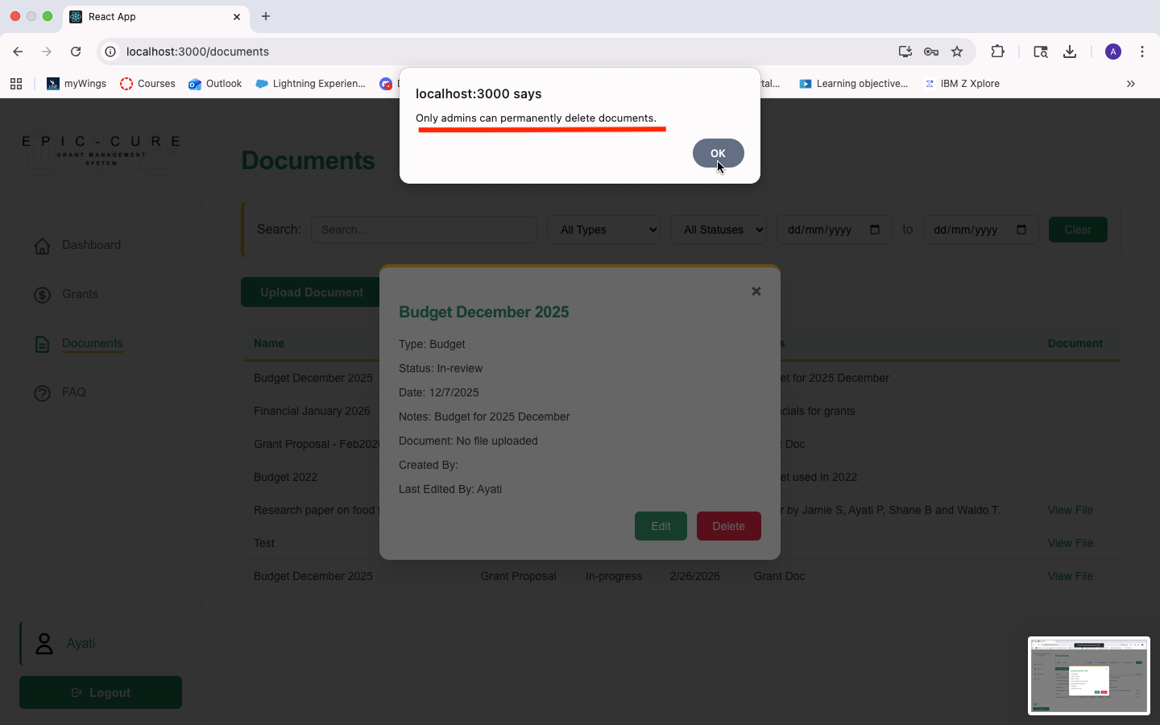
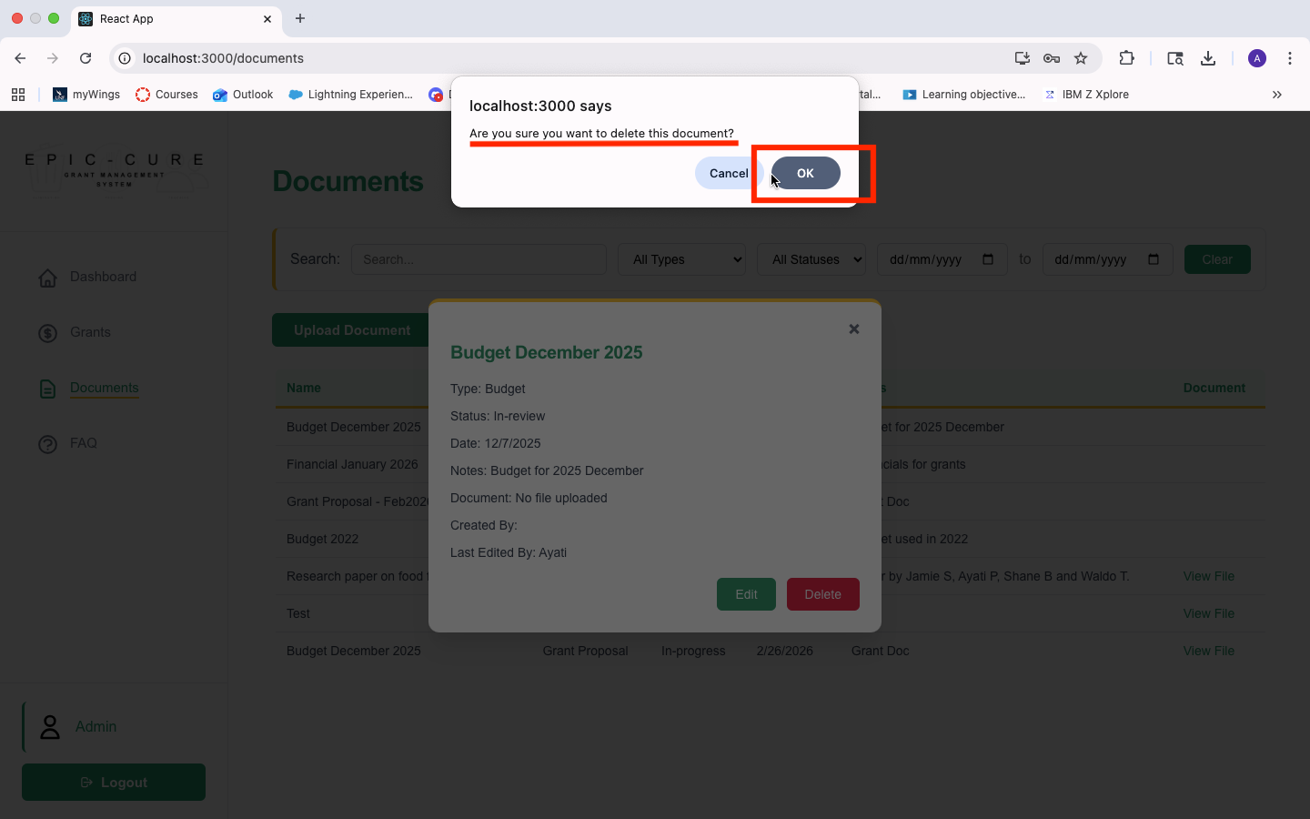
For the delete document features, only the admin can delete a document, once the user clicks the delete button on the document preview, a popup message shows up for the admin confirming the request and a popup message saying that only admin can delete a document for the grant writer role.
Developed by: Ayati Pandey

Use Case: Download documents for offline access
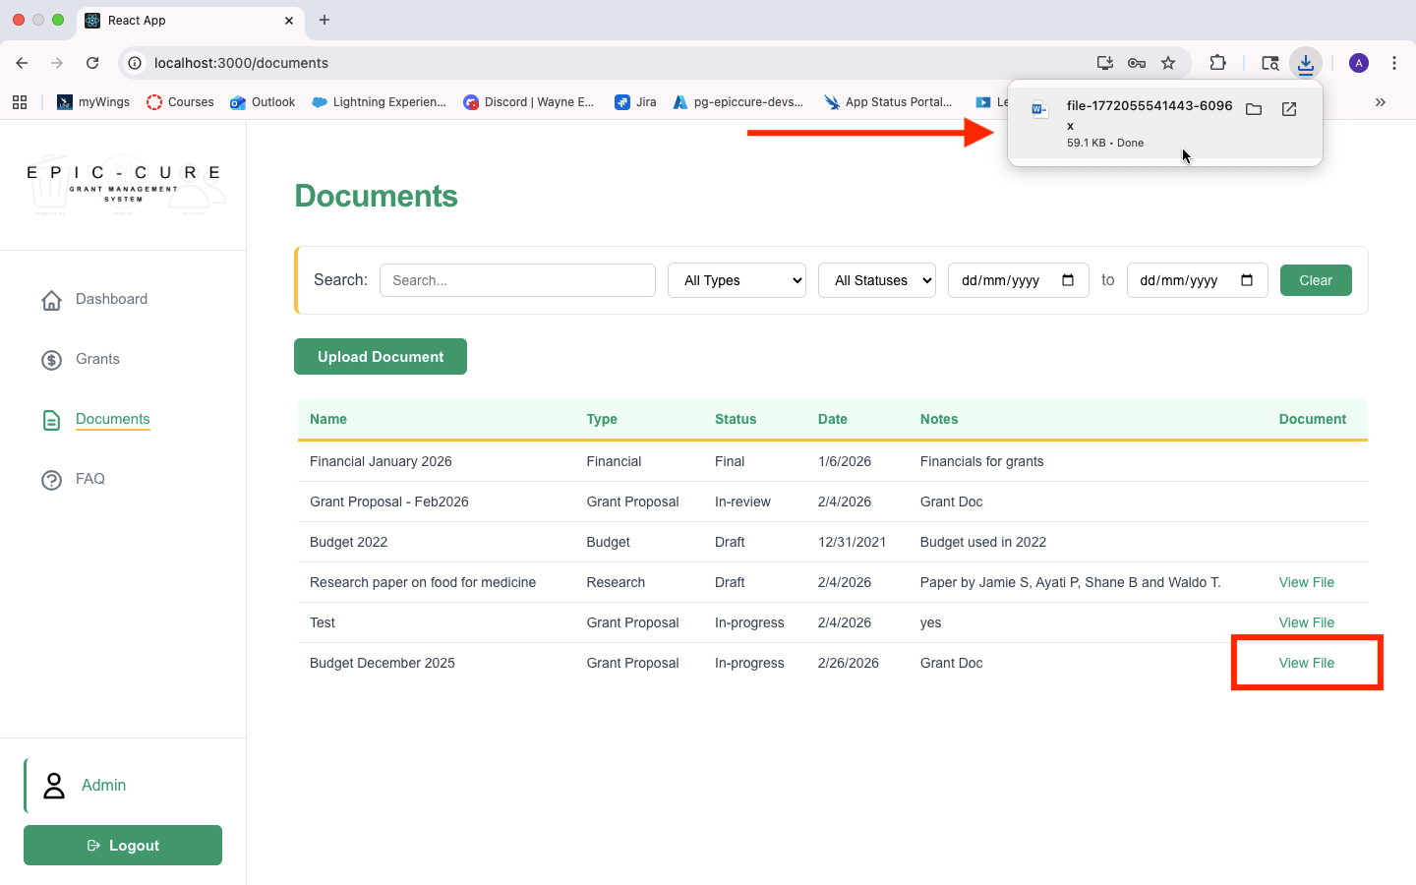
Developed by: Ayati Pandey
Both the grant writer and the admin can view and download a file by navigating to the documents table on the documents page by clicking on the “View File” button and downloading a document. This will bring the user to view the download file in the download section.

Use Case: View all documents with key details
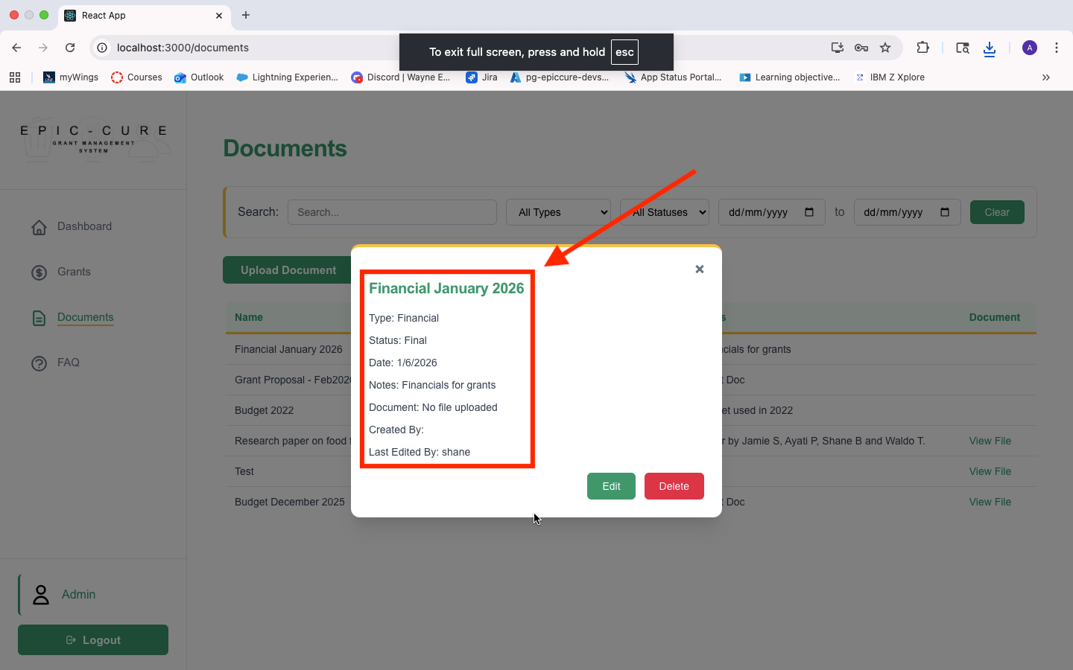
The admin and grant writer can view key document table by navigating to the documents table on the documents page and clicking on the document name to view the key details.
Developed by: Ayati Pandey

Use Case: Assign a document type or a status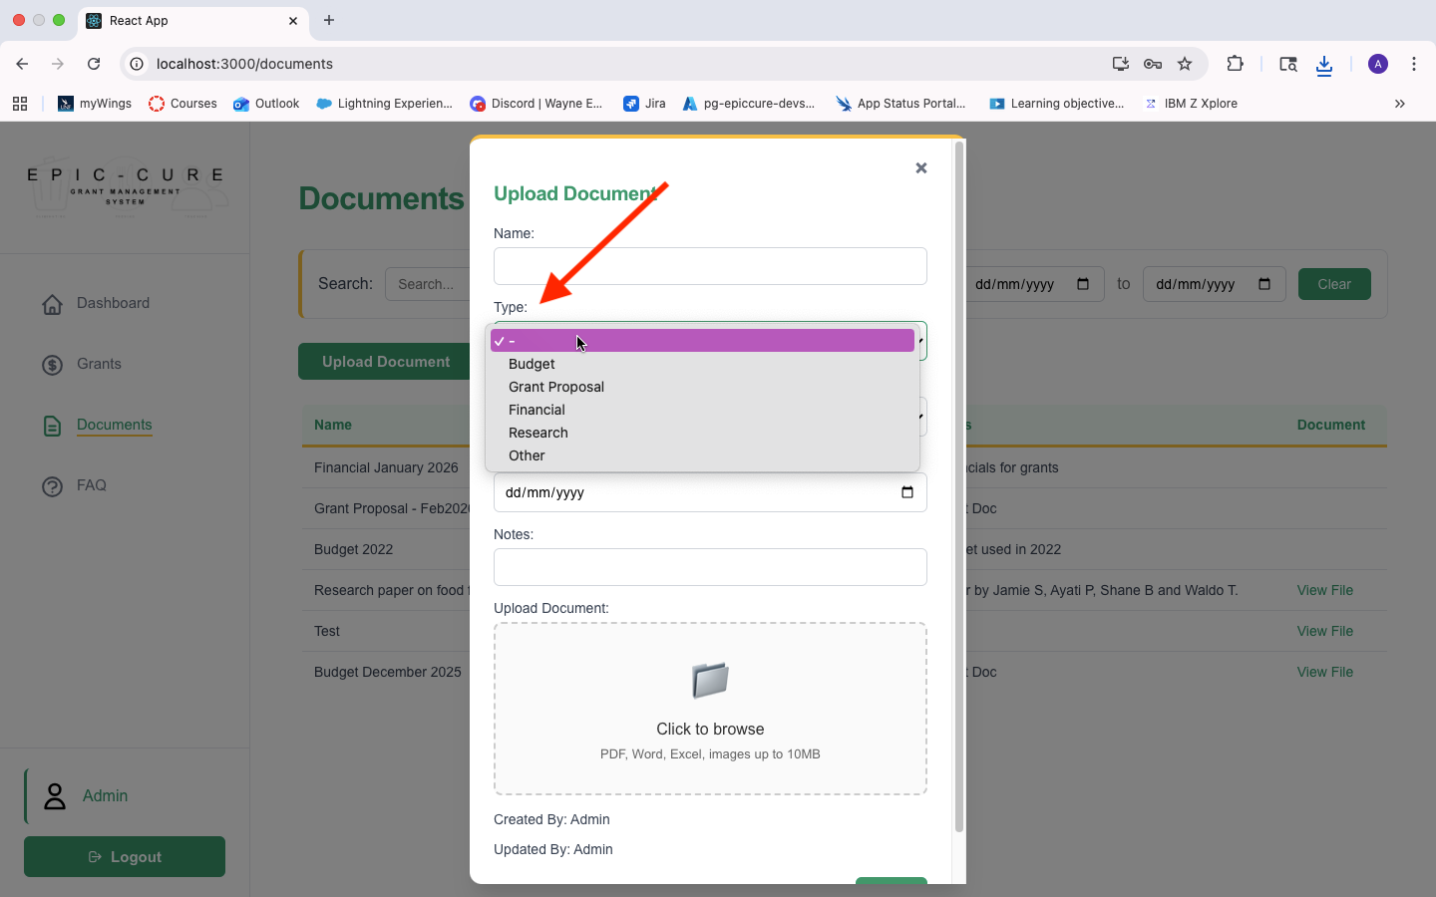
To assign a type or status to a document the admin or the grant writer can click the upload document button on the documents page to assign a type or status to the document. A dropdown list appears with options of “Types of documents” and “Status”.
Developed by: Ayati Pandey

Use Case: Sort documents by date, type, or status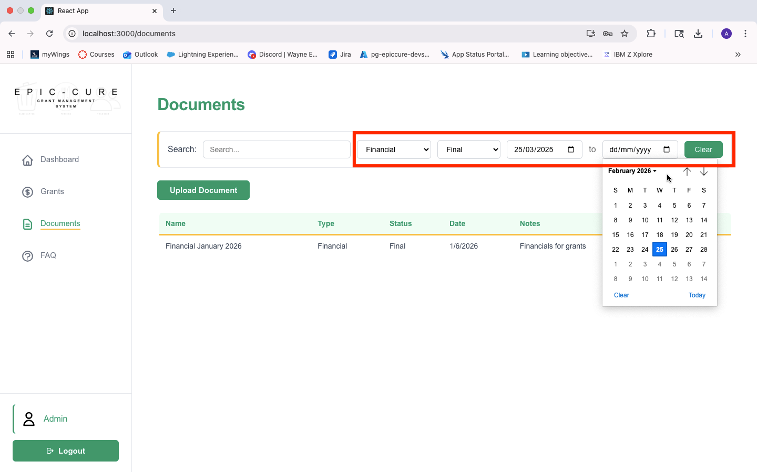
An admin or a grant writer can sort and filter through documents by name, type, status and date by navigating to the documents page and selecting a filter on the sort and filter bar. They can also clear the filters by clicking the “Clear” button.
Developed by: Ayati Pandey

Use Case: Add notes to a document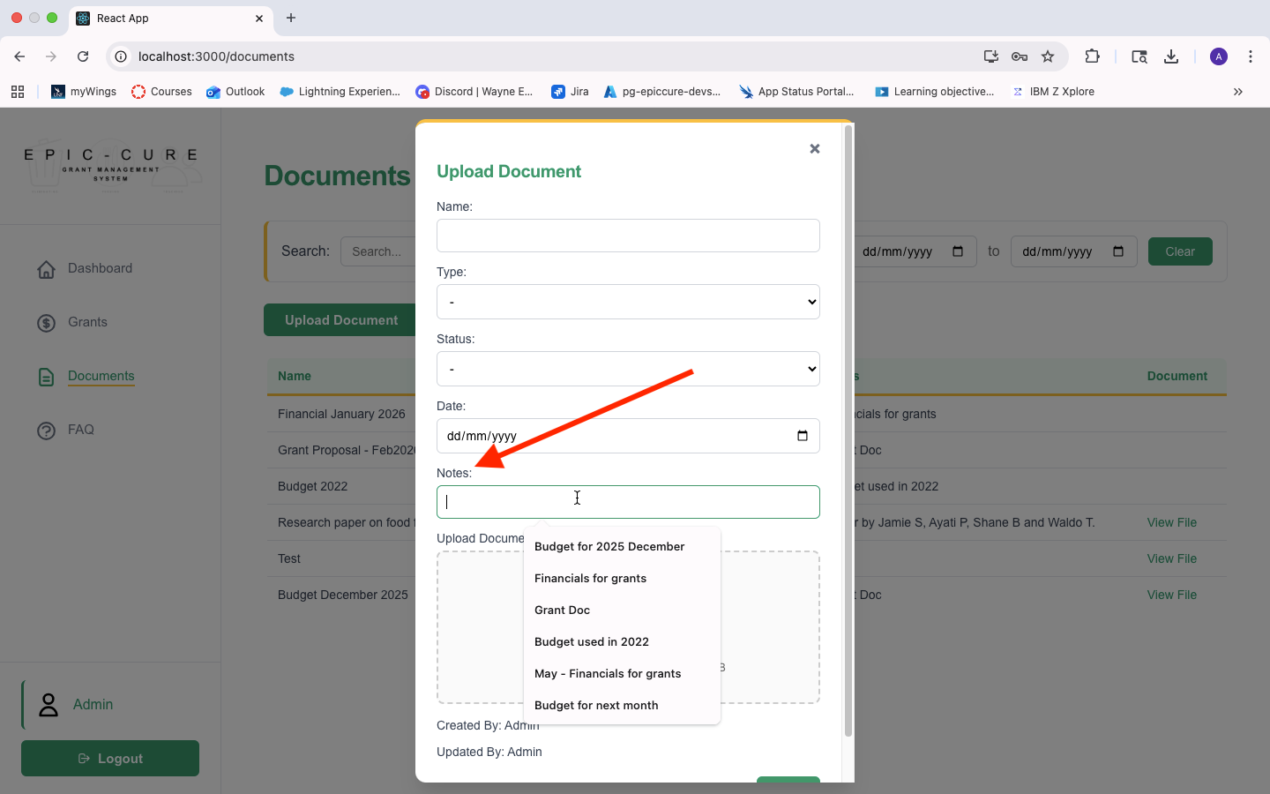
To add a note to a document the admin or the grant writer can click the upload document button on the documents page and type a note in the notes textbox .
Developed by: Ayati Pandey

Use Case: Edit document date/type/status/name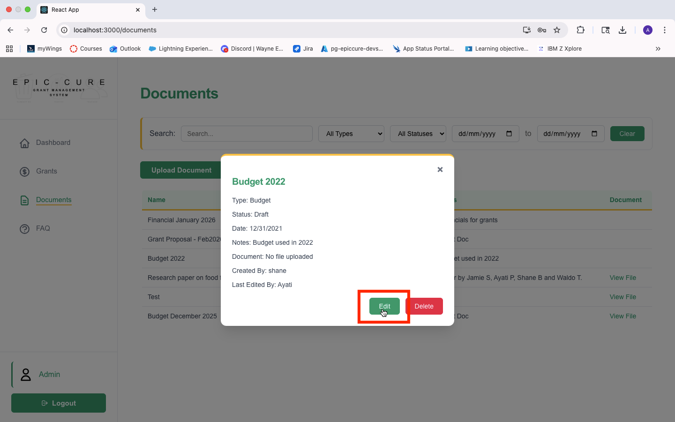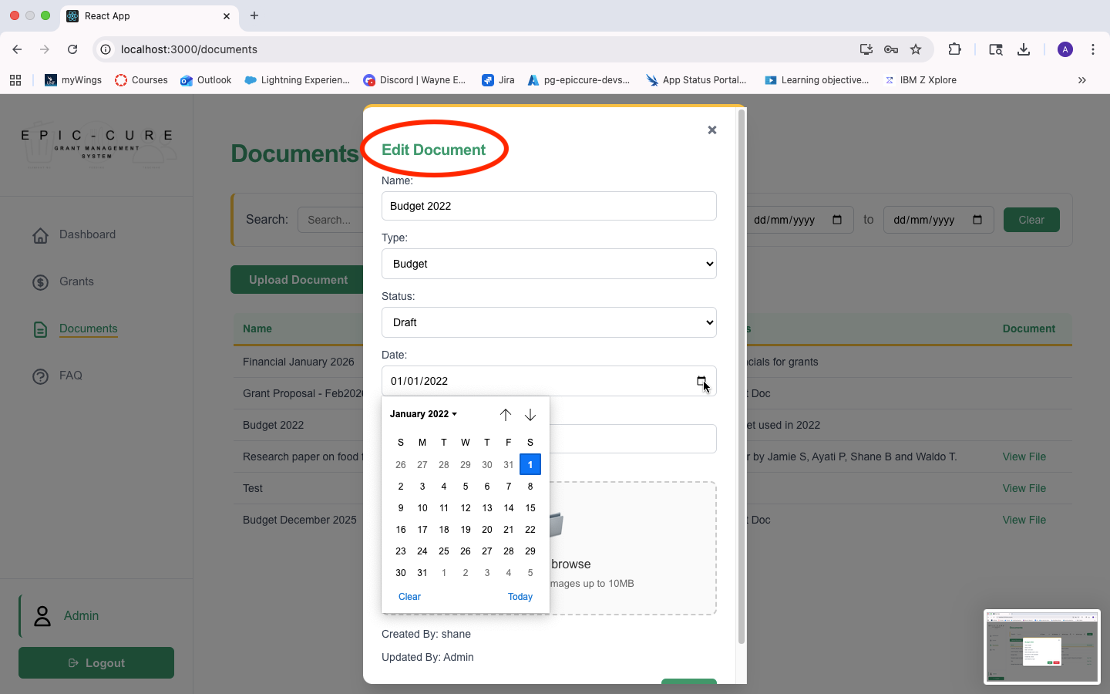
A grant writer and an admin can edit the document by clicking on the document name on the document table on the document page and then click on the edit button. The edit popup appears and the user can edit the preexisting information and hit “Save”
Developed by: Ayati Pandey

Use Case: Provide a custom document name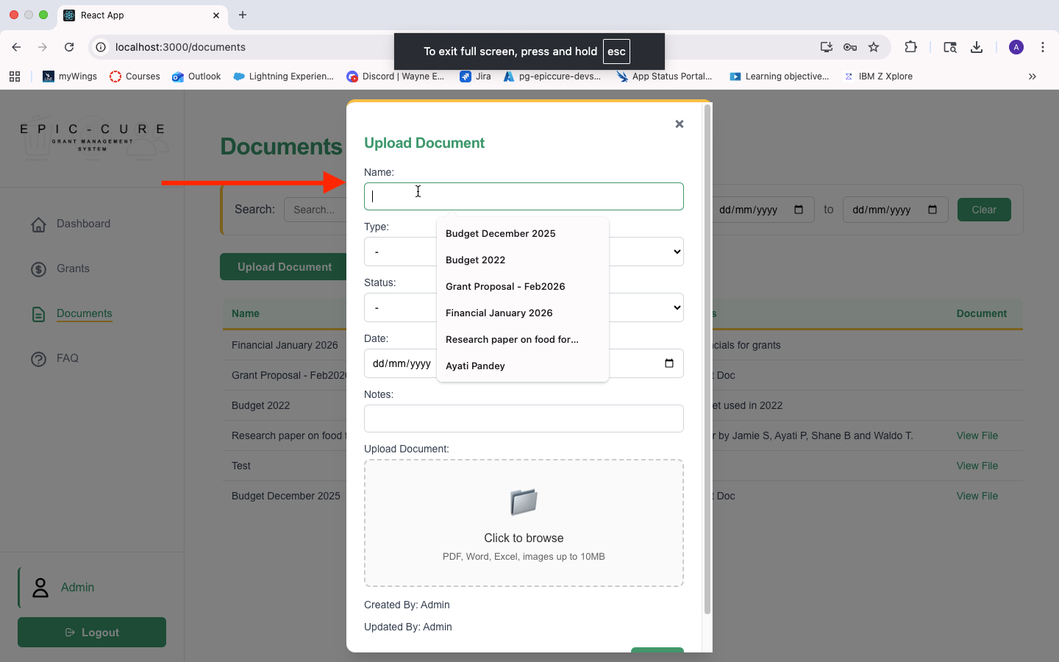
To assign a custom name to a document the admin or the grant writer can click the upload document button on the documents page and type out a custom name in the “Name” textbox.
Developed by: Ayati Pandey

