**SHANE BOLDING**

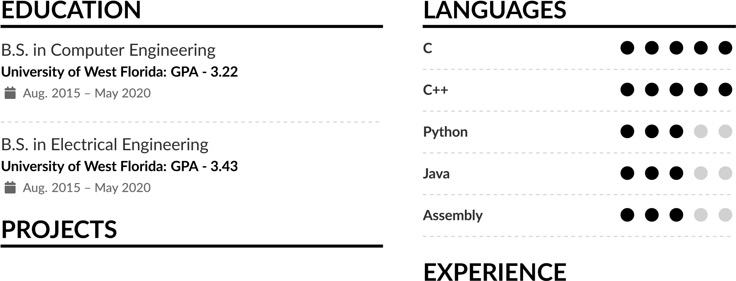@ **Shane.B.Engineer@gmail.com** Address: **35504 Weiss Rd, 70785**  **Walker,LA** Website: [**https://shanebolding.github.io/Showcase/**](https://https://shanebolding.github.io/Showcase/)

# Lego Collecting Robot

## C#

Date: Oct. 2019 - Mar. 2020 Location: UWF

∙ Entered the Southeast IEEE PI Day Competition.

∙ Built a robot, including the power system, to pick up the most Legos in a specific order in under 3 minutes.

∙ Accomplished 13 blocks stacked in 3 minutes.

∙ Unfortunately, the contest was cancelled due to Covid.

# Personal Handheld Game System

## Python/Solidworks

Date: July 6 - 9, 2020 Location: My Home

∙ Utilized a Raspberry Pi Zero and a 2.2 inch screen to create the system.

∙ Soldered a safe battery system to ensure fast charging and a battery life of approximately 6 hours.

# Home Security Camera

## Python/Solidworks

Date: July 11 Location: My Home

∙ Designed a self-contained power supply system for it.

∙ Utilized Python and a machine learning algorithm library to watch my doorway and send me a picture through email when it detected a human at the door.

∙ Designed and printed a black casing to hold the raspberry pi and camera.

# Chebyshev Filter

## Electronics

Date: Fall 2019 Location: UWF

∙ Created using Chebyshev filter table and other physics functions.

∙ Used this idea of stacking filters on one another in my signals and systems class.

# Tutor

## University of West Florida

Date: Aug. 2019 - May 2020 Location: Pensacola, Fl

∙ Help countless students understand Computer Science, Computer Engineering, and Electrical Engineering that they may not have understood the first time.

∙ Worked more than the 10 hours I was paid a week to ensure the students that came to me for help got the help they needed.

# **MORE PROJECTS**

## Clock based on 555 timer

### Digital Logic

Date: Spring 2018 Location: UWF

∙ Assembled a clock that counted the time using JK flip flop chips and utilized seven segment displays to display the time.

∙ Utilized a truth table and Karnaugh map to create this project.

## Programs to Demonstrate Multi-Threading

### C/C++

Date: Spring 2019 Location: UWF

∙ Utilized threading to do computationally complex problems in a fraction of the time using a single thread program.

∙ Learned about protection of race conditions when

threading using a data structure called a Semaphore.

∙ Constructed throughout multiple projects the under-

standing of Multi-Threading.