Matlab simulation:

(a) repetition coding under different time diversity

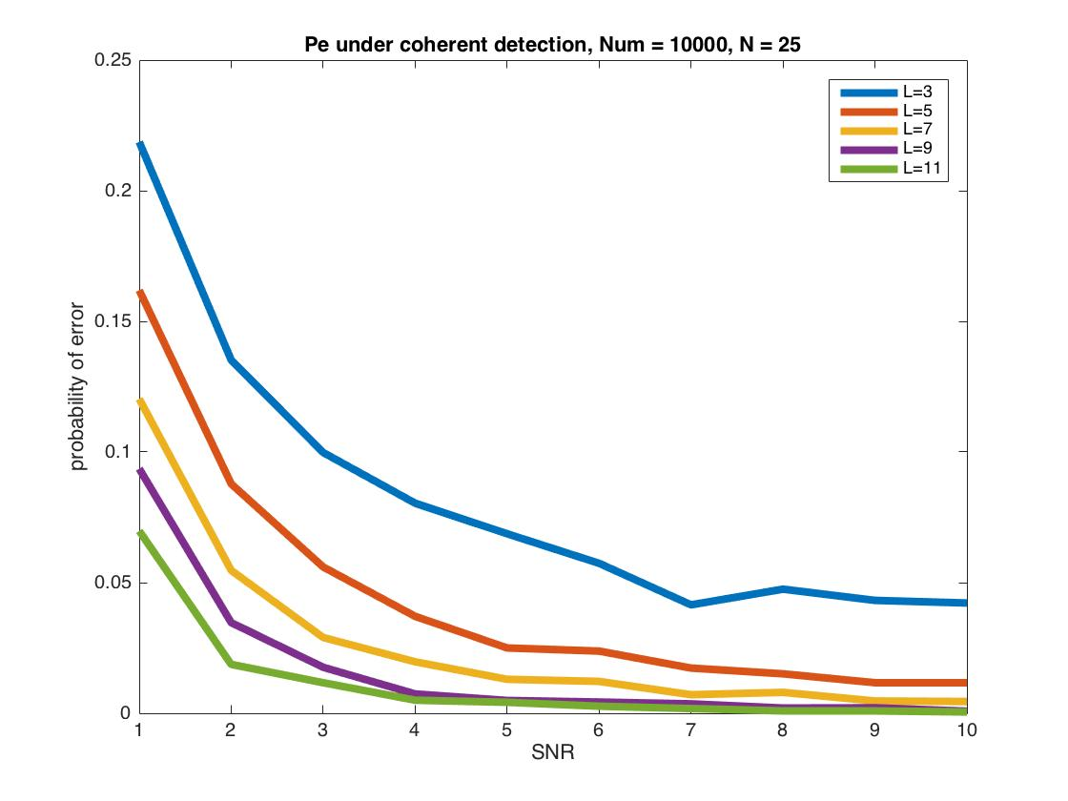

The effect of time diversity is showed in the plot.

(b) Hamming(7,4) coding

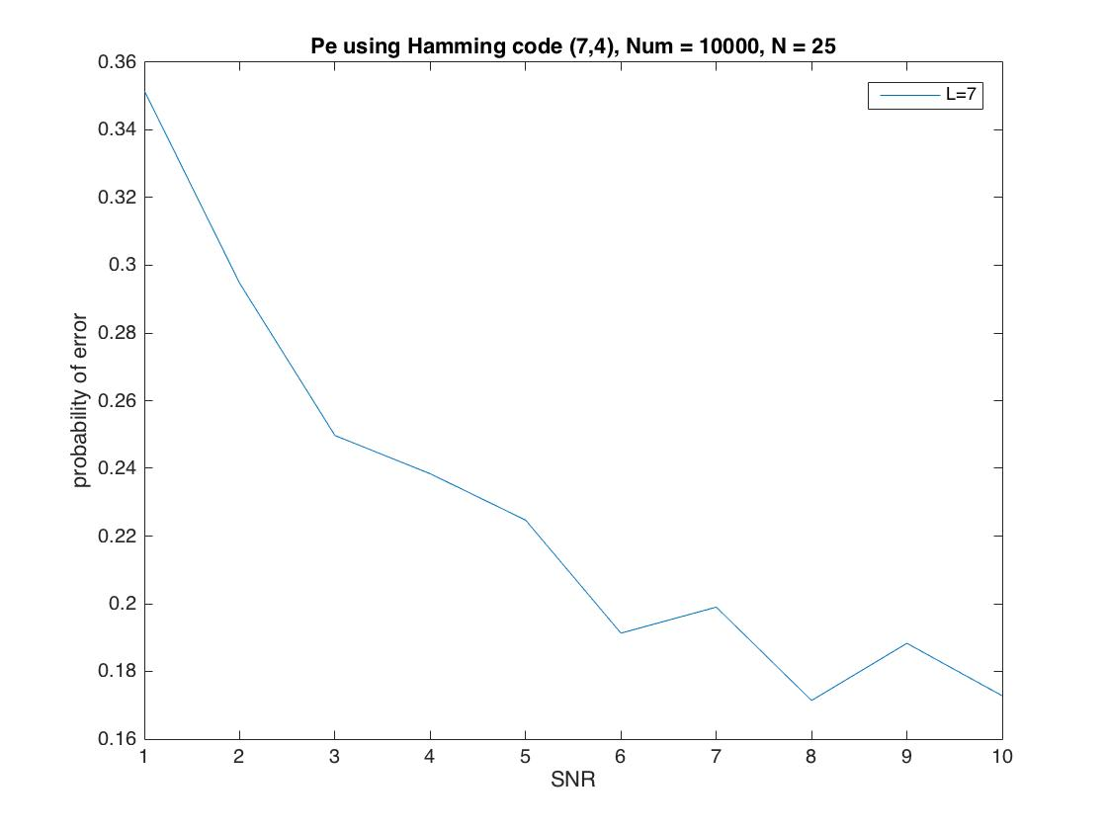

it is obvious that Hamming(7,4) perform worse than repetition coding. This is because the coding rate here only 7/4 = 1.75, but the coding rate in repetition coding in 3, 5, 7, 9, 11, respectively.