# Overview

This document outlines the steps required to build and deploy the example NETHook project for Mastercam. This document assumes you installed to the default Mastercam location, if you installed elsewhere adjust the paths shown as appropriate.

# 

# Visual Studio Setup

Visual Studio must be in administrator mode (as Administrator) for this project to build properly. The easiest way to do this is to setup your Visual Studio shortcut to always run as Administrator by doing the following…

1. Right-click on your Visual Studio shortcut and select **Properties**
2. In the **Properties** dialog, click the **Shortcut** tab
3. Click the **Advanced…** button
4. Check the **Run as administrator** option in **Advanced Properties** dialog
5. Click **OK** to close the **Advanced Properties** dialog
6. Click **OK** again to save and close the shortcut properties

# Project Setup

This NETHook project was written in Visual Studio 2017 and targets the .NET 4.0x Framework as well as the Mastercam NET-Hook 3.0 library (**NETHook3_0.dll**). This project may work with multiple versions of Mastercam. Make sure the reference to the **NETHook3_0** library is valid. If there is a warning symbol displayed on the **NETHook3_0** reference in the Solution Explorer, or if you receive errors/warnings, such as the one below, when building the project, the path to your **NETHook3_0.dll** file may need to be re-established.

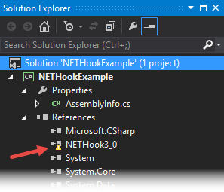

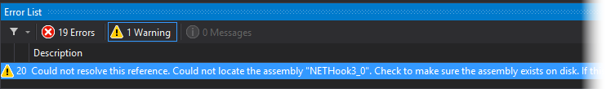

This can be done in the **Solution Explorer** by removing the existing **NETHook3_0** reference and then re-adding it per the steps below.

1. If necessary, expand the main project (e.g., **NETHookExample)** node  
   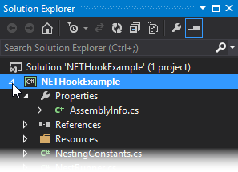
2. Expand the **References** node  
   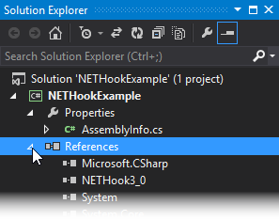
3. Right-click on the **NETHook3_0** reference and click **Remove**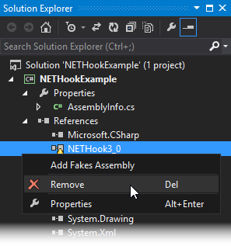
4. Right-click on the **References** node and click **Add Reference…**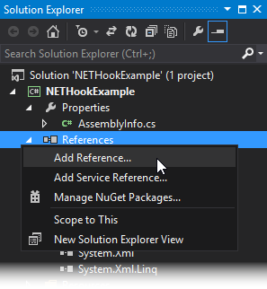
5. In the **Reference Manager** dialog, click the **Browse…** button  
   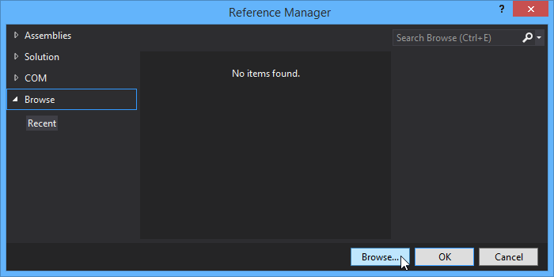
6. Browse to the Mastercam installation folder (**e.g., C:\Program Files\mcam\*\*\***), select the **NETHook3_0.dll** file and click **Add**  
   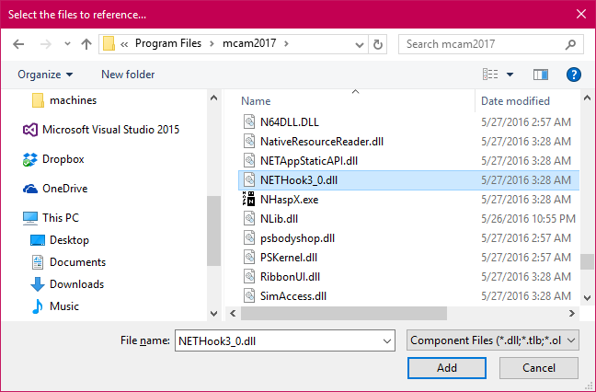
7. In the **Reference Manager** dialog, ensure that **NETHook3_0.dll** is checked and click **OK**  
   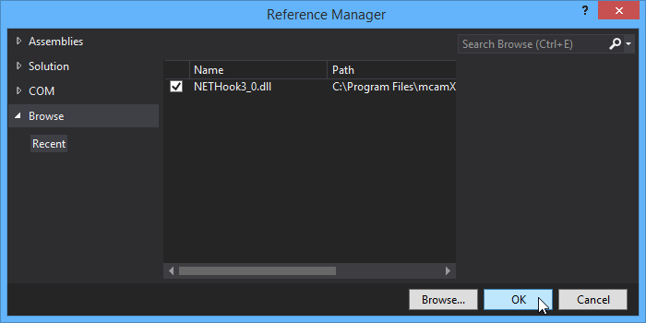

The **NETHook3_0** reference should then appear in the **References** list without the warning symbol.  
  
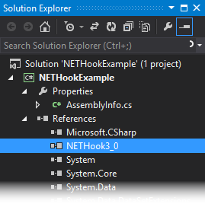

1. Set the project to start **Mastercam.exe** as an external program. To do this, go to **PROJECT** menu in Visual Studio and then select **NETHookExample Properties…** In the **Debug** properties section, use the browse button to set the **Start external program** property to the path to your **Mastercam.exe** (e.g., "C:\Program Files\mcam***\Mastercam.exe"). Then do the same to set the **Working directory** property to the Mastercam installation folder (e.g., “C:\Program Files\mcam***”) Mastercam 2017 is shown below.

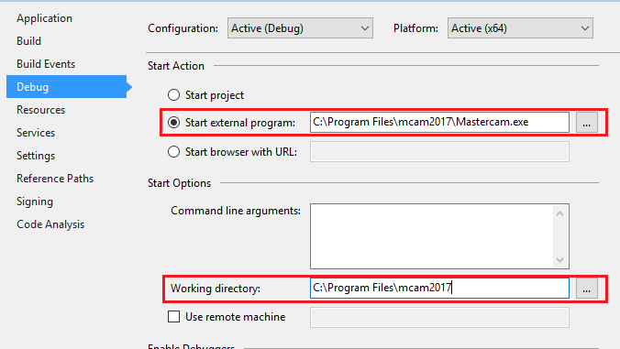

1. Add post-build events to copy the built NETHook **.dll** and **ft.** files to your Mastercam installation. To do this, go to **PROJECT** menu in Visual Studio and then select **NETHookExample Properties…** (if the properties are not already open from the previous step). In the **Build Events** properties section, click the **Edit Post-build…** button then enter the following two lines into the **Post-Build Event Command Line** field as shown below…

*copy "$(TargetPath)" "C:\Program Files\mcam***\chooks\"*

*copy "$(ProjectDir)Resources\FunctionTable\$(TargetName).ft" "C:\Program Files\mcam***\chooks\$(TargetName).ft"*

Note that “*C:\Program Files\mcam***”* is the path to your Mastercam installation folder and may vary. **Visual Studio must be run as Administrator for a successful post build**.

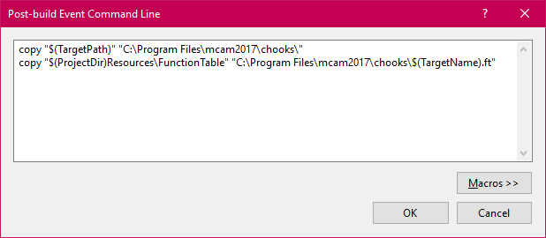

## Adding to Ribbon, QAT and Context Menu

If you use the projects post build step the NET-Hook and the FT file will be copied automatically to the correct location otherwise, you will need to copy the DLL and the FT file to your **mcam***\ chooks** folder. This will allow the NETHook commands specified in the FT file to be added to the ribbon/ribbon tab, quick access toolbar and context menu (reference the Mastercam online help documentation on how to customize the ribbon, etc.)