# Group F KA-306 Lab group B

Group Members:

* Sean Hartnett
* Mark Flanagan
* Shane Fanning

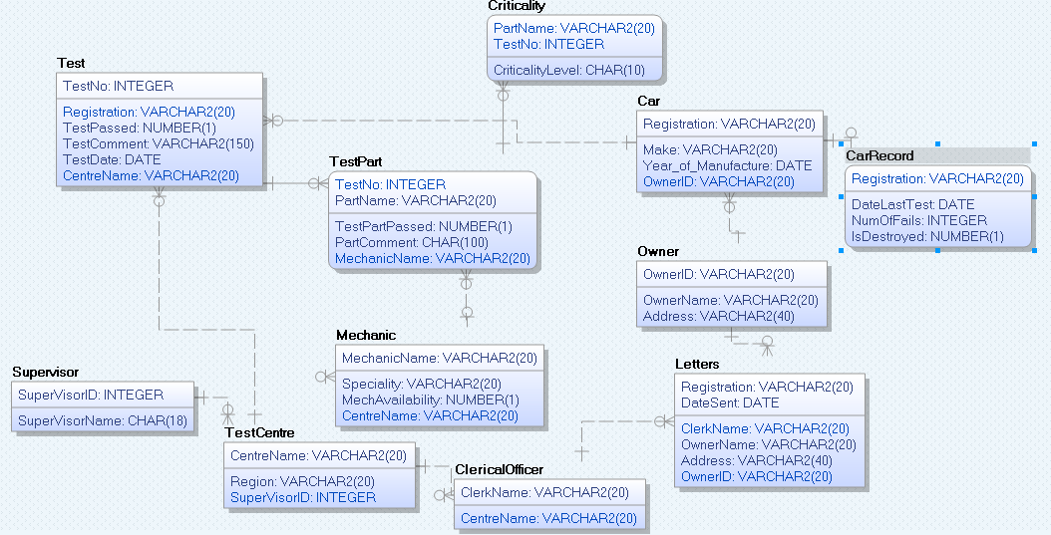

Car Test Transaction Specifications

**Transaction:** Enter the date to check if any cars are required to take a test due to cars age or date since last test. If they do require test, create a Letter for the Owner

**Description:** The transactions purpose is to take in a date through a front end and return the owners of cars that are older than 5 years or cars that are older than 5 years and haven’t had a test in a year, by joining the Car table with the Owner and CarRecord table. If those conditions are true, a letter will be created for the owners. The transaction will also look to see if a letter with a recent date exists for that owner, to stop a new letter being created every day after they due to be tested. There will be an exception catch for the possibility that no cars are due to be tested that day. Messages will be written to screen showing the user which owners have vehicles that need to be tested.

**Transaction:** Enter a test no. and check if there are any high criticality failures on any of the Test Parts. If there are, the test as a whole is failed.

**Description:** The user enters a Test number into a front end which will be used to join the Test table with TestPart and Criticality. If a TestParts ‘TestPartPassed’ value is equal to 0, this means it has failed that test. If the ‘CriticalityLevel’ value in the Criticality table is ‘high’, then the ‘TestPassed’ value in the Test table is set to 0, representing a fail. The ‘NumOfFails’ value in the CarRecord table is also incremented by one. Messages will be written to screen informing the user of the status of the test. There will be exceptions in place to catch the possibility that the Test no. does not exsist.

**Transaction:** The Supervisor enters if each mechanic is available to work that day, for that Test Centre.

**Description:** Every day the supervisor will enter each mechanics availability into the Mechanic table. We assume that the supervisor will have prior knowledge to every mechanics availability that day. This will be used to decide what TestParts each mechanic will be testing that day and also as a record of when each mechanic worked. All available mechanics are then allocated a set of checks that they must carry out during the tests.